**Lab 13 - Form Modeler**

JBoss BPM Suite 6 allows you to generate forms both to start a process and for human tasks. Once generated, you can further tweak and configure these forms using the form modeler.

**Goal:**

Add a process start form and review quote form using the form modeler, and test the process using BPM Central.

**Prerequisites:**

Data model objects using the JBoss BPM Suite 6 data modeler.

**1. Generate Forms**

1. Point your browser to the BPM Central web application of your online lab environment.
2. Open the **policyquoteprocess** business process.
3. Check your variables and properties. The variable definitions should look like this:

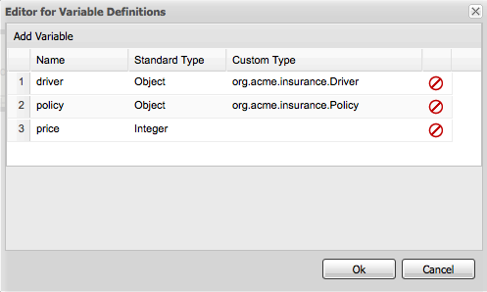

Figure 1. Variable definitions

1. Select the reusable subprocess node **Calculate Policy Quote**.
2. Add the code snippet shown below as an **Action** into the **On Exit Actions** property on the **Properties (Reusable)** panel on the right.

acme.policyquote.policy _policy = (acme.policyquote.policy)kcontext.getVarialbe(“policy”); kcontext.setVariable(“price”,_policy.getPrice()); System.out.println(“Price before review: “+ policy.getPrice());

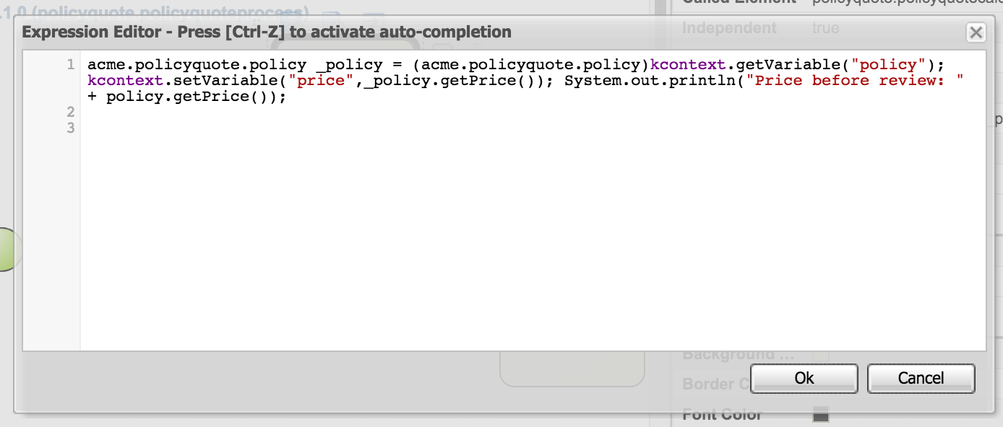

Figure 5. Actions editor

1. Select the Review Quote User Task node and add the code snippet shown below as an **Action** into the **On Exit Actions** property in the **Properties** panel on the right.

Integer p = (Integer)kcontext.getVariable("price"); System.out.println("Price After review: " + p);

1. To generate the forms for the policyquoteprocess process, open the process in the Process Designer and select the **Generate all Forms** menu option.

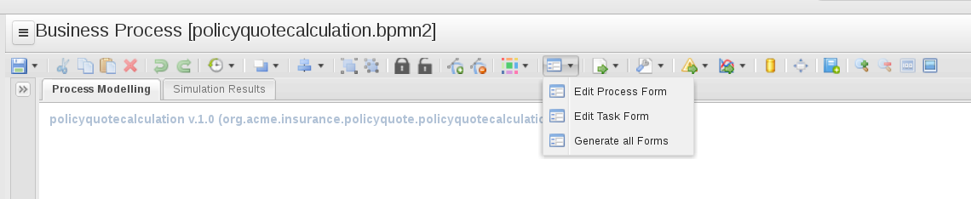

Figure 6. Generate all Forms option

Selecting this option produces two forms in the FORM DEFINITIONS section of the policyquote project Project Explorer:

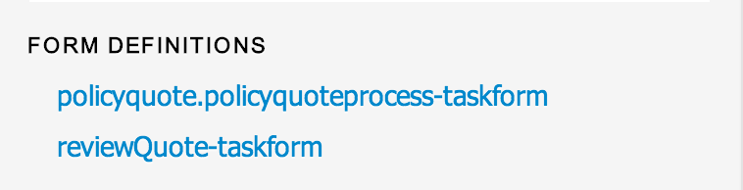

Figure 7. Form definitions

**2. Modify the Process Start Form**

1. From **Project Explorer**, open the process start form: **policyquote.policyquoteprocess-taskform**.
2. Notice that the generated form is based on the process variable names, which are mapped as the origin (driver and policy) of your business process.
3. Tweak the form slightly to make it more usable:
   * Change the labels.
   * Rearrange the fields.
   * Remove the fields that you do not need to start the process—for example, **driver (policy)**,**price** and **price discount**

Here is a screenshot of the properties for each field

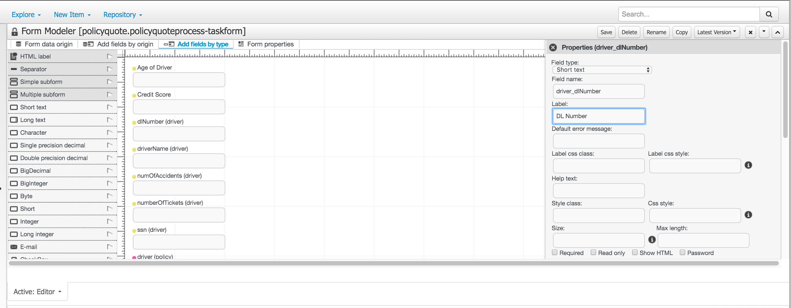

1. Hover over a field, and observe that the icons in the palette allow you to move and edit the fields. When you click **Edit**, a panel of field properties appears adjacent to the form. You must click **Save** at the bottom of the properties for the changes to take effect.

Note:

***Make sure you do not change the binding expressions, which link the field to a process variable.***

1. To edit the properties of a field, click the **pencil** icon.
2. After some tweaking, your form could look like the following:

Figure 8. Start form (policyquote.policyquoteprocess-taskform)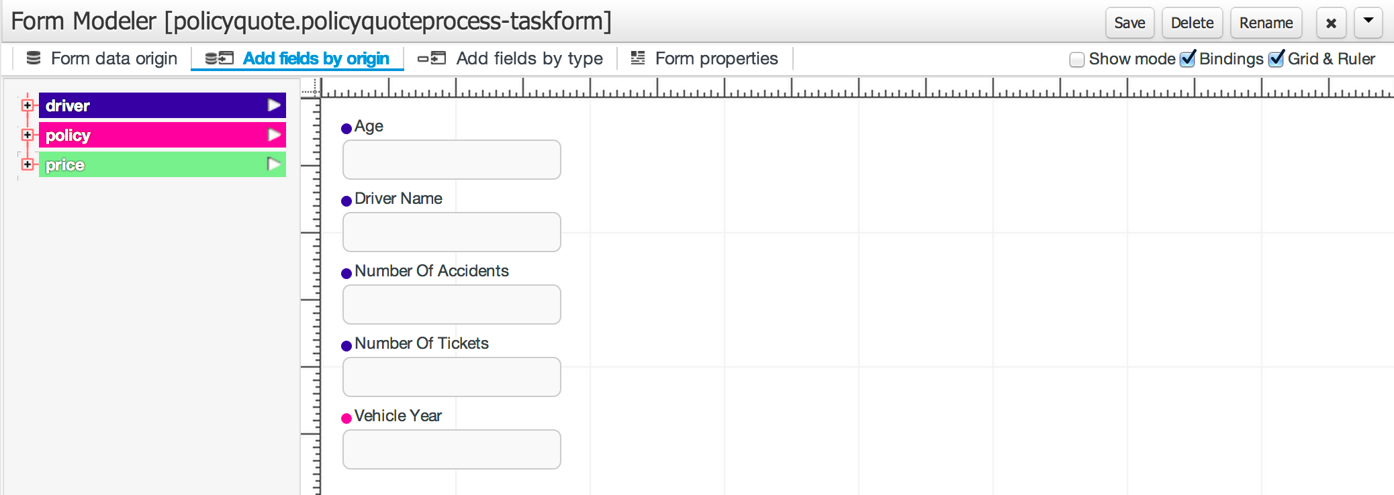

1. Click the **Form data origin** tab. You should be able to find your process variables as data model object origins. You used these to create the process start form.
2. Observe the colors that bind fields to a specific data object origin:

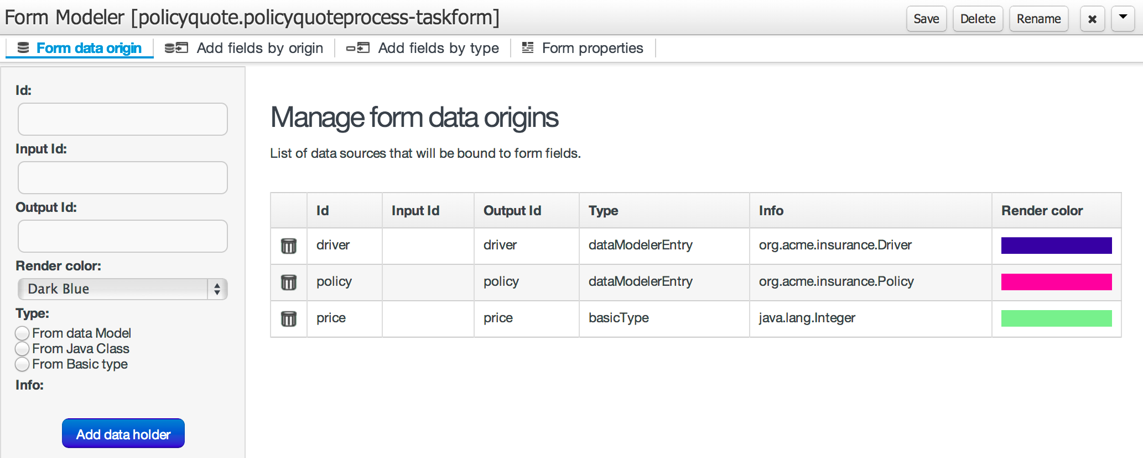

Figure 9. Manage form data origins

1. When you are satisfied with the result, save the form.

**3. Modify the Task Form**

1. Follow the steps in **Modify the Process Start Form** for the **reviewQuote**-taskform task form. Your form should look like this:

Figure 10. reviewQuote form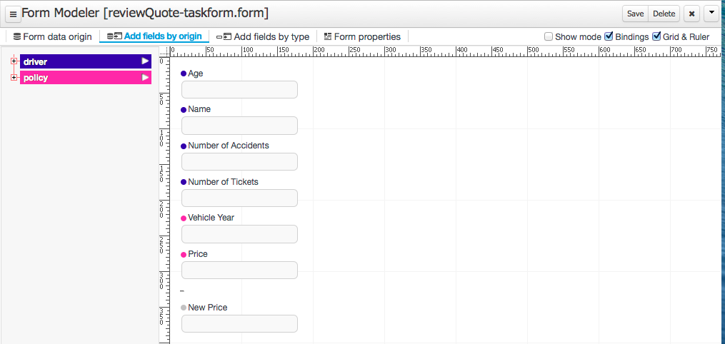

1. Click the **Form data origin** tab. You should be able to find the variables that the form was based on:

Figure 11. reviewQuote origin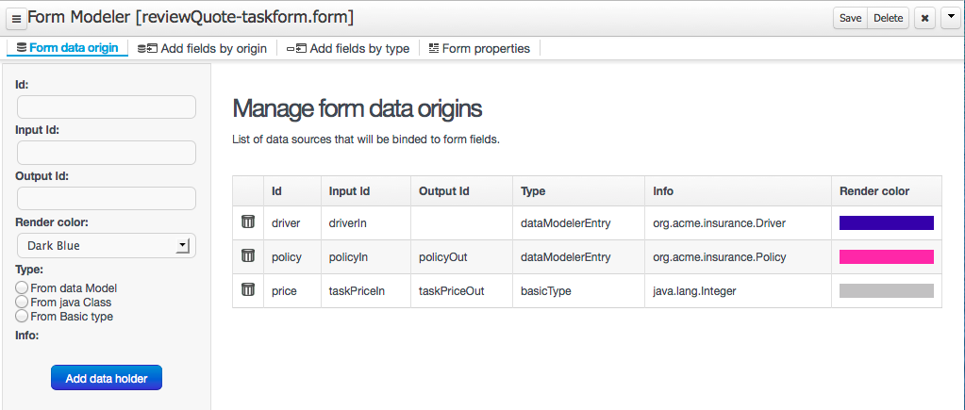

1. Except for the **New Price** field, you can mark all the other fields as **Read only**.

Figure 12. reviewQuote form attribute read-only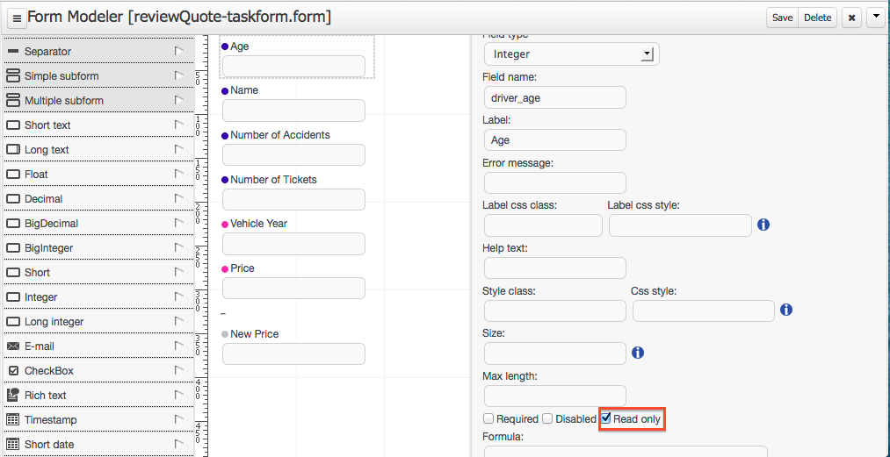

1. You can see two price fields:
   * **Price** - This field is **Read only** and is bound to policyIn/price and policyOut/price, which is the price defined in the Policy object originating from the process variable policy (see Figure 4, above).
   * **taskpricein** - This field is bound to **taskPriceIn** and **taskPriceOut**, which is the price defined as a process variable and used to override the calculated price.
2. When you are satisfied with the result, save the form.

Now that you have built your forms, you are nearly ready to execute and test your process. You will do this in the next lab.