**Lab 14 – Running the Process**

**Goal:**

Start a process instance and interact with created forms, entered data, and completed tasks.

**1. Execute and Test the Process**

Now you can execute and test your process.

**1.1. Build and Deploy the Project**

First you need to build and deploy the project.

1. Click **Tools → Project Editor** to open the **Project** screen.
2. Click **Build & Deploy**.

A green alert should appear indicating a successful build. If the build fails, this means there is something wrong with your process. Review the server.log to identify and fix the problem.

1. If your project builds successfully, click **Deploy → Deployments** to view your deployment on the **Deployment Units** screen. The process definitions should appear in the **Process Definitions** panel.
2. Click **Process Management → Process Definitions** to open the **Process Definitions** screen.

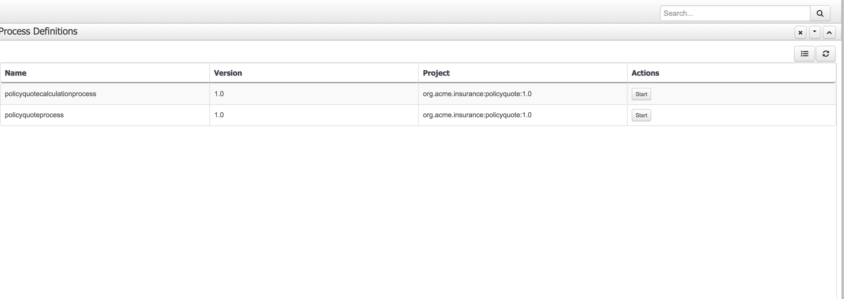

Figure 1. Process Definitions screen

**1.2. Start a New Instance of the Process**

Note that the main process is the **policyquote** process (the policyquotecalculation process is a sub-process that is only invoked by the policyquote process)

1. Click **Start**

This opens up a form. Enter the following values in the form per this screenshot

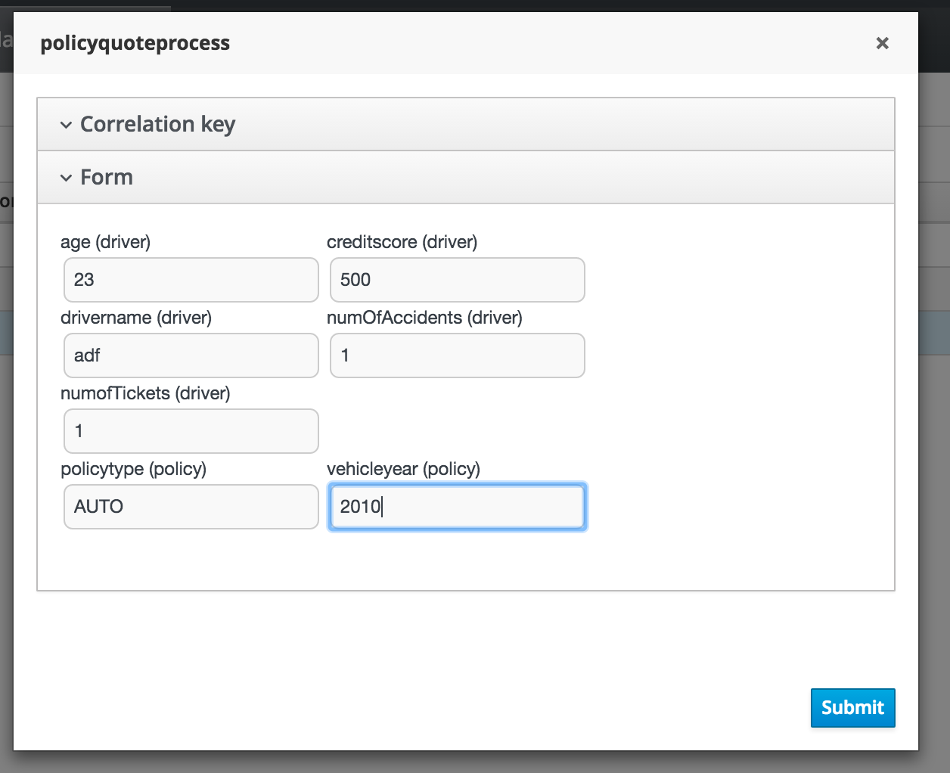

**Good test data**

Age: Creditscore: Expectedprice, accidents, tickets: 23,500,1,1….Expected price: 450

Age: Creditscore: Expectedprice, accidents, tickets: 55,500,1,1….Expected price: 120

**To trigger human task:**

**Age: Creditscore: Expectedprice, accidents, tickets: 19,500,3,4….Expected price: 700**

1. Click the black arrow at the bottom of the form to submit. The **Process Instance Details** screen appears. You can see and edit the values of the process variables, the process state (active in this case), and so on.
2. Click **View Process Model** to see the process image. From the image, you can see that the process is waiting in the Review Quote node.

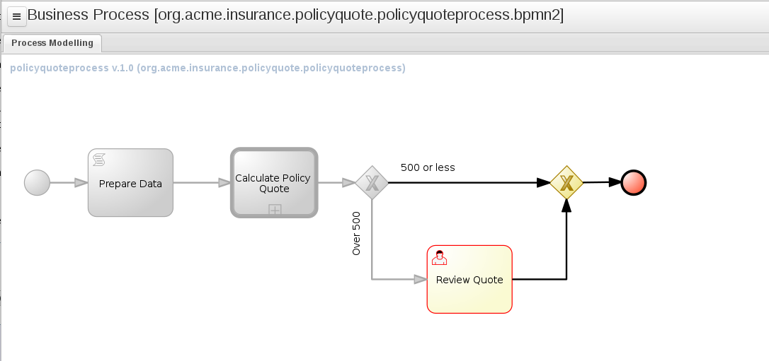

**1.3. Review and Complete the Task**

The jboss user that you are using is a member of the reviewer group. You can check this by selecting the **user: jboss** menu item. A task should be waiting for you.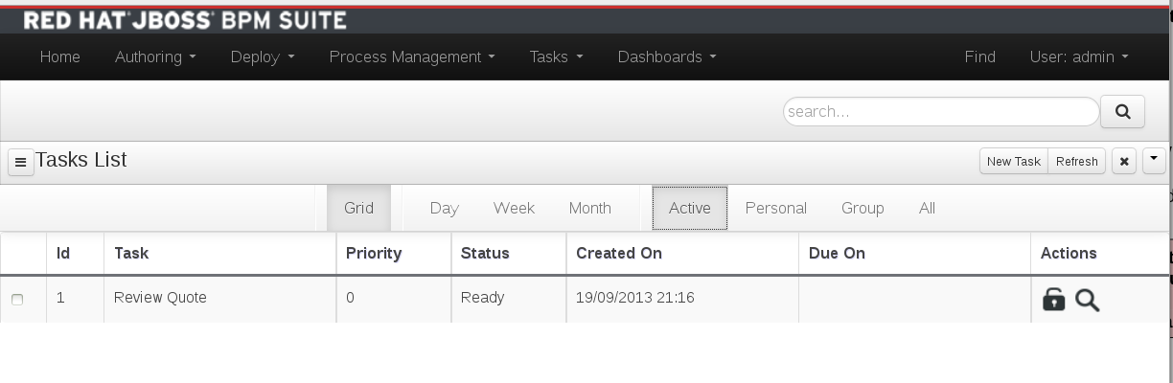

1. Click **Task → Task Lists** to open the Task List screen.

The task is assigned to the group reviewer, so any member of the reviewer group can claim the task to start working on it.

1. Click the **start button** to start the task.
2. Edit the taskpricein variable to set a new price

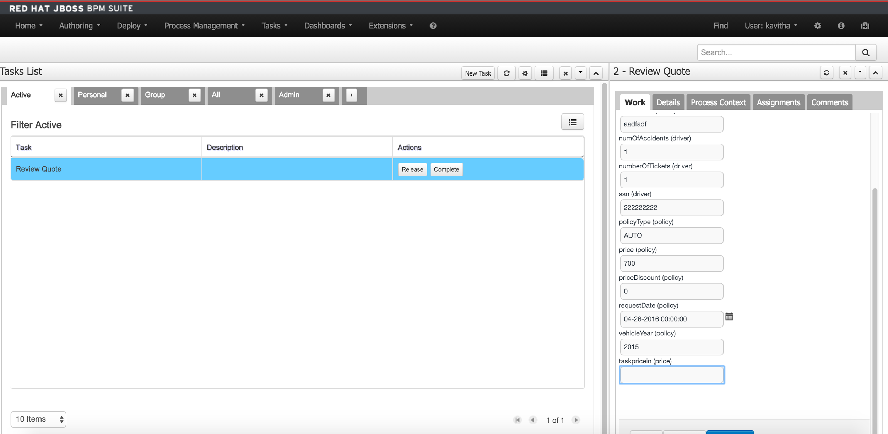

Figure 5. Review Quote form

1. Enter a value for the new price, say 550, and then click the **Complete** icon.

Note:

Clicking the **Save** icon saves the state of the form, but it does not complete the task. Click **Save** if you want to come back to the task later.

1. Observe that your task is completed and no longer appears in your task view. The process instance is also removed from the process instances view, because this process is finished.
2. Check the server.log to confirm that the price was indeed overridden:

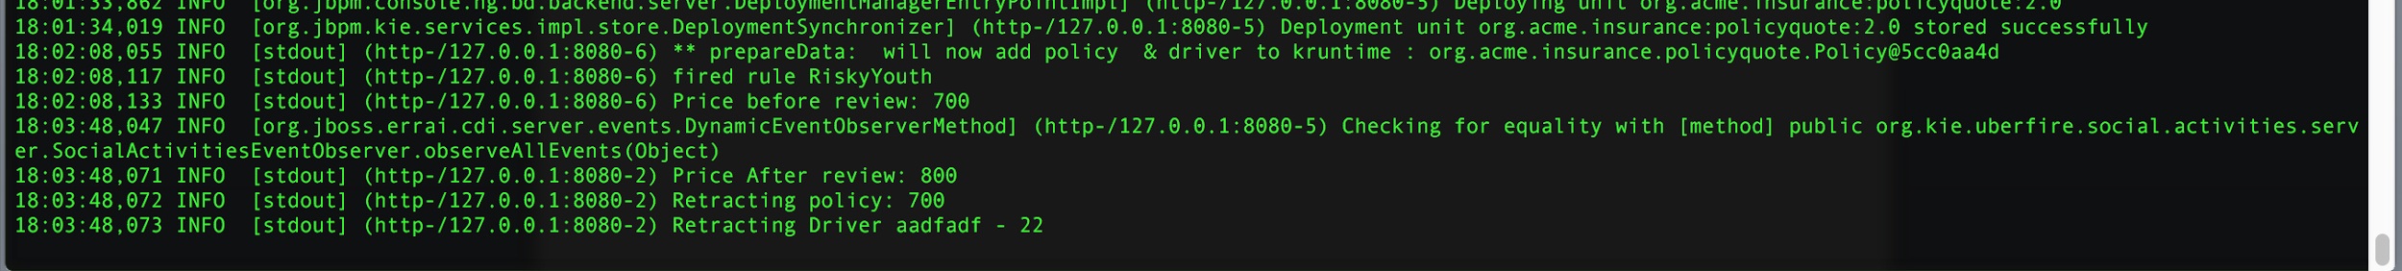

Figure 6. server.log after review price