🛍️
ShopBot
AI Shopping Chatbot Project

Module | IT 11 — Web Development
Project Type | Mini Project — Full Stack AI Chatbot
Technologies | Python, Django, HTML, CSS, JavaScript, Groq AI
AI Library | openai (Python library)
AI Provider | Groq
AI Model | llama-3.1-8b-instant
Date | March 2026

1. Project Introduction
ShopBot is a full-stack AI-powered shopping chatbot built using Python, Django, HTML, CSS, and JavaScript. The user types messages in a web browser, and the chatbot responds intelligently with product information, cart management, and checkout functionality.
In its final version, ShopBot is connected to a real AI model (Groq AI) using the openai Python library, allowing it to understand natural language, spelling mistakes, and messages in multiple languages.

1.1 Project Goals
- Build a chatbot that understands natural language shopping requests
- Create a professional web interface connected to a Python backend
- Connect the chatbot to a real free AI API (Groq)
- Learn how frontend (HTML/JS) communicates with a backend (Django)
- Practice full-stack web development from scratch

1.2 Project Architecture
Layer | Technology | Role
Frontend | HTML + CSS + JavaScript | The website the user sees and types in
Backend | Python + Django | The server that processes messages
AI Layer | openai library + Groq API | Understands natural language messages
Database | SQLite (db.sqlite3) | Stores sessions and user data

2. Installation & Setup

2.1 Install Thonny IDE
Thonny is a beginner-friendly Python IDE. It comes with Python 3 built-in.

1 | Download Thonny  Go to https://thonny.org and download the installer for Windows

2 | Run the installer  Double-click the downloaded .exe file and follow the installation steps

3 | Open Thonny  Launch Thonny from the Start menu or Desktop shortcut

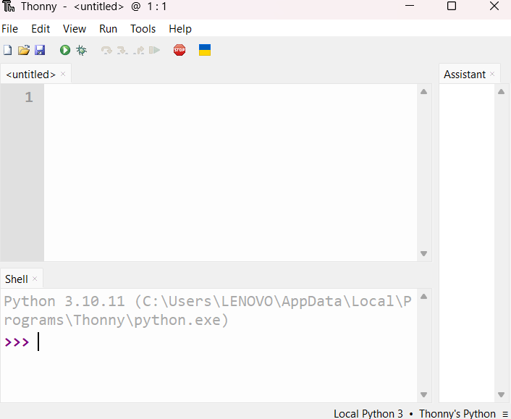

2.2 Install Required Libraries
- Django server
Django is the Python web framework we use as our backend server.

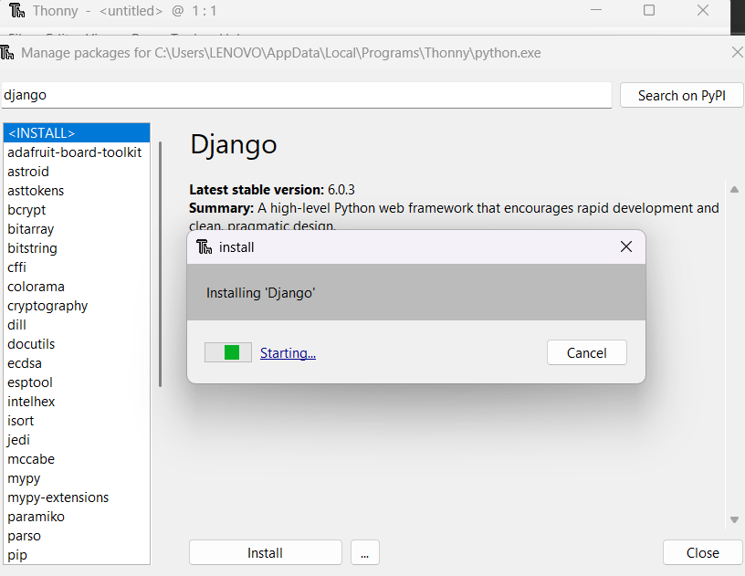

I verify the installation was successful whith this commands type in Python:
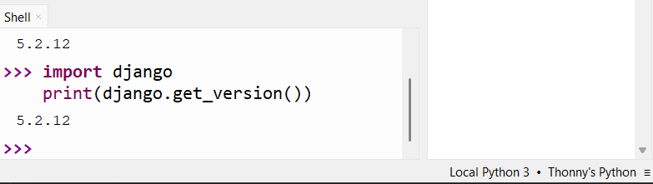
Expected result: a version number 5.2.12 — this confirms Django is installed correctly.
- Openai Librarie
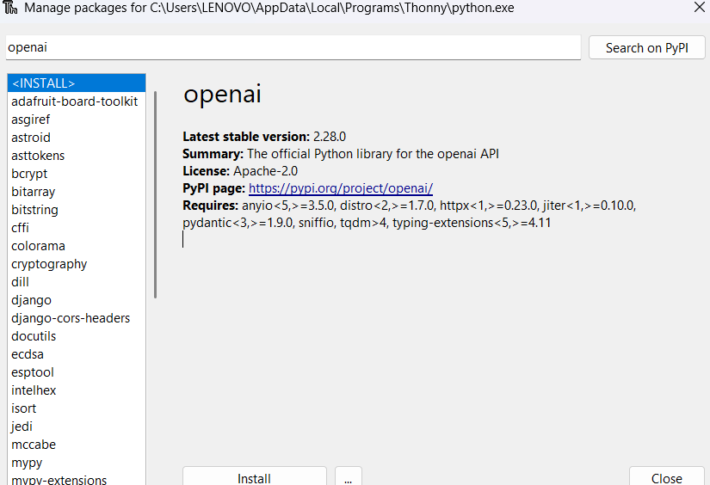

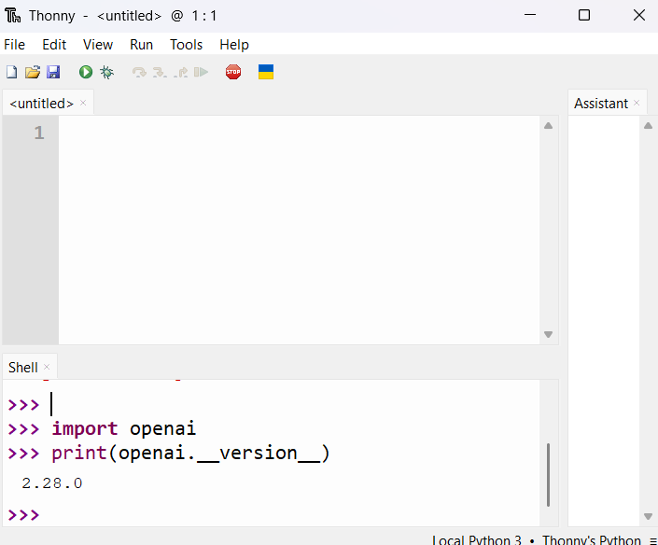
Package | Version | Purpose
django | 5.2.1 | Web backend framework
django-cors-headers | 4.9.0 | Allow frontend to connect to Django
openai | 2.28.0 | Connect to Groq AI API (free)
Python | 3.10 | Programming language

3. Project Structure Creation

3.1 CMD Commands
Open Windows CMD and run these commands one by one:

1 | Navigate to the project folder  cd "C:\Users\LENOVO\Desktop\IT 11\second part\mini project\chatbot-shopping"

cd "C:\Users\LENOVO\Desktop\IT 11\second part\mini project\chatbot-shopping"

2 | Create the Django project  django-admin startproject shopbot_project . (the dot is important!)

django-admin startproject shopbot_project .

3 | Create the chatbot app  python manage.py startapp chatbot

"C:\Users\LENOVO\AppData\Local\Programs\Thonny\python.exe" manage.py startapp chatbot

4 | Set up the database  python manage.py migrate

"C:\Users\LENOVO\AppData\Local\Programs\Thonny\python.exe" manage.py migrate
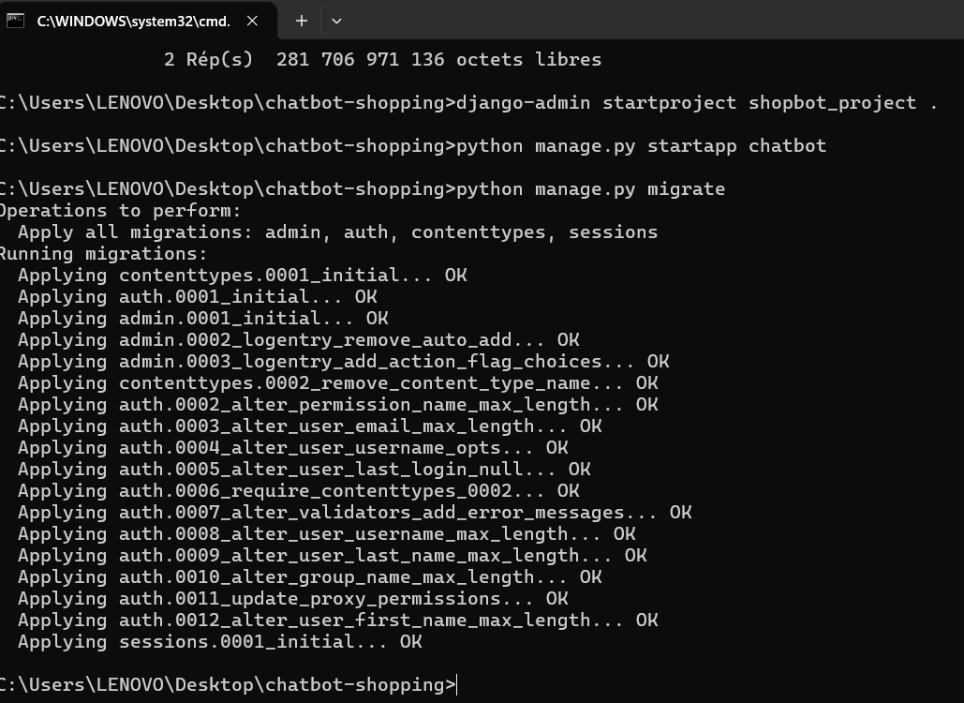

3.2 Final Folder Structure
chatbot-shopping/
manage.py <- controls the Django server
db.sqlite3 <- the database file
shopbot_project/
settings.py <- project configuration
urls.py <- URL routing
chatbot/
views.py <- chatbot logic + AI connection
urls.py <- chatbot URL routes
frontend/
index.html <- the website (HTML+CSS+JS)

4. How the Chatbot Works befor Open AI

4.1 Intent Detection System
The chatbot does not use AI in the traditional sense. Instead, it uses keyword detection to understand what the user wants. This technique is called Intent Detection.

When the user types a message, the bot scans it for keywords:

Intent | Keywords detected | Bot action
Greeting | hello, hi, hey, bonjour | Welcomes the user
Search | show, list, find, browse | Shows products by category
Add to cart | add, buy, want, purchase | Adds item to cart
View cart | cart, basket, my order | Displays cart contents
Checkout | checkout, pay, confirm | Places the order
Price query | price, cost, how much | Shows product price
Farewell | bye, goodbye, exit | Says goodbye

4.2 Request Flow
This is exactly what happens every time the user sends a message:

1 | User types a message  For example: "show phones" in the chat input on the website

2 | JavaScript sends the message to Django  fetch() sends a POST request to http://127.0.0.1:8000/api/chat/

3 | Django receives and processes  detect_intent() identifies intent = "search", extract_category() finds "phones"

4 | generate_response() builds the reply  Filters products by category and creates a JSON response

5 | Frontend receives the JSON response  JavaScript reads the response and displays product cards and chat message

5. AI Integration with Groq API

5.1 What is the openai Library?
The openai library is a Python package that provides a simple way to communicate with AI language models. Originally designed for OpenAI's models, it has become a universal standard that many AI providers support — including Google Gemini and Groq.

In this project, we use the openai library NOT to connect to OpenAI the company, but to connect to Groq — a completely free alternative that is fully compatible with the same library.

 | openai library | What it connects to
❌ NOT used in this project | openai library + OpenAI servers | Paid — requires credit card
✅ Used in this project | openai library + Groq servers | Free — no payment needed

5.2 What is Groq?
Groq is a free AI platform that provides access to powerful language models including LLaMA (developed by Meta/Facebook). It offers:

- Free API access — no credit card required
- Fast response times (faster than most AI providers)
- Compatible with the openai Python library
- Free account creation with just an email address
- The model we use: llama-3.1-8b-instant

5.3 What is an API Key?
An API key is a unique secret code that identifies your account when you make requests to the AI service. Think of it as a password between your application and the AI server.

Format | gsk_xxxxxxxxxxxxxxxxxxxxxxxxxxxxxxxxxxxxxxxxxxxxxxxx

Where to get it | https://console.groq.com → API Keys → Create API Key

Cost | 100% Free — no payment, no credit card

Validity | 90 days (then create a new one for free)

⚠️ Important security rule: Never share your API key publicly. Treat it like a password.

5.4 How to Get the Groq API Key — Step by Step

1 | Go to Groq website  Open your browser and go to: https://console.groq.com

2 | Create a free account  Click Sign Up and register with your email address

3 | Go to API Keys section  In the dashboard, click on API Keys in the left menu

4 | Create a new key  Click Create API Key, enter name: shopbot, expiration: 90 days, then click Submit

5 | Copy the key  Copy the key that appears — it starts with gsk_

6 | Put it in views.py  Replace PUT_YOUR_GROQ_KEY_HERE in views.py with your actual key
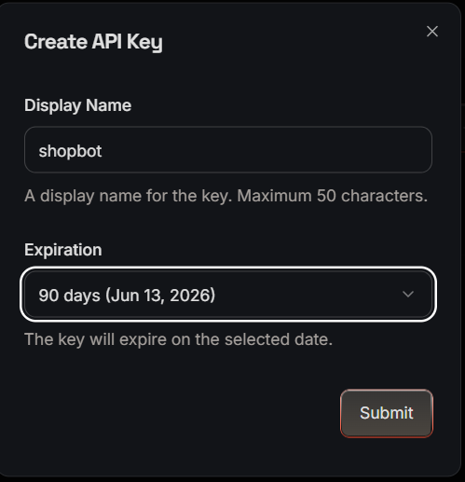

5.5 How the AI Works in the Chatbot
When the user sends a message, instead of checking keywords, the chatbot now sends the message to the Groq AI with a detailed system prompt explaining the products and asking for a structured JSON response.

The flow works like this:

1 | User types a message  Example: 'I need something to listen to music with'

2 | views.py sends message to Groq AI  Using the openai library with the Groq base URL

3 | AI understands the meaning  Groq AI identifies: intent=search, category=headphones

4 | AI returns structured JSON  { intent: search, category: headphones, message: Here are our headphones! }

5 | Django processes the JSON  Filters products by category and builds the response

6 | Frontend shows the result  Product cards appear in the chat with photos and prices
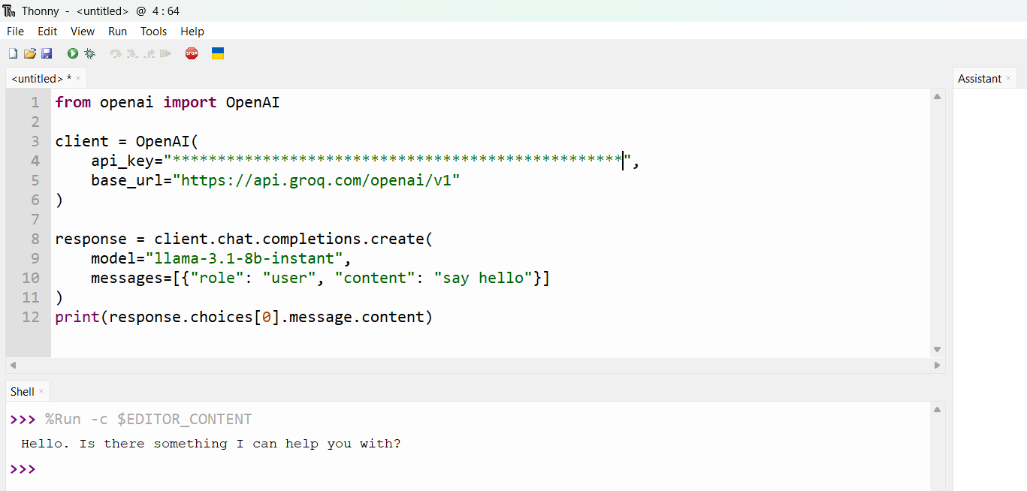

5.6 The AI Code in views.py
Here is the key part of the code that connects to Groq AI:

from openai import OpenAI

client = OpenAI(
api_key="gsk_YOUR_KEY_HERE",
base_url="https://api.groq.com/openai/v1"
)

response = client.chat.completions.create(
model="llama-3.1-8b-instant",
messages=[
{"role": "system", "content": system_prompt},
{"role": "user", "content": user_message}
]
)

5.7 Comparison: Before and After AI
User types | Before AI (keywords) | After AI (Groq)
show phones | ✅ Works | ✅ Works
I need a phone | ❌ Fails | ✅ Works
montre les telephones | ❌ Fails | ✅ Works (French!)
shwo phons | ❌ Fails | ✅ Works (typos!)
something cheap for music | ❌ Fails | ✅ Works (context!)

6. File Configuration

6.1 settings.py
- Added 'corsheaders' and 'chatbot' to INSTALLED_APPS
- Added CorsMiddleware at the top of MIDDLEWARE
- Set CORS_ALLOW_ALL_ORIGINS = True

6.2 urls.py
- shopbot_project/urls.py: routes /api/ to the chatbot app
- chatbot/urls.py: defines /api/chat/ and /api/products/ endpoints

6.3 views.py — The AI Brain
Function | What it does
PRODUCTS list | Contains all 8 products with name, price, category, stock
OpenAI client setup | Connects to Groq API using the openai library
ask_ai() | Sends user message to Groq AI and gets structured JSON back
generate_response() | Processes AI response and manages the cart
chat() view | Django API endpoint that receives POST requests from frontend
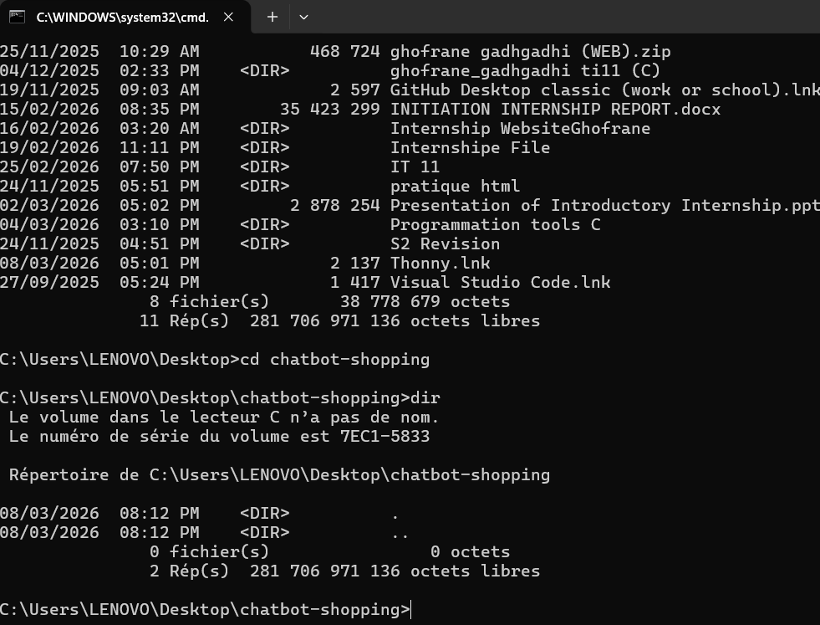
7. Frontend — index.html

7.1 Structure
The entire frontend is a single HTML file that contains three parts:
- HTML: the structure (header, sidebar, chat area, input box)
- CSS: the styling (dark theme, orange accents, animations, product cards)
- JavaScript: the logic (sending messages, receiving responses, updating the UI)

7.2 Key Features
- Live search bar in the header that searches as you type
- Sidebar with category buttons (Phones, Laptops, Headphones, Tablets, Shoes)
- Flash sale banner with quick category tags
- Product cards with real photos from Unsplash, star ratings, sale badges
- Chat bubbles with timestamps for both user and bot messages
- Typing indicator (animated dots) while waiting for response
- Toast notification when an item is added to cart
- Cart counter in the header that updates in real time

7.3 How JavaScript Communicates with Django
The JavaScript fetch() function sends an HTTP POST request to Django:

const response = await fetch('http://127.0.0.1:8000/api/chat/', {
method: 'POST',
headers: { 'Content-Type': 'application/json' },
body: JSON.stringify({ message: text, session_id: sessionId })
});
const data = await response.json();

Django returns a JSON object that the JavaScript uses to update the page:
{
"message": "Found 2 phones for you!",
"intent": "search",
"products": [ {"id":1, "name":"iPhone 15 Pro", "price":999, ...} ]
}

8. Running the Project

8.1 Starting the Django Server
Every time you want to use the chatbot, you must start the Django server first ; open CMD and run:

cd "C:\Users\LENOVO\Desktop\IT 11\second part\mini project\chatbot-shopping"

"C:\Users\LENOVO\AppData\Local\Programs\Thonny\python.exe" manage.py runserver

Expected output:
Starting development server at http://127.0.0.1:8000/

8.2 Opening the Website
The Problem we face in the testing :
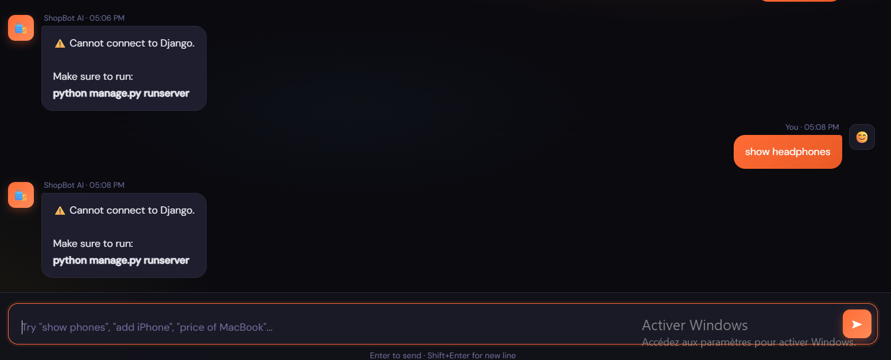

Solution :must start the Django server
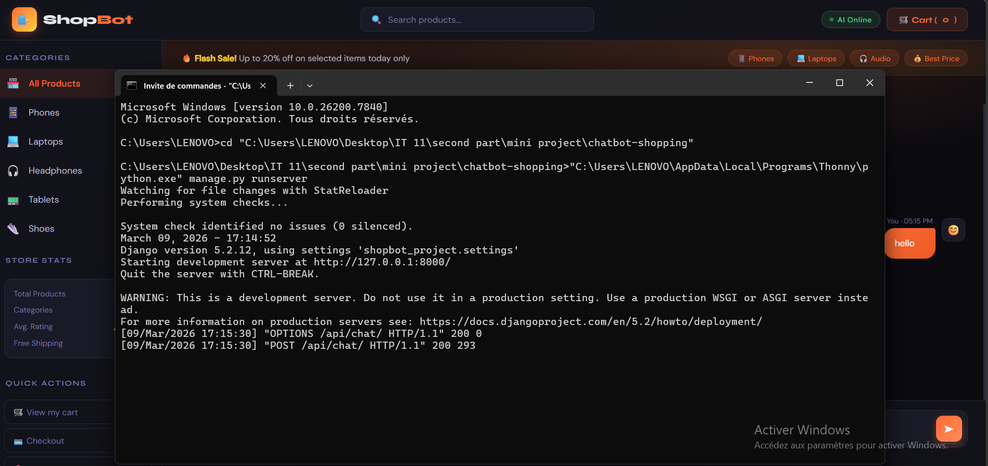

8.3 Important Rules
- Always keep the CMD window open while using the chatbot
- The chatbot needs internet connection to reach the Groq AI servers
- The Groq API key is valid for 90 days — renew it for free when it expires
9. Testing the Chatbot

9.1 Test Results
User types | Bot response | Result
hello | Welcome message with options | ✅ Pass
show phones | 2 phone product cards | ✅ Pass
I need a computer | Shows laptops (AI understood!) | ✅ Pass
montre les telephones | Shows phones (French!) | ✅ Pass
add iPhone | Item added, cart updates | ✅ Pass
shwo me phons | Shows phones (typo fixed!) | ✅ Pass
cart | Shows cart contents and total | ✅ Pass
checkout | Order confirmed, cart clears | ✅ Pass
something cheap for music | Shows headphones (context!) | ✅ Pass

9.2 Common Errors & Solutions

Error | Cannot connect to Django  Run: python manage.py runserver in CMD
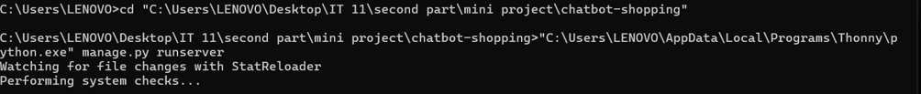

Error | No module named chatbot.urls  Solution: Create the file chatbot/urls.py with the URL patterns
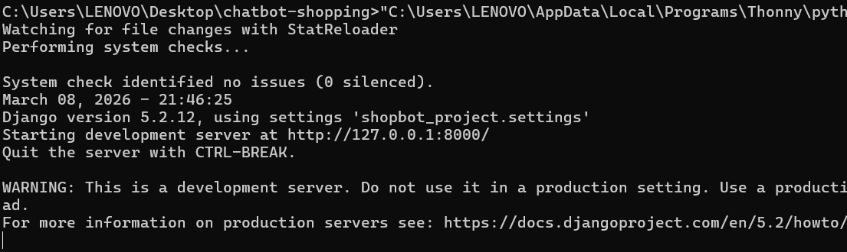

Error | Python not found in CMD  Solution: Use the full Thonny Python path: C:\Users\LENOVO\AppData\Local\Programs\Thonny\python.exe
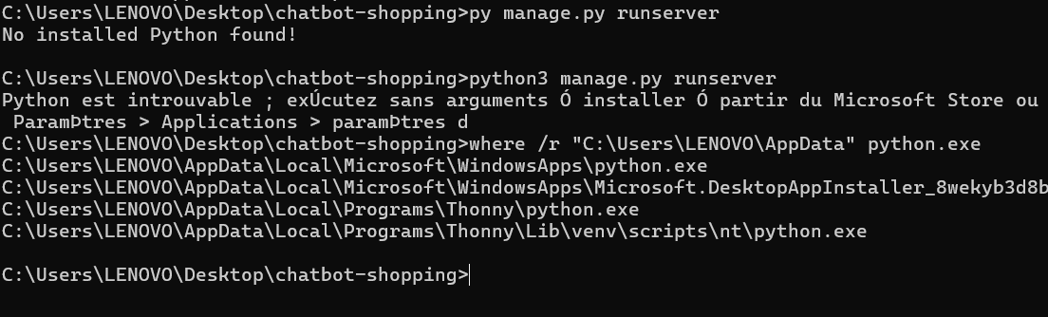

Error | ModuleNotFoundError: openai

Error | Quota exceeded (Groq)  Wait a few minutes or create a new API key at console.groq.com

Error | Model decommissioned  Change model name to: llama-3.1-8b-instant

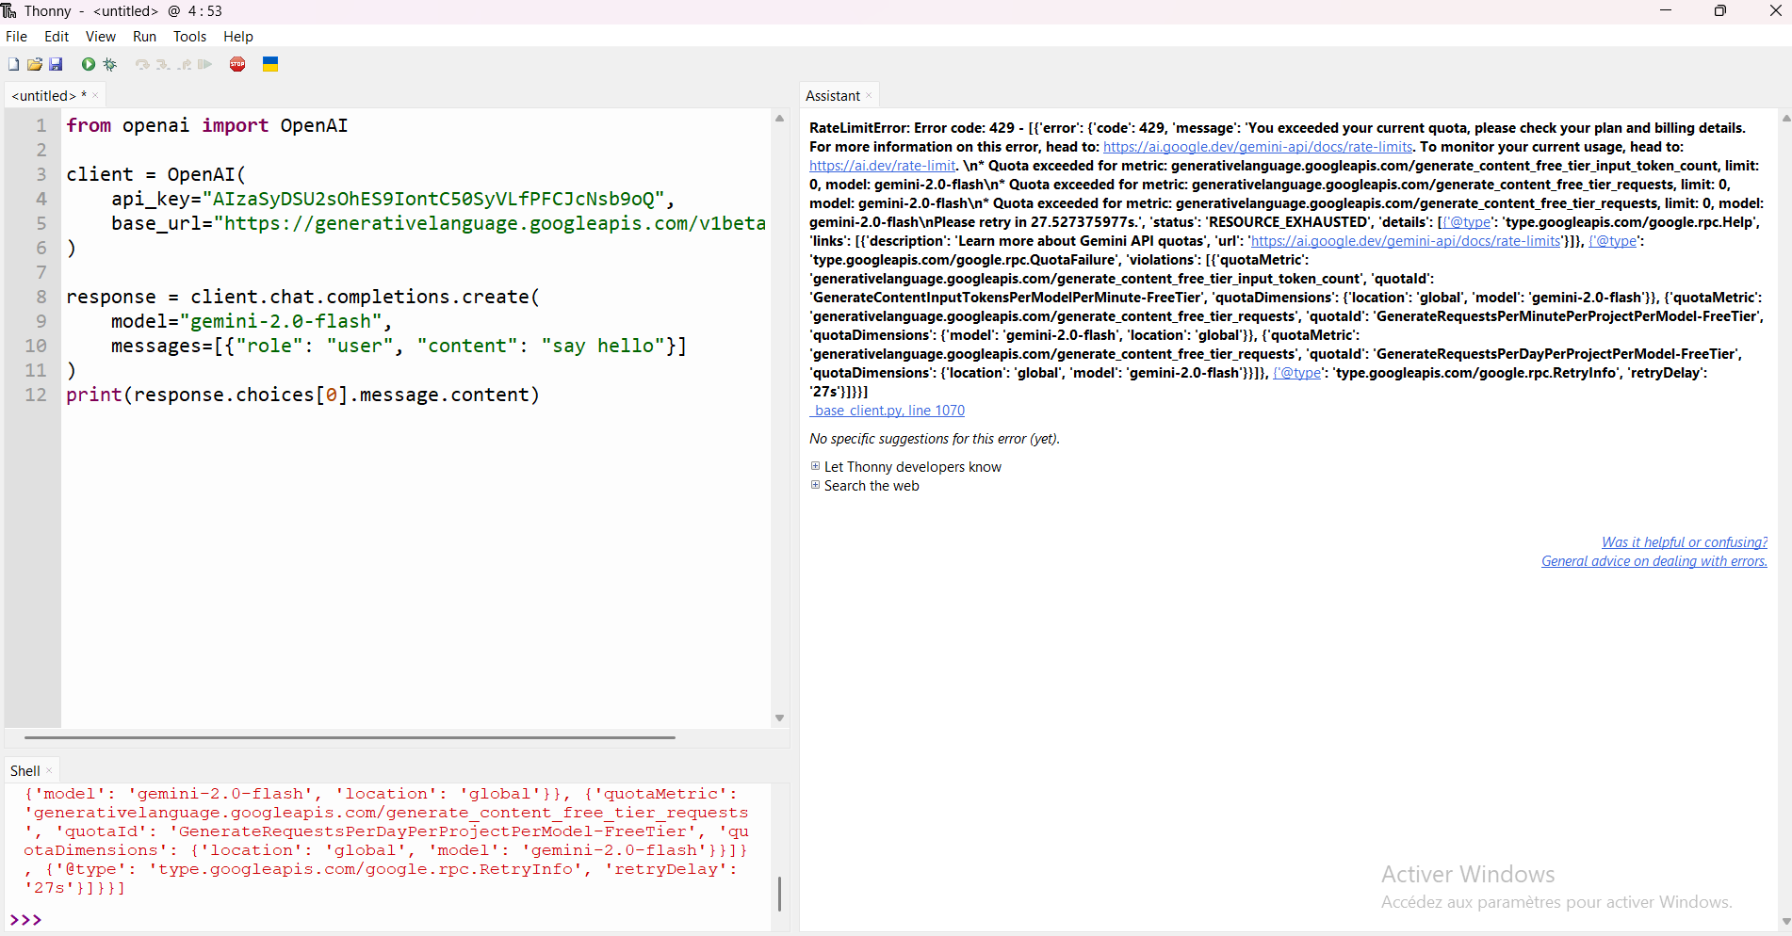

10. Conclusion
This project successfully demonstrates how to build a full-stack AI-powered web application from scratch. Starting from a simple keyword-based chatbot, the project was upgraded to use a real AI language model through the Groq API, making it able to understand natural language, multiple languages, and spelling mistakes.

10.1 Skills Learned
- Installing and configuring Thonny IDE and Python
- Installing Django and creating a Django project from scratch
- Installing and using the openai Python library
- Creating a free Groq account and generating an API key
- Connecting a Python backend to a free AI API
- Creating REST API endpoints with Django views
- Connecting a frontend (HTML/JS) to a backend (Django) using fetch() and JSON
- Understanding CORS and how to configure it
- Debugging common errors (quota limits, decommissioned models, missing modules)

10.2 Possible Improvements
- Connect to a real database using Django models instead of a hardcoded list
- Add user authentication (login and registration system)
- Integrate a real payment system like Stripe
- Deploy the project online so anyone can access it from the internet
- Add product image upload feature for the admin

Git and gitHub collaboration

Ghofrane gadhgadhi :

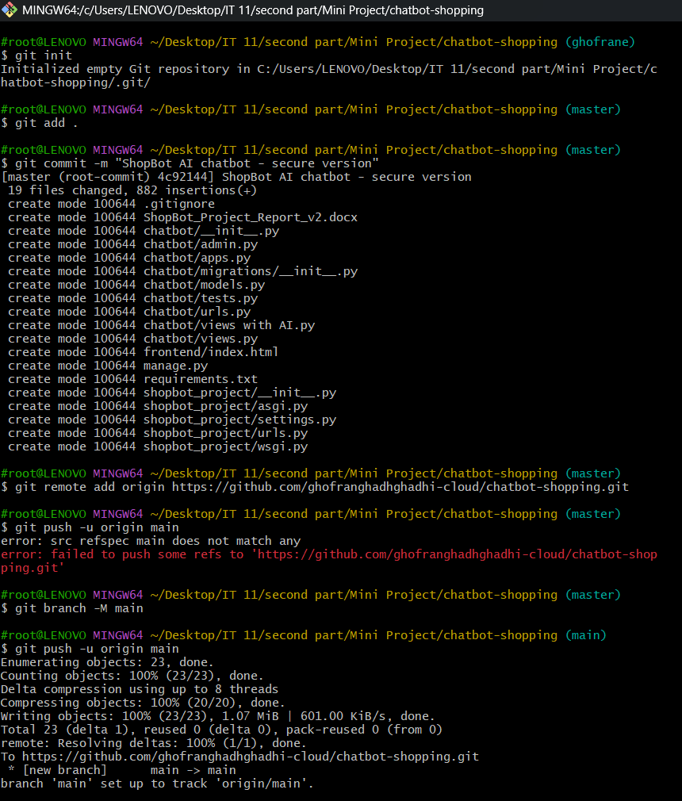

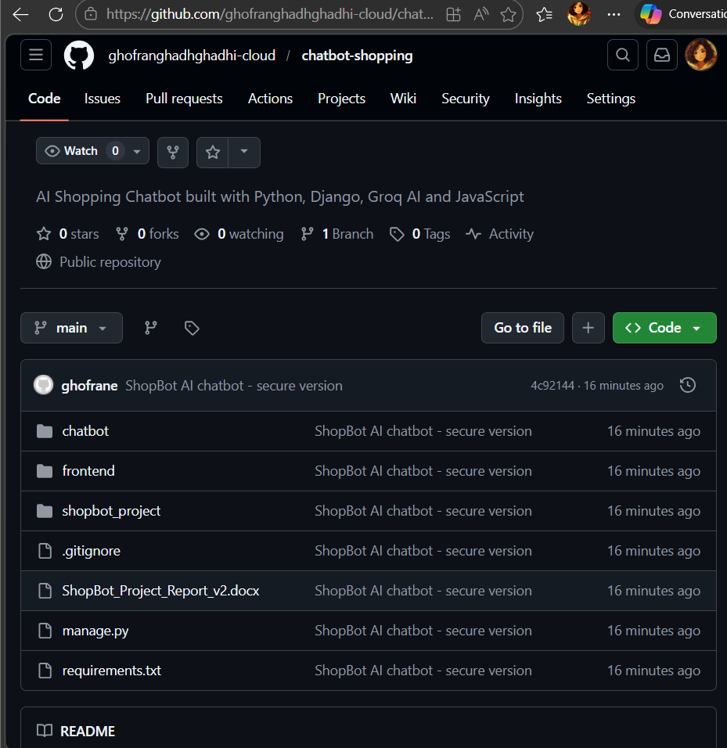

End of Report — ShopBot AI Shopping Chatbot Project

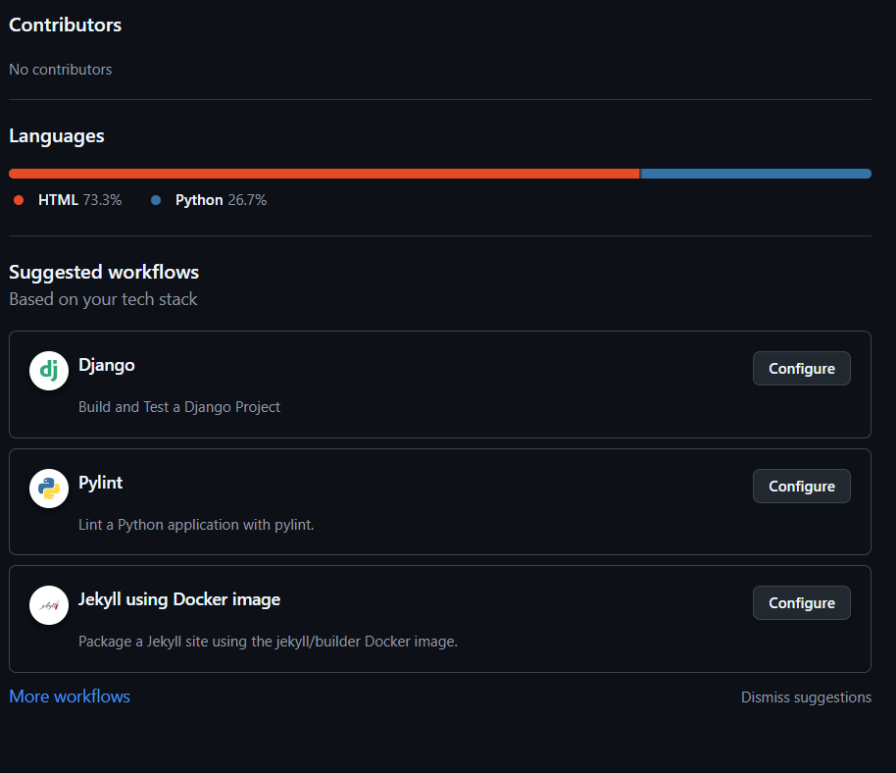

May jaballah :
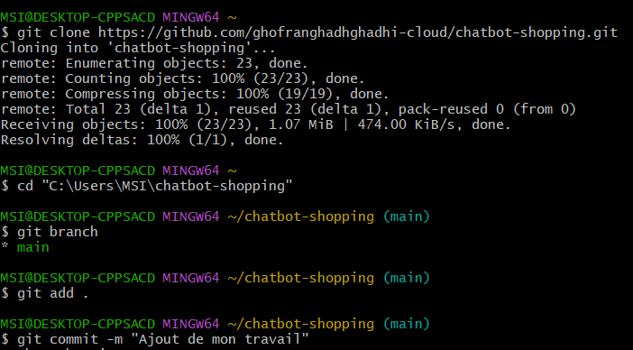
Ella ben salama
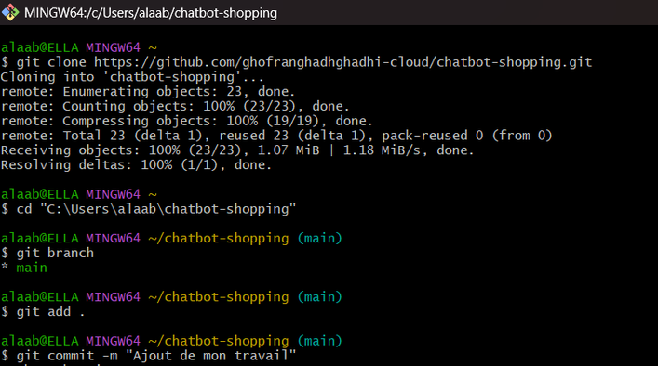

Ghofrane gadhgadhi – IT11
Ella ben salama
May jaballah

