17) Implementing full text search functionality in a database.
CREATE DATABASE job_portal1;
USE job_portal1;
CREATE TABLE jobs(
job_id INT AUTO_INCREMENT PRIMARY KEY,
title VARCHAR(255),
description TEXT,
location VARCHAR(100),
FULLTEXT(title,description)
);
INSERT INTO jobs (title,description,location)VALUES
('Software Developer','Looking for a devloper skilled in java,Spring Boot,and MySqL.','Bangalore'),
('Data Analysis','Analyze data using Python, SQL,and Power BI.','Mumbai'),
('Full nStack Engineer','React and Node.js developer required for web development.','Remote'),
('Database Administrator','Manage MySQL database and optimize performance','Delhi'),
('Python Developer','Backend Python developer with experience in Django.','Pune');
select * from jobs;
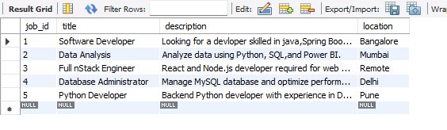
SELECT* FROM jobs
WHERE MATCH(title,description)AGAINST('Python developer'IN NATURAL LANGUAGE MODE);
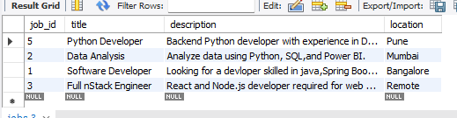
SELECT * FROM jobs
WHERE MATCH(title,description) AGAINST('+Python +Django -Java' IN BOOLEAN MODE);
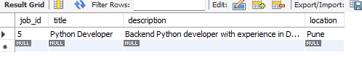
ALTER TABLE jobs ADD FULLTEXT(title,description);
SET @search='MySQL developer';
SELECT * FROM jobs
WHERE MATCH(title,description)AGAINST(@search IN NATURAL LANGUAGE MODE);
