19) Designing and implementing a data warehouse for analytics and reporting.
CREATE DATABASE sales_datawarehouse;
USE sales_datawarehouse;
1.DIMENSION TABLES
DROP TABLE IF EXISTS fact_sales;
DROP TABLE IF EXISTS dim_customer;
DROP TABLE IF EXISTS dim_product;
DROP TABLE IF EXISTS dim_date;
DROP TABLE IF EXISTS dim_lacation;

Customer Dimension
CREATE TABLE dim_customer1(
cutomer_key INT AUTO_INCREMENT PRIMARY KEY,
cutomer_id INT,
custmer_name VARCHAR(100),
gender VARCHAR(10),
age INT
);

Product Dimension
CREATE TABLE dim_product1(
product_key INT AUTO_INCREMENT PRIMARY KEY ,
product_id INT,
product_name VARCHAR(100),
category VARCHAR(50),
price DECIMAL(10,2)
);

Data Dimension
CREATE TABLE dim_date1(
date_key INT PRIMARY KEY ,
full_date DATE,
day INT,
month INT,
month_name VARCHAR(20),
quarter INT,
year int);

Location Dimension
CREATE TABLE dim_location1 (
location_key INT AUTO_INCREMENT PRIMARY KEY,
city VARCHAR(50),
state VARCHAR(50),
country VARCHAR(50)
);
2.FACT TABLE
CREATE TABLE fact_sales(
sales_key INT AUTO_INCREMENT PRIMARY KEY,
cutomer_key INT,
product_key INT,
date_key INT,
location_key INT,
quantity INT,
sales_amount DECIMAL(12,2),
FOREIGN KEY(customer_key)
REFERENCES dim_customer1(customer_key),
FOREIGN KEY (product_key)
REFERENCES dim_product1(product_key),
FOREIGN KEY (date_key)
REFERENCES dim_date1(date_key),
FOREIGN KEY (location_key)
REFERENCES dim_location1(location_key)
);
3. INSERT DATA INTO CUSTOMER DIMENSION
INSERT INTO dim_customer1
(cutomer_id,custmer_name,gender,age)
VALUES
(101,'Ajay','Male',25),
(102,'Pranita','Female',28),
(103,'Swaraj','Male',32),
(104,'Snehal','Female',24),
(104,'Rohit','Male',30);
select*from dim_customer1;
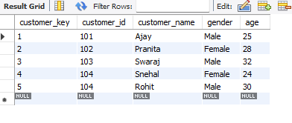
4. INSERT DATA INTO PRODUCT DIMENSION.
INSERT INTO dim_product1
(product_id,product_name,category,price)
VALUES
(1,'Laptop','Electronics',55000),
(2,'Mobile','Electronics',20000),
(3,'Mouse','Accessories',500),
(4,'Keyboard','Accessories',1200),
(5,'Headphones','Accessories',1500);
select*from dim_product1;
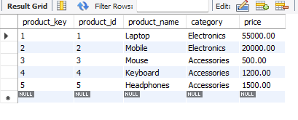

5. INSERT DATA INTO DATE DIMENSION
INSERT INTO dim_date1
(date_key, full_date, day,month,month_name,quarter,year)
VALUES
(20260105,'2026-01-05', 5,1,'January',1,2026),
(20260110,'2026-01-10', 10,1,'January',1,2026),
(20260205,'2026-02-05', 5,2,'February',1,2026),
(20260210,'2026-02-10', 10,2,'February',1,2026),
(20260305,'2026-03-05', 5,3,'March', 1,2026),
(20260310,'2026-03-10', 10,3,'March', 1,2026),
(20260315,'2026-03-15', 15,3,'March', 1,2026);
select *From dim_date1;
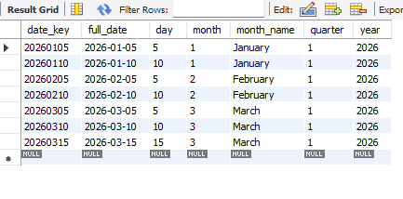
6. INSERT DATA INTO LOCATION DIMENSION
INSERT INTO dim_location1
(city,state,country)
VALUES
('Mumbai','Maharashtra','India'),
('Pune','Maharashtra','India'),
('Nagpur','Maharashtra','India');
select *from dim_location1;
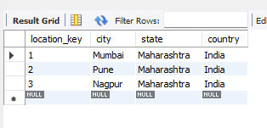

7. INSERT DATA INTO FACT TABLE
INSERT INTO fact_sales1
(customer_key,product_key,date_key,location_key,quantity,sales_amount)
VALUES
(1,1,20260105,1,1,55000),
(2,2,20260110,2,2,40000),
(3,3,20260205,3,3,1500),
(4,4,20260210,2,2,2400),
(5,5,20260305,3,2,3000),
(1,2,20260310,1,1,20000),
(2,1,20260315,2,1,55000),
(3,3,20260315,3,4,2000),
(4,2,20260305,2,1,20000),
(5,1,20260310,3,1,55000);
select *from fact_sales1;
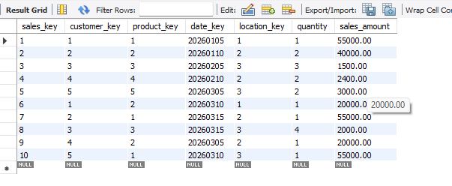
8.ANALYTICS AND REPORTING.
Total Sales
SELECT
SUM(sales_amount)AS total_sales
FROM fact_sales1;
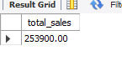
Sales by product
SELECT
p.product_name,
p.category,
SUM(f.quantity)AS total_quantity,
SUM(f.sales_amount)AS total_sales
FROM fact_sales1 f
JOIN dim_product1 p
ON f.product_key=p.product_key
GROUP BY p.product_name,p.category
ORDER BY total_sales DESC;
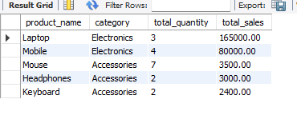
Sales by Customer
SELECT
c.customer_name,
SUM(f.sales_amount) AS total_spending
FROM fact_sales1 f
JOIN dim_customer1 c
ON f.customer_key=c.customer_key
GROUP BY c.customer_name
ORDER BY total_spending DESC;
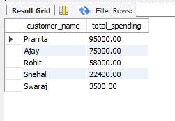
Sales by City
SELECT
l.city,
SUM(f.sales_amount)AS total_sales
FROM fact_sales1 f
JOIN dim_location1 l
ON f.location_key=l.location_key
GROUP BY l.city
ORDER BY total_sales DESC;
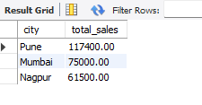
Month Sales Report
SELECT
d.year,
d.month,
d.month_name,
SUM(f.sales_amount)AS monthly_sales
FROM fact_sales1 f
JOIN dim_date1 d
ON f.date_key=d.date_key
GROUP BY d.year,d.month,d.month_name
ORDER BY d.year,d.month;
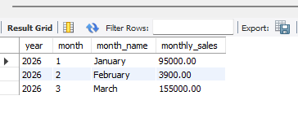
Category wise Sales
SELECT
p.category,
SUM(f.quantity)AS total_units,
SUM(f.sales_amount)AS total_sales
FROM fact_sales1 f
JOIN dim_product1 p
ON f.product_key=p.product_key
GROUP BY p.category
ORDER BY total_sales DESC;
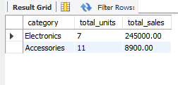
Quarterly Sales Reports
SELECT
d.year,
d.quarter,
SUM(f.sales_amount)As quarterly_sales
FROM fact_sales1 f
JOIN dim_date1 d
ON f.date_key=d.date_key
GROUP BY d.year,d.quarter
ORDER BY d.year,d.quarter;
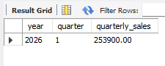
Top Customer
SELECT
p.product_name,
SUM(f.quantity)AS units_sold
FROM fact_sales1 f
Join dim_product1 p
ON f.product_key=p.product_key
GROUP BY p.product_name
ORDER BY units_sold DESC
LIMIT 1;
