16). Performing data import and export operation between databases.

CREATE DATABASE library1;
USE library1;
CREATE TABLE book(
book_id INT PRIMARY KEY AUTO_INCREMENT,
title VARCHAR(100),
author VARCHAR(100)
);
INSERT INTO book (title,author) VALUES
('The Alchemist','Paulo Coelho'),
('Wings of fire','A.P.J Abdul Kala,'),
('1984','George Orwell');
select * from book;
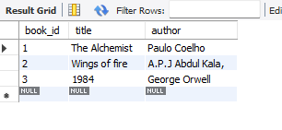
CREATE DATABASE backup_library1;
USE backup_library1;
CREATE TABLE book(
books_id INT PRIMARY KEY AUTO_INCREMENT,
title VARCHAR(100),
author VARCHAR(100)
);
INSERT INTO book (title,author) VALUES
('The Alchemist','Paulo Coelho'),
('Wings of fire','A.P.J Abdul Kala,'),
('1984','George Orwell');
USE backup_library1;
SELECT *from library1.book;
