18) Implementing datamining techniques to discover patterns and trends in large reporting .

CREATE DATABASE sales;
USE sales;
CREATE TABLE sale(
sale_id INT AUTO_INCREMENT PRIMARY KEY,
product VARCHAR(100),
category VARCHAR(50),
sale_date DATE,
quantity INT,
price DECIMAL(10,2)
);
INSERT INTO sale(product, category, sale_date,quantity,price)VALUES
('Laptop','Electronic','2023=01-05',10,800.00),
('Laptop','Electronics','2023-02-10',5,820.00),
('Headphones','Electronics','2023-01-10',20,50.00),
('Chair','Furniture','2023-03-01',15,120.00),
('Desk','Furniture','2023-02-20',7,300.00),
('Laptop','Electronics','2023-03-05',3,810.00),
('Chair','Furniture','2023-01-25',10,115.00);
select * from sale;
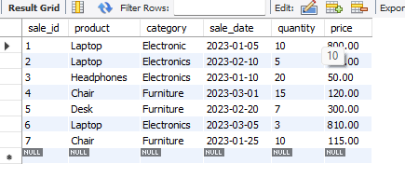

SELECT category,SUM(quantity)AS total_quantity,SUM(quantity*price)AS total_revenue FROM sale
GROUP BY category
ORDER BY total_revenue DESC;
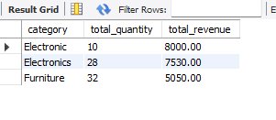
SELECT DATE_FORMAT(sale_date,'%Y-%m')AS month,SUM(quantity)AS total_quantity,SUM(quantity*price) AS revenue
FROM sale
WHERE category='Electronics'
GROUP BY month
ORDER BY month;
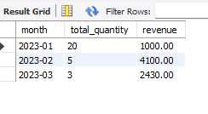
SELECT product,SUM(quantity)AS total_quantity,SUM(quantity*price)AS total_revenue FROM sale
GROUP BY product
ORDER BY total_revenue DESC
LIMIT 3;
