10). Implementing transaction to ensure data integrity and consistency . ( use BEGIN TRANSACTION/START TRANSACTION , COMMIT, ROLL BACK along with other sql queries).
use DBMT;
show databases;
start transaction;
COMMIT;
ROLLBACK;
create database Job;
show databases;
use Job;
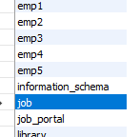

CREATE TABLE And Insert data
CREATE TABLE account4(
account_id INT PRIMARY KEY,
name VARCHAR(50),
balance DECIMAL(10,2)
);
INSERT INTO account4 VALUES
(1,'Akansha',1000.00),
(2,'Snehal',500.00);
SELECT * FROM account4;
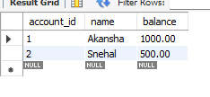

START TRANSACTION;
UPDATE account4
SET balance=balance-200
where ACCOUNT_ID=1;
SELECT * FROM account4;
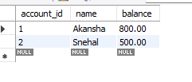

UPDATE account4
SET balance =balance+200
WHERE account_id=2;
SELECT*FROM account4;
