15) Implementing concurrency control mechanisms to handle multiple simultaneous transaction.
use DBMT;
CREATE TABLE account1(
id INT PRIMARY KEY,
balance DECIMAL(10,2)
);
INSERT INTO account1 VALUES (1,1000.00),(2,2000.00);
select * from account1;
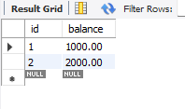
DELIMITER $$
CREATE PROCEDURE transfer_funds5(
IN from_account INT,
IN to_account INT,
IN amount DECIMAL(10,2)
)
BEGIN
DECLARE current_balance DECIMAL(10,2);
START TRANSACTION;
SELECT balance INTO current_balance FROM account WHERE id=from_account FOR
UPDATE;
IF current_balance<amount THEN
SIGNAL SQLSTATE'85000' SET MESSAGE_TEXT='Insufficient funds';
ELSE
UPDATE account SET balance= balance-amount WHERE id=from_account;
UPDATE account SET balance= balance+ amount WHERE id=to_account;
END IF;
COMMIT;
END$$
DELIMITER ;
CALL transfer_funds5(1,2,800);
select * from account1;

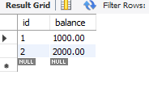
SHOW VARIABLES LIKE 'tansaction_isolation';
