8). Implement in aggregation function (eg. Sum , count, avg) on database record run on mysql workbench.
Create a Table
create table employees7(
emp_id int primary key auto_increment ,
emp_name varchar(50),
department varchar(30),
salary decimal(10,2)
);
desc employees7;

Insert some sample data
insert into employees7(emp_name,department,salary)values
('Ritika','IT',40000),
('Pranita','IT',55000),
('Sanjana','HR',42000),
('Snehal','Finance',40000),
('Akshada','Finance',35000),
('Rasika','HR',28000);
select *from employees7;
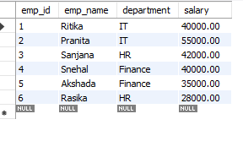
Sum() Total salary per department
select department,sum(salary)as department_salary
FROM employees7
GROUP BY department;
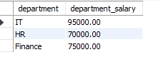
COUNT() employees in each department
select department,count(*)as total_employees
FROM employees7
GROUP BY department;
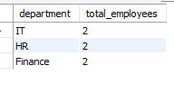
AVG() average (salary) per department
select department ,AVG(salary)as avg_salary
FROM employees7
GROUP BY department;
