11). Applying databases normalization techniques to elimination redundancy and improve data integrity in workbench querry .
use DBMT;
show databases;
- Create unnormalized table
CREATE TABLE student_courses(
student_id INT,
student_name VARCHAR(50),
course_id INT,
course_name VARCHAR(50),
PRIMARY KEY (student_id,course_id)
);
INSERT INTO student_courses VALUES
(1,'Achal',201,'Math'),
(1,'Achal',202,'Physics'),
(2,'Rohit',201,'Math'),
(3,'Sam',203,'Computer');
SELECT *FROM student_courses;

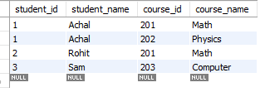
2: (Normalize to 1NF,2NF,and 3NF)-
Create students table(Remove redundant student info)
CREATE TABLE student6 (
student_id INT PRIMARY KEY,
student_name VARCHAR(50)
);
INSERT INTO student6 (student_id,student_name)
SELECT DISTINCT student_id,student_name
FROM student_courses;
SELECT * FROM student6;
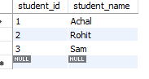
Create Courses Table (Remove redundant course info)
CREATE TABLE courses1(
course_id INT PRIMARY KEY,
course_name varchar(50)
);
INSERT INTO courses1(course_id,course_name)
SELECT DISTINCT course_id,course_name
FROM student_courses;
SELECT *FROM student6;
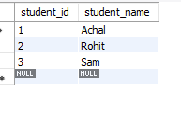
Create Enrollments Table(Mapping table between students and course)
CREATE TABLE enrollments20(
student_id INT,
course_id INT,
PRIMARY KEY (student_id,course_id),
FOREIGN KEY (student_id) REFERENCES student6(student_id),
FOREIGN KEY (course_id) REFERENCES courses1(course_id)
);
INSERT INTO enrollments20(student_id,course_id)
SELECT student_id,course_id
FROM student_courses;
SELECT*FROM enrollments20;

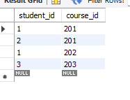

3: Test the normalized structure.(at a time execute this querry)
SELECT*FROM student6;
SELECT *FROM courses;
SELECT*FROM enrollments20;
SELECT c.course_name
FROM student6 s
JOIN enrollments20 e ON s.student_id=e.student_id
JOIN courses1 c ON e.course_id=c.course_id
WHERE s.student_name='Achal';

