W5H FOR RESTORANT WEBSITE

1. Why is the system being developed? (Business Case)
The restaurant website is developed to:
- Increase online visibility and attract more customers
- Allow customers to view the menu, prices, and offers easily
- Enable online table reservations and food ordering
- Reduce manual workload (phone orders, walk-ins confusion)
- Improve customer experience and brand image

2. What will be done? (Scope & Tasks)
Scope of the Restaurant Website:
- Home page with restaurant details
- Digital menu with categories (starters, main course, desserts)
- Online table reservation system
- Online food ordering and payment integration
- Contact page with map and feedback form
- Admin panel to manage menu, orders, and reservations
Tasks Include:
- Requirement gathering
- Frontend and backend development
- Database creation
- Testing and deployment

3. When will it be accomplished? (Schedule & Milestones)
Project Timeline Example (8 Weeks):
- Week 1: Requirement analysis
- Week 2: System design
- Weeks 3–5: Development
- Week 6: Testing
- Week 7: Bug fixing and improvements
- Week 8: Deployment and launch
Milestones:
- Design approval
- Functional prototype
- Final website launch

4. Who is responsible for the function? (Roles & Resources)
Roles Assigned:
- Project Manager
- Business Analyst
- Web Designer
- Frontend Developer – builds website interface
- Backend Developer – manages server, database, logic
- Tester – tests functionality and performance
- Restaurant Owner/Admin – approves final system

5. Where are they organizationally located? (Communication & Context)
- Development team may work remotely or in-house
- Restaurant owner and staff are on-site
- Communication via email, meetings, Zoom, or project tools
Deployment Location:
- Hosted on a cloud or web server
- Used by customers on mobile and desktop browsers

6. How will the job be done? (Technical & Managerial Strategy)
Technical Stack Example:
- Frontend: HTML, CSS, JavaScript
- Backend: Python
- Database: MySQL
- Payment Gateway: Online payment API
Standards & Practices:
- Secure coding standards
- Regular testing (unit + system testing)
- Version control

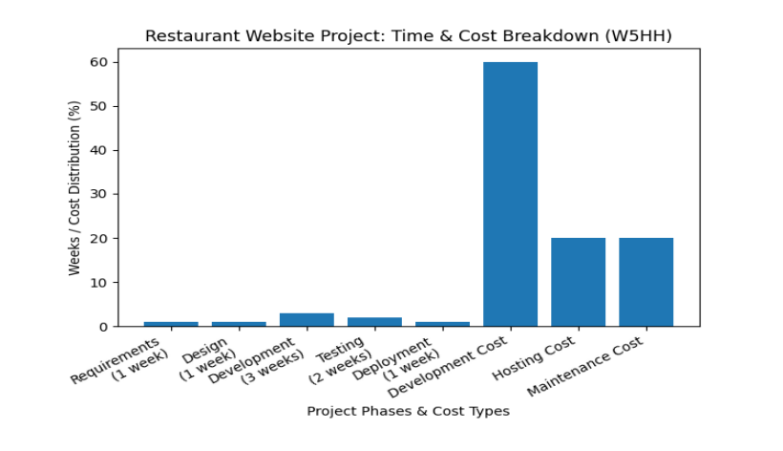
The bar chart explains the W5H principle by showing the project timeline in weeks and the budget distribution for developing a restaurant website.

How Much? – Cost Analysis
- Development cost (60%) is the highest because it involves developers, tools, and implementation.
- Hosting cost (20%) covers server and domain expenses.
- Maintenance cost (20%) is needed for updates and bug fixes (problem fixing ) after deployment.( making small improvement )

