Trojan page: Trojan horse

<logo> <nav bar>

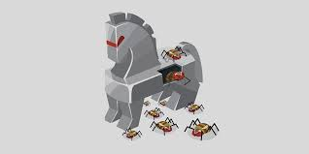

Trojan horse virus name is derived from the story of the trojan horse. Like in the story a trojan horse virus presents itself as a program that it is not. Trojan horse generally do not perform any of the functions that they claim themselves to do. Trojan horse virus bypass firewalls by getting users to give them permission to pass through. Many trojans contain either spyware that aims to collect personal information or a program that can make your computer unusable.



Trojans have to get your permission to be downloaded so by making sure that what you are downloading is actually what is says it is you can prevent your system form being infected by one. An effective way to keep trojans off you computer is to not go for overly flashy ads that promise a one in a lifetime deal that seems too good to be true. If one gets onto your computer hopefully your anti-virus is capable of dealing with it.

<redundant nav bar>