Virus page: Computer viruses

<logo> <nav bar>

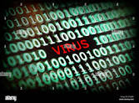

While computer virus seems like a general term for most ill intended programs computer virus is a specific type of virus. The main feature of every computer virus is self replication. Most computer virus do this by copying their code into the code of other programs. Many virus also include methods of sending themselves to other systems through various means, like mass emails or making themselves a download button on unmonitored websites. Some virus are hard to find on your system due to only taking up more space on your hard drive without any other effects on your systems performance.

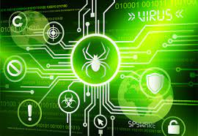

Computer viruses can not access anything that does not interact with them. With this in mind most computer virus can be avoided be being mindful of what you interact with in online. Another thing to be mindful of is if things seem out of place it is usually better to not interact with it. If your system gets a computer virus sometimes it takes removing other software it has embedded itself in to get rid of it.

<redundant nav bar>