**CSE 212 – Programming with Data Structures**

**W01 Prove – Response Document**

|  |  |
| --- | --- |
| **Name:** | Gavin Holway |
| **Date:** | 4/27/2024 |
| **Teacher:** | Zachariah Alvey |

*It is a violation of BYU-Idaho Honor Code to post or share this document with others or to post it online. Storage into a personal and private repository (e.g. private GitHub repository, unshared Google Drive folder) is acceptable.*

**Question 1: For the rotate right problem, provide a description of how you solved the problem.**

To solve the rotate right list to me it was keeping the smallest number through the end then reinserting the smaller numbers. It seemed simple to me to use GetRange to grab the numbers that would slide toward the start of the array then using a loop to add the smaller numbers back into the array.

**Question 2: For the rotate right problem, draw a picture of how you solved the problem.**

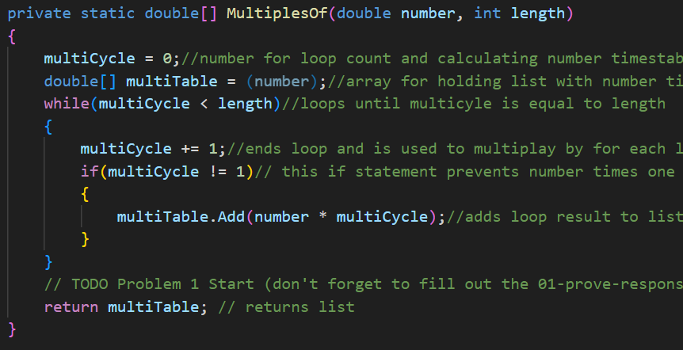

Remember: You need to commit all the changes to the prove-01-<username> repository along with this document. Then submit a link to the repository in I-Learn.