Longitudinal Supply Chain Monitoring using Generalized estimating equation and Joint Optimization method (A case study in the Personal Care Industry)

Abstract:
The goal of supply chain management is to provide the right quantity of the appropriate product at the right time. To effectively manage the supply chain, a company must have the ability to identify and respond to unexpected events in the early stages, and this is where the concept of supply chain monitoring becomes increasingly important day by day. Numerous factors in each of the five layers of the supply chain have an impact on sales and production. This article presents a comprehensive method for monitoring the relationship between influential variables on sales and production. To achieve this, after composing the corresponding data matrix for the supply chain variables, a longitudinal analysis was used to model sales and production. In this stage, Generalized Estimating Equation (GEE) was used for modeling the longitudinal response, and significant variables in the regression relationship were identified. Then, using the multivariable control chart, sales and production of monitored products were evaluated, and products with out-of-control performance were simultaneously identified for optimization. Finally, for products that exhibited out-of-control behavior, and considering the influential variables on sales and production, the method of simultaneous optimization chart was used to determine the optimal values for input factors that simultaneously minimize the cost of goods and finance cost. The application of the proposed method on a case study in the Personal Care industry demonstrated that using this approach leads to an increase in the operation profit rate for critical products.

Introduction:
A supply chain network combines a vast interconnected system encompassing suppliers, manufacturing units, warehouses, retailers, and customers, responsible for acquiring raw materials, producing goods, and delivering them to end-users. Material moves downstream from suppliers to customers, while information flows in the opposite direction. Extensive research on supply chain networks highlights the pivotal role of a streamlined network in determining a business’s overall economic success (Jing Wang, 2020). Papageorgiou, Grossmann and Shah have provided assessments on supply chain studies from a process system engineering perspective (Grossmann, 2005, Shah, 2005 and Papageorgiou, 2009). Supply chain operations come across various types of risks, such as delays, poor quality from suppliers, procurement failures, imprecise forecasts, uncertain consumer demands, and potential supply chain disruption like natural disasters (Chopra & Sodhi, 2006, Tang, 2006). In Carvalho et al.’s case study supply delays are underscored as a significant disturbance on supply chain networks. Wilson also mentions transportation disruptions affect severely on supply chain performance (Carvalho et al. 2012, Wilson, 2007). Clearly, in the absence of a well-organized mitigation strategy, these disruptions might result in financial losses or even a complete collapse of supply chain (Wang et al., 2020). Therefore, a critical aspect of supply chain management involves creating a measurement system that facilitates a coordination approach for joint decision-making (Kim & Oh, 2005). This system should align the goals of independent members and coordinate their efforts, ultimately enhancing the overall performance of the entire supply chain (Wang, 2010). Accordingly, the monitoring of supply chain operations and the timely detection of abnormal operations are crucial for the effective functioning and economic viability of a supply chain system. In this context, supply chain network is gaining increasing attention. The ability to promptly detect and provide early warnings of abnormal operations is crucial for effective supply chain management. The primary objective of supply chain analytics is to improve decision-making by characterizing the normal operating conditions of a supply chain, warnings for abnormal situations, identifying possible root causes, and providing recommendations for mitigation (Wang et al., 2020). Truong et al, 2017 categorized the supply chain studies into five main fields as follows figure (1):

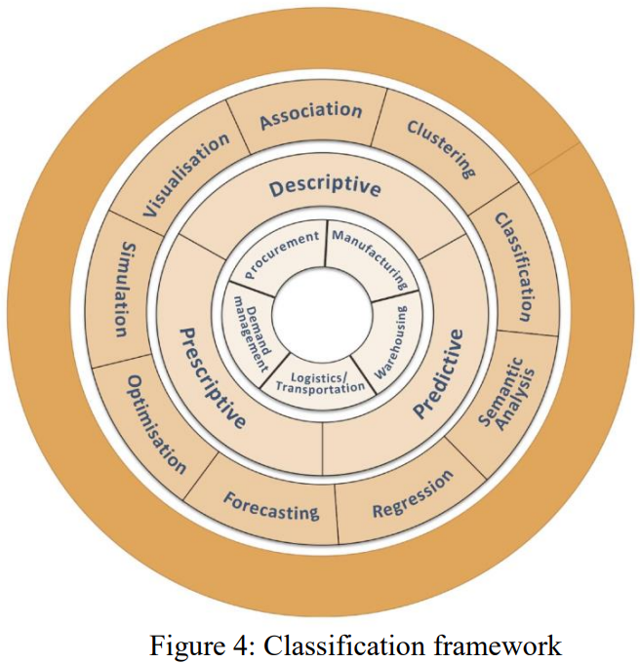
Figure 1 studies classification framework

Contributions of Study:
There have been several studies exploring various sections of supply chain functions and addressing their interdependent challenges through statistical data-driven methods. However, most of these studies have focused solely on one specific function out of the five in the supply chain. The primary contributions of this paper consist of a comparative analysis through a data-driven statistical model across all supply chain functions. To achieve this, a Generalized Estimating Equation model is employed to create a control chart for detecting inefficient products. Additionally, the paper proposes a joint optimization approach to further enhance supply chain efficiency. Accordingly, monitoring the supply chain across its five functions over time requires the application of specific statistical methods due to the presence of correlated characteristics in the data and the consideration of numerous variables. Longitudinal studies prove to be particularly suitable for handling such data. In contrast to cross-sectional data, which only provide one measurement for each response at a specific time point, longitudinal data offer distinct advantages. The correlation among observations within an experimental unit leads to more specific power level in longitudinal data compared to cross-sectional data. Consequently, a smaller number of experimental units is needed in the sample to achieve a specific power level. Achieving a specific power level means ensuring that the study is designed and conducted in a way that allows it to have a high likelihood of detecting meaningful effects or relationships between characteristics (variables). (Diggle et al, 2002). Additionally, simultaneous optimization of effective variables in the model is another serious challenge addressed in this research.

Study Method
We have developed a comprehensive method to monitor and optimize the supply chain network, aiming to enhance performance for a company operating in the personal care industry. The method entails extracting data from the five main sections of the supply chain over a twelve-month interval and organizing it as a matrix. To conduct a longitudinal analysis over the matrix and examine changes in production and sales of products based on the case study's variables, we employed the GEE method. Then, a multi-variable control chart was utilized to monitor the results of the modeling process. we closely monitored the performance of products by employing the T2 Hotelling multivariate control chart to detect any unusual or out-of-control behavior in the supply chain. Finally, the simultaneous optimization (joint optimization) method was applied to the products that exhibited out-of-control behavior during the supply chain monitoring. In this step, we optimized the relevant variables derived from previous stages to achieve optimal cost values, including the cost of goods and operational expenses. The goal is to ensure that the profit and loss statement reflects a profit and enhances the company’s overall supply chain performance. The above-mentioned steps of the current study were outlined as follows:
Step 1: The variables resulting from the problem were reshaped into a longitudinal form to make a set of explanatory and response variables for sales and production. The supply chain has essentially been decomposed for further analysis.
Step 2: In this longitudinal supply chain study, we introduced the time variable as a fixed effect. Additionally, we considered variables associated with all five functions of the supply chain as covariates to assess their influence on the response variables. The Generalized Estimating Equation (GEE) method was utilized to analyze the data, considering the within-Stock Keeping Unit (SKU) effect as a latent variable. The modeling process involved utilizing the "xtgee command" in Stata software. Two separate analyses were carried out: one for sales and another for production.
Step 3: Using the Hotteling $T^{2}$ control chart, we monitored two resulting variables obtained from the fitted values in the previous Step 2 of the Phase I control chart. In this stage, we identified out-of-control products for optimization using the Joint Optimization (JOP) method. This crucial step was executed through the MSQC package in the R software.
Step 4: Optimization of variables related to products beyond the control chart, we utilized the joint optimization model, considering the cost of goods sold and finance costs of the products as the response variables. The decision variables for the modeling process were internal factors within the business. This phase was executed using the JOP package in R software. The following chart shows the steps of this study:
Figure (2) steps of the method

References:
- Jing Wang, Christopher L. E. Swartz, Brandon Corbett, and Kai Huang, “Supply Chain Monitoring Using Principal Component Analysis”, Industrial & Engineering Chemistry Research 2020 59 (27), 12487-12503 DOI: 10.1021/acs.iecr.0c01038
- Grossmann, I. E. Enterprise-wide optimization: A new frontier in process systems engineering. AIChE J. 2005, 51, 1846−1857.
- Papageorgiou, L. G. Supply chain optimization for the process industries: Advances and opportunities. Comput. Chem. Eng. 2009, 33,1931−1938.
- Chopra, S.; Sodhi, M. S. Managing risk to avoid supply-chain breakdown. MIT Sloan Management Review 2004, 46, 53−62.
- Tang, C. S. Perspectives in supply chain risk management. International Journal of Production Economics 2006, 103, 451−488.
- Carvalho, H.; Barroso, A. P.; Machado, V. H.; Azevedo, S.; Cruz-Machado, V. Supply chain redesign for resilience using simulation. Computers & Industrial Engineering 2012, 62, 329−341.
- Fernández, E., Salomone, E., Chiotti, O. (2010). Model Based on Bayesian Networks for Monitoring Events in a Supply Chain. In: Vallespir, B., Alix, T. (eds) Advances in Production Management Systems. New Challenges, New Approaches. APMS 2009. IFIP Advances in Information and Communication Technology, vol 338. Springer, Berlin, Heidelberg. https://doi.org/10.1007/978-3-642-16358-6_45
- Gilvan C. Souza,2014,'Supply chain analytics', Business Horizons, Volume 57, Issue 5, Pages 595-605, ISSN 0007-6813, https://doi.org/10.1016/j.bushor.2014.06.004.
- Diggle P, Heagerty P, Liang K-Y, Zeger S. Analysis of longitudinal data: Oxford University Press; 2002.

