**Sam Media Challenge Report**

This report shows current situation in the specified country.

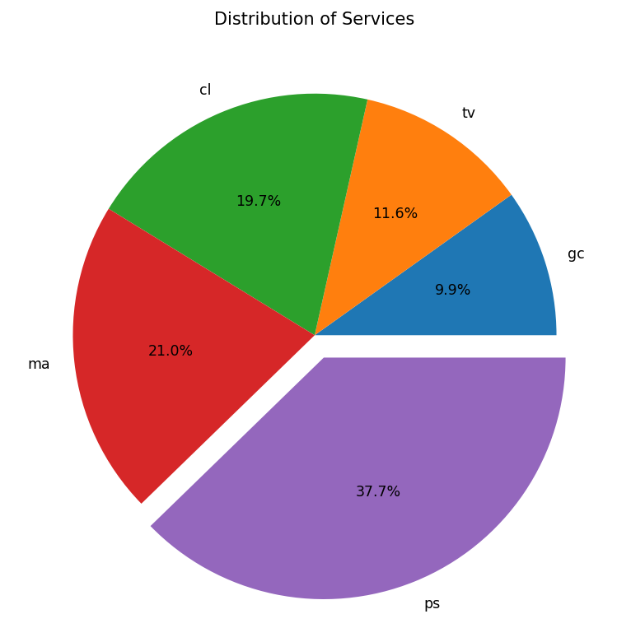

1. Distribution of Services

* As you can see predominant service is PS that about 38 percent of all users have used this service.

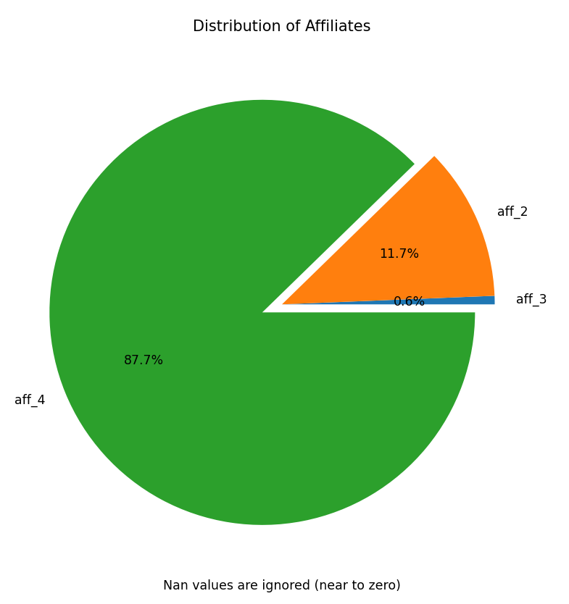

2. Distribution of Affiliates

* As you can see predominant is aff_4, so maybe we should be thankful for this affiliate. We should also scrutinize why aff_3 have done poor job.

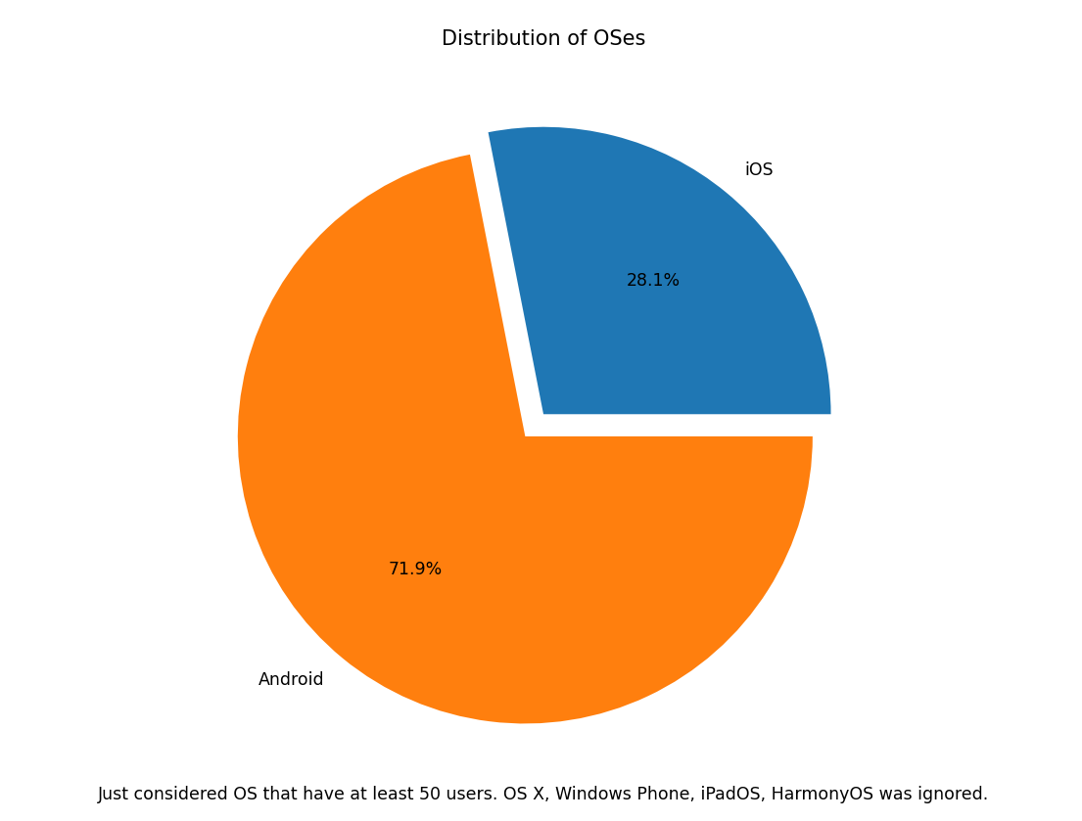

3. Distribution of OSs

* This pie chart shows distribution of OS in our users. So, most of our users use Android devices, thus maybe we should optimize our services for Android devices.

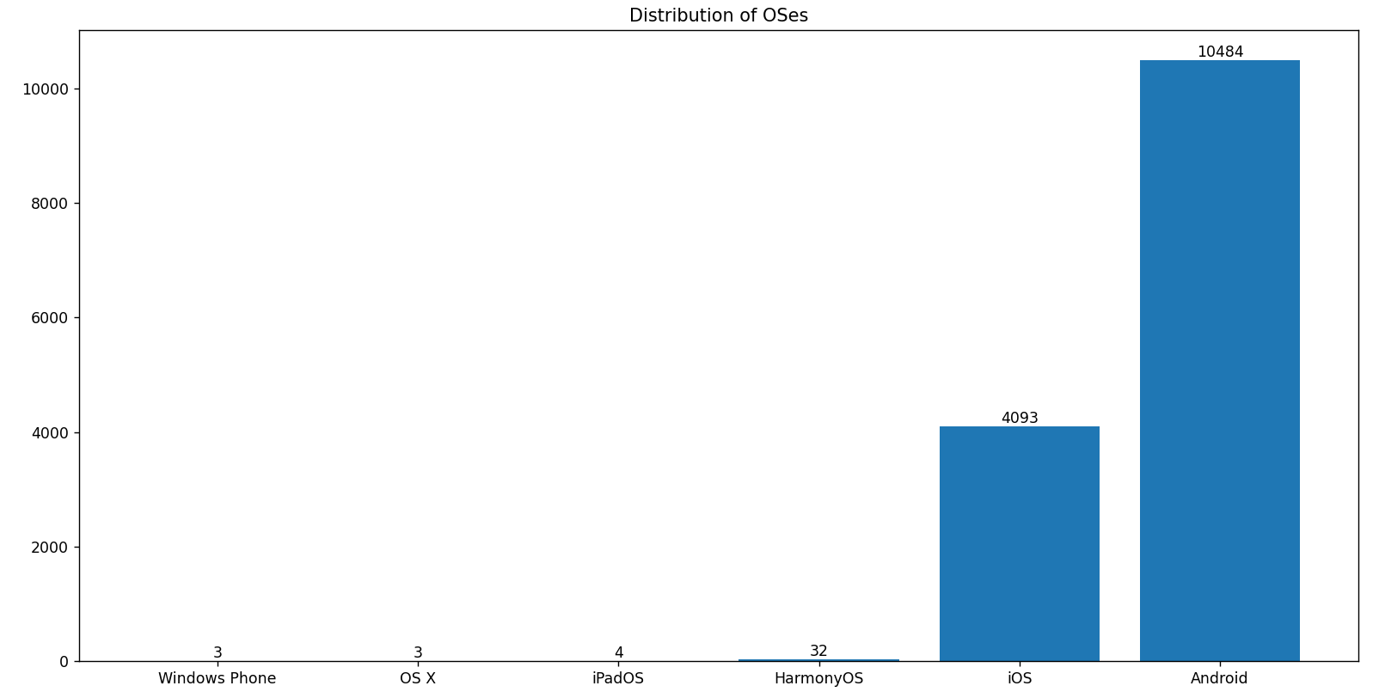

4. Distribution of OSs (Bar Chart)

* This bar chart has more detail about quote of each distribution between our users.

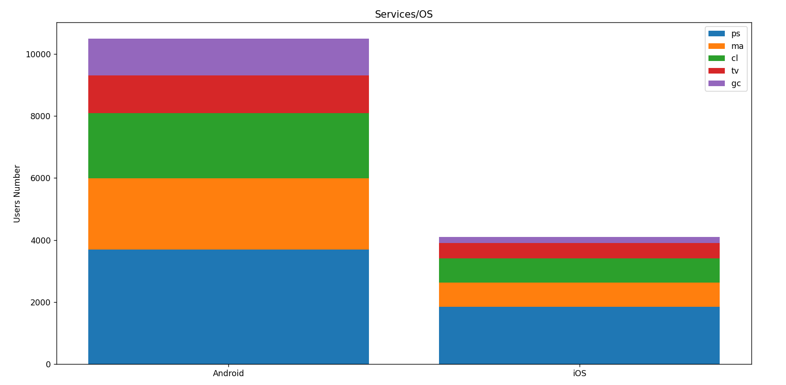

5. Distribution of Services Based on OSs

* This stacked bar chart shows that different services on two most frequent OSs have similar pattern.

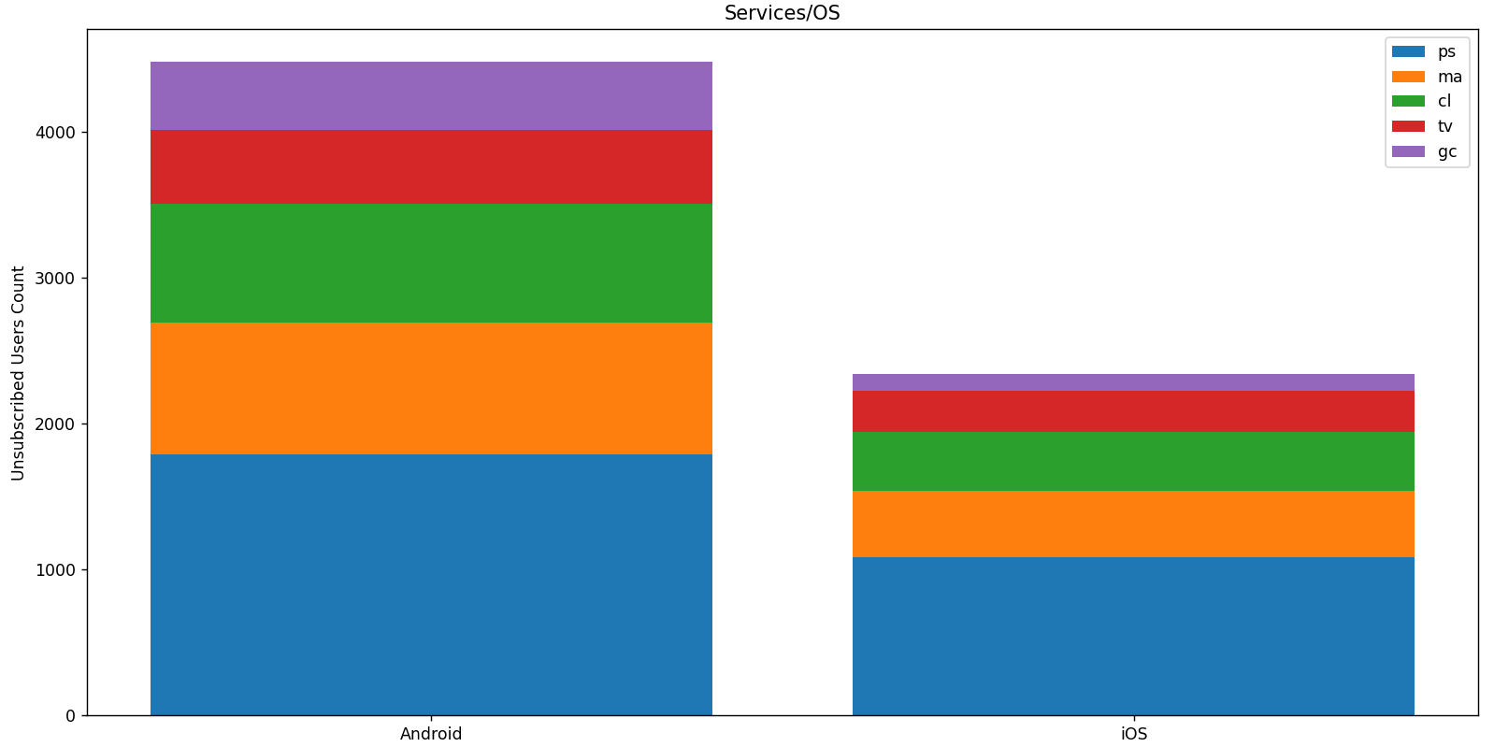

6. Distribution of Services Based on OSs For Unsubscribed Users

* In this stacked bar chart, we just considered users that decided to un-subscribe their services. We thought that, maybe there is an abnormal pattern. But it seems that distributions are normal.

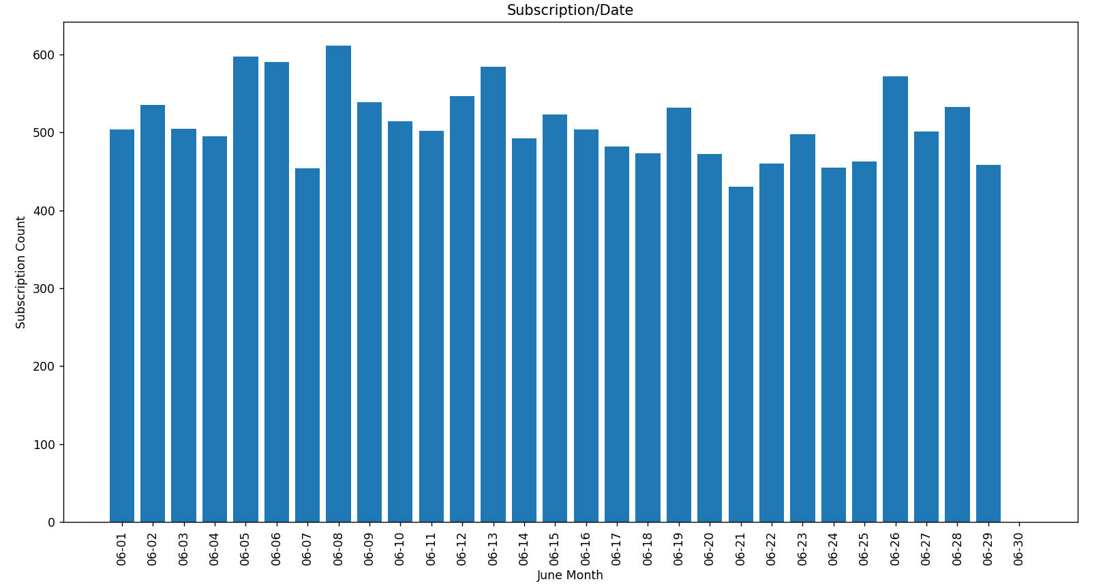

7. Subscription Count Per Day

* This bar chart shows subscription start count per day. We thought that maybe we have surge in the weekends or other similar patterns. After scrutinizing it, we noticed we have increment in Sundays (05, 12, 19, 26).

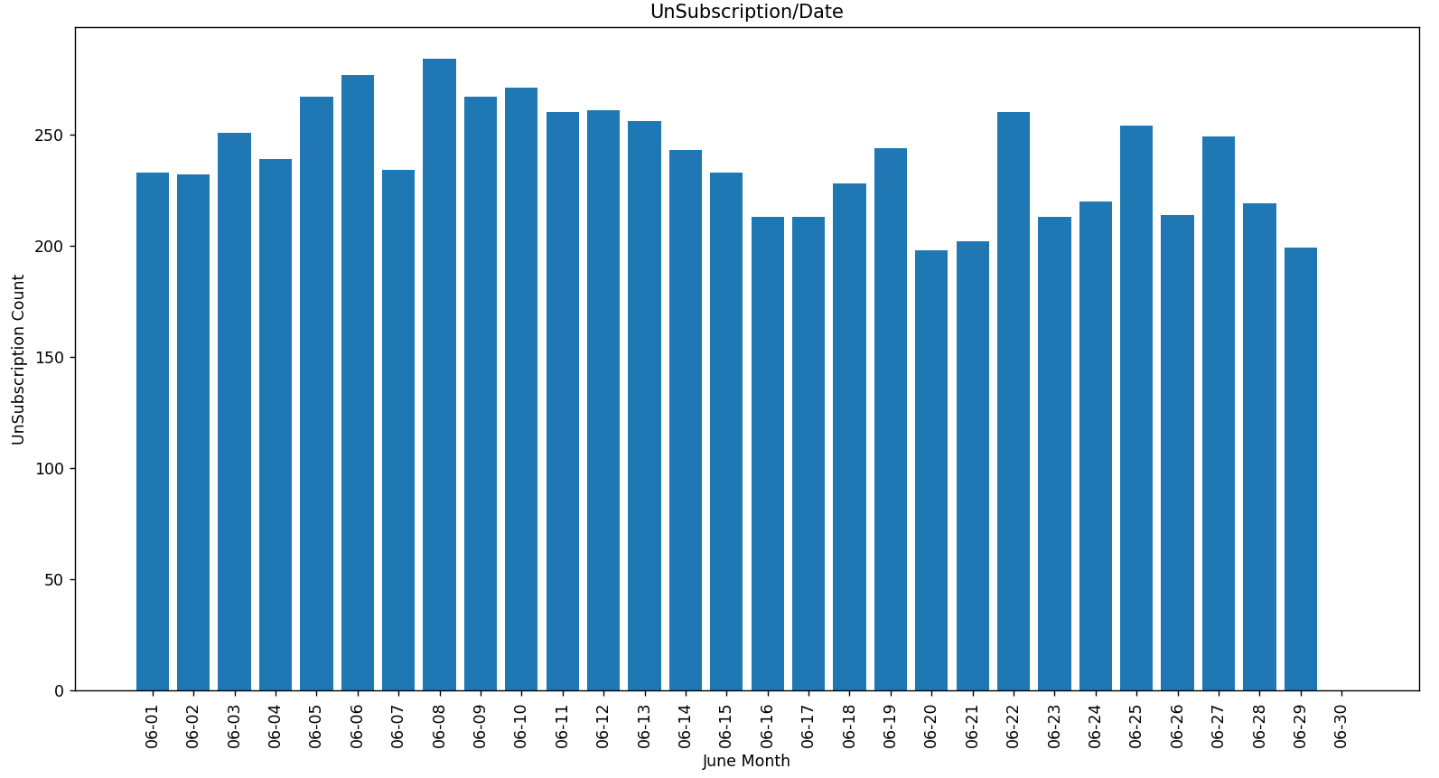

8. Un-Subscription Count Per Day

* This bar chart shows un-subscription start count per day. We thought that maybe we have surge in the weekends or other similar patterns. We can’t see exact previous pattern in here.

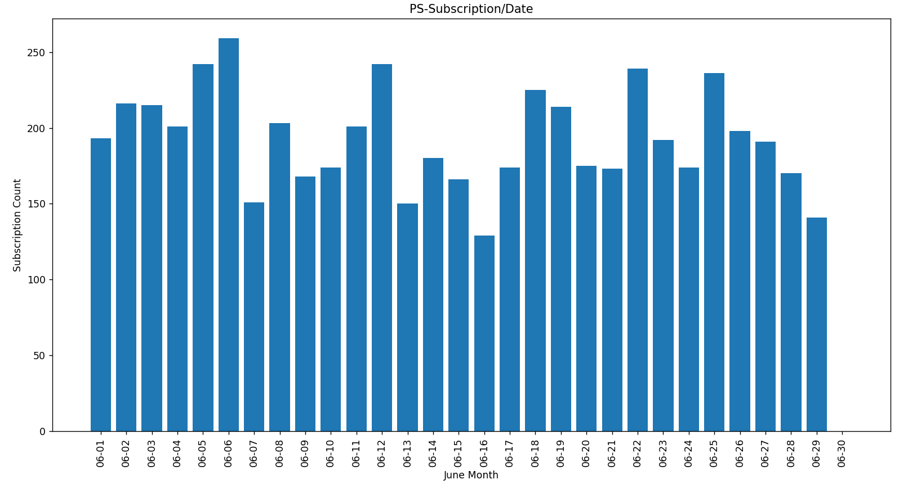

9. PS Subscription Count Per Day

* This bar chart shows subscription start count per day for the PS service.

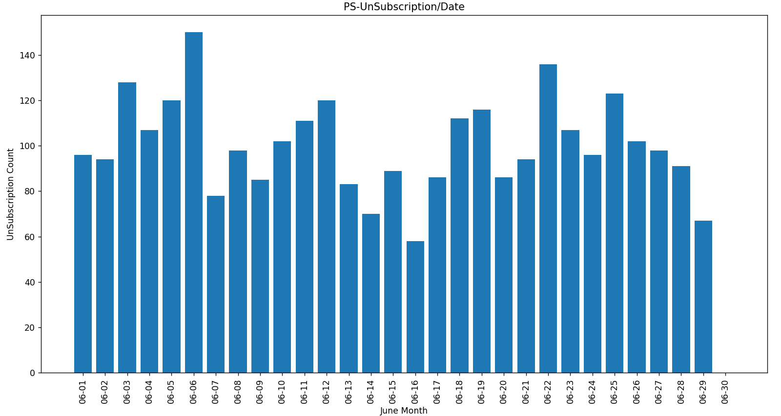

10. PS Un-Subscription Count Per Day

* This bar chart shows un-subscription count per day for the PS service.

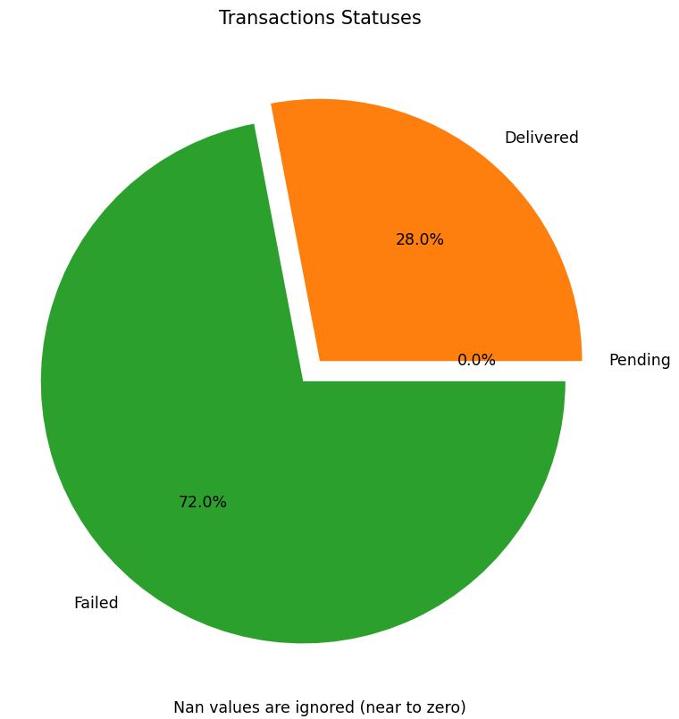

11. Distribution of Transactions Statuses

* As you can see most transactions are failed. Maybe we should consider better approaches to getting billed our users.

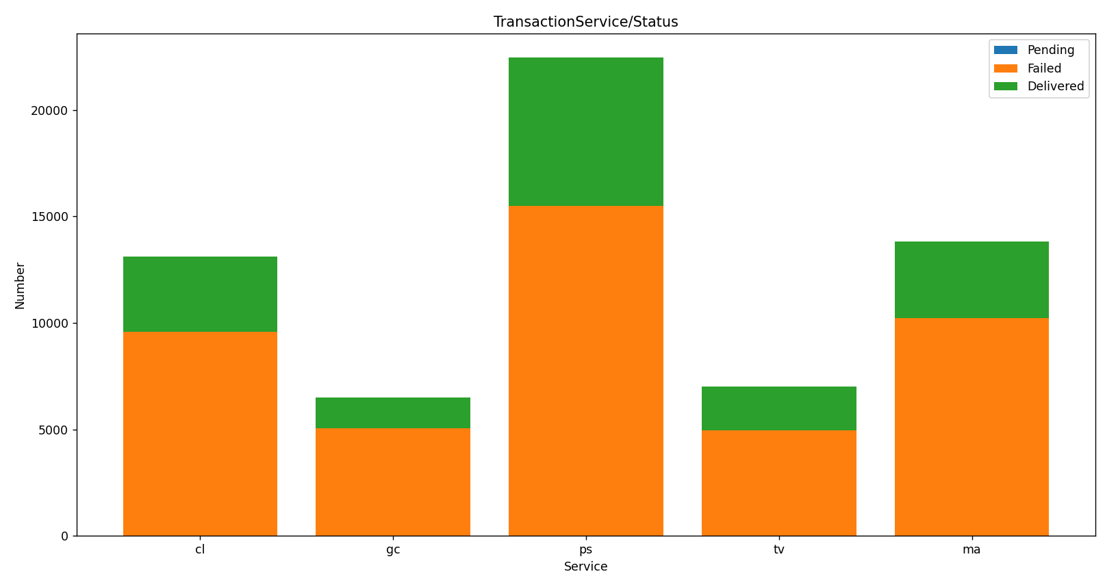

12. Distribution of Transactions Statuses Per Service

* We created this stacked bar chart, because we thought that maybe we have more failed transaction in a specific service.

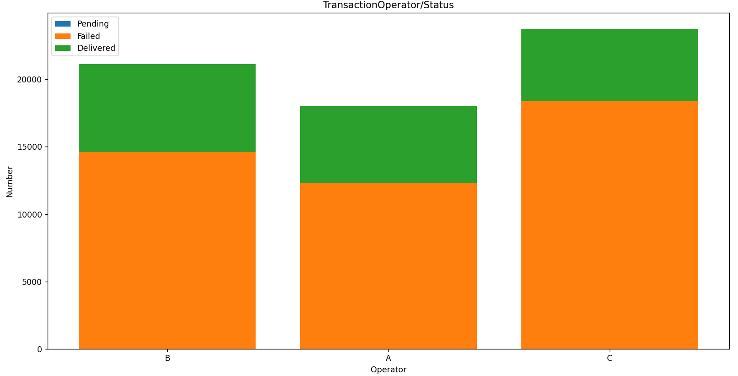

13. Distribution of Transactions Statuses Per Operator

* We also created this stacked bar chart, because we thought that maybe we have more failed transaction in a specific operator.

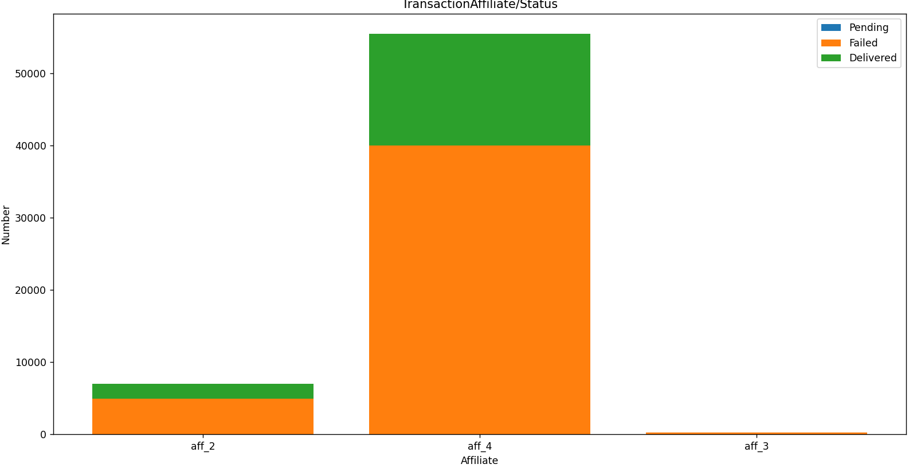

14. Distribution of Transactions Statuses Per Affiliate

* We also created this stacked bar chart, because we thought that maybe we have more failed transaction in a specific affiliate.

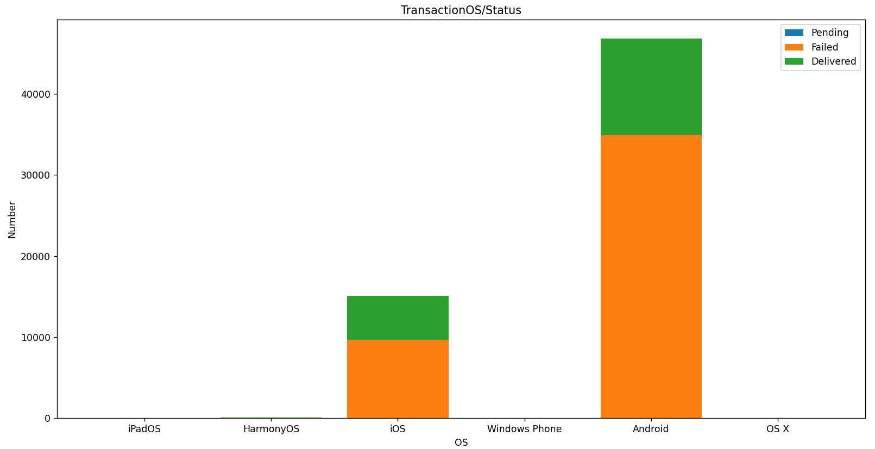

15. Distribution of Transactions Statuses Per OS

* We also created this stacked bar chart, because we thought that maybe we have more failed transaction in a specific OS.

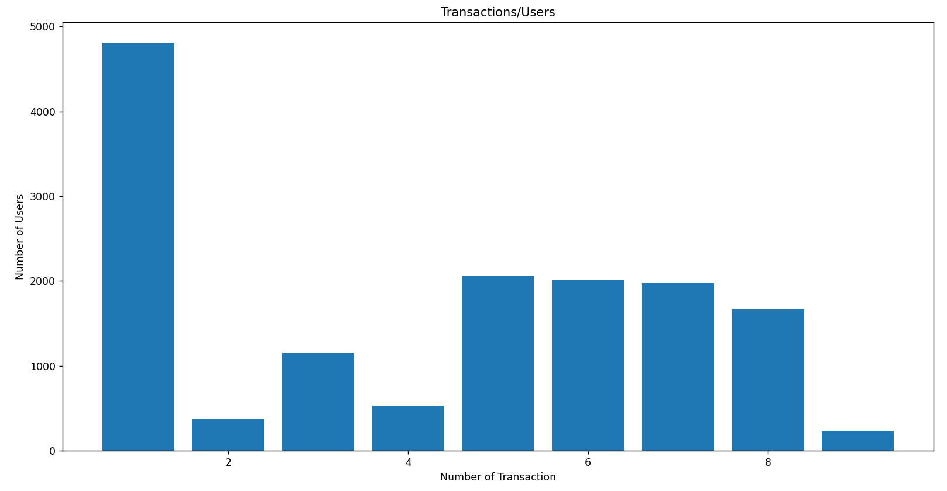

16. Transactions Count for Users

* Let me explain this chart by an example. This chart shows how many users have one transaction (based on the chart about five thousand users).

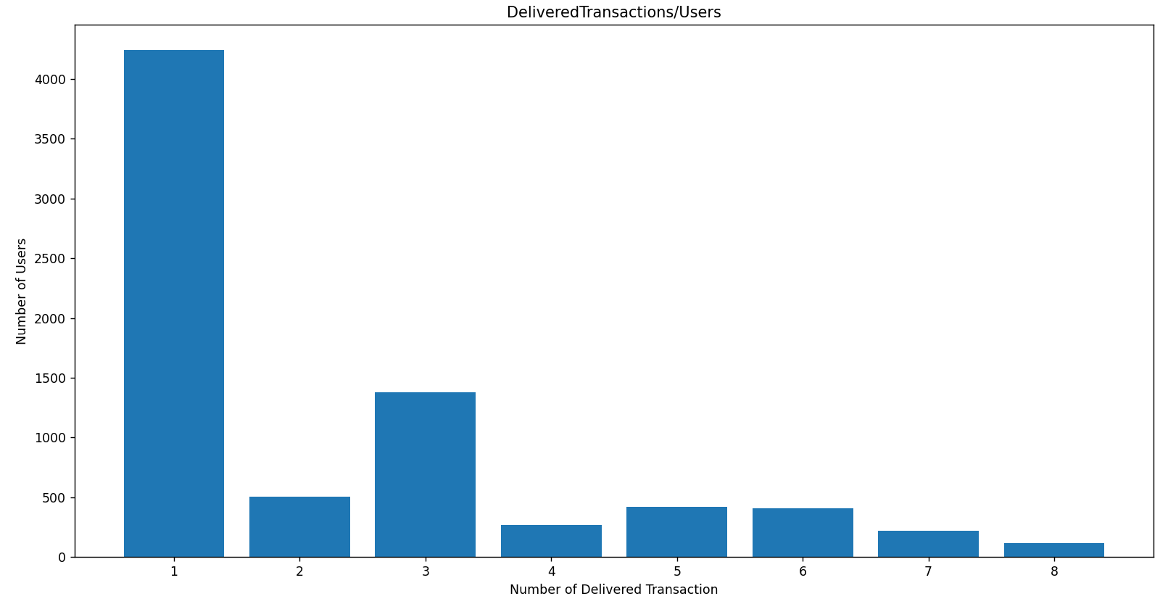

17. Delivered Transactions Count for Users

* Let me explain this chart by an example. This chart shows how many users have one delivered transaction (based on the chart about four thousand users).