# Math_003 – control loop

**Mathematical Description**

Equations:

, ,





Independent variable:

, , 

To solve for: 4 variables:



**Decomposition**

Number of parts: 3

|  |  |  |  |
| --- | --- | --- | --- |
| Part | Input | Equations | Output |
| 1 | - | ,  , | , |
| 2 |  |  |  |
| 3 |  |  |  |

Priority table

The parts with smaller priority should be calculated before the parts with higher priority because of the directed signal flow between the parts. Begin with priority 0.

|  |  |
| --- | --- |
| Priority | Part |
| 0 | 1 |
| 1 | 2, 3 |

The decomposition can be visualized by:

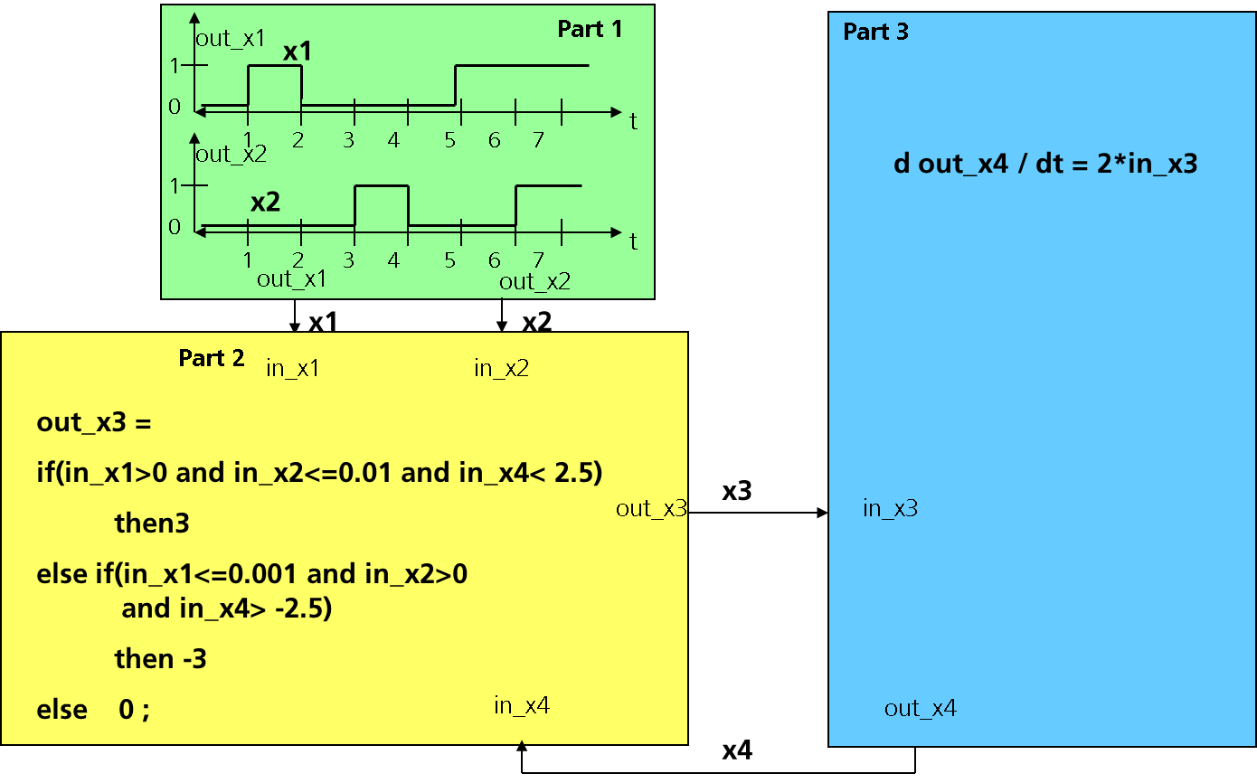

**Expected Solution**



**Remarks**

Quasi digitale Signale steuern eine Differentialgleichung (Anstieg). Kopplung Boolescher Ausdrücke mit analogem Verhalten. Ein Zyklus.

Former internal name of example was example C.

**Source**

Designed by Fraunhofer IIS EAS, C. Clauß.