# Math_019_lin_equ_small

**Mathematical Description**

Equations:

,   
,   


Independent variable:

, , 

To solve for: 3 variables:



**Decomposition**

Number of parts: 2

|  |  |  |  |
| --- | --- | --- | --- |
| Part | Input | Equations | Output |
| 1 |  |  |  |
| 2 |  | , |  |

Priority table

The parts with smaller priority should be calculated before the parts with higher priority because of the directed signal flow between the parts. Begin with priority 0.

|  |  |
| --- | --- |
| Priority | Part |
| 0 | 1, 2 |

The decomposition can be visualized by:

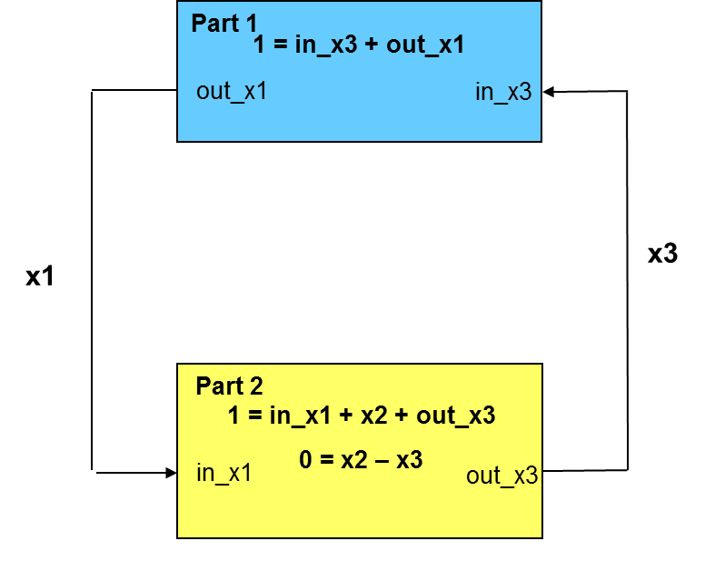

**Expected Solution**



**Remarks**

Einfaches Beispiel zum Test des Newtonverfahrens bei der Simulatorkopplung, wobei ein Block eine innere Variable enthält, die außerhalb nicht sichtbar ist.

**Designed by**

C: Clauß, 28.8.2014