Gede Ria Ghosalya
1001841

50.012 Networks – Lab 5

3.1 Warming Up

What is the local network chosen for the host?

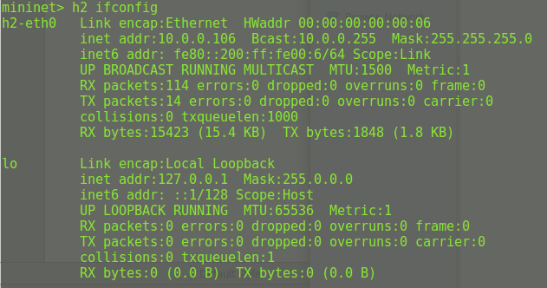

Ans: 10.0.0.0/24

Are the two servers srv1 and srv2 in the same subnet?

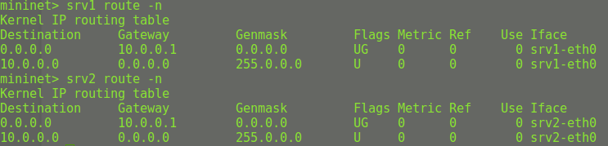
Since both servers have the same IP after mask (subnet address), they are in the same subnet.

Test if you can tracepath from h1 to srv1.

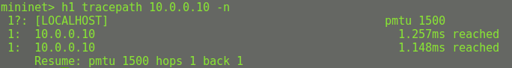

We are unable to observe the switch; the only machine visible through tracepath is the server.

What is the gateway for all the devices?

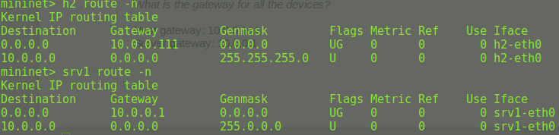

Host gateway: 10.0.0.111
Server gateway: 10.0.0.1

Can you ping the server nils.net (8.8.8.2) from h1? If not, any idea what is going wrong?

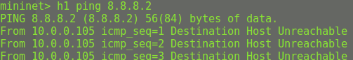
H1 is unable to ping nils.net (8.8.8.2). No idea~

Is a DHCP server running in the local network? On which machine?

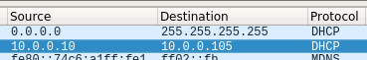

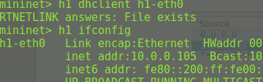

Yes, the DHCP is running on local network, which is on srv1.

4.1 Changing DHCP Configuration

Improve the configuration of the DHCP server.

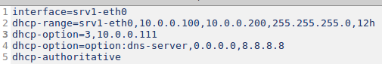
On line 3, this configuration will has 10.0.0.111 as its router (option 3). However, we dont have a device with this address. Neither srv1 nor h1 can ping to this address.

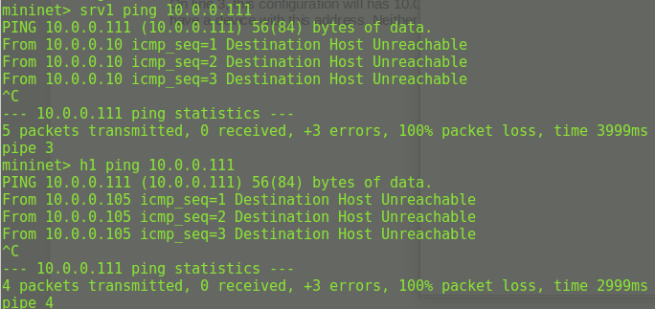

However, we do know that 10.0.0.1 exists as a router. So we can improve the configuration by changing the router.

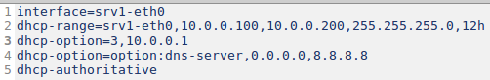
Now h1 is able to ping 8.8.8.8

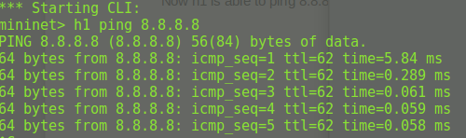

4.2 DNS

On h1, try to ping nils.net. Can you reach it? Why?

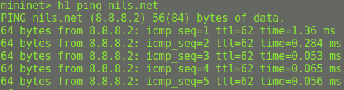

Yes, h1 was able to ping nils.net, with the ip (8.8.8.2).

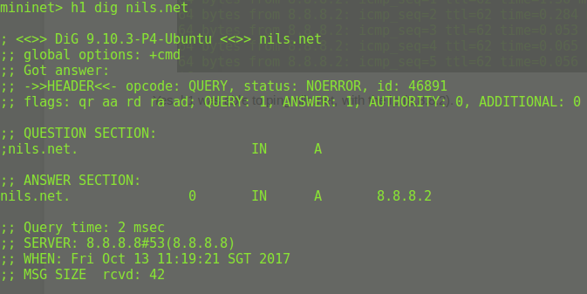

Upon using dig, it is discovered that the server 8.8.8.8 recognizes the address “nils.net” and return the IP address (8.8.8.2). As we know that h1 is able to reach 8.8.8.8, this is why h1 can connect to nils.net and recognize its IP address.

4.3 Observing NAT in action

In the provided setup, one node provides NAT for the hosts with private IP address. Which node is this?

Dunno yet, should be intGW

