Gede Ria Ghosalya
1001841

50.012 Networks Lab 3

Segment 3.1 Simple TCP (wget)

From mininet> h2 wget h1 it can be concluded that the normal download time for the webpage from h1 to h2 is ~1.0s.

The initial size of congestion window is expected to be low at the start but increasing over time.

Segment 3.2 With iperf

It is observed that when executing mininet> h2 ping h1 , the RTT significantly increases, from the usual 30ms on average, to about 750ms on average when running with iperf.

With iperf, an increase in download time for wget is also observed, significantly increasing from the usual ~1.0s to 5.2s. This is because, with iperf continuously occupying the bandwidth, some of the packets for download will end up in buffer. If this buffer is full, incoming packets will also be dropped, hence requiring h1 to retransmit said packet. This packet loss wastes time and cause h2 to have to wait for the retransmitted packet, hence the longer download time.

Segment 3.3 First experiment

Fig 1. Queue

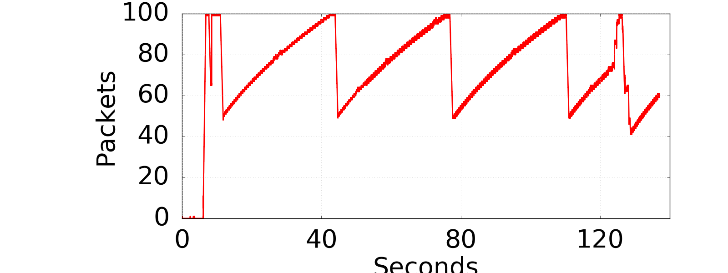

Fig 2. Congestion Window (iperf)
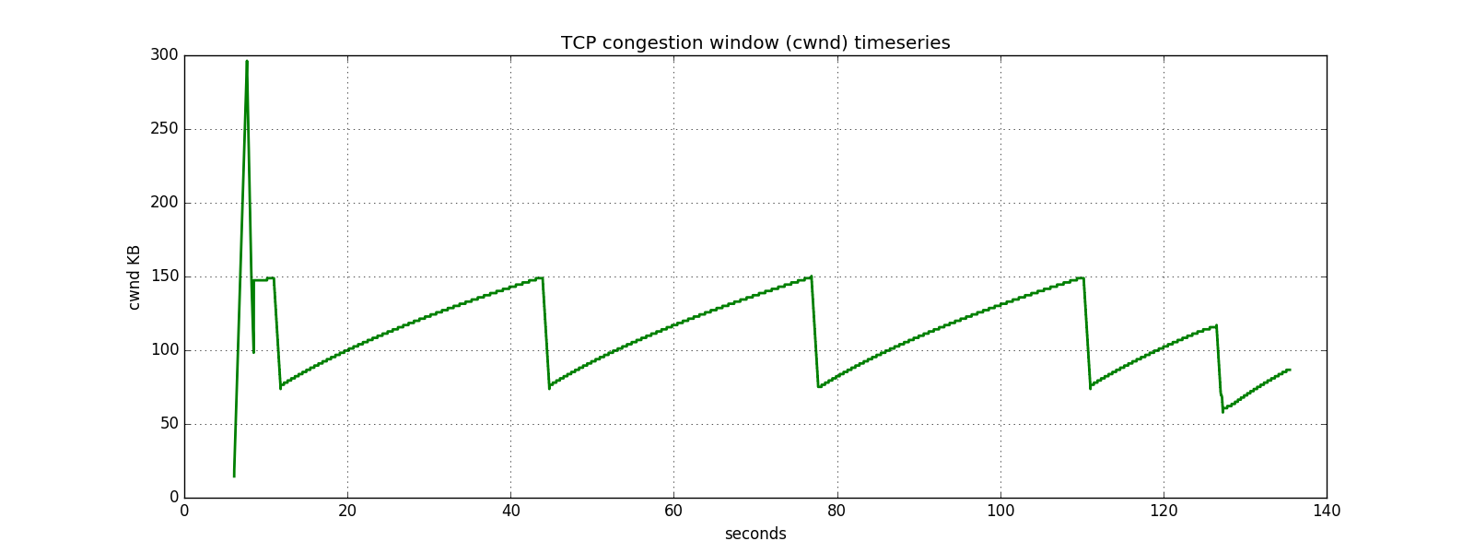
Fig 3. Congestion Window (wget)
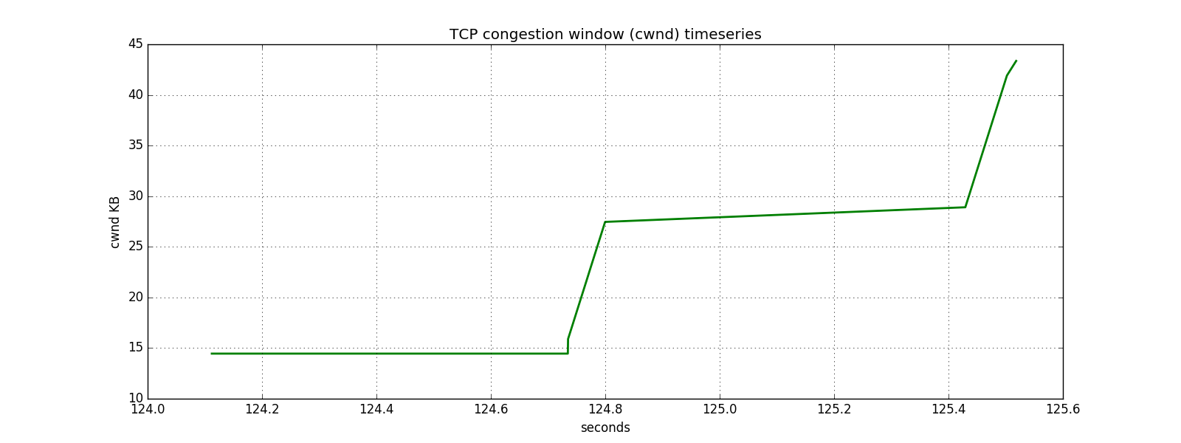

In the 100-sized buffer mininet, wget takes 3.9s to download from h1. It can be seen that after 20s, the iperf starts its congestion avoidance mode and keeps repeating it, rising constantly and dropping when it hits 150. This continues to be the pattern until 120s mark.

The download started at 124s, and this also supports the smaller window that iperf reaches before dropping at ard 125s, as well as the weird packet spike in the queue. After the download has finished (125.6 s) both queue and iperf returns to normal pattern.

Segment 3.4 Second experiment (smaller buffer)

Fig 1. Queue
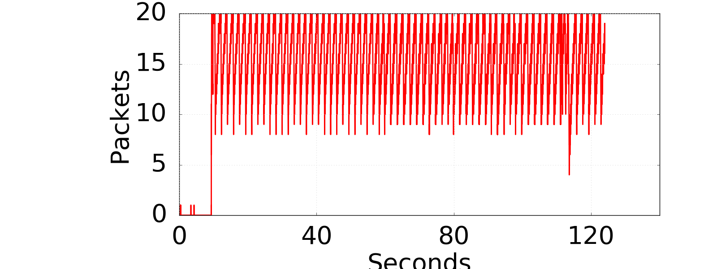

Fig 2. Congestion Window (iperf)
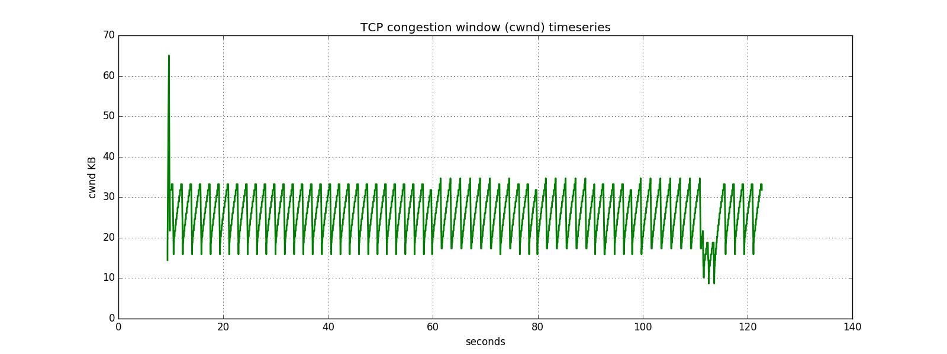

Fig 3. Congestion Window (wget)
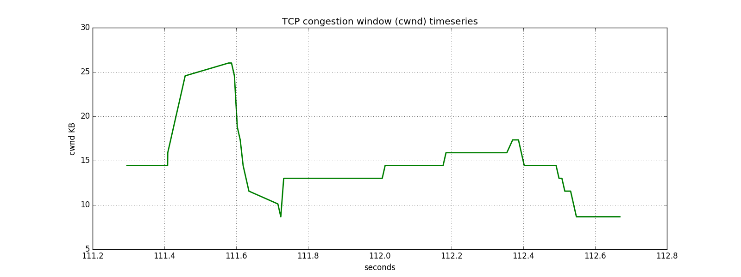

With smaller buffer size (20 instead of 100), packets from iperf is more frequently lost, and its congestion window more quickly reduced. This result in a buffer in which a packet from wget occupies a more significat portion of the buffer; for example, 1 out of 20 packets (5%) is occupied by wget, as opposed by 1 out of 100 (1%) in the larger buffer.

Since the bandwith for the two model is the same, this means that in a smaller buffer, the wget gets more effective bandwidth than with a larger buffer, hence faster download time (2.6s).

