**Gede Ria Ghosalya**

**1001841**

*50.012 Networks – Lab 5*

3.1 Warming Up

*What is the local network chosen for the host?*

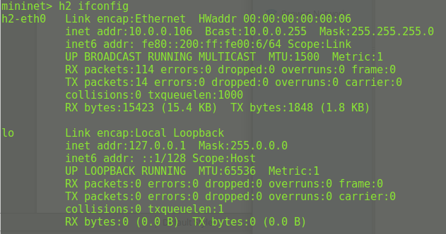

Ans: 10.0.0.0/24

*Are the two servers* srv1 *and* srv2 in the same subnet?

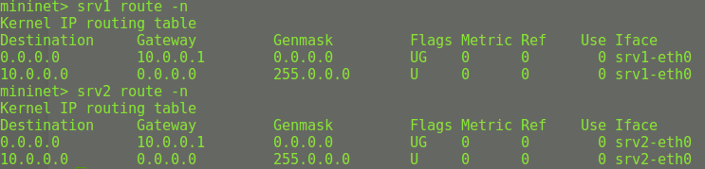

Since both servers have the same IP after mask (subnet address), they are in the same subnet.

*Test if you can* tracepath *from* h1 *to* srv1.

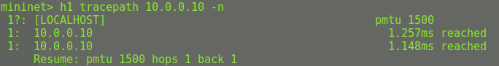

We are unable to observe the switch; the only machine visible through tracepath is the server.

*What is the gateway for all the devices?*

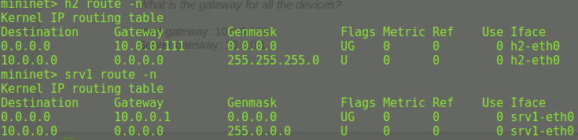

Host gateway: 10.0.0.111

Server gateway: 10.0.0.1

*Can you ping the server* nils.net (8.8.8.2) *from* h1? *If not, any idea what is going wrong?*

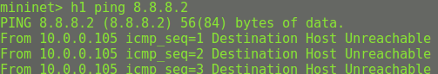

H1 is unable to ping nils.net (8.8.8.2). No idea~

*Is a DHCP server running in the local network? On which machine?*



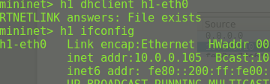

Yes, the DHCP is running on local network, which is on srv1.

4.1 Changing DHCP Configuration

*Improve the configuration of the DHCP server.*

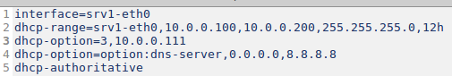

On line 3, this configuration will has 10.0.0.111 as its router (option 3). However, we dont have a device with this address. Neither srv1 nor h1 can ping to this address.

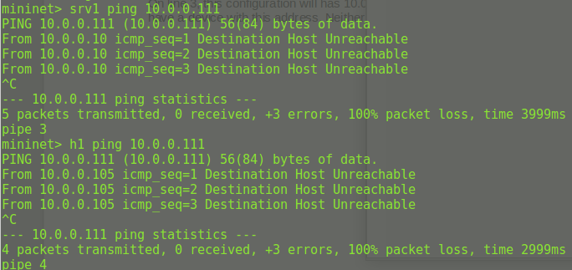

However, we do know that 10.0.0.1 exists as a router. So we can improve the configuration by changing the router.

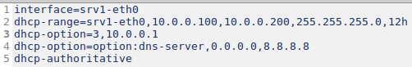

Now h1 is able to ping 8.8.8.8

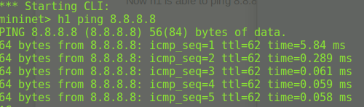

4.2 DNS

*On* h1, *try to ping* nils.net. *Can you reach it? Why?*

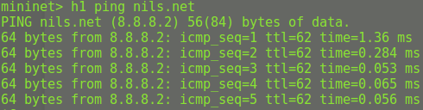

Yes, h1 was able to ping nils.net, with the ip (8.8.8.2).

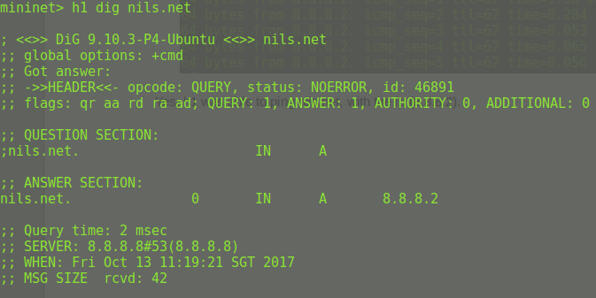

Upon using dig, it is discovered that the server 8.8.8.8 recognizes the address “nils.net” and return the IP address (8.8.8.2). As we know that h1 is able to reach 8.8.8.8, this is why h1 can connect to nils.net and recognize its IP address.

4.3 Observing NAT in action

*In the provided setup, one node provides NAT for the hosts with private IP address. Which node is this?*

The node providing NAT is intGW.

Below is 2 screen capture from wireshark, for h1 and intGW.

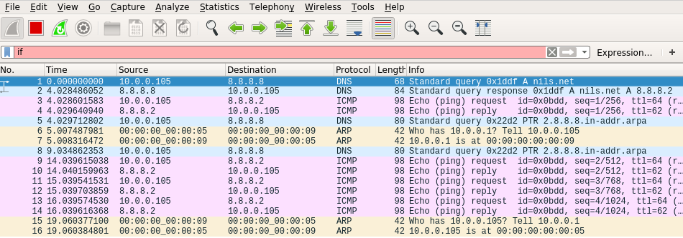

*Figure 4.3.1 wireshark screen capture from h1*

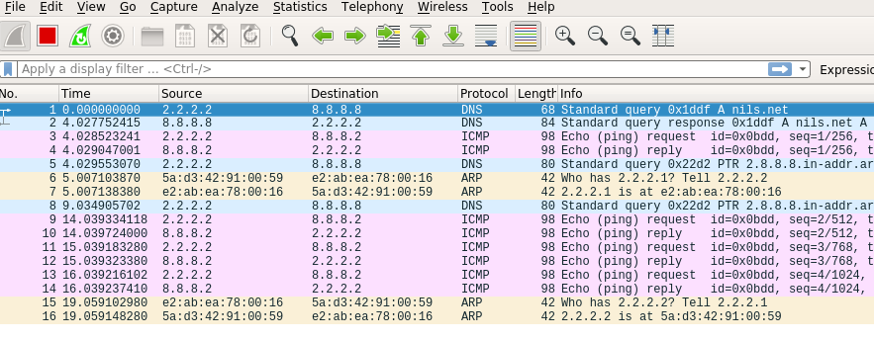*Figure 4.3.2 wireshark screen capture from intGW*

It can be seen that the request sent from h1 (10.0.0.105) to nils.net is reflected as request from intGW (2.2.2.2) to nils.net.

Opening net.py, the *enableNAT* function is written as follows.

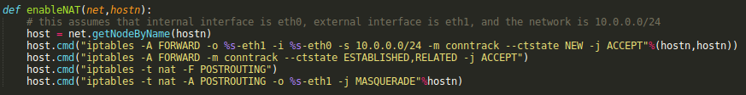

From here we can see that the address range for NAT translation is 10.0.0.0/24 ( or 10.0.0.0 10.0.0.255)

4.4 Simple Firewalling

Initially, srv2 ( 10.0.0.11) is able to ping both intGW (10.0.0.1) and outside network (8.8.8.8) as shown below.

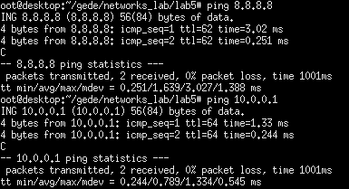

However, we are able to block srv2 by adding REJECT rule to iptables, as follows.



Note that FORWARD rule should also be added to prevent forward connection from srv2 to outside network, such as 8.8.8.8 node. After the above rule is added, we can see that srv2 is no longer able to ping neither intGW nor 8.8.8.8 node.

