TASK 1: Iris Flower Classification
● Using measurements of Iris flowers (setosa, versicolor, virginica) as input data.
About the iris dataset :
Each flower sample has 4 measurements (features):
Feature | Description
sepal length | Length of the sepal (cm)
sepal width | Width of the sepal (cm)
petal length | Length of the petal (cm)
petal width | Width of the petal (cm)

The target (output) is the species:
- Setosa is considered as 0
- Versicolor is considered as 1
- Virginica is considered as 2
Example record:
Sepal Length | Sepal Width | Petal Length | Petal Width | Species
5.1 | 3.5 | 1.4 | 0.2 | Setosa
- Here:
- X = [5.1, 3.5, 1.4, 0.2] # input features
y = 0 # output label (Setosa)
#Loading the Iris Dataset
Code:
import pandas as pd
irs_df=pd.read_csv("D:\promit file\Backup_14.02.2025\Documents\Excel_sheets\Iris_dataset.csv")
irs_df
Output:
Id | SepalLengthCm | SepalWidthCm | PetalLengthCm | PetalWidthCm | Species
0 | 1 | 5.1 | 3.5 | 1.4 | 0.2 | Iris-setosa
1 | 2 | 4.9 | 3.0 | 1.4 | 0.2 | Iris-setosa
2 | 3 | 4.7 | 3.2 | 1.3 | 0.2 | Iris-setosa
3 | 4 | 4.6 | 3.1 | 1.5 | 0.2 | Iris-setosa
4 | 5 | 5.0 | 3.6 | 1.4 | 0.2 | Iris-setosa
... | ... | ... | ... | ... | ... | ...
145 | 146 | 6.7 | 3.0 | 5.2 | 2.3 | Iris-virginica
146 | 147 | 6.3 | 2.5 | 5.0 | 1.9 | Iris-virginica
147 | 148 | 6.5 | 3.0 | 5.2 | 2.0 | Iris-virginica
148 | 149 | 6.2 | 3.4 | 5.4 | 2.3 | Iris-virginica
149 | 150 | 5.9 | 3.0 | 5.1 | 1.8 | Iris-virginica
150 rows × 6 columns
Code:
from sklearn.datasets import load_iris
iris = load_iris()

# Features (measurements)
X = iris.data
# Target labels
y = iris.target
print(X[:5])
print(y[:5])
Output:
[[5.1 3.5 1.4 0.2]
[4.9 3. 1.4 0.2]
[4.7 3.2 1.3 0.2]
[4.6 3.1 1.5 0.2]
[5. 3.6 1.4 0.2]]
[0 0 0 0 0]
#Checking Feature and Species Names
Code:
print(iris.feature_names)
print(iris.target_names)
Output:
['sepal length (cm)', 'sepal width (cm)', 'petal length (cm)', 'petal width (cm)']
['setosa' 'versicolor' 'virginica']
#Splitting Data into Training and Testing Sets
Code:
from sklearn.model_selection import train_test_split
X_train, X_test, y_train, y_test = train_test_split(X, y,test_size=0.2,random_state=42)
Here,80% data is training and 20% data is testing.
random_state=42 is used to make the train-test split reproducible.
When train_test_split() divides the dataset, it randomly selects which samples go into the training set and which go into the test set. Without a fixed random_state, you may get a different split every time you run the code.
#Training a Classification Model
Code:
from sklearn.tree import DecisionTreeClassifier
model = DecisionTreeClassifier()
model.fit(X_train, y_train)
The model learns the relationship between measurements and flower species.
Output:
DecisionTreeClassifier
Parameters
 | criterion | 'gini'
 | splitter | 'best'
 | max_depth | None
 | min_samples_split | 2
 | min_samples_leaf | 1
 | min_weight_fraction_leaf | 0.0
 | max_features | None
 | random_state | None
 | max_leaf_nodes | None
 | min_impurity_decrease | 0.0
 | class_weight | None
 | ccp_alpha | 0.0
 | monotonic_cst | None
#Making Predictions

Code:
y_pred = model.predict(X_test)
print(y_pred)

Output:
[1 0 2 1 1 0 1 2 1 1 2 0 0 0 0 1 2 1 1 2 0 2 0 2 2 2 2 2 0 0]

#Evaluating Accuracy
Code:
from sklearn.metrics import accuracy_score
accuracy = accuracy_score(y_test, y_pred)
print("Accuracy:", accuracy)

Output:
Accuracy: 1.0

#Predicting Flower Species from Measurements
Code:
from sklearn.datasets import load_iris
iris = load_iris()
# Features (measurements)
X = iris.data
# Target labels
y = iris.target
from sklearn.model_selection import train_test_split
X_train, X_test, y_train, y_test = train_test_split(X, y,test_size=0.2,random_state=42)
from sklearn.tree import DecisionTreeClassifier
model = DecisionTreeClassifier()
model.fit(X_train, y_train)
sample = [[5.1, 3.5, 1.4, 0.2]]
prediction = model.predict(sample)
print(iris.target_names[prediction[0]])
Output:
setosa
Code:
from sklearn.datasets import load_iris
iris = load_iris()
# Features (measurements)
X = iris.data
# Target labels
y = iris.target
from sklearn.model_selection import train_test_split
X_train, X_test, y_train, y_test = train_test_split(X, y,test_size=0.2,random_state=42)
from sklearn.tree import DecisionTreeClassifier
model = DecisionTreeClassifier()
model.fit(X_train, y_train)
sample = [[5.1, 3.5, 1.4, 0.2],[7,3.2,4.7,1.4]]
prediction = model.predict(sample)
print(iris.target_names[prediction[0]])
print(iris.target_names[prediction[1]])
Output:
setosa
versicolor
- Training a machine learning model to classify the species based on these measurements.
Code:
from sklearn import datasets
iris = datasets.load_iris()
import matplotlib.pyplot as plt
_, ax = plt.subplots()
scatter = ax.scatter(iris.data[:, 0], iris.data[:, 1], c=iris.target)
ax.set(xlabel=iris.feature_names[0], ylabel=iris.feature_names[1])
_ = ax.legend(scatter.legend_elements()[0], iris.target_names, loc="lower right", title="Classes")
Output:
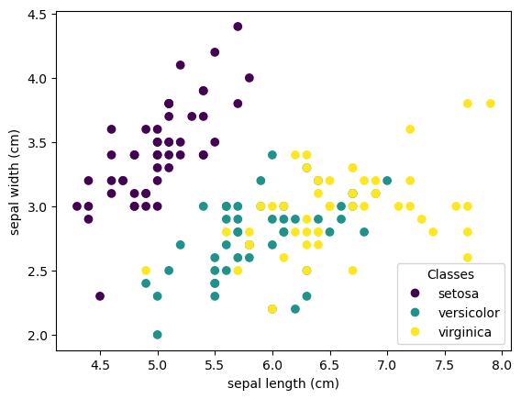
Each point in the scatter plot refers to one of the 150 iris flowers in the dataset, with the color indicating their respective type (Setosa, Versicolour, and Virginica). You can already see a pattern regarding the Setosa type, which is easily identifiable based on its short and wide sepal. Only considering these 2 dimensions, sepal width and length, there’s still overlap between the Versicolor and Virginica types.
- Applying a Principal Component Analysis (PCA) to the iris dataset and then plotting the irises across the first three PCA dimensions. This will allow us to better differentiate between the three types!
#Plotting a PCA
# unused but required import for doing 3d projections with matplotlib < 3.2
Code:
import mpl_toolkits.mplot3d # noqa: F401
import matplotlib.pyplot as plt
from sklearn.decomposition import PCA
from sklearn import datasets
iris = datasets.load_iris()

fig = plt.figure(1, figsize=(8, 6))
ax = fig.add_subplot(111, projection="3d", elev=-150, azim=110)

X_reduced = PCA(n_components=3).fit_transform(iris.data)
ax.scatter(X_reduced[:, 0],X_reduced[:, 1],X_reduced[:, 2],c=iris.target,s=40,)
ax.set_title("First three PCA dimensions")
ax.set_xlabel("1st Eigenvector")
ax.xaxis.set_ticklabels([])
ax.set_ylabel("2nd Eigenvector")
ax.yaxis.set_ticklabels([])
ax.set_zlabel("3rd Eigenvector")
ax.zaxis.set_ticklabels([])
plt.show()

Output:
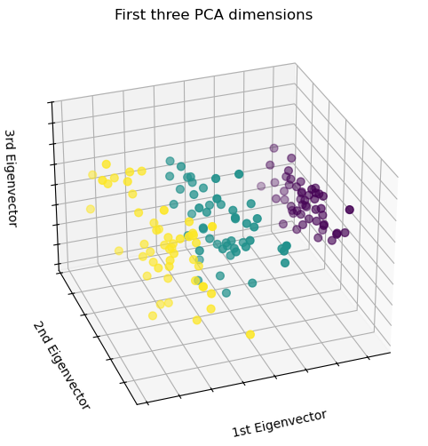

PCA will create 3 new features that are a linear combination of the 4 original features. In addition, this transform maximizes the variance. With this transformation, we see that we can identify each species using only the first feature (i.e. first eigenvalues).
Code:
import matplotlib.pyplot as plt
# unused but required import for doing 3d projections with matplotlib < 3.2
import mpl_toolkits.mplot3d # noqa: F401
import numpy as np
from sklearn import datasets, decomposition
np.random.seed(5)
iris = datasets.load_iris()
X = iris.data
y = iris.target

fig = plt.figure(1, figsize=(4, 3))
plt.clf()

ax = fig.add_subplot(111, projection="3d", elev=48, azim=134)
ax.set_position([0, 0, 0.95, 1])

plt.cla()
pca = decomposition.PCA(n_components=3)
pca.fit(X)
X = pca.transform(X)

for name, label in [("Setosa", 0), ("Versicolour", 1), ("Virginica", 2)]:
ax.text3D(
X[y == label, 0].mean(),
X[y == label, 1].mean() + 1.5,
X[y == label, 2].mean(),
name,
horizontalalignment="center",
bbox=dict(alpha=0.5, edgecolor="w", facecolor="w"),
)
# Reorder the labels to have colors matching the cluster results
y = np.choose(y, [1, 2, 0]).astype(float)
ax.scatter(X[:, 0], X[:, 1], X[:, 2], c=y, cmap=plt.cm.nipy_spectral, edgecolor="k")

ax.xaxis.set_ticklabels([])
ax.yaxis.set_ticklabels([])
ax.zaxis.set_ticklabels([])

plt.show()
Output:
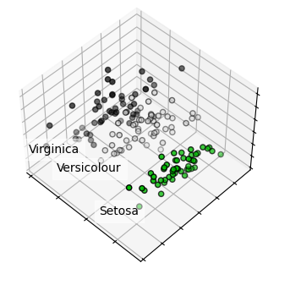
K-means clustering :
Code:
import matplotlib.pyplot as plt
# for 3D projection to work with matplotlib < 3.2
import mpl_toolkits.mplot3d # noqa: F401
import numpy as np

from sklearn import datasets
from sklearn.cluster import KMeans

np.random.seed(5)

iris = datasets.load_iris()
X = iris.data
y = iris.target

estimators = [
("k_means_iris_8", KMeans(n_clusters=8)),
("k_means_iris_3", KMeans(n_clusters=3)),
("k_means_iris_bad_init", KMeans(n_clusters=3, n_init=1, init="random")),
]

fig = plt.figure(figsize=(10, 8))
titles = ["8 clusters", "3 clusters", "3 clusters, bad initialization"]
for idx, ((name, est), title) in enumerate(zip(estimators, titles)):
ax = fig.add_subplot(2, 2, idx + 1, projection="3d", elev=48, azim=134)
est.fit(X)
labels = est.labels_

ax.scatter(X[:, 3], X[:, 0], X[:, 2], c=labels.astype(float), edgecolor="k")

ax.xaxis.set_ticklabels([])
ax.yaxis.set_ticklabels([])
ax.zaxis.set_ticklabels([])
ax.set_xlabel("Petal width")
ax.set_ylabel("Sepal length")
ax.set_zlabel("Petal length")
ax.set_title(title)

# Plot the ground truth
ax = fig.add_subplot(2, 2, 4, projection="3d", elev=48, azim=134)

for name, label in [("Setosa", 0), ("Versicolour", 1), ("Virginica", 2)]:
ax.text3D(
X[y == label, 3].mean(),
X[y == label, 0].mean(),
X[y == label, 2].mean() + 2,
name,
horizontalalignment="center",
bbox=dict(alpha=0.2, edgecolor="w", facecolor="w"),
)

ax.scatter(X[:, 3], X[:, 0], X[:, 2], c=y, edgecolor="k")

ax.xaxis.set_ticklabels([])
ax.yaxis.set_ticklabels([])
ax.zaxis.set_ticklabels([])
ax.set_xlabel("Petal width")
ax.set_ylabel("Sepal length")
ax.set_zlabel("Petal length")
ax.set_title("Ground Truth")

plt.subplots_adjust(wspace=0.25, hspace=0.25)
plt.show()
Output:
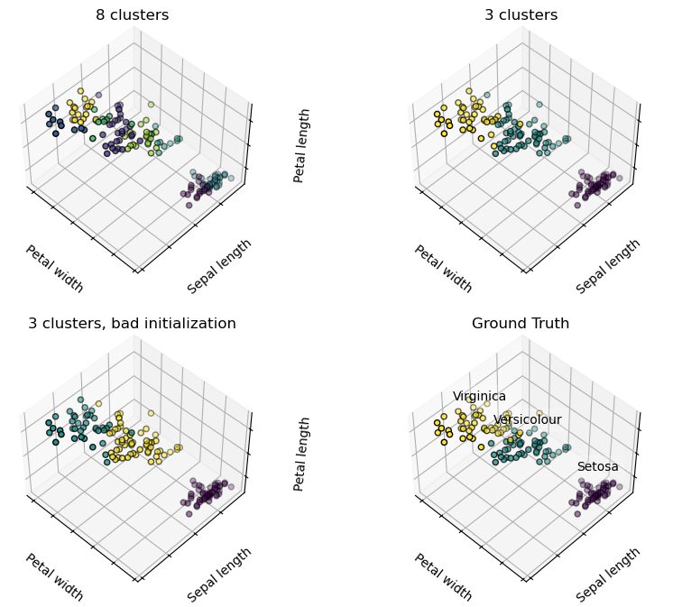
The plot shows:
- top left: What a K-means algorithm would yield using 8 clusters.
- top right: What using three clusters would deliver.
- bottom left: What the effect of a bad initialization is on the classification process: By setting n_init to only 1 (default is 10), the amount of times that the algorithm will be run with different centroid seeds is reduced.
- bottom right: The ground truth.

Logistic Regression 3-class Classifier
Code:
import matplotlib.pyplot as plt

from sklearn import datasets
from sklearn.inspection import DecisionBoundaryDisplay
from sklearn.linear_model import LogisticRegression

# importing some data to play with
iris = datasets.load_iris()
X = iris.data[:, :2] # we only take the first two features.
Y = iris.target

# Creating an instance of Logistic Regression Classifier and fit the data.
logreg = LogisticRegression(C=1e5)
logreg.fit(X, Y)

_, ax = plt.subplots(figsize=(4, 3))
DecisionBoundaryDisplay.from_estimator(logreg,X,cmap=plt.cm.Paired,ax=ax,response_method="predict",plot_method="pcolormesh",shading="auto",xlabel="Sepal length",ylabel="Sepal width",eps=0.5,)
# Plotting also the training points
plt.scatter(X[:, 0], X[:, 1], c=Y, edgecolors="k", cmap=plt.cm.Paired)
plt.xticks(())
plt.yticks(())
plt.show()
Output:
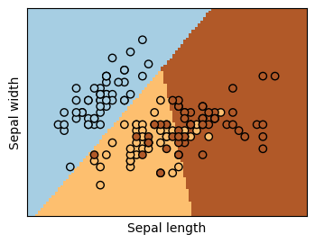
The above graph is a logistic-regression classifiers decision boundaries on the first two dimensions (Sepal length and width) of the iris dataset. The datapoints are colored according to their labels.

Code:
import matplotlib.pyplot as plt
from sklearn import datasets
from sklearn.inspection import DecisionBoundaryDisplay
from sklearn.linear_model import LogisticRegression

# importing some data to play with
iris = datasets.load_iris()
X = iris.data[:, :2] # we only take the first two features.
Y = iris.target

# Creating an instance of Logistic Regression Classifier and fit the data.
logreg = LogisticRegression(C=1e5)
logreg.fit(X, Y)
_, ax = plt.subplots(figsize=(4, 3))
DecisionBoundaryDisplay.from_estimator(logreg,X,cmap=plt.cm.Paired,ax=ax,response_method="predict",plot_method="pcolormesh",shading="auto",xlabel="PetalLength",ylabel="PetalWidth",eps=0.5,)

# Plotting also the training points
plt.scatter(X[:, 0], X[:, 1], c=Y, edgecolors="k", cmap=plt.cm.Paired)
plt.xticks(())
plt.yticks(())
plt.show()
Output:
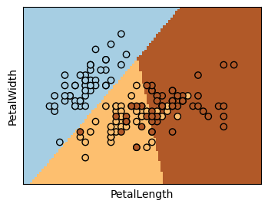
The above graph is a logistic-regression classifiers decision boundaries on the first two dimensions (Petal length and width) of the iris dataset. The datapoints are colored according to their labels.
Plotting the decision surface of decision trees trained on the iris dataset :
Code:
from sklearn.datasets import load_iris
iris = load_iris()
import matplotlib.pyplot as plt
import numpy as np
from sklearn.datasets import load_iris
from sklearn.inspection import DecisionBoundaryDisplay
from sklearn.tree import DecisionTreeClassifier
# Parameters
n_classes = 3
plot_colors = "ryb"
plot_step = 0.02
for pairidx, pair in enumerate([[0, 1], [0, 2], [0, 3], [1, 2], [1, 3], [2, 3]]):
# We only take the two corresponding features
X = iris.data[:, pair]
y = iris.target

# Training
clf = DecisionTreeClassifier().fit(X, y)

# Plotting the decision boundary
ax = plt.subplot(2, 3, pairidx + 1)
plt.tight_layout(h_pad=0.5, w_pad=0.5, pad=2.5)
DecisionBoundaryDisplay.from_estimator(clf,X,cmap=plt.cm.RdYlBu,response_method="predict",ax=ax,xlabel=iris.feature_names[pair[0]],ylabel=iris.feature_names[pair[1]],)

# Plotting the training points
for i, color in zip(range(n_classes), plot_colors):
idx = np.where(y == i)
plt.scatter(X[idx, 0],X[idx, 1],c=color,label=iris.target_names[i],cmap=plt.cm.RdYlBu,edgecolor="black",s=15,)
plt.suptitle("Decision surface of decision trees trained on pairs of features")
plt.legend(loc="lower right", borderpad=0, handletextpad=0)
_ = plt.axis("tight")
Output:
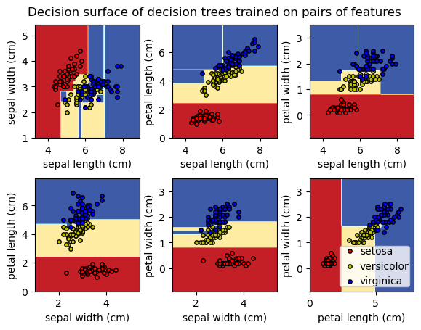
- Using libraries like Scikit-learn for easy dataset access and model building
Scikit-learn is an open-source Python library that simplifies the process of building machine learning models. It offers a clean and consistent interface that helps both beginners and experienced users work efficiently.
i)Supports tasks like classification, regression, clustering and preprocessing
ii) Makes model building fast and reliable
iii) Provides ready-to-use tools for training and evaluation
iv) Reduces complexity by avoiding manual implementation of algorithms

Scikit-learn provides multiple encoding methods:
Label Encoding: It converts each category into a unique integer. For example in a column with categories like 'cat', 'dog' and 'bird', it would convert them to 0, 1 and 2 respectively. This method works well when the categories have a meaningful order such as “Low”, “Medium” and “High”.
- LabelEncoder(): It is initialized to create an encoder object that will convert categorical values into numerical labels.
- fit_transform(): This method first fits the encoder to the categorical data and then transforms the categories into corresponding numeric labels.
Code:
from sklearn.preprocessing import LabelEncoder
categorical_feature = ['cat', 'dog', 'dog', 'cat', 'bird']
encoder = LabelEncoder()
encoded_feature = encoder.fit_transform(categorical_feature)
print("Encoded feature:", encoded_feature)
Output:
Encoded feature: [1 2 2 1 0]

. One-Hot Encoding: One-Hot Encoding creates separate binary columns for each category. This is useful when categories do not have any natural ordering. Example: cat, dog, bird -> 3 new columns (cat/dog/bird) with 1s and 0s.
- Input must be reshaped into a 2D array
- OneHotEncoder(sparse_output=False) generates binary columns

Code:
from sklearn.preprocessing import OneHotEncoder
import numpy as np
categorical_feature = ['cat', 'dog', 'dog', 'cat', 'bird']
categorical_feature = np.array(categorical_feature).reshape(-1, 1)
encoder = OneHotEncoder(sparse_output=False)
encoded_feature = encoder.fit_transform(categorical_feature)
print("OneHotEncoded feature:\n", encoded_feature)
Output:
OneHotEncoded feature:
[[0. 1. 0.]
[0. 0. 1.]
[0. 0. 1.]
[0. 1. 0.]
[1. 0. 0.]]

GridSearchCV:
GridSearchCV is a powerful tool from the scikit-learn library used to automate hyperparameter tuning by testing all possible combinations of a specified parameter grid using cross-validation.

Code:
from sklearn.datasets import make_classification
from sklearn.model_selection import train_test_split, GridSearchCV
from sklearn.ensemble import RandomForestClassifier
from sklearn.metrics import accuracy_score

# Generating data and split
X, y = make_classification(n_samples=1000, n_features=10, random_state=42)
X_train, X_test, y_train, y_test = train_test_split(X, y, test_size=0.2, random_state=42)

# Defining model and parameter grid
rf_model = RandomForestClassifier(random_state=42)
param_grid = {
'n_estimators': [50, 100],
'max_depth': [None, 10],
'min_samples_split': [2, 5]
}

# Initializing and running GridSearchCV
grid_search = GridSearchCV(estimator=rf_model, param_grid=param_grid, cv=5, n_jobs=-1)
grid_search.fit(X_train, y_train)

# Results
print(f"Best Params: {grid_search.best_params_}")
print(f"Test Accuracy: {grid_search.best_estimator_.score(X_test, y_test):.4f}")

Output:
Best Params: {'max_depth': 10, 'min_samples_split': 5, 'n_estimators': 50}
Test Accuracy: 0.8800
Tensorflow library :
TensorFlow offers multiple data tools to help us consolidate, clean and preprocess data at scale with standard datasets for initial training and validation,highly scalable data pipelines for loading data,preprocessing layers for common input transformations and tools to validate and transform large datasets.

Code:
import tensorflow as tf
from sklearn.datasets import load_iris
from sklearn.model_selection import train_test_split
from sklearn.preprocessing import StandardScaler

# Loading Iris dataset
iris = load_iris()
X = iris.data
y = iris.target

# Splitting dataset into training and testing sets
X_train, X_test, y_train, y_test = train_test_split(
X, y, test_size=0.2, random_state=42
)

# Featuring scaling
scaler = StandardScaler()
X_train = scaler.fit_transform(X_train)
X_test = scaler.transform(X_test)

# Building Neural Network Model
model = tf.keras.Sequential([
tf.keras.layers.Dense(16, activation='relu', input_shape=(4,)),
tf.keras.layers.Dense(8, activation='relu'),
tf.keras.layers.Dense(3, activation='softmax')
])

# Compiling model
model.compile(
optimizer='adam',
loss='sparse_categorical_crossentropy',
metrics=['accuracy']
)

# Training model
model.fit(X_train, y_train, epochs=50, batch_size=8, verbose=1)

# Evaluating model
loss, accuracy = model.evaluate(X_test, y_test, verbose=0)
print(f"Test Accuracy: {accuracy:.2f}")

# Making predictions
predictions = model.predict(X_test)

# Displaying first prediction
predicted_class = tf.argmax(predictions[0]).numpy()
print("Predicted Class:", predicted_class)
print("Actual Class:", y_test[0])

Output:
Predicted Class: 1
Actual Class: 1

PyTorch :
PyTorch is an open-source machine learning Python library based on the C programming language framework Torch. It is mainly used in ML applications that involve natural language processing or computer vision. PyTorch is known for being exceptionally fast at executing large, dense data sets and graphs.
Brief description of the attached python code
This Python program demonstrates a simple Iris flower classification model using PyTorch, a popular deep learning library. The goal is to classify iris flowers into one of three species—Setosa, Versicolor, or Virginica—based on four flower measurements: sepal length, sepal width, petal length, and petal width.
The program first imports the required libraries, including PyTorch for building and training the neural network and Scikit-learn for loading and preprocessing the Iris dataset. The dataset is loaded using load_iris(), and the input features are standardized using StandardScaler to improve the model's training performance.
Next, the dataset is divided into 80% training data and 20% testing data using train_test_split(). The training and testing data are then converted into PyTorch tensors so they can be processed by the neural network.
A simple feedforward neural network named IrisClassifier is defined. It consists of:
- An input layer with 4 neurons (one for each feature),
- A hidden layer with 16 neurons using the ReLU activation function, and
- An output layer with 3 neurons representing the three iris species.
The model is trained for 100 epochs using the Adam optimizer and CrossEntropyLoss, which is suitable for multi-class classification problems. During training, the model performs forward propagation, computes the loss, backpropagates the error, and updates the network weights. The training loss is displayed every 10 epochs.
After training, the model is evaluated using the test dataset. The test accuracy is calculated by comparing the predicted labels with the actual labels, providing a measure of the model's performance.
Finally, the program predicts the class of a sample from the test dataset and prints both the predicted flower species and the actual flower species, demonstrating how the trained model can classify new data.
Overall, this code provides a simple and effective example of implementing a multi-class classification problem using a feedforward neural network in PyTorch.
Top of Form

- Bottom of Form
- Evaluation the model’s accuracy and performance using test data
Brief description of the attached python code
This program evaluates the performance of a PyTorch neural network trained on the Iris dataset using unseen test data. After training, the model predicts the species of flowers in the test set and compares the predicted labels with the actual labels.
The evaluation uses three commonly used performance metrics:
- Accuracy
  - Accuracy measures the percentage of correctly classified samples.
  - It is calculated as:
Accuracy=Number of Correct PredictionsTotal Number of Test Samples\text{Accuracy} = \frac{\text{Number of Correct Predictions}}{\text{Total Number of Test Samples}}Accuracy=Total Number of Test SamplesNumber of Correct Predictions​
  - For the Iris dataset, the model typically achieves an accuracy between 95% and 100%, depending on the train-test split and random initialization.
- Classification Report
  - The classification report provides detailed metrics for each flower species:
    - Precision: The proportion of predicted samples that are correctly classified.
    - Recall: The proportion of actual samples that are correctly identified.
    - F1-Score: The harmonic mean of precision and recall.
    - Support: The number of test samples belonging to each class.
- Confusion Matrix
  - The confusion matrix summarizes the model's predictions.
  - Each row represents the actual class, and each column represents the predicted class.
  - A matrix with most values on the main diagonal indicates that the classifier is performing well.

- Understanding classification basic concepts in machine learning
Classification is a supervised machine learning technique used to predict the category or class of an input based on its features. In a classification problem, the model learns from labeled training data and then predicts the correct class for new, unseen data.
The Iris dataset is one of the most widely used datasets for learning classification concepts. It contains 150 flower samples belonging to three species: Setosa, Versicolor, and Virginica. Each sample is described by four numerical features: sepal length, sepal width, petal length, and petal width.
In the classification process, the dataset is first divided into training and testing sets. The training data is used to train the machine learning model by identifying relationships between the input features and the corresponding flower species. After training, the model is evaluated on the testing data to determine how accurately it can classify flowers it has not seen before.
A neural network built using PyTorch can be used as the classification model. The network processes the four input features through hidden layers and predicts one of the three output classes. During training, the model minimizes prediction errors using a loss function and updates its parameters through an optimization algorithm.
The model's performance is measured using evaluation metrics such as accuracy, precision, recall, F1-score, and the confusion matrix. High values for these metrics indicate that the classifier has learned the patterns in the data effectively and can accurately classify new flower samples.
Overall, the Iris dataset provides a simple and effective introduction to the fundamental concepts of classification in machine learning, including data preprocessing, model training, prediction, and performance evaluation.

