### Script Automation for Azure Administrative Tasks:

### Power Shell Scripts

The sample automation scripts are created for the following operations:

1. Create AD Groups
2. Add Application Roles to AD Groups
3. Add AD Users to AD Groups
4. Remove AD Users from AD Groups

These scripts are customized to support any application type. There is no need for the user to run specific script for different application types. For example: there is no need to run different commands for KeyVault, VM, SQL Server contrary to what I have seen in the scripts file shared.

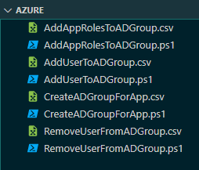

We’ll further add additional validation checks on these scripts to avoid duplicate role assignment/ duplicate group creation. But as of now, these can be reviewed for next steps.

1. CreateADGroupsForApp –

Input: A CSV file with all the group names.

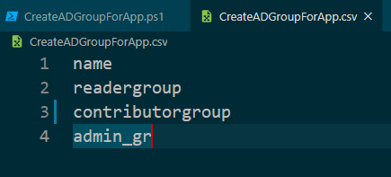

Script:

1. Loops through each line.
2. Checks if the group name exists and ignore if it does
3. If doesn’t exist, creates an AD group and output

Output:

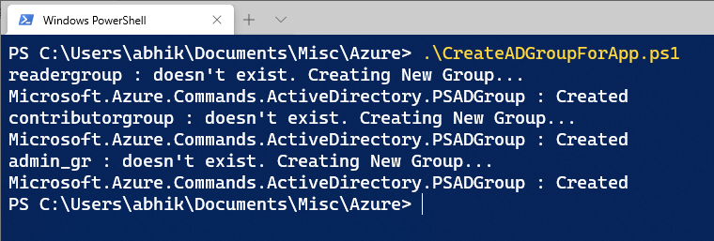

1. AddAppRoleToADGroup –

Input: A CSV file with all the group names, app name and role types

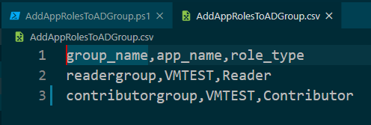

Script:

1. Loops through each line
2. Checks if the Group exists. If not, moves to the next line
3. Checks if the App exists. If it does, determines app type. If doesn’t exist, it moves to the next line
4. Applies the role to the AD group for the app

Output:

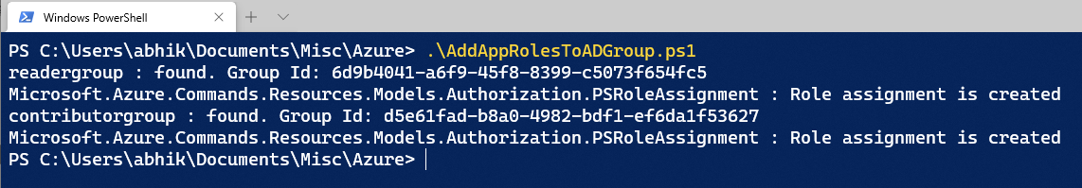

1. AddUserToADGroup –

Input: A CSV file with all the group names and user name

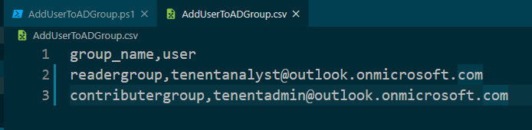

Script:

1. Loops through each line
2. Checks if the Group exists. If not, moves to the next line
3. Checks if the User exists. If doesn’t exist, it moves to the next line
4. Adds the AD user to the AD group

Output:

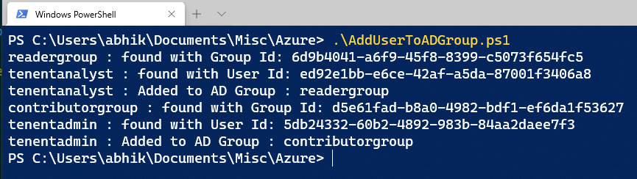

1. RemoveUserFromADGroup –

Input: A CSV file with all the group names and user name

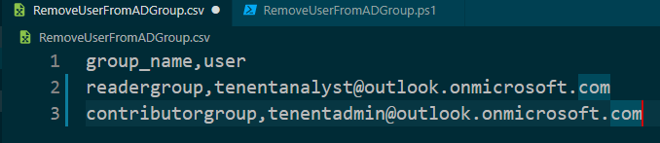

Script:

1. Loops through each line
2. Checks if the Group exists. If not, moves to the next line
3. Checks if the User exists. If doesn’t exist, it moves to the next line
4. Removes the AD user to the AD group

Output:

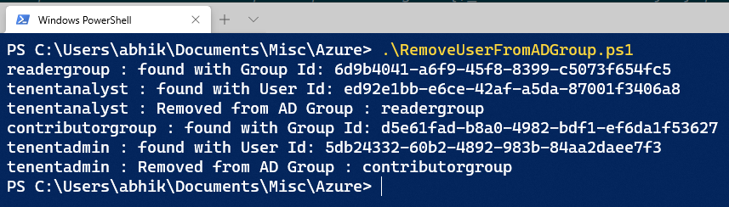

## Azure Runbooks

As mentioned earlier, these scripts can be converted to Azure Runbooks:

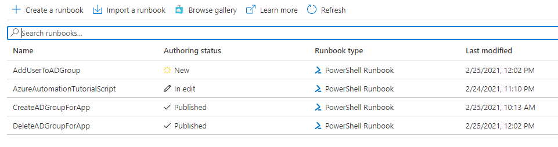

I created couple of them for reference.

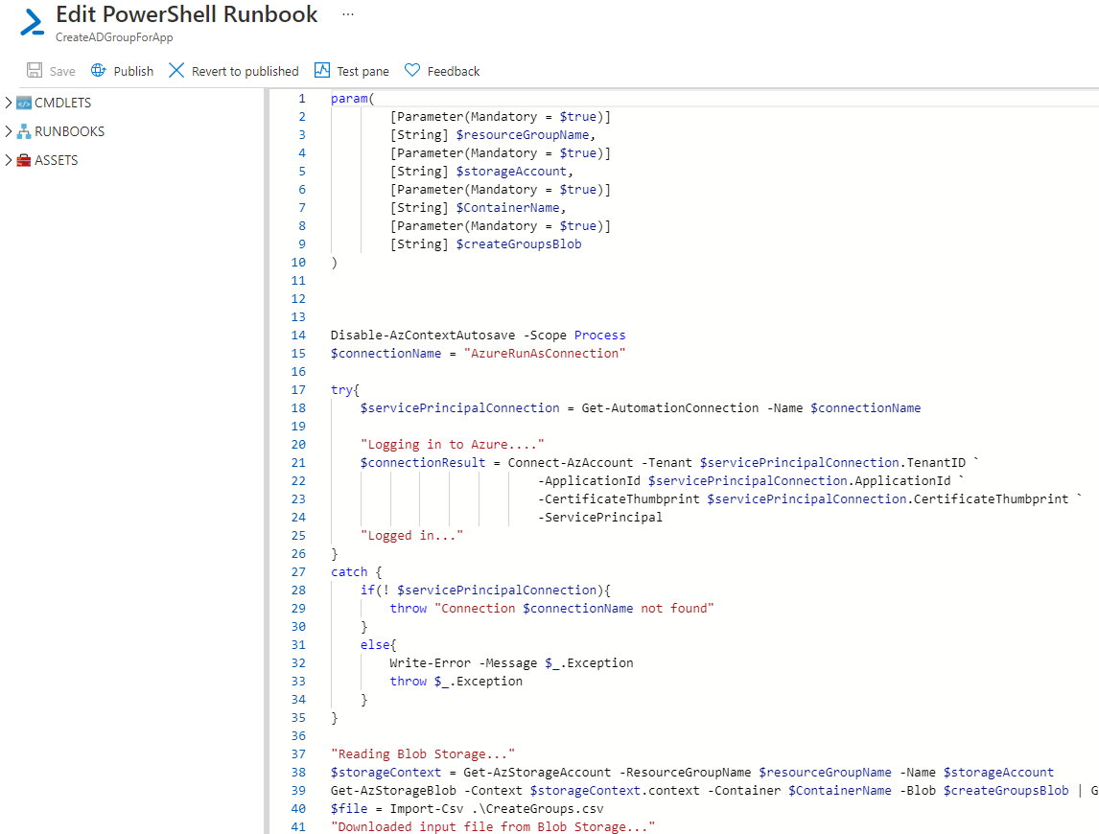

The input CSV files can be uploaded to a Blob Storage Container and the container details can be passed as parameters to the runbooks:

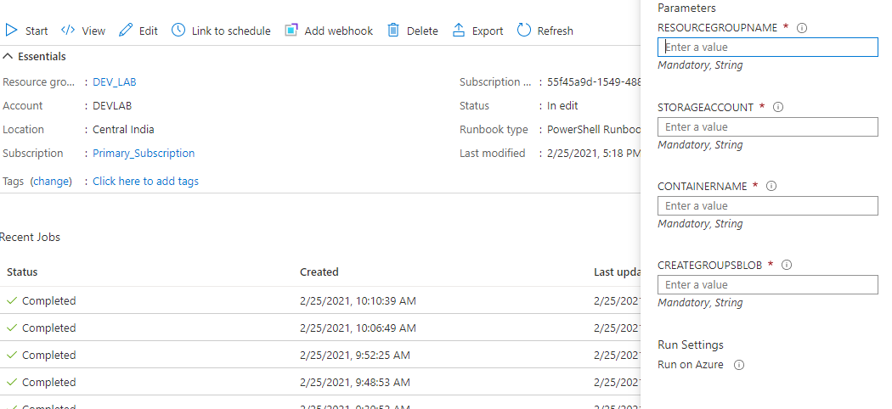

Output Logs:

