Development and Experimental Applications of a Direct Digital Synthesis (DDS)-Based Signal Generation Platform
(A Low-Cost RF Signal Generator and Antenna Analyser Using Arduino Uno and AD9850)

Mini Project Report Submitted in partial fulfilment of the requirements for the award of the degree of Bachelor of Technology from Maulana Abul Kalam Azad University of Technology, West Bengal (formerly known as West Bengal University of Technology)
In
Electronics and Communication Engineering

By
- ADRIPTA GHOSH (Roll No.- 34900323001)
- ANUSHKA ROY (Roll No.- 34900323004)
- ARIJIT MANNA (Roll No.- 34900323006)
- ARYA GHOSH (Roll No.- 34900323008)
- SWASTIK BAL (Roll No.- 34900323054)

Under the Guidance of
Project Supervisor/(s): Dr. Sourav Chakraborty
Technical Facilitator: Mr. Abhijit Sarma

Department of Electronics and Communication Engineering
Cooch Behar Government Engineering College
Cooch Behar, West Bengal
2026
ACKNOWLEDGEMENT

We express our sincere gratitude to the Department of Electronics and Communication Engineering, Cooch Behar Government Engineering College, for providing us with the opportunity to undertake this mini project.
We are deeply grateful to our project guide, Dr. SOURAV CHAKRABORTY, for his valuable guidance, continuous encouragement, constructive suggestions, and constant support throughout the course of this project. His technical knowledge and motivation greatly contributed to the successful completion of this work.
We also extend our heartfelt thanks to the Head of the Department and all the faculty members of the Department of Electronics and Communication Engineering for their encouragement and support.
We sincerely acknowledge our friends and classmates for their valuable suggestions and cooperation during the development and testing of the project.
Finally, we express our deepest gratitude to our parents and family members for their constant encouragement, moral support, and inspiration throughout our academic journey.

Project Members

Roll No. | Name | Signature
34900323001 | ADRIPTA GHOSH | --------------------------------------------
34900323004 | ANUSHKA ROY | --------------------------------------------
34900323006 | ARIJIT MANNA | --------------------------------------------
34900323008 | ARYA GHOSH | --------------------------------------------
34900323054 | SWASTIK BAL | --------------------------------------------

CONTENTS
Contents
List of Principal Symbols and Acronyms v
Principal Symbols v
Acronyms vi
List of Figures vii
List of Tables viii
ABSTRACT x
CHAPTER 1 11
Introduction 11
1.1 Background 11
1.2 Problem Statement 11
1.3 Objectives 12
1.4 Scope of the Project 12
CHAPTER 2 13
Theory of Direct Digital Synthesis (DDS) 13
2.1 Introduction to Direct Digital Synthesis (DDS) 13
Why Direct Digital Synthesis (DDS)? 13
Why DDS was selected for this project? 13
Why AD9850? 14
Key Specifications of AD9850: 14
Design of a Low-Cost DDS Platform 14
2.2 Working Principle of DDS 16
2.3 DDS Architecture 17
2.4 Frequency Tuning Equation 17
2.5 Advantages and Limitations of DDS 19
2.6 AD9850 DDS Module 19
Features 20
Functional Block Diagram of AD9850 20
Pin Configuration of AD9850 20
Pin Configuration Diagram: 21
Programming Interface 21
2.7 Applications of AD9850 22
1. Basic AD9850 Clock Generator Application with Low-Pass Filter 22
2. AD9850 Clock Generator Application in a Spread-Spectrum Receiver 22
3. AD9850 Complete DDS Synthesizer in Frequency Up-Conversion 23
3a. Frequency/Phase–Agile Local Oscillator 23
3b. Frequency/Phase–Agile Reference for PLL 24
3c. Digitally-Programmable Divide-by-N Function in PLL 25
CHAPTER 3 27
Application I 27
DDS-Based Digital Communication (Proposed System) 27
3.1 Introduction 27
3.2 Proposed Communication System 27
3.3 Binary Phase Shift Keying (BPSK) 27
3.4 Quadrature Phase Shift Keying (QPSK) 28
3.5 I-Q Carrier Generation 29
3.6 Proposed Simulation Results 29
3.7 Future Implementation 30
CHAPTER 4 32
Application II 32
Antenna Analyser Using AD9850 and Arduino 32
4.1 Introduction: 32
4.2 Objectives: 32
4.3 Theory: 32
4.3.1 Antenna Resonance: 32
4.3.2 Standing Wave Ratio (SWR): 33
4.3.3 Direct Digital Synthesis (DDS): 33
4.3.4 RF Bridge Principle: 33
4.3.5 Diode Detector: 33
4.4 Components Required: 34
4.5 Block Diagram: 34
4.6 Circuit Description: 34
4.7 Connections: 35
4.7.1 AD9850 to Arduino 35
4.7.2 RF Bridge: 35
4.7.3 Diode Detector: 35
4.7.4 Implemented Circuit: 35
4.8 Arduino Program 36
4.9 Python Visualization 36
4.10 Working Principle 37
4.11 Observations 37
4.12 Advantages 37
4.13 Limitations 38
4.14 Applications 38
4.15 Result 38
4.16 Conclusion 38
CHAPTER 5 39
Application III 39
DDS-Based RF Component Analyser (RLC Components) 39
5.1 Introduction: 39
5.2 Objectives 39
5.3 Working Principle 39
5.4 Hardware Components 39
5.5 Block Diagram & Implemented Circuit 40
5.6 Experimental Procedure 40
5.7 Results 40
5.8 Applications 41
5.9 Advantages 41
5.10 Limitations 41
CHAPTER 6 42
Comparison Or Performance Analysis 42
6.1 Comparison Table: 42
6.2 Performance Analysis of the Proposed DDS-Based RF Platform 42
6.2.1 Technical Advantages of DDS-Based Signal Generation 42
6.2.2 Advantages for Digital Communication Systems 43
6.2.3 Current Limitations 43
CHAPTER 7 44
Future Scope 44
7.1 DDS-Based Digital Communication 44
7.2 Software Defined Radio Integration 44
7.3 Advanced RF Measurement 44
7.4 Portable RF Instrument 44
7.5 Intelligent Automation 44
CHAPTER 8 45
8.1 Conclusion 45
8.2 References 45
8.2.1 Books 45
8.2.2 Datasheets & Technical Documentation 45
8.2.3 Software Documentation 45
8.2.4 Research & Standards 45

List of Principal Symbols and Acronyms

Principal Symbols
Symbol | Description | Unit
$$f_{out}$$ | Output Frequency | Hz
$$f_{clock}$$ | Reference Clock Frequency | Hz
FTW | Frequency Tuning Word | –
$$N$$ | Number of Bits in Phase Accumulator | –
$$V_{in}$$ | Input Voltage | V
$$V_{out}$$ | Output Voltage | V
$$V_{r}$$ | Reflected Voltage | V
$$P_{f}$$ | Forward Power | W
$$P_{r}$$ | Reflected Power | W
$$Γ$$ | Reflection Coefficient | –
SWR | Standing Wave Ratio | –
RL | Return Loss | dB
$$Z_{L}$$ | Load Impedance | Ω
$$Z_{0}$$ | Characteristic Impedance | Ω
$$R$$ | Resistance | Ω
$$X$$ | Reactance | Ω
$$Z$$ | Impedance | Ω
$$I$$ | In-phase Component | –
$$Q$$ | Quadrature Component | –
$$A$$ | Signal Amplitude | V
$$t$$ | Time | s
$$ω$$ | Angular Frequency | rad/s
$$ϕ$$ | Phase Angle | Degree (°) or Radian

Acronyms
Acronym | Full Form
ADC | Analog-to-Digital Converter
AD9850 | Direct Digital Synthesis Integrated Circuit by Analog Devices
AUT | Antenna Under Test
BER | Bit Error Rate
BPSK | Binary Phase Shift Keying
DAC | Digital-to-Analog Converter
DDS | Direct Digital Synthesis
DSP | Digital Signal Processing
FTW | Frequency Tuning Word
GPIO | General Purpose Input/Output
IF | Intermediate Frequency
IQ | In-phase and Quadrature
LO | Local Oscillator
LPF | Low-Pass Filter
MCU | Microcontroller Unit
PCB | Printed Circuit Board
PLL | Phase-Locked Loop
PSD | Power Spectral Density
PSK | Phase Shift Keying
Python | High-Level Programming Language
QPSK | Quadrature Phase Shift Keying
RF | Radio Frequency
ROM | Read-Only Memory
SDR | Software Defined Radio
SMA | Sub Miniature Version A Connector
SNR | Signal-to-Noise Ratio
SPI | Serial Peripheral Interface
SWR | Standing Wave Ratio
UART | Universal Asynchronous Receiver-Transmitter
USB | Universal Serial Bus
VCO | Voltage-Controlled Oscillator
VNA | Vector Network Analyser

List of Figures
Figure No. | Title | Page No.
Figure 2.1 | Generated a 500 Hz Sinusoidal Signal using Python GUI | 16
Figure 2.2 | Basic Architecture of Direct Digital Synthesis (DDS) | 19
Figure 2.3 | Functional Block Diagram of the AD9850 DDS Synthesizer | 22
Figure 2.4 | Pin Configuration of the AD9850 | 23
Figure 2.5 | Basic AD9850 Clock Generator with Low-Pass Filter | 24
Figure 2.6 | AD9850 Clock Generator in a Spread Spectrum Receiver | 24
Figure 2.7 | Frequency/Phase Agile Local Oscillator | 26
Figure 2.8 | Frequency/Phase–Agile Reference for PLL | 27
Figure 2.9 | Digitally Programmable Divide-by-N Function in PLL | 28
Figure 3.1 | System Architecture of an Arduino-Based BPSK/QPSK RF Transmitter | 29
Figure 3.2 | Block Diagram of BPSK Modulator | 30
Figure 3.3 | Block Diagram of QPSK Modulator | 31
Figure 3.4 | QPSK Constellation Diagram | 32
Figure 4.1 | Antenna Analyser Block Diagram using AD9850 DDS Module | 36
Figure 4.2 | RF Bridge Circuit | 37
Figure 4.3 | RF Diode Detector Circuit | 37
Figure 4.4 | Practical Hardware implementation of Antenna Analyser | 38
Figure 4.5 | Antenna response graph(for 1MHz step response & step size of 500KHz) | 39
Figure 4.6 | Graph at the end of accumulation | 39
Figure 5.1 | Block Diagram & Implemented Circuit DDS-Based RF Component Analyser (RLC Components) | 43
Figure 5.2 | 220Ω Relative RF amplitude vs frequency graph | 44

List of Tables

Table No. | Title | Page No.
Table 2.1 | Key Specifications of AD9850 | 15
Table 2.2 | Pin Configuration of AD9850 | 22-23
Table 4.1 | Components required for Antenna Analyser using AD9850 & Arduino | 36
Table 4.2 | Connection pins from AD9850 to Arduino | 37
Table 5.1 | Function of Hardware Components used in DDS-Based RF Component Analyser (RLC Components) | 42
Table 6.1 | Performance comparison between Commercial RF instruments & Proposed DDS-Based Platform | 45

ABSTRACT

Accurate RF signal generation and antenna characterization are essential in modern wireless communication systems. However, commercial RF signal generators, and antenna analysers, are often expensive, making them less accessible for educational and research laboratories. This project presents the development of a low-cost Direct Digital Synthesis (DDS)-based signal generation platform using an Arduino Uno and an AD9850 DDS module for RF signal generation and experimental measurement applications.
The Arduino Uno controls the AD9850 DDS module to generate programmable RF signals over a specified frequency range. These signals are applied to an Antenna Under Test (AUT), where reflected signals caused by impedance mismatches are detected using an RF detector circuit. The Arduino acquires the detector output through its Analog-to-Digital Converter (ADC) and transmits the measured data to a computer via serial communication. A Python-based application processes the data to calculate the reflection coefficient and Standing Wave Ratio (SWR), and visualizes the results using the Matplotlib library.
In addition to antenna analysis, the proposed platform provides a foundation for a low-cost RLC impedance analyser capable of measuring resistance (R), inductance (L), capacitance (C), and impedance (Z), as well as analyzing the frequency response of RLC circuits. Furthermore, the system is designed to support future implementation of DDS-based digital communication techniques such as Binary Phase Shift Keying (BPSK) and Quadrature Phase Shift Keying (QPSK).
The developed platform demonstrates a practical integration of RF signal generation, embedded systems, and software-based data analysis into a compact, programmable, and economical solution suitable for communication engineering education, laboratory experimentation, and future research.
Keywords: Direct Digital Synthesis (DDS), AD9850, Arduino Uno, RF Signal Generator, Antenna Analyser, Reflection Coefficient, Standing Wave Ratio (SWR), Python, Matplotlib, Embedded Systems.

CHAPTER 1

Introduction
The rapid advancement of wireless communication and embedded systems has significantly increased the demand for accurate, programmable, and cost-effective RF signal generation and measurement systems. In communication engineering, RF signal generators are essential for testing electronic circuits, characterizing antennas, evaluating RF components, and conducting laboratory experiments. However, commercial RF signal generators, antenna analysers, and vector network analysers (VNAs) are often expensive and therefore inaccessible to many educational institutions, students, and hobbyists.
Direct Digital Synthesis (DDS) is a modern frequency generation technique that enables precise control of frequency and phase using digital methods. Compared to conventional analog oscillators, DDS provides superior frequency resolution, excellent stability, rapid frequency switching, and software programmability. The availability of low-cost DDS integrated circuits, such as the AD9850, has made it possible to develop compact and affordable RF signal generation platforms suitable for academic and research applications.
This project presents the design and development of a DDS-based RF signal generation platform using an Arduino Uno and the AD9850 DDS module. The developed platform is capable of generating programmable RF signals for experimental applications. One of its primary applications is antenna characterization, where the generated RF signal is applied to an antenna under test (AUT). The reflected signal is detected using an RF detector circuit, and the measured data are processed by the Arduino and transferred to a computer. A Python-based application calculates the reflection coefficient and Standing Wave Ratio (SWR), and visualizes the results using graphical plots.
In addition to antenna analysis, the proposed platform serves as a foundation for future implementation of DDS-based digital communication systems such as Binary Phase Shift Keying (BPSK) and Quadrature Phase Shift Keying (QPSK), as well as impedance measurement of RLC circuits. Thus, the developed system demonstrates the versatility of DDS technology in RF signal generation, measurement, and communication engineering.

1.1 Background
Modern electronic and communication systems rely heavily on precise signal generation and measurement. RF signal generators are indispensable tools for testing antennas, communication circuits, filters, amplifiers, and other RF components. Similarly, antenna analysers are widely used to evaluate antenna characteristics such as impedance matching, reflection coefficient, return loss, and Standing Wave Ratio (SWR).
Although commercial RF instruments provide excellent performance, their high cost makes them unsuitable for many educational laboratories and individual researchers. This limitation has encouraged the development of low-cost alternatives using embedded systems and digital signal processing techniques.
Direct Digital Synthesis (DDS) has emerged as an efficient method for generating stable and programmable RF signals. Devices such as the AD9850 integrate a DDS core, a high-speed Digital-to-Analog Converter (DAC), and digital control circuitry into a single chip, allowing accurate frequency generation with minimal external hardware. Combined with microcontrollers such as the Arduino Uno, DDS technology provides a flexible platform for implementing various RF applications at significantly lower cost.

1.2 Problem Statement
Commercial RF signal generators and antenna analysers provide high accuracy and wide measurement capabilities but are expensive and often unavailable in academic laboratories. Consequently, students and researchers face difficulties in conducting practical RF experiments and antenna characterization.
There is a need for a compact, programmable, and low-cost RF signal generation platform that can generate stable RF signals, perform basic antenna analysis, and provide software-based visualization of measurement results.
The project addresses this challenge by developing a DDS-based RF signal generation system using the AD9850 DDS module and Arduino Uno. The generated RF signal is used to characterize antennas by measuring reflected signals, calculating the reflection coefficient and SWR, and displaying the results using Python-based graphical visualization. The same hardware platform also serves as a foundation for future digital communication applications.

1.3 Objectives

The primary objectives of this project are:
- To design and develop a low-cost DDS-based RF signal generation platform.
- To interface the AD9850 DDS module with an Arduino Uno for programmable frequency generation.
- To generate stable RF signals over a configurable frequency range.
- To develop an RF detection circuit for measuring reflected signals from an antenna under test.
- To acquire measurement data using the Arduino's Analog-to-Digital Converter (ADC).
- To implement Python-based software for calculating the reflection coefficient and Standing Wave Ratio (SWR)of a wired antenna.
- To visualize SWR characteristics using Matplotlib.
- To evaluate the feasibility of using DDS technology for antenna analysis.
- To establish a hardware platform suitable for future implementation of DDS-based BPSK and QPSK communication systems.
- To measure the impedance, resistance (R), inductance (L), and capacitance (C) of electronic components.
- To analyse the frequency response and electrical characteristics of RLC circuits.

1.4 Scope of the Project
The scope of this project includes the design, implementation, and evaluation of a DDS-based RF signal generation platform for educational and laboratory applications.
The developed system focuses on generating programmable RF signals using the AD9850 DDS module under the control of an Arduino Uno. The platform supports antenna characterization by measuring reflected RF signals, estimating the reflection coefficient, calculating Standing Wave Ratio (SWR), and displaying the results through a Python-based graphical interface.
The project also investigates the potential applications of the developed DDS platform in digital communication systems and impedance measurement. Although hardware implementation of BPSK, QPSK, and RLC impedance analysis is beyond the scope of the present work, the proposed system architecture has been designed to support these applications in future developments. The platform is intended primarily for educational laboratories, embedded system research, communication engineering experiments, and low-cost RF testing.

CHAPTER 2

Theory of Direct Digital Synthesis (DDS)

2.1 Introduction to Direct Digital Synthesis (DDS)
Direct Digital Synthesis (DDS) is a digital frequency generation technique used to produce stable, accurate, and programmable periodic waveforms such as sine, square, triangular, and cosine waves. Unlike conventional analog oscillators, DDS generates waveforms mathematically using digital circuits. The generated digital waveform is then converted into an analog signal using a high-speed Digital-to-Analog Converter (DAC).
DDS technology offers high frequency resolution, excellent frequency stability, rapid frequency switching, and digital programmability, making it widely used in communication systems, signal generators, instrumentation, radar systems, software-defined radio (SDR), and antenna measurement equipment.
The AD9850 is a complete DDS synthesizer that integrates the DDS core, a 32-bit phase accumulator, a high-speed 10-bit DAC, and a high-speed comparator into a single integrated circuit, allowing accurate frequency synthesis with minimal external components.

Why Direct Digital Synthesis (DDS)?
Direct Digital Synthesis (DDS) is a modern technique used to generate precise waveforms digitally. Unlike conventional signal generators that rely on analog oscillators and passive components, DDS uses digital circuitry to synthesize waveforms with high frequency accuracy and stability. The generated digital waveform is converted into an analog signal using a Digital-to-Analog Converter (DAC).
DDS technology has become popular in communication systems, instrumentation, laboratories, and educational platforms because it provides accurate frequency generation while reducing circuit complexity.
Advantages of DDS
- High frequency resolution with very small tuning steps.
- Excellent frequency stability because the output depends on a crystal reference clock.
- Fast frequency switching within microseconds.
- Digital control through a microcontroller.
- Ability to generate sine, square, and other waveforms.
- Low power consumption.
- Compact design with fewer external components.
- Cost-effective compared to analog function generators.

Why DDS was selected for this project?
For this project, DDS technology was selected because it enables the Arduino Uno to generate accurate and programmable signals over a wide frequency range. It is ideal for laboratory experiments, embedded system education, communication experiments, and testing electronic circuits while maintaining low implementation cost.

Why AD9850?
The AD9850 is one of the most widely used DDS integrated circuits developed by Analog Devices. It combines a complete DDS core, a high-speed 10-bit DAC, and a high-speed comparator on a single chip, making it suitable for low-cost signal generator applications.
The AD9850 receives a digital frequency tuning word from the Arduino Uno through a serial interface. Internally, it calculates the required waveform digitally and converts it into an analog sine wave using its built-in DAC. The module can also provide a square-wave output using its internal comparator.
Reasons for selecting AD9850
- Maximum reference clock up to 125 MHz.
- 32-bit frequency tuning word provides extremely fine frequency resolution (approximately 0.029 Hz with a 125 MHz reference clock).
- Generates sine-wave outputs up to approximately 62.5 MHz.
- Built-in 10-bit Digital-to-Analog Converter (DAC).
- High spectral purity with good Spurious-Free Dynamic Range (SFDR).
- Supports both serial and parallel programming.
- Compatible with 5 V Arduino Uno logic.
- Low power consumption.
- Easily available as inexpensive DDS modules.
- Large community support and Arduino libraries simplify development.

Key Specifications of AD9850:
Parameter | Value
Maximum Clock Frequency | 125 MHz
Frequency Tuning Word | 32-bit
DAC Resolution | 10-bit
Supply Voltage | 3.3 V / 5 V
Maximum Analog Output | ≈62.5 MHz
Communication Interface | Serial / Parallel
Output Types | Sine Wave and Square Wave

Design of a Low-Cost DDS Platform
The objective of this project is to develop a compact and inexpensive programmable signal generator using an Arduino Uno and the AD9850 DDS module. The Arduino Uno serves as the controller, while the AD9850 performs waveform synthesis.
The user selects the desired output frequency through the Arduino program. The Arduino calculates the corresponding 32-bit frequency tuning word and sends it to the AD9850 through serial communication. The AD9850 processes this digital data and generates the required analog sine wave. If required, the onboard comparator can also provide a square-wave output.
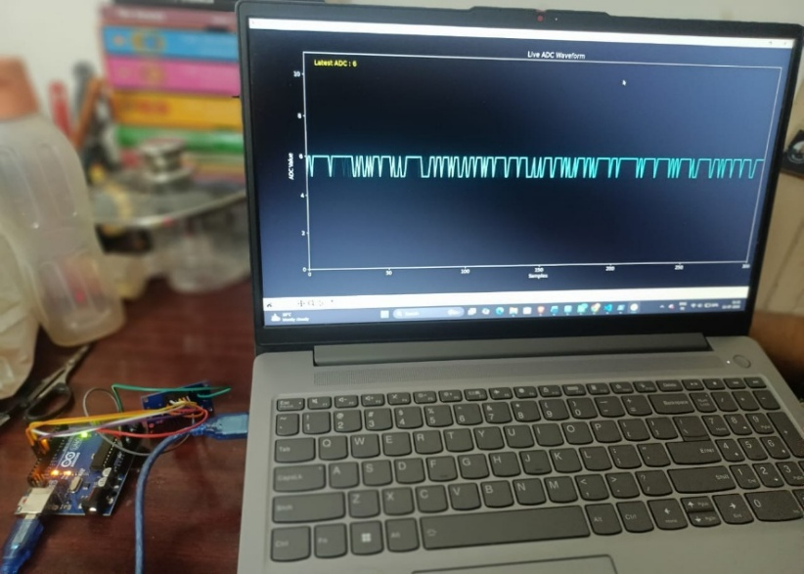
Figure 2.1 Generated a 500 Hz Sinusoidal Signal using Python GUI

Hardware Components
- Arduino Uno
- AD9850 DDS Module
- 16×2 LCD (optional)
- Rotary Encoder or Push Buttons (optional)
- Power Supply (5 V)
- Connecting wires
- Breadboard or PCB

Working Principle
- Arduino Uno initializes the AD9850.
- User enters or selects the desired frequency.
- Arduino computes the 32-bit tuning word using
$$\text{Frequency Tuning Word}=\frac{f_{out}×2^{32}}{f_{clock}}$$
where:
- $f_{out}$= Desired output frequency
- $f_{clock}$= Reference clock frequency (125 MHz)
This is the standard frequency relationship specified for the AD9850 DDS architecture.
- Arduino transfers the tuning word serially to the AD9850.
- AD9850 synthesizes the waveform digitally.
- The internal DAC converts the digital waveform into an analog sine wave.
- The output signal is available for testing electronic circuits or laboratory experiments.

Advantages of the Proposed Platform
- Very low development cost.
- Easy to build and program.
- Portable and compact.
- High frequency accuracy.
- Wide frequency generation range.
- Suitable for educational laboratories.
- Useful for communication and electronics experiments.
- Easily expandable by adding an LCD display, keypad, rotary encoder, Bluetooth, or Wi-Fi.

Applications
- Function generator
- Signal generator for laboratories
- Communication system experiments
- Filter testing
- Oscilloscope calibration
- Frequency response measurements
- Embedded systems education
- Electronics project development

2.2 Working Principle of DDS
The fundamental principle of DDS is digital phase accumulation.
A highly stable reference clock continuously increments a digital phase accumulator. The phase information is converted into amplitude values through a sine lookup algorithm (or ROM lookup table). These amplitude values are then converted into an analog voltage using a Digital-to-Analog Converter (DAC). Finally, a low-pass filter removes unwanted high-frequency components, producing a clean analog sine wave.
Since waveform generation is entirely digital, changing the output frequency simply requires changing the digital frequency tuning word instead of modifying analog components.
The output frequency is determined by
$$f_{out}=\frac{ΔPhase×f_{clock}}{2^{32}}$$
where
- $f_{out}$= Output frequency
- $f_{clock}$= Reference clock frequency
- $ΔPhase$= 32-bit Frequency Tuning Word
With a 125 MHz reference clock, the AD9850 achieves a theoretical frequency resolution of approximately 0.029 Hz.
- Working of DDS
The operation of the DDS synthesizer can be explained in the following steps.
Step 1: Reference Clock
A stable reference clock (typically 125 MHz) is supplied to the AD9850. This clock determines the timing accuracy of waveform generation.
Step 2: Frequency Tuning Word
The desired output frequency is converted into a 32-bit Frequency Tuning Word (FTW).
The Arduino Uno calculates this tuning word and transfers it to the AD9850 using serial communication.
Step 3: Phase Accumulator
During every reference clock pulse, the phase accumulator adds the tuning word to its previous value.
The accumulator continuously overflows and wraps around after reaching its maximum value, creating a continuously increasing digital phase.
The larger the tuning word, the faster the phase accumulator overflows, producing a higher output frequency.
Step 4: Phase-to-Amplitude Conversion
The phase value is converted into corresponding sine amplitude values using an internal mathematical algorithm and lookup table.
Instead of storing every sine value, the AD9850 uses a proprietary algorithm that minimizes memory usage while maintaining high accuracy.
Step 5: Digital-to-Analog Conversion
The internal 10-bit DAC converts the digital amplitude samples into analog current.
The DAC output contains the desired sine wave together with sampling images.
Step 6: Low-Pass Filtering
An external low-pass filter removes unwanted harmonic and image frequencies produced during digital sampling.
The filtered output becomes a clean analog sine wave.
Step 7: Comparator Output
The AD9850 also includes a high-speed comparator.
By feeding the filtered sine wave into the comparator, a low-jitter square wave can also be generated.
This feature allows the AD9850 to function as both
- RF Signal Generator
- Clock Generator

2.3 DDS Architecture
The AD9850 DDS consists of the following major functional blocks:
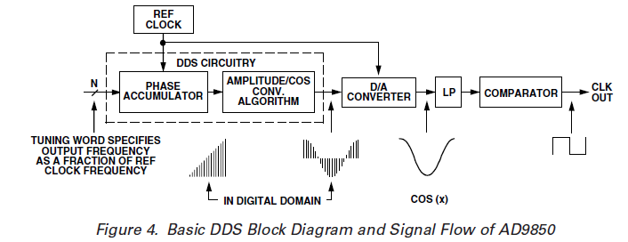
Figure 2.2 | Basic Architecture of Direct Digital Synthesis (DDS)

This architecture follows the operational principle described in the AD9850 datasheet.

2.4 Frequency Tuning Equation
One of the most significant advantages of Direct Digital Synthesis (DDS) is its ability to generate output frequencies with extremely fine resolution. The output frequency is determined by a Frequency Tuning Word (FTW), which is loaded into the phase accumulator. During every clock cycle, the FTW is added to the accumulator, causing the phase to increase linearly with time. The rate of phase accumulation determines the frequency of the generated waveform.
The output frequency of a DDS synthesizer is given by
$$f_{out}=\frac{FTW×f_{clock}}{2^{N}}$$
where:
- $f_{out}$= Output frequency (Hz)
- $FTW$= Frequency Tuning Word
- $f_{clock}$= Reference clock frequency (Hz)
- $N$= Number of bits in the phase accumulator
For the AD9850 DDS synthesizer:
- Reference clock frequency = 125 MHz
- Phase accumulator = 32 bits
Therefore,
$$f_{out}=\frac{FTW×125×{10}^{6}}{2^{32}}$$
The required Frequency Tuning Word is obtained from
$$FTW=\frac{f_{out}×2^{32}}{f_{clock}}$$
This equation is used by the Arduino Uno in the proposed system. The Arduino calculates the tuning word corresponding to the desired RF frequency and transfers it serially to the AD9850. The DDS then generates the programmed output frequency with high precision.
Example
Suppose the desired output frequency is
$$f_{out}=10 MHz$$
Using a reference clock of
$$f_{clock}=125 MHz$$
the tuning word becomes
$$FTW=\frac{10×{10}^{6}×2^{32}}{125×{10}^{6}} \\ FTW≈343597384$$
The Arduino transmits this 32-bit value to the AD9850, which produces a 10 MHz output signal.
Frequency Resolution
The minimum frequency increment, known as the frequency resolution, is
$$Δf=\frac{f_{clock}}{2^{32}}$$
For a 125 MHz reference clock,
$$Δf≈0.0291 Hz$$
This extremely fine frequency resolution enables highly accurate signal generation and is one of the major advantages of DDS technology.

2.5 Advantages and Limitations of DDS
Advantages
Direct Digital Synthesis offers numerous advantages over conventional analog frequency generation techniques.
- High Frequency Resolution: DDS provides extremely fine frequency resolution because the output frequency is digitally controlled using a 32-bit tuning word. The AD9850 achieves a theoretical resolution of approximately 0.029 Hz with a 125 MHz reference clock.
- Excellent Frequency Stability: Since the output frequency is derived directly from a stable crystal reference clock, the generated signal exhibits excellent long-term stability and repeatability.
- Rapid Frequency Switching: Changing the output frequency requires only updating the frequency tuning word. This allows the DDS to switch frequencies within a few clock cycles, making it suitable for agile communication systems.
- Digital Programmability: The output frequency and phase can be controlled entirely through software using a microcontroller, eliminating the need for adjustable analog components.
- Phase Continuity: DDS maintains continuous phase during frequency changes, minimizing phase discontinuities and reducing transient effects.
- Compact Design: Modern DDS ICs integrate the phase accumulator, waveform generator, DAC, and control circuitry into a single chip, reducing hardware complexity.
- Low Power Consumption: Compared to traditional analog frequency synthesizers, DDS devices require relatively low power while providing high performance.
- Cost Effectiveness: DDS modules such as the AD9850 are inexpensive and widely available, making them ideal for educational laboratories and low-cost instrumentation.

Limitations
Despite its advantages, DDS technology has certain limitations.
- Limited Output Frequency: The maximum usable output frequency is generally limited to approximately half of the reference clock frequency due to the Nyquist sampling criterion.
- Spurious Signals: Finite DAC resolution and digital quantization introduce unwanted spectral components known as spurious signals (spurs), which may affect spectral purity.
- Harmonic Generation: The DAC output contains harmonic components and sampling images that must be removed using an external low-pass filter.
- Dependence on Reference Clock: The frequency accuracy and phase noise of the DDS output are directly influenced by the quality of the reference clock source.
- DAC Resolution Constraints: The finite resolution of the DAC limits the achievable dynamic range and signal purity.
- High-Frequency PCB Design: Operation at RF frequencies requires careful PCB layout, impedance matching, proper grounding, and shielding to minimize noise and signal degradation.

2.6 AD9850 DDS Module
Introduction
The AD9850 is a complete Direct Digital Synthesis (DDS) integrated circuit developed by Analog Devices. It combines a high-speed DDS core, a 32-bit phase accumulator, a 10-bit Digital-to-Analog Converter (DAC), and a high-speed comparator into a single chip. The device is capable of generating stable and programmable sine-wave and square-wave outputs over a wide frequency range.
The AD9850 is widely used in RF signal generators, function generators, communication systems, software-defined radio (SDR), phase-locked loops (PLL), antenna analysers, and educational laboratories due to its high performance, low cost, and ease of interfacing with microcontrollers such as the Arduino Uno.

Features
The major features of the AD9850 are listed below:
- 125 MHz maximum reference clock frequency
- 32-bit frequency tuning word
- 10-bit high-speed Digital-to-Analog Converter (DAC)
- Frequency resolution of approximately 0.029 Hz
- Output frequency up to approximately 62.5 MHz
- High-speed comparator for square-wave generation
- Serial and parallel programming interfaces
- Fast frequency switching capability
- Phase modulation support
- Low power consumption
- High spectral purity
- Compact 28-pin SSOP package
- Compatible with both 3.3 V and 5 V systems
These features make the AD9850 suitable for precision RF signal generation and communication applications.

Functional Block Diagram of AD9850
The simplified internal architecture of the AD9850 is shown below.
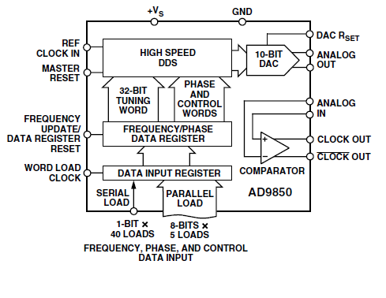
Figure 2.3 | Functional Block Diagram of the AD9850 DDS Synthesizer

This architecture corresponds to the functional block diagram described in the AD9850 datasheet.

Pin Configuration of AD9850
The AD9850 is available in a 28-pin SSOP package and contains separate analog and digital sections for improved performance.
Important Pins
Pin | Name | Function
D0–D7 | Data Bus | Frequency and control word input
W_CLK | Word Clock | Loads serial/parallel data
FQ_UD | Frequency Update | Updates output frequency
CLKIN | Reference Clock | Clock input (up to 125 MHz)
RESET | Reset | Initializes the DDS registers
IOUT | DAC Output | Analog sine-wave output
IOUTB | Complement DAC Output | Complementary analog output
VINP | Comparator Input (+) | Positive comparator input
VINN | Comparator Input (−) | Negative comparator input
QOUT | Comparator Output | Square-wave output
QOUTB | Complement Comparator Output | Complementary square-wave output
RSET | DAC Current Set | Sets full-scale DAC current
AVDD | Analog Supply | Analog power supply
DVDD | Digital Supply | Digital power supply
AGND | Analog Ground | Analog ground
DGND | Digital Ground | Digital ground

Pin Configuration Diagram:
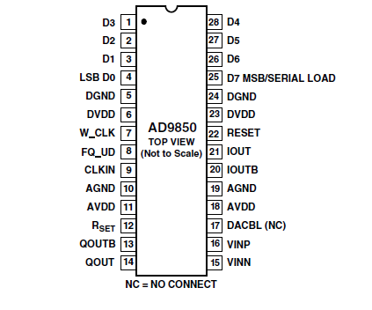
Figure 2.4 Pin Configuration of the AD9850

Programming Interface
The AD9850 supports both parallel and serial programming. In this project, serial programming is employed because it requires fewer microcontroller pins and simplifies hardware design.
The programming sequence is as follows:
- The Arduino calculates the 32-bit Frequency Tuning Word based on the desired output frequency.
- The tuning word is transmitted serially to the AD9850 using the DATA and W_CLK pins.
- After all bits are transferred, the FQ_UD (Frequency Update) pin is pulsed to load the new frequency into the DDS core.
- If required, the RESET pin initializes the internal registers before programming.
- The AD9850 immediately generates the new output frequency corresponding to the received tuning word.
This serial interface enables rapid and precise frequency updates, making the AD9850 highly suitable for programmable RF signal generation using the Arduino Uno.

2.7 Applications of AD9850

1. Basic AD9850 Clock Generator Application with Low-Pass Filter
This is the simplest and most common application of the AD9850. In this configuration, the AD9850 generates a programmable sine wave using Direct Digital Synthesis (DDS). The output of the internal DAC contains the desired signal along with high-frequency images produced by the sampling process. Therefore, a low-pass filter (LPF) is placed at the output to remove these unwanted harmonics and images, producing a clean sine wave. The filtered signal can also be applied to the internal comparator to generate a low-jitter square wave for clock generation.
Block Diagram:
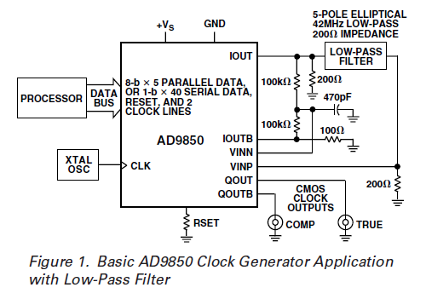
Figure 2.5 Basic AD9850 Clock Generator with Low-Pass Filter

This configuration is suitable for:
- RF signal generators
- Function generators
- Clock generators
- Educational laboratory experiments
Working:
- Reference clock is applied to the AD9850.
- Frequency tuning word is loaded through the serial or parallel interface.
- DDS generates the digital sine wave.
- Internal DAC converts it to an analog signal.
- Low-pass filter removes harmonics.
- Clean sine wave (or square wave through the comparator) is obtained.

2. AD9850 Clock Generator Application in a Spread-Spectrum Receiver
In spread-spectrum communication systems, the receiver requires a highly stable and synchronized clock to correctly recover the transmitted information. In this application, the AD9850 generates the clock signal used by the Analog-to-Digital Converter (ADC) and digital demodulator.
The DDS provides a programmable clock that remains synchronized with the transmitted chip rate or symbol rate. This improves timing accuracy and ensures proper demodulation of the received signal.
Block Diagram:
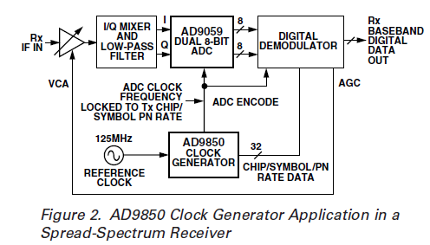
Figure 2.6 AD9850 Clock Generator in a Spread Spectrum Receiver

Applications
- GPS receivers
- CDMA communication
- DSSS communication systems
- Digital wireless receivers
Advantages
- Precise clock generation
- Low jitter
- High synchronization accuracy
- Digital programmability

3. AD9850 Complete DDS Synthesizer in Frequency Up-Conversion
Applications
Frequency up-conversion is a fundamental process in RF communication systems where a low-frequency signal, such as an Intermediate Frequency (IF), is translated to a higher Radio Frequency (RF) suitable for wireless transmission.
In the configurations outlined in the AD9850 datasheet, the device functions as a complete Direct Digital Synthesis (DDS) engine capable of generating a highly stable and programmable Local Oscillator (LO) signal or acting as an agile reference within Phase-Locked Loops (PLLs). The digital control capability of the AD9850 allows for sub-Hertz adjustment of the output frequency and phase, making it highly suitable for modern communication systems.
General Applications
- RF transmitters and transceivers
- Software-Defined Radio (SDR)
- Satellite communication systems
- Signal generators and test equipment
General Advantages
- Accurate and highly stable local oscillator generation
- Wide frequency tuning capability with 32-bit resolution
- Fast, bounce-free digital frequency control
- High spectral purity and low phase noise

3a. Frequency/Phase–Agile Local Oscillator
Introduction
A Local Oscillator (LO) is a signal source used in communication systems to generate a stable reference frequency for frequency conversion (mixing). In this application, the AD9850 DDS synthesizer acts as a frequency/phase-agile LO, meaning its output frequency and phase can be digitally controlled with extreme precision. This makes the AD9850 an excellent replacement for conventional crystal oscillators and analog frequency synthesizers.
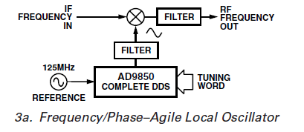
Figure 2.7 Frequency/Phase Agile Local Oscillator

Block Diagram Description
A 125 MHz reference clock and a digital tuning word are fed into the AD9850. The synthesized sine wave is filtered to remove harmonics and fed into an RF mixer. The mixer combines this LO with an incoming IF signal, and the resulting product is passed through a band-pass filter to yield the final RF output.
Working Principle
- A microcontroller (e.g., Arduino) sends a 32-bit frequency tuning word to the AD9850.
- Using a master clock, the AD9850 generates a highly stable RF carrier with the programmed frequency and phase.
- This signal passes through a low-pass filter to remove aliasing and is used as the LO input of an RF mixer.
- The mixer combines the LO signal with the Intermediate Frequency (IF) input signal.
- This mixing process produces new frequencies equal to the sum and difference of the inputs ($f_{RF}=f_{LO}±f_{IF}$).
- A final band-pass filter isolates the desired RF output frequency while suppressing unwanted mixing products and LO feedthrough.
Advantages
- High frequency accuracy and stability.
- Very fine frequency resolution (32-bit tuning).
- Rapid frequency and phase switching capabilities.
- Digital control without requiring hardware modifications.
- Compact, single-chip footprint.
Applications
- Up-conversion stages in RF transmitters.
- Agile radar systems.
- Fast-hopping frequency synthesizers.

3b. Frequency/Phase–Agile Reference for PLL
Introduction
In this configuration, the AD9850 does not generate the final RF frequency directly. Instead, it acts as a programmable reference source for a Phase-Locked Loop (PLL). By replacing a fixed crystal reference with a DDS, the PLL can generate a wide range of RF frequencies while leveraging the rapid digital update rates and fine frequency resolution of the AD9850.
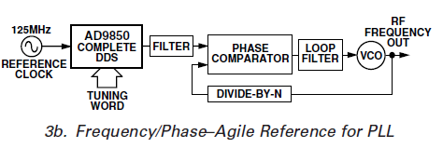
Figure 2.8 Frequency/Phase–Agile Reference for PLL
Block Diagram Description
The AD9850 generates a low-frequency, agile reference signal based on its tuning word. This signal is filtered and applied to the Phase Comparator of a PLL. The comparator drives a Loop Filter and a Voltage-Controlled Oscillator (VCO). A hardware Divide-by-N counter loops the VCO output back to the Phase Comparator.
Working Principle
- The AD9850 receives a reference clock and tuning word to generate a precise, low-frequency reference signal.
- This signal is filtered and applied to one input of the PLL’s phase detector.
- The phase detector compares this DDS-generated reference against a feedback signal coming from the VCO (divided down by an integer $N$).
- Any phase/frequency difference produces an error voltage that passes through the loop filter.
- This filtered voltage steers the VCO to increase or decrease its frequency until the divided feedback exactly matches the DDS reference.
- By changing the DDS tuning word digitally, the reference shifts instantly, forcing the PLL to smoothly lock to a new, multiplied RF output frequency.
Advantages
- Combines DDS fine-tuning resolution with high-frequency PLL output.
- Faster frequency switching compared to traditional fractional-N PLLs.
- High frequency accuracy inherited from the DDS master clock.
- Excellent phase stability.
Applications
- Base station local oscillators.
- High-frequency wireless communication systems.
- Wideband RF transceivers.

3c. Digitally-Programmable Divide-by-N Function in PLL
Introduction
A Phase-Locked Loop (PLL) typically uses a dedicated hardware frequency divider (Divide-by-N) in its feedback loop to determine the output frequency. However, the AD9850 DDS can be integrated directly into the feedback path to perform a highly complex, digitally programmable fractional divide-by-N function. This enables rapid, sub-Hertz frequency control without relying on traditional prescalers or multi-modulus dividers.
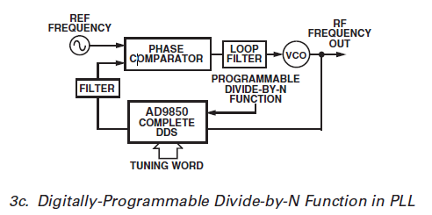
Figure 2.9 Digitally Programmable Divide-by-N Function in PLL

Block Diagram Description
A fixed, stable reference frequency is fed directly to the Phase Comparator. The high-frequency VCO output (RF Frequency Out) acts as the clock input for the AD9850 DDS. The AD9850 scales this frequency down based on its digital tuning word, and this scaled, filtered output is fed into the other side of the Phase Comparator to close the loop.
Working Principle
- A stable, fixed reference frequency is applied directly to the phase detector of the PLL.
- The high-frequency RF output of the VCO is routed into the feedback path and acts as the master clock input for the AD9850 DDS.
- The microcontroller sends a specific tuning word to the AD9850. In this topology, the DDS acts as a programmable frequency translator/divider.
- The AD9850 outputs a synthesized lower frequency ($f_{out}=\frac{f_{VCO}×\text{Tuning Word}}{2^{32}}$).
- This signal is filtered and applied to the feedback input of the phase detector.
- The phase detector compares the fixed reference with the DDS-translated feedback, adjusting the VCO until lock is achieved. Changing the tuning word digitally reprograms the effective division ratio.
Advantages
- Extremely fine frequency resolution (sub-Hertz steps at RF frequencies).
- Eliminates the need for complex, physical fractional-N divider hardware.
- Maintains the low phase noise characteristic of the stable master reference.
- Highly agile frequency shifting purely through software.
Applications
- High-end RF frequency synthesizers.
- Cellular base stations requiring tight channel spacing.
- Precision test and measurement instruments.

CHAPTER 3

Application I

DDS-Based Digital Communication (Proposed System)

3.1 Introduction
The developed DDS platform has applications beyond RF signal generation and antenna analysis. One of its most promising future applications is the implementation of digital communication systems such as Binary Phase Shift Keying (BPSK) and Quadrature Phase Shift Keying (QPSK) transmitters.
Direct Digital Synthesis (DDS) is particularly suitable for digital modulation because it allows precise control of the carrier frequency and phase through software. Since phase modulation is achieved digitally, DDS-based transmitters provide high frequency stability, rapid phase switching, and excellent spectral purity. The AD9850 also supports digital phase control, making it a suitable candidate for implementing phase modulation techniques.
The current project uses a single AD9850 module as a programmable RF signal generator. In future work, the platform can be expanded by incorporating two synchronized DDS modules to realize BPSK and QPSK transmitters.

3.2 Proposed Communication System
The proposed communication system consists of an Arduino Uno controlling one or more DDS modules. Digital information is converted into appropriate phase shifts of the RF carrier before transmission through an antenna.
Proposed System Block Diagram
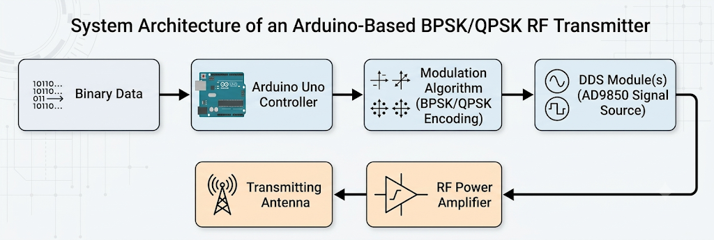

3.3 Binary Phase Shift Keying (BPSK)
Introduction
Binary Phase Shift Keying (BPSK) is one of the simplest digital modulation techniques. It represents binary information by changing the phase of a sinusoidal carrier.
Only two phase states are used:
- Binary '1' → 0°
- Binary '0' → 180°
Since only the carrier phase changes while amplitude and frequency remain constant, BPSK offers excellent noise immunity and is widely used in satellite communication, telemetry, GPS, and military communication systems.
BPSK Block Diagram
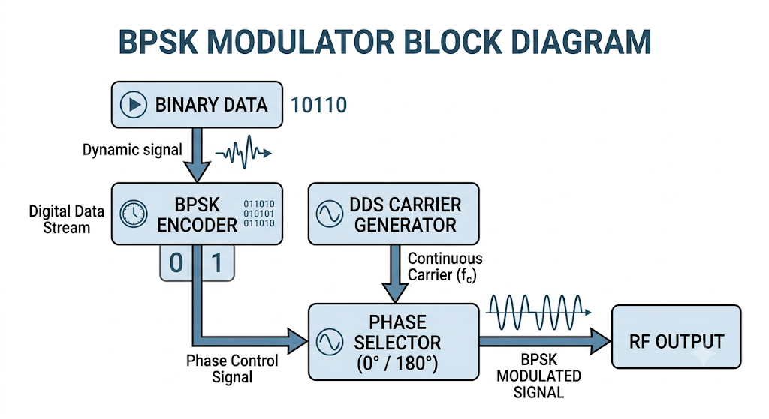
Figure 3.2 Block Diagram of BPSK Modulator
Working Principle
- The Arduino receives digital data.
- Each bit is examined.
- If the bit is '1', the DDS outputs a carrier with 0° phase.
- If the bit is '0', the DDS outputs the same carrier with a 180° phase shift.
- The antenna transmits the modulated RF signal.
Mathematical Representation
$$s(t)=Acos⁡(2πf_{c}t)$$
for binary 1
$$s(t)=-Acos⁡(2πf_{c}t)$$
for binary 0
The two signals differ only by 180° phase.

3.4 Quadrature Phase Shift Keying (QPSK)
Introduction
Quadrature Phase Shift Keying (QPSK) is an advanced form of PSK in which each symbol carries two bits of information.
Instead of only two-phase values, QPSK uses four equally spaced phases.

Bits | Phase
00 | 45°
01 | 135°
11 | 225°
10 | 315°

Thus, QPSK doubles the data rate compared to BPSK without increasing the bandwidth.
QPSK Block Diagram:
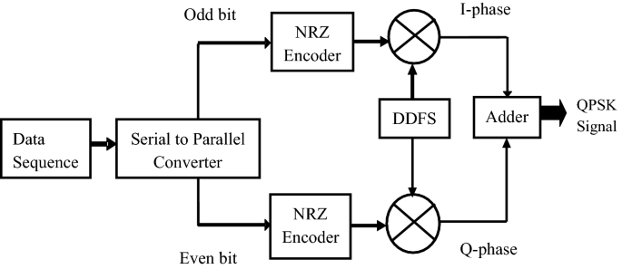
Figure 3.3 Block Diagram of QPSK Modulator

3.5 I-Q Carrier Generation
Quadrature Phase Shift Keying (QPSK) employs two carrier signals having the same frequency but differing in phase by 90°. These carriers are known as the In-phase (I) carrier and the Quadrature (Q) carrier.
The I and Q carriers are mathematically expressed as
$$I(t)=cos⁡(ω_{c}t) \\ Q(t)=sin⁡(ω_{c}t)$$
The I-channel carries one bit, while the Q-channel carries another bit simultaneously.
The transmitted signal is
$$s(t)=I(t)cos⁡(ω_{c}t)-Q(t)sin⁡(ω_{c}t)$$
where
- $I(t)$= In-phase carrier
- $Q(t)$= Quadrature carrier
- $ω_{c}$= Carrier angular frequency
The input binary stream is divided into two parallel data streams. One stream modulates the in-phase carrier while the other modulates the quadrature carrier. The two modulated signals are then combined to produce the QPSK waveform.
In the proposed implementation, two synchronized AD9850 DDS modules can be used to generate the orthogonal I and Q carriers. An Arduino Uno controls both DDS modules and updates their phase information according to the input data, enabling software-controlled QPSK modulation.

3.6 Proposed Simulation Results
Before moving to physical hardware implementation, it is essential to validate the communication system's design through software simulation. This step allows us to verify our theoretical models and debug the system architecture in a controlled environment. We plan to utilize industry-standard platforms for this phase, with potential options including MATLAB (with Simulink), GNU Radio, Python (leveraging the NumPy and Matplotlib libraries), or GNU Octave.
To thoroughly evaluate the modulation schemes, we will perform a series of targeted simulations:
BPSK Simulation Metrics
- Signal Visualization: We will first plot the initial input binary sequence alongside the raw carrier waveform to establish a baseline.
- Modulated Output: This step will generate the time-domain representation of the resulting BPSK modulated signal.
- Performance Analysis: To assess signal quality, we will produce a constellation diagram to verify the 180-degree phase shifts. Additionally, we will analyse the Power Spectral Density (PSD) for bandwidth efficiency and plot the Bit Error Rate (BER) versus Signal-to-Noise Ratio (SNR) to test the system's robustness against noise.
QPSK Simulation Metrics
- Data Processing: We will visualize the serial-to-parallel conversion process, clearly showing the splitting of data into In-phase (I) and Quadrature (Q) channel waveforms.
- Modulated Output: We will simulate and observe the combined QPSK modulated signal in the time domain.
- Signal Integrity: To properly evaluate the QPSK implementation, the simulation will generate an IQ constellation plot and an eye diagram to check for inter-symbol interference (ISI). We will also run a comprehensive BER performance curve.
For visual reference, an example of an expected QPSK constellation diagram is provided below. In this plot, each distinct point clearly represents one of the four possible QPSK phase symbols.
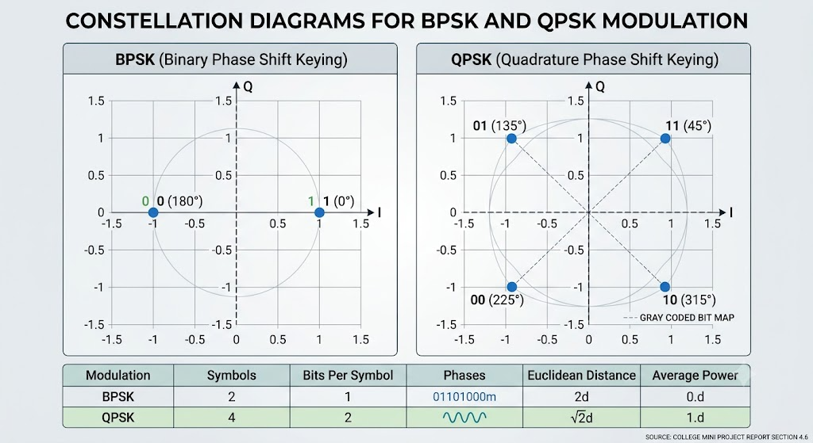

3.7 Future Implementation
The present project focuses on developing a DDS-based RF signal generator and antenna analyser. In future work, the platform will be extended into a complete DDS-based digital communication transmitter.
The proposed implementation includes:
- Integration of two synchronized AD9850 DDS modules for generating orthogonal I and Q carriers.
- Development of Arduino-based BPSK and QPSK modulation algorithms.
- Implementation of symbol synchronization and phase control.
- Design of an RF power amplifier for transmission.
- Construction of a complete wireless transmitter with antenna.
- Performance evaluation through constellation analysis, Bit Error Rate (BER), Error Vector Magnitude (EVM), and spectrum measurements.
- Extension to higher-order modulation schemes such as 8-PSK and 16-QAM.
The proposed system will demonstrate how DDS technology can be used not only for RF signal generation but also as the core of a flexible and software-controlled digital communication platform.

CHAPTER 4

Application II

Antenna Analyser Using AD9850 and Arduino

4.1 Introduction:
Antennas are fundamental components in all wireless communication systems. Their performance depends heavily on impedance matching and resonance characteristics. One of the most important parameters used in antenna testing is the Standing Wave Ratio (SWR), which indicates how efficiently radio frequency (RF) power is transferred from the transmission line to the antenna.
This project demonstrates the construction of a low-cost antenna analyser using the AD9850 DDS Signal Generator Module, an Arduino microcontroller, a simple RF bridge network, and a diode detector circuit. The system sweeps frequencies across the HF band and measures reflected RF energy from the antenna. The measured values are transferred to a computer where Python is used to plot the antenna response graph. It successfully demonstrates core RF engineering principles such as:
- Frequency sweeping
- Antenna resonance
- Reflection coefficient
- SWR behaviour
- RF bridge operation
- Signal detection and visualization
The project provides an accessible introduction to antenna characterization techniques used in modern communication systems

4.2 Objectives:
The objective of this project is to develop a low-cost antenna analyser using the AD9850 DDS module and Arduino to generate RF signals and perform frequency sweeping. The system measures reflected RF energy using a resistive bridge and diode detector, acquires the data through Arduino, and visualizes the antenna response using Python to identify its resonance characteristics.

4.3 Theory:

4.3.1 Antenna Resonance:
An antenna resonates when its electrical length matches the wavelength of the applied RF signal. At resonance, the antenna impedance closely matches the transmission line impedance, resulting in maximum power transfer and minimum reflected power.
The wavelength is related to frequency by:
$$λ=\frac{c}{f}$$
$λ$ = Wavelength (m), (c) = Speed of light ((3$×$10^8) m/s), (f) = Frequency (Hz)
Changing the physical length of the antenna changes its resonant frequency.

4.3.2 Standing Wave Ratio (SWR):
SWR indicates the quality of impedance matching between the antenna and the transmission line. A mismatch causes part of the RF signal to reflect back, creating standing waves.
SWR=$\frac{1-\left|Γ\right|}{1+\left|Γ\right|}$
where, Γ = reflection coefficient, Γ=$\frac{Z_{L}-Z_{0}}{Z_{L}+Z_{0}}$
(ZL) = Antenna (load) impedance
(Z0) = Characteristic impedance of the transmission line
SWR Values:
- 1:1 – Perfect impedance match
- 2:1 – Moderate mismatch
- High SWR – Severe mismatch
In this project, SWR is not calculated directly; instead, the magnitude of the reflected RF signal is measured, which indicates the antenna's matching and resonance characteristics.

4.3.3 Direct Digital Synthesis (DDS):
The AD9850 module uses Direct Digital Synthesis (DDS) to generate stable RF signals.
DDS operation involves: 1) Phase accumulator 2) Lookup table 3) Digital-to-analog conversion
Advantages of DDS: High frequency stability, Fine frequency resolution, Fast frequency switching, Fast frequency switching
The output frequency of DDS depends on the tuning word:
$$f_{out}=\frac{M×f_{clock}}{2^{32}}$$
Where:
- $M$= tuning word
- $f_{clock}$= reference clock frequency
The AD9850 used in this project operates with a 125 MHz reference clock.
4.3.4 RF Bridge Principle:
A resistive RF bridge is used to separate forward and reflected signals.
The bridge consists of matched resistors arranged so that:
- With proper impedance matching, bridge voltage becomes minimum.
- During mismatch, imbalance occurs.
- Reflected energy appears at the detector node.
This principle enables measurement of antenna mismatch characteristics.

4.3.5 Diode Detector:
The RF signal is converted into a measurable DC voltage using a diode detector circuit. The detector consists of: 1) 1N4148 diode, 2) Capacitor filter, 3) Load resistor
The diode rectifies the RF waveform while the capacitor smooths the signal to produce a DC voltage proportional to reflected RF power.

4.4 Components Required:
Component | Quantity
Arduino Uno | 1
AD9850 DDS Module | 1
50Ω Resistors | 4
1N4148 Diode | 1
100 nF Capacitor | 1
100Ω Resistor | 1
Connecting Wires | As required
Breadboard | 1
Wire Antenna | 1

4.5 Block Diagram:
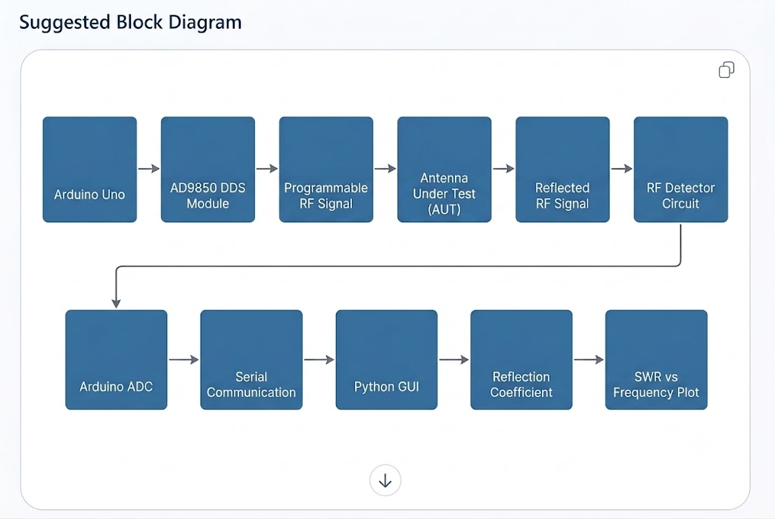
Figure 4.1 Antenna Analyser Block Diagram using AD9850 DDS Module

4.6 Circuit Description:
The system consists of four major sections:
- RF signal generation using AD9850
- RF bridge network
- Diode detector
- Data acquisition through Arduino
The AD9850 generates RF signals over a sweep range of 1 MHz to 30 MHz. The RF signal is applied to the antenna through the bridge circuit. Reflected signals are detected and converted into DC voltage. Arduino reads the detector output through analog pin A0 and sends the data to the computer via serial communication.

4.7 Connections:

4.7.1 AD9850 to Arduino
AD9850 Pin | Arduino pin
W_CLK | D8
FQ_UD | D9
DATA | D10
RESET | D11
VCC | 5V
GND | GND

4.7.2 RF Bridge:
R1 = 50Ω, R2 = 50Ω, the junction points act as the measurement node.
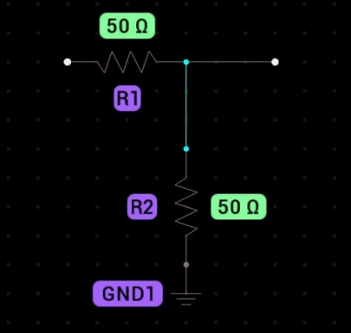
Configuration:
ANTENNA
DDS Input

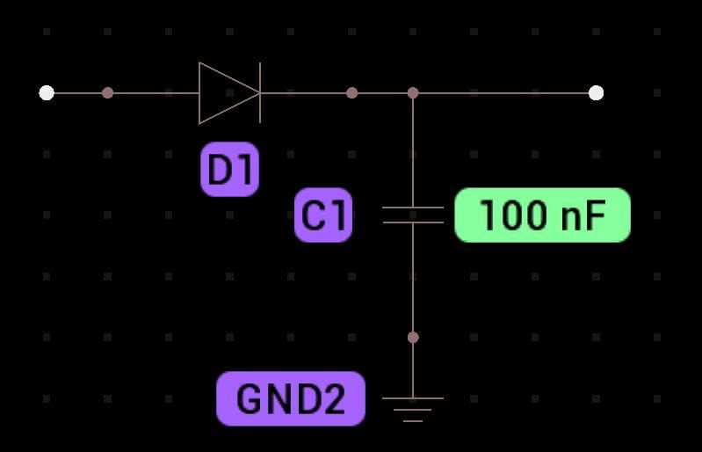
4.7.3 Diode Detector:
Bridge Node

4.7.4 Implemented Circuit:
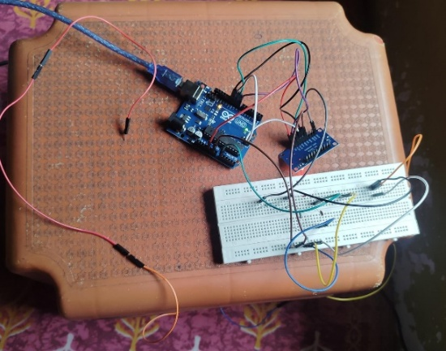
Figure 4.4 Practical Hardware implementation of Antenna Analyser

4.8 Arduino Program
The Arduino performs the following tasks:
- Controls AD9850 frequency generation.
- Sweeps frequencies from 1 MHz to 30 MHz.
- Reads analog voltage from detector.
- Sends data through serial communication.
The sweep step size used is 500 kHz.
The analog readings correspond to reflected RF energy.

4.9 Python Visualization
Python is used to:
- Read serial data
- Store frequency values
- Normalize readings
- Plot antenna response graph
The plotted graph represents reflected energy versus frequency.
A dip in the graph indicates antenna resonance.
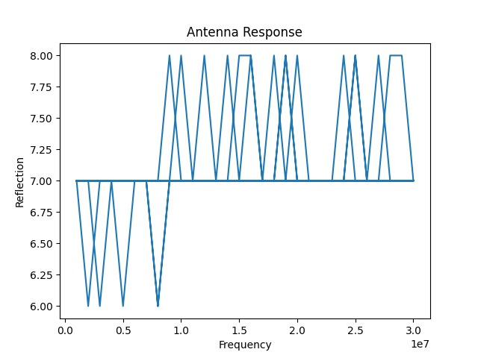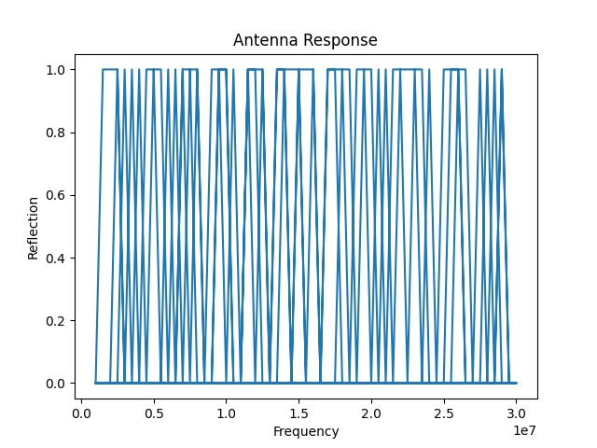
Antenna response graph(step size = 500 KHz)
Antenna response graph(1 MHz step response)
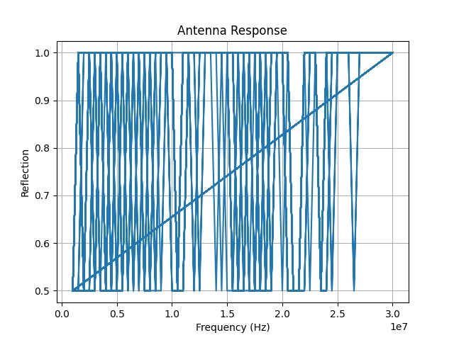
Graph at the end of accumulation

4.10 Working Principle
The antenna analyser operates by measuring the amount of RF energy reflected from the antenna over a range of frequencies to determine its resonance characteristics and impedance matching.
- The AD9850 Direct Digital Synthesis (DDS) module generates a stable sinusoidal RF signal whose frequency is swept over the desired operating range under the control of the Arduino.
- The generated RF signal is applied to the RF bridge network, which feeds the signal to the antenna while simultaneously providing a means to separate the forward and reflected waves.
- As the signal excites the antenna, the antenna impedance varies with frequency. If the antenna impedance differs from the characteristic impedance of the transmission line (typically 50 Ω), a portion of the transmitted RF power is reflected back toward the source.
- The reflected RF signal produces an imbalance in the bridge network, resulting in a voltage proportional to the magnitude of the reflected power at the bridge output.
- This reflected RF voltage is applied to a diode detector circuit, where the high-frequency AC signal is rectified and filtered to produce a DC voltage proportional to the reflected RF energy.
- The Arduino acquires the detector output through its Analog-to-Digital Converter (ADC) and records the detector voltage corresponding to each frequency during the sweep.
- The measured data are transmitted to a computer through serial communication, where a Python-based application processes and plots the detector voltage as a function of frequency to obtain the antenna response curve.
- The resulting frequency-response graph enables the identification of the antenna's resonant frequency and provides an indication of its impedance matching performance.
At the resonant frequency:
- The antenna impedance closely matches the transmission line impedance.
- The reflection coefficient and reflected RF power reach their minimum values.
- The detector output voltage decreases to its minimum value.
- The plotted frequency-response curve exhibits a distinct resonance dip, indicating maximum power transfer from the source to the antenna.

4.11 Observations
The following behaviours are expected:
- Smooth response curve across frequencies
- Resonance dip at specific frequency
- Resonance shifts when antenna length changes
Increasing antenna length lowers resonant frequency, while decreasing antenna length raises resonant frequency.

4.12 Advantages
- Low-Cost Implementation: The analyser is developed using inexpensive and readily available components such as the AD9850 DDS module and Arduino, making it a cost-effective alternative to commercial RF measurement instruments.
- Simple and Modular Design: The hardware architecture is straightforward and easy to assemble, modify, and maintain, allowing convenient experimentation and future upgrades.
- Practical Demonstration of RF Concepts: The system effectively demonstrates fundamental RF engineering concepts, including frequency sweeping, impedance matching, antenna resonance, reflected power measurement, and standing wave behavior.
- Educational and Research Platform: The analyser serves as an effective laboratory tool for students and researchers to study antenna characteristics, RF measurements, and basic instrumentation techniques through hands-on experimentation.
- Real-Time Frequency Analysis: The combination of Arduino-based data acquisition and Python-based visualization enables real-time monitoring of the antenna response, allowing rapid identification of resonant frequencies and impedance matching conditions.

4.13 Limitations
- Not calibrated for precise SWR measurement
- Sensitive to wiring noise
- Limited RF shielding
- Breadboard construction introduces parasitic effects
- Detector nonlinearity affects accuracy

4.14 Applications
- Basic antenna testing
- Educational RF experiments
- Resonance studies
- Amateur radio projects
- RF system demonstrations

4.15 Result
A functional antenna analyser system was successfully developed using the AD9850 DDS module and Arduino. The system demonstrated frequency-dependent antenna behaviour and successfully identified resonance regions through reflected signal analysis.
The plotted response graph clearly showed resonance dips corresponding to antenna characteristics.

4.16 Conclusion
The project successfully demonstrates the principles of antenna resonance and RF reflection measurement using inexpensive hardware components. The analyser provides a practical introduction to RF instrumentation and antenna characterization techniques.
Despite its simplicity, the system effectively visualizes resonance behaviour and provides meaningful insight into antenna impedance matching. The project can further be improved through calibration, improved bridge design, shielding, and mathematical SWR computation.

CHAPTER 5

Application III

DDS-Based RF Component Analyser (RLC Components)

5.1 Introduction:
Passive components such as resistors, inductors, and capacitors exhibit different electrical characteristics at radio frequencies (RF) due to parasitic effects. The DDS-Based RF Component Analyser is a low-cost system developed to study the RF response of RLC components. It uses a DDS signal generator to produce RF signals, an Arduino Uno for data acquisition, and a Python GUI for real-time visualization of the component response over a range of frequencies.

5.2 Objectives
- Generate RF signals using a DDS module.
- Analyse the RF response of passive RLC components.
- Perform frequency sweep measurements.
- Display the response graphically using a Python GUI.
- Provide a simple and economical educational RF measurement setup.

5.3 Working Principle
The AD9850 DDS module generates a sinusoidal RF signal whose frequency is controlled by the Arduino Uno. The signal is applied to the Device Under Test (DUT), and its response is converted into a measurable voltage using an RF detector circuit. The Arduino reads this voltage through its ADC and sends the data to a computer via serial communication. The Python GUI plots the measured ADC value against frequency, showing the RF response of the component.

5.4 Hardware Components
Component | Function
Arduino Uno | Controls DDS and acquires data
AD9850 DDS Module | Generates RF signals
RF Detector Circuit | Converts RF signal to DC voltage
RLC Component | Device Under Test (DUT)
Python GUI | Displays response graph
USB Cable | Serial communication

5.5 Block Diagram & Implemented Circuit
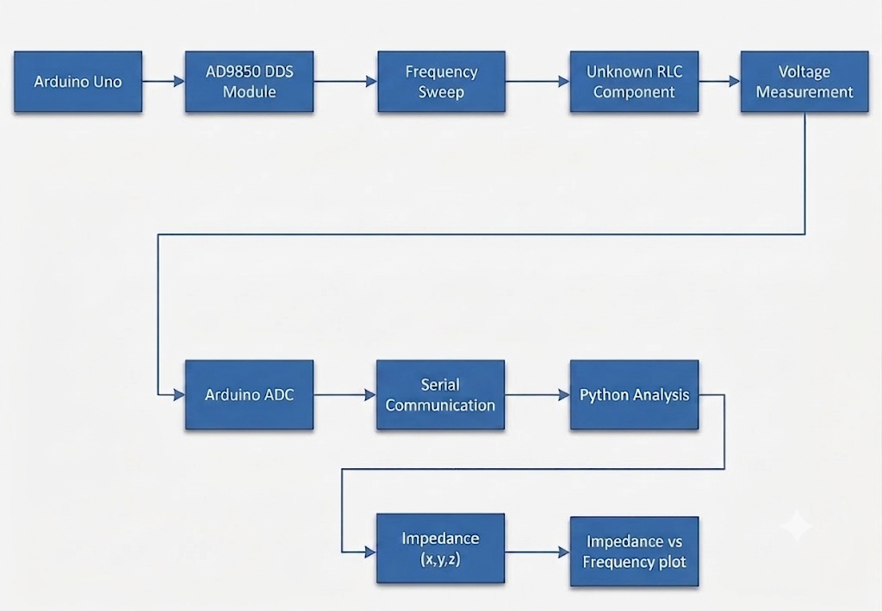
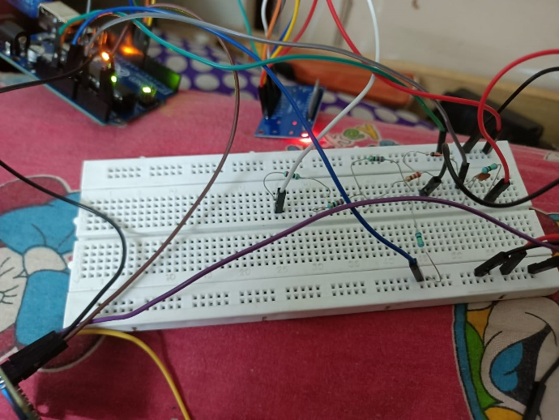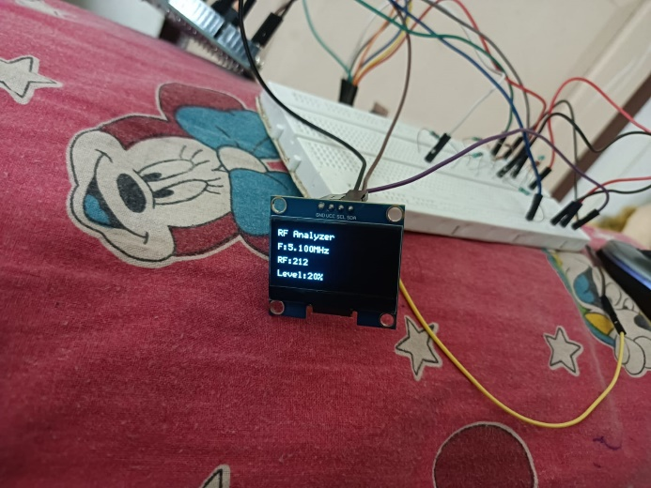

5.6 Experimental Procedure
- Connect the unknown RLC component to the impedance measurement circuit and ensure all hardware connections are secure.
- Upload the Arduino program and establish serial communication between the Arduino and the computer.
- Launch the Python-based graphical interface (GUI) to initiate data acquisition and visualization.
- Perform a frequency sweep over the desired range using the AD9850 DDS module, which generates a variable-frequency sinusoidal signal.
- Measure and record the ADC values corresponding to the voltage across the unknown component at each frequency.
- Process the acquired data and plot the impedance, phase, and frequency-response graphs to determine the electrical characteristics and resonant frequency of the RLC component.

5.7 Results
The analyser successfully performed RF frequency sweeps and displayed the response of passive components in real time. For the tested 0.1 µF capacitor, the measured amplitude remained nearly constant with small variations and a peak around 9 MHz, indicating the influence of circuit parasitics and measurement limitations.
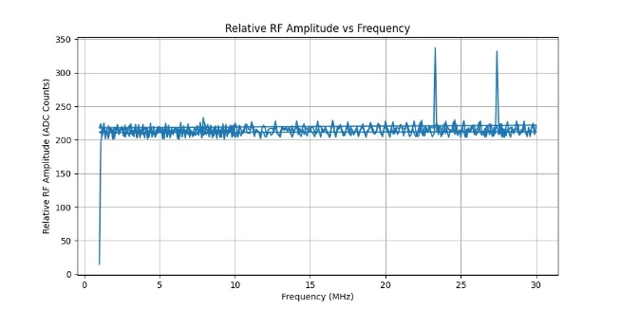
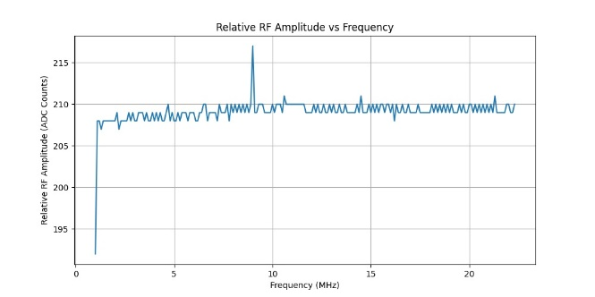
220 ohm Relative RF amplitude vs frequency 0.1microF capacitor graph
graph

5.8 Applications
- RF laboratory experiments
- Frequency response analysis
- Educational demonstrations
- Basic testing of RLC components
- Learning RF measurement techniques

5.9 Advantages
- Low-Cost Implementation: The system is developed using economical and readily available hardware components, making it an affordable alternative to commercial RLC analysers.
- Portable and Compact Design: The compact hardware architecture allows easy portability and convenient use in laboratory and educational environments.
- Real-Time Graphical Visualization: The integration of Arduino with Python enables real-time acquisition and graphical display of impedance, phase, and resonance characteristics.
- Simple Operation: The analyser requires minimal user intervention, with automated frequency sweeping and data processing, making it easy to operate.
- Suitable for Educational and Research Applications: The system serves as an effective platform for studying RLC circuits, impedance analysis, resonance, and frequency response in academic laboratories and research projects.

5.10 Limitations
- Measures only relative RF response.
- Does not measure phase or exact impedance.
- Limited by the Arduino's 10-bit ADC.
- Accuracy is affected by parasitic effects at high frequencies.

CHAPTER 6

Comparison Or Performance Analysis

6.1 Comparison Table:
Parameter | Commercial RF Instruments | Proposed DDS-Based Platform
Approximate Cost | ₹50,000 – ₹3,00,000+ | < ₹3,000
Signal Generation Technique | Analog Oscillator / PLL / DDS | AD9850 Direct Digital Synthesis (DDS)
Operating Frequency Range | Model Dependent | Programmable (Software Controlled)
Frequency Sweep Capability | Built-in Hardware Sweep | Software-Controlled Sweep
SWR Measurement | Supported | Supported
Frequency Resolution | Instrument Dependent | 32-bit DDS Resolution (~0.029 Hz)
Frequency Programming | Front Panel / Menu Based | Arduino-Controlled Digital Programming
Phase Control | Manual / Limited Digital Control | Real-Time Software Phase Control
Waveform Configuration | Fixed Instrument Functions | Software Configurable
Automation Capability | Limited External Control | Full Arduino & Python Integration
Expandability | Hardware Dependent | Modular and Highly Expandable
Embedded System Integration | Limited | Direct Microcontroller Interface
Digital Communication Support | Optional / High-Cost Models | Suitable for BPSK, QPSK & SDR Development
Software Support | Proprietary Software | Open-Source Python Platform

6.2 Performance Analysis of the Proposed DDS-Based RF Platform

6.2.1 Technical Advantages of DDS-Based Signal Generation
Conventional function generators typically rely on analog oscillators, PLL synthesizers, or fixed-function architectures, where parameters such as frequency, phase, and sweep rate are adjusted manually through hardware controls. This limits their flexibility for embedded RF and communication applications.
The proposed system employs Direct Digital Synthesis (DDS) using the AD9850 DDS module, controlled by an Arduino Uno. The output signal is generated digitally using a 32-bit Frequency Tuning Word (FTW), allowing the waveform characteristics to be modified entirely through software.
The software-controlled architecture provides several advantages:
- High frequency resolution (approximately 0.029 Hz)
- Real-time frequency and phase control
- Programmable frequency sweeping
- Easy implementation of digital modulation techniques
- Python-based automation for data acquisition and visualization
- Modular architecture suitable for multiple RF applications
These features make the proposed platform highly flexible, cost-effective, and suitable for RF experimentation.

6.2.2 Advantages for Digital Communication Systems
The DDS architecture enables precise control of carrier frequency and phase, making it well suited for digital communication applications. Unlike conventional function generators that require manual configuration or dedicated hardware, modulation can be implemented through software.
The proposed platform can be extended to support:
- Binary Phase Shift Keying (BPSK)
- Quadrature Phase Shift Keying (QPSK)
- Frequency Shift Keying (FSK)
- Software Defined Radio (SDR)
- Frequency hopping communication
- Adaptive communication experiments
The software-defined approach provides greater flexibility while significantly reducing implementation cost.

6.2.3 Current Limitations
Although the proposed platform successfully demonstrates low-cost RF signal generation, certain limitations remain.
- Frequency accuracy depends on the stability of the 125 MHz reference oscillator.
- The RF detector requires calibration for accurate SWR measurements.
- Output power is limited and requires an external RF amplifier for transmission.
- The current implementation is intended for educational and laboratory applications rather than precision RF instrumentation.
Future improvements in calibration, amplification, and filtering can further enhance system performance.

CHAPTER 7

Future Scope
The developed DDS-based RF platform provides a flexible foundation for future communication and RF measurement applications. Its software-controlled architecture allows new functionalities to be added with minimal hardware modification.

7.1 DDS-Based Digital Communication
The platform can be extended to implement digital modulation techniques such as BPSK, QPSK, FSK, and higher-order modulation schemes. Precise frequency and phase control enables the development of low-cost digital communication transmitters.

7.2 Software Defined Radio Integration
Integration with SDR hardware such as RTL-SDR or HackRF can enable real-time spectrum analysis, digital modulation and demodulation, and wireless communication experiments, expanding the platform for communication research.

7.3 Advanced RF Measurement
The antenna analyzer can be upgraded to include Return Loss, Smith Chart visualization, complex impedance analysis, and Vector Network Analyzer (VNA) functionality for improved RF measurements.

7.4 Portable RF Instrument
Future versions may incorporate a TFT display, battery operation, wireless connectivity, and onboard data logging, making the system suitable for portable RF testing.

7.5 Intelligent Automation
Future software improvements may include automatic frequency sweeping, resonance detection, self-calibration, AI-assisted analysis, and cloud-based data logging, improving both accuracy and usability.

CHAPTER 8

8.1 Conclusion
The project successfully demonstrates the development of a low-cost Arduino-controlled Direct Digital Synthesis (DDS)-based RF platform using the AD9850 DDS module. The system provides stable, programmable RF signal generation through software control while maintaining low implementation cost.
The developed platform successfully implements wire antenna analysis, including Reflection Coefficient and Standing Wave Ratio (SWR) measurements, supported by a Python-based graphical interface for real-time visualization. Additionally, the same DDS architecture has been extended conceptually for RLC impedance analysis and future BPSK/QPSK communication systems, demonstrating its versatility.
Compared with conventional laboratory instruments, the proposed DDS platform offers software-controlled frequency, phase, and sweep generation, making it highly adaptable for RF experiments and communication research. Its modular design enables future integration with Software Defined Radio (SDR), advanced RF measurement techniques, and portable instrumentation.
Overall, the proposed system establishes a cost-effective, flexible, and scalable DDS-based RF experimentation platform capable of supporting multiple communication and measurement applications for academic and research purposes.

8.2 References

8.2.1 Books
- Constantine A. Balanis, Antenna Theory: Analysis and Design, 4th Edition, John Wiley & Sons, 2016.
- John G. Proakis and Masoud Salehi, Digital Communications, 5th Edition, McGraw-Hill Education, 2008.
- Simon Haykin, Communication Systems, 5th Edition, John Wiley & Sons, 2009.
- Behzad Razavi, RF Microelectronics, 2nd Edition, Pearson Education, 2012.
- Thomas H. Lee, The Design of CMOS Radio-Frequency Integrated Circuits, Cambridge University Press, 2004.

8.2.2 Datasheets & Technical Documentation
- Analog Devices Inc., AD9850 CMOS 125 MHz Complete DDS Synthesizer Datasheet.
- Arduino Documentation, Arduino Uno Rev3 Technical Specifications.

8.2.3 Software Documentation
- Python Software Foundation, Python 3 Documentation.
- Matplotlib Development Team, Matplotlib Documentation.

8.2.4 Research & Standards
- IEEE Xplore Digital Library – Research articles on Direct Digital Synthesis (DDS), RF Signal Generation, Digital Modulation, and Antenna Measurements.
- ARRL Antenna Book, 25th Edition, American Radio Relay League.

