**IoT PROJECT**

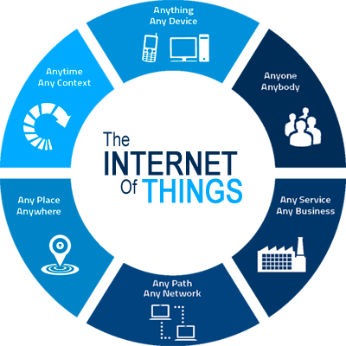

**Kalinga Institute of Industrial Technology**

Patia, Bhubaneswar - 751024



**A Project on**

***“*Alcohol Sensing Mechanism for Cars with GSM Module Application”**

Submitted for IoT summer training programme

by department of Training and Placement

Submitted by

1. **Indranil Ghosh**
2. **Nihar Dwivedi**

**(GROUP-2)**

Under the Guidance Of

Mr. Ashutosh Behura

Professor & FIC-IoT,

KIIT University, Bhubaneswar

**ABSTRACT**

Modern hand held devices such as smart phones and PDAs have become increasingly powerful in recent years. Dramatic breakthroughs in processing power along with the number of extra features included in these devices have opened the doors to a wide range of commercial possibilities. In particular, most cell phones regularly include cameras, GPS tracker, GSM messaging systems and internet access. However, even with all these added abilities, there is a lot of misuse done by users of today’s generation.

Drunk driving has recently become a major issue in today’s India. According to India’s National Crime Records Bureau’s (NCRB) annual data on traffic accidents, deaths caused from accidents has increased up to 70 percent due to drunk driving.

The prime objective of our project is to create a mechanism which would detect the percentage of alcohol in the breath of the driver and if it crosses the threshold limit then immediately an alert SMS will be sent to the guardian of the user or concerned authorities (maybe the traffic police department). This application not only encourages safe driving but also protects the life of pedestrians from rash driving.

The Project is developed in Embedded C Language by using the Arduino Genuino Environment. We have used our knowledge of IoT and basic electronics to build this project. The main components used in our project are an alcohol sensor(MQ-3) and a GSM module which are embedded in an Arduino Uno board.