**Configure:**

Please provide access key and secret key of AWS environment

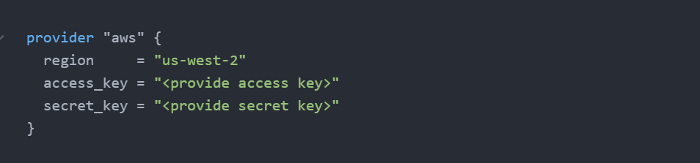

Terraform apply result:

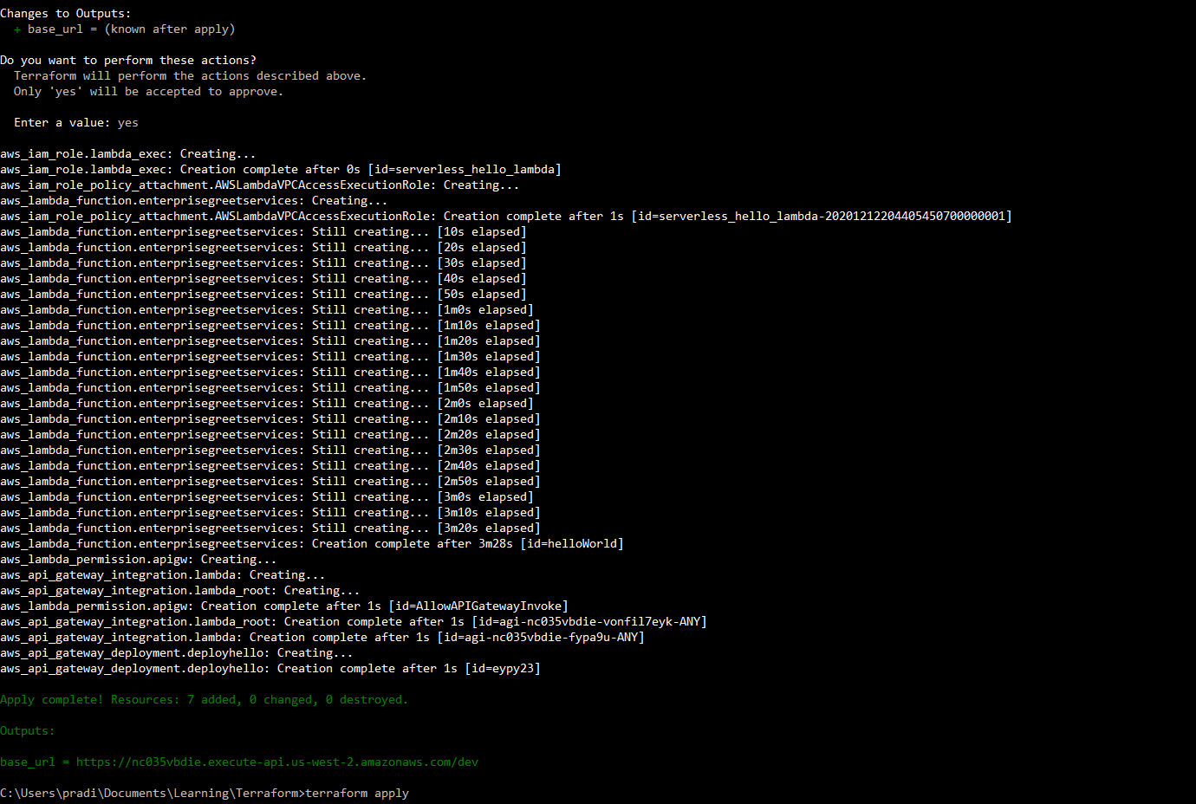

**Lambda:**

Created Function

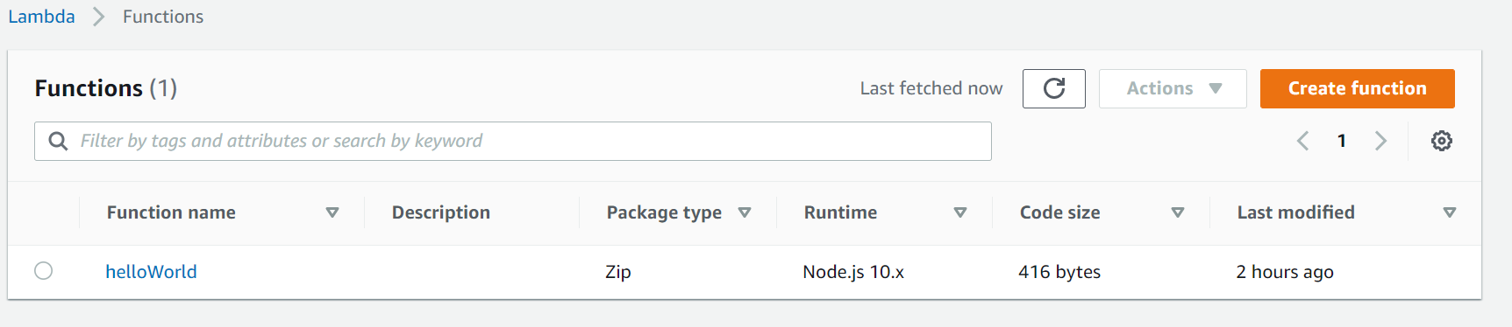

Function code from Inline terraform config

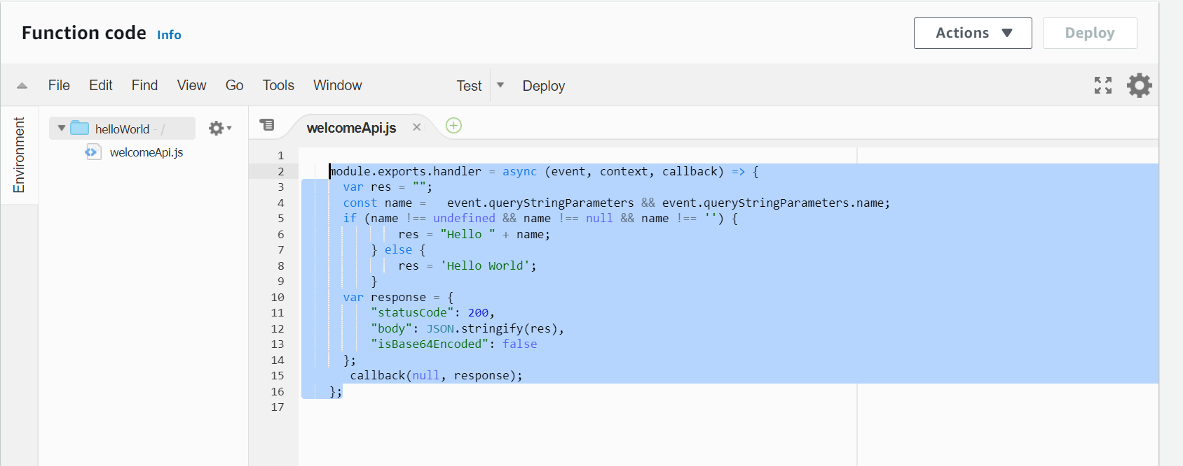

Associated VPC, SG, Subnet

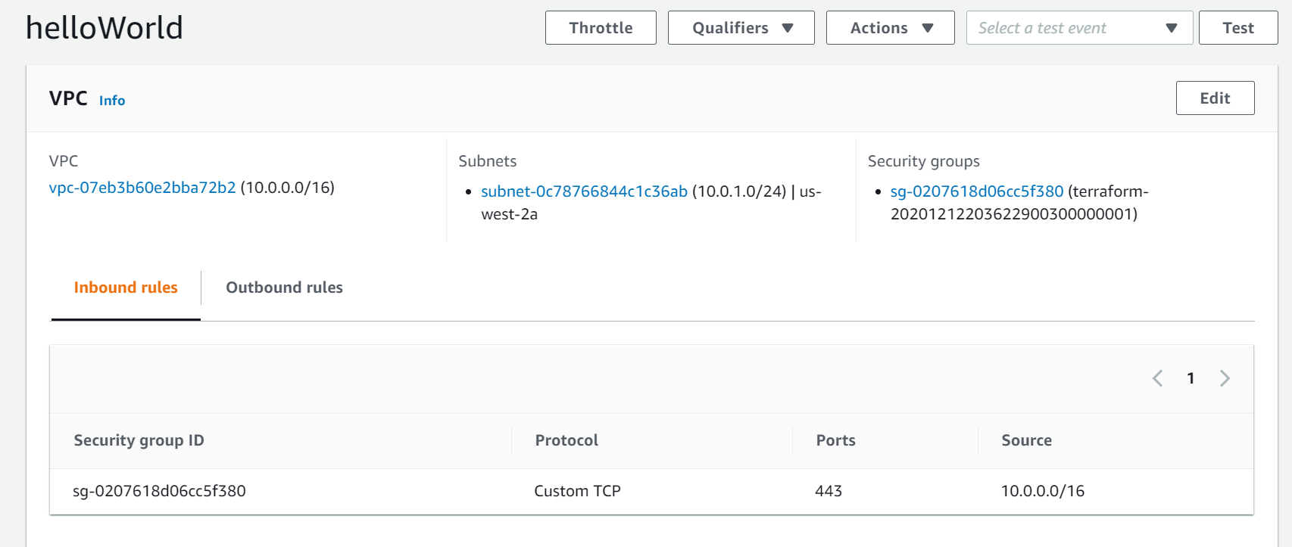

**API Gateway:**

Created API

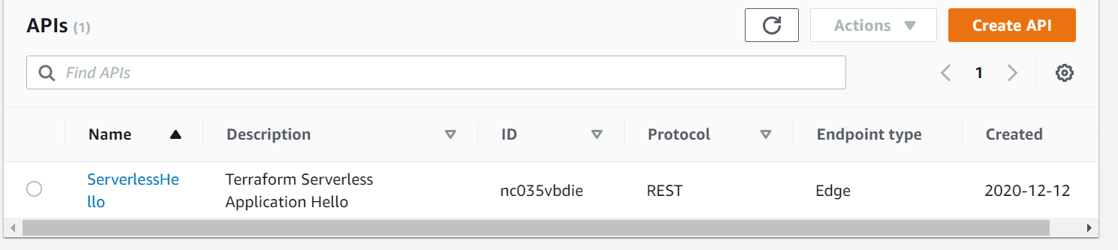

Integration with lambda

