**Overall description of the test including a list of configurations and conditions:**

|  |
| --- |
| The purpose of this test is to perform the integration testing of the API gateway and lambda created through terraform configuration”  This is a proxy integration.The api can be called with its base url and also with adding query parameter “**name**” in the form of (baseUrl)?name=BlueJeans e.g. both of the below are valid requests  <https://nc035vbdie.execute-api.us-west-2.amazonaws.com/dev>  <https://nc035vbdie.execute-api.us-west-2.amazonaws.com/dev>?name=BlueJeans |

**Configuration for the node project:**

**Prerequisite**: Node should be installed

**Set up steps:**

1. Unzip the zip folder and navigate to /enterprisehelloservices directory
2. Run **npm install -y** (it will install all dependent modules as mentioned package.json)
3. Go to init.js file under utils dir and change the bas url to the one that was the output of terraform apply

**init.js**

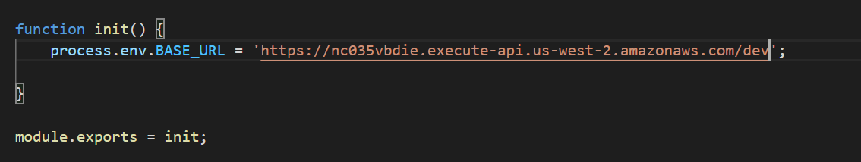

**Terraform Output:**

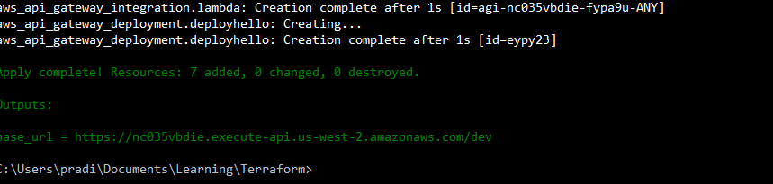

1. **Run - npm run test-integration**

**Test Result:**

|  |  |  |  |
| --- | --- | --- | --- |
| **Step** | **Condition** | **Expected/Actual Result** | **PASS/FAIL** |
| **1** | Invoke base url <https://nc035vbdie.execute-api.us-west-2.amazonaws.com/dev> | **Expected:**  Hello World  **Actual:**  Hello World | **Pass** |
| **2** | Invoke with Query String **?name=BlueJeans** | **Expected:**  Hello BlueJeans  **Actual:**  Hello BlueJeans | **Pass** |
| **3** | **Negative Scenario:**  Update the **api.integration.test.js** file with a new expected value as below: (append **“!!”** in expected result)  expect(response.data).  toBe('Hello BlueJeans !!'); | **Expected:**  Integration test should fail after running **npm run test-integration**  **Actual:**  Integration test failed as we have changed the expected value in the testcase by appending “!!” | **Pass** |
| **4** | Remove **“!!”** in **api.integration.test.js** file to match the expected value as below:  expect(response.data).  toBe('Hello BlueJeans'); | **Expected:**  Integration test should pass again after running **npm run test-integration**  **Actual:**  Integration test passed as we have changed the expected value in the testcase and remove “!!” | **Pass** |
| **5.** | Teardown the infrastructure by running terraform destroy command | **Expected:**  Integration test should fail as no infrastructure is present  **Actual :** Infrastructure is destroyed and test failed | **Pass** |