minikube service user-hasher -n user-hasher

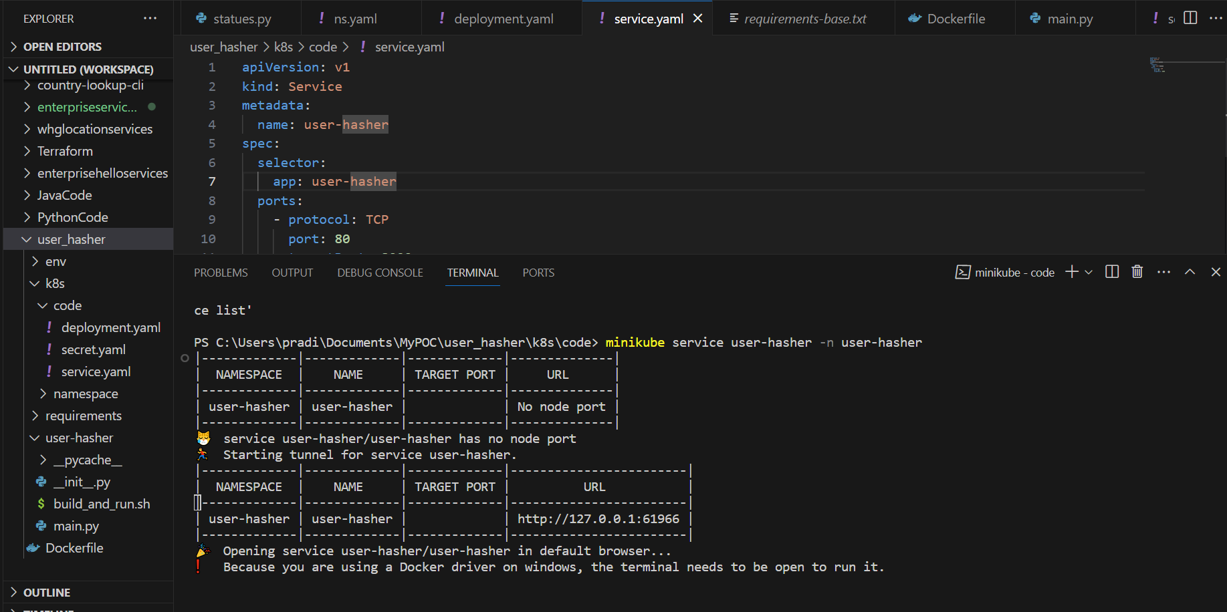

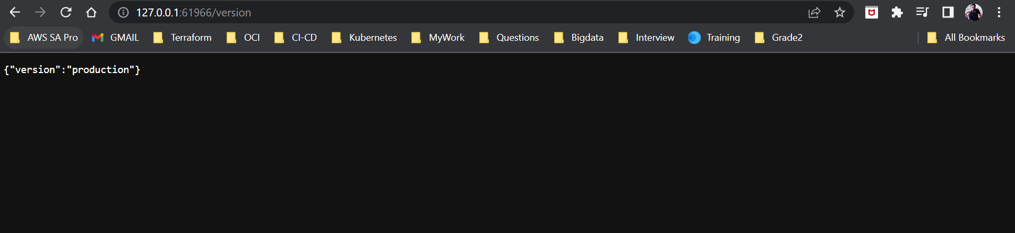

Verification with USER_SALT Secret:

