14-Day Roadmap
Day | Topic | What I Learn | Practical Exercise | Expected Outcome
1 | LLM Fundamentals | LLM, prompt, system/user messages, API, tokens, context | Make a simple LLM call | Understand basic LLM application flow
2 | Prompting | Prompt structure, instructions, context, output control | Build a PM-status prompt | Write better prompts intentionally
3 | Documents & Loaders | Documents, loaders, parsing, metadata | Load a small project document | Understand ingestion
4 | Chunking | Why documents are split, chunk size, overlap | Split a document into chunks | Understand why chunking matters
5 | Embeddings | Embedding, vector, semantic meaning | Generate embeddings for small data | Understand text → vector
6 | Vector Database | Vector storage, metadata, similarity search | Store/search vectors | Understand vector DB purpose
7 | Semantic Search & Retrieval | Query embedding, similarity, top-K, retrieval | Search project information | Understand retrieval independently of RAG
8 | RAG | Complete RAG architecture | Build basic RAG | Explain RAG end-to-end
9 | RAG Improvement | Retrieval quality, hallucination, chunking problems, basic evaluation | Improve retrieval/answers | Understand basic RAG limitations
10 | Tool / Function Calling | Tools, schemas, tool input/output, LLM → tool | Project-status/calculator tool | Understand how LLMs interact with external systems
11 | AI Agents | Agent vs chatbot, decision-making, tool selection | Simple Agent | Understand basic Agent architecture
12 | Agentic Workflows | Workflow vs Agent, state, memory, multi-step execution | PM workflow | Understand when orchestration is useful
13 | AI Project Manager Perspective | Architecture, cost, security, risks, evaluation, production | Review the solution as a TPM | Learn how to challenge/review AI designs
14 | Final Mini-Project | Combine LLM + RAG + Tool + Agent | Complete PM Assistant | Explain and demonstrate the complete architecture

Recommended Technology Stack
Technology | Why we need it
Python | Your practical implementation language; you already have basic Python exposure
OpenAI API | Gives us access to an actual LLM without building/training one
LangChain | We will introduce it after understanding the underlying concepts; useful for loaders, prompts, retrieval, tools, etc.
PostgreSQL | You already work with PostgreSQL, so it is a familiar foundation
pgvector | Later, we can use PostgreSQL to store and search embeddings rather than introducing another database immediately
VS Code | Simple local development environment
Small local sample documents | Keeps ingestion/retrieval exercises small and inexpensive

Final Mini-Project Architecture
Our final project will be:
Project Management AI Assistant
IDEA is –
A PM asks questions about project documents, and the AI retrieves relevant project information, answers using that information, and can use tools when it needs live/project-system data
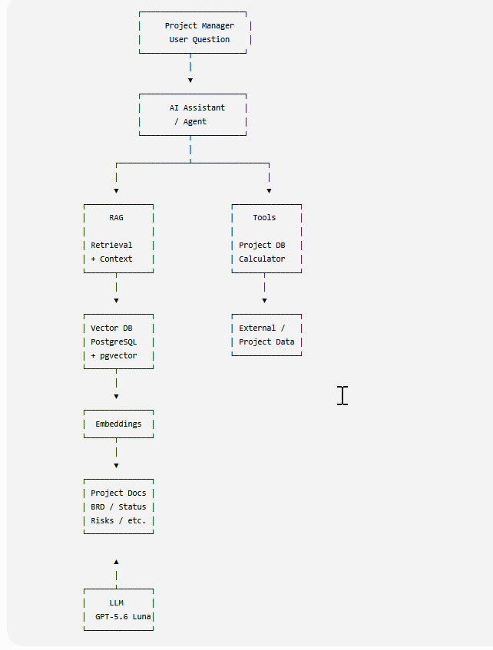
Day 1 — Understanding an LLM Application
By the end of today, you should understand this simple picture:
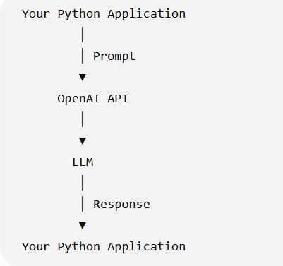
What is an LLM?
LLM = Large Language Model.
In simple terms:
An LLM is a model that has learned patterns from huge amounts of text and can generate/transform text based on the input you provide.
For our purposes, Think of it as:
Input
↓
LLM
↓
Generated Output
For ex
Input:
"Summarize this project status."

↓
LLM
↓
Output:
"The project is on track,
with two high-priority risks..."
Your job as an AI application developer is usually not to build the LLM.
Your application uses an existing LLM.
What is an LLM Application?
The LLM is not the entire application. Example
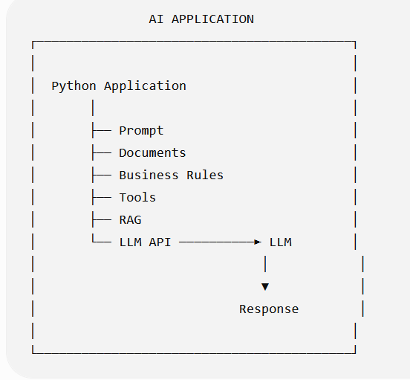
The LLM is a component inside an AI application.
Later, RAG, vector databases, tools, agents, guardrails, evaluation, logging, etc. will become additional components.
What is a Prompt?
A prompt is the input/instruction we give to the LLM. The prompt contains instructions and/or information that we want the model to process.
System Prompt vs User Prompt
Modern LLM applications commonly separate instructions into different message roles.
A simplified example:
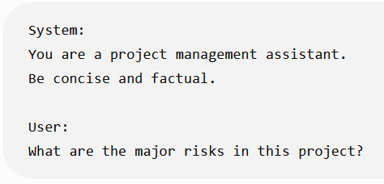
Think of them like this:
Message | Purpose
System | Defines behavior/instructions
User | Provides the user's request
Assistant | Model's response
For today, Just understand the basic relationship:
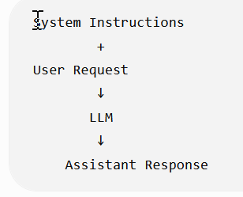
What is an API?
An API is simply the interface through which our application communicates with the LLM service.
For example:
Python Application
│
│ HTTP/API request
▼
OpenAI API
│
▼
Model
│
│ response
▼
Python Application
So instead of thinking: "My Python program talks directly to an AI brain."
Think - My Python application sends a request to an LLM service through an API
What are Tokens?
This is another term you will hear constantly. A token is a unit of text processed by the model.
Don't think of it as exactly equal to a word. For example:
"Project management is important"
might be represented internally as several tokens. The exact tokenization depends on the tokenizer/model.
For your current level, remember:
Tokens are the basic units used to measure the text processed by an LLM.
And this matters because API pricing is generally based on token usage.
Conceptually:
Input tokens
+
Output tokens
↓
API usage / cost

What is Context?
Context is the information available to the model when generating its response.
For example:
System instruction
+
User question
+
Previous conversation
+
Retrieved document
+
Tool result
↓
Context
↓
LLM

What is a Context Window?
A context window is the amount of information a model can process as context for a request.
You can think of it as the model's temporary working area for the current request.

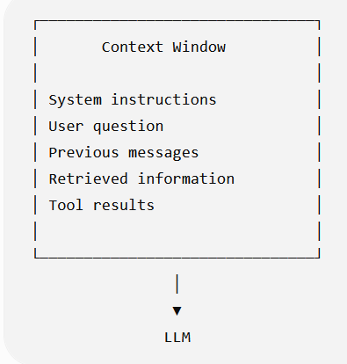
Just remember:
More context is not automatically better.
Later, when we learn RAG, you'll understand why we retrieve relevant chunks instead of blindly sending an entire document to the LLM.
Temperature
You will often see a parameter called temperature.
At a high level:
Temperature influences how deterministic vs varied the model's output can be.
Lower temperature
↓
More predictable output

Higher temperature
↓
More variation
For many of our PM-oriented tasks—summarization, extraction, structured responses—we generally want predictable behavior.
First Architecture
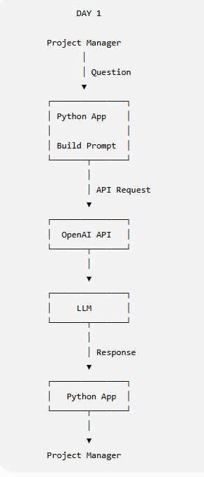
Day 1 — Simple Python Example
First install the OpenAI package:
- python -m venv venv
- pip install python-dotenv
- pip install openai
from openai import OpenAI

client = OpenAI()

response = client.responses.create(
model="gpt-5.6-luna",
input="Explain project risk in one simple sentence."
)

print(response.output_text)

Understand the flow:
client = OpenAI() Creates the API client.
Then:
client.responses.create(...)

means: "Send this request to the OpenAI API."
Then: model="gpt-5.6-luna"
selects the model. And: input="Explain project risk..."
is our prompt. Finally:
- response.output_text
gets the generated text.
What Happens Behind the Scenes?
Suppose you execute: input="What are the project risks?"
The simplified flow is:
Python
│
│ "What are the project risks?"
▼
OpenAI API
│
▼
Model
│
│ Processes input
▼
Generated response
│
▼
OpenAI API
│
▼
Python
│
▼
print(response)

TPM Perspective
This is where I want you to start thinking differently from a pure developer.
If an AI developer tells you:
We are integrating an LLM into the application.

You should eventually be able to ask:
- Which model?
- Why that model?
- What data is being sent to it?
- How large are the prompts?
- What is the expected token usage?
- What is the expected latency?
- What happens if the API is unavailable?
- What sensitive information is being sent?
- How are responses evaluated?
- Why do we need an LLM for this particular problem?
You don't need all the answers today.
But these are the kinds of questions that will turn you from:
"PM managing an AI development project"
into:
"Technical PM who understands the AI architecture being built."
Today's Key Takeaways
- An LLM is a component, not the complete AI application.
- An application communicates with the LLM through an API.
- A prompt provides instructions/information to the model.
- Tokens are the units used to process text and are important for cost.
- Context is the information available to the model for generating its response.

Day 2 — Prompting
How do I give an LLM instructions so that I get a useful and predictable response?
A Simple Prompt Structure :-For our learning, use this mental model:
Role
+
Instruction
+
Context
+
Task
+
Output Requirement
Not every prompt needs every component. For example:
Role:
You are a Technical Project Manager.

Context:
The payment API is delayed by 5 days.

Task:
Explain the impact of this delay.

Output requirement:
Give 3 concise bullet points.

Role:-
A role gives the model some behavioural context. Ex
You are a Technical Project Manager. OR You are a software support engineer.
Important
The role does not magically turn the LLM into that profession. It is simply an instruction that helps guide the response.
Instruction
The instruction tells the model what you want it to do.
Ex- Summarize the project status. OR Identify the project risks. OR Extract all action items.
The instruction should be reasonably clear
Context
Context is the information required to perform the task.EX –
Project:
Vehicle Insurance Portal

Status:
Development is complete.

Testing:
Testing is 60% complete.

Risk:
Payment gateway integration is delayed.

Then: Task- Identify the major project risk.
The project information is the context.
Task
The task is the actual operation you want the LLM to perform.
Ex Identify the top 2 risks. Or Summarize the status.
Output Requirement
This tells the LLM how you want the answer formatted. Ex
Return exactly 3 bullet points. OR Return the result as JSON.

Compare These Two Prompts
Prompt A - Tell me about this project.
Prompt B
You are a Technical Project Manager.

Project:
Vehicle Insurance Portal

Status:
Development is 90% complete.
Testing is 70% complete.
Payment integration is delayed by 3 days.

Task:
Summarize the current project status.

Output:
Provide exactly 3 bullet points.
Include one bullet about the payment integration delay.

Documents and Loaders
The LLM doesn't automatically have access of local files. So our application needs to get the information from the files. That gives us:
Document
↓
Read the document
↓
Extract its content
↓
Use the content in our AI application
The component that helps us with this is a Document Loader.
What Is a Document Loader?
A Document Loader is a component that reads data from a particular source/file and converts it into a format that our GenAI application can work with
Source | Possible Loader
TXT | Text loader
PDF | PDF loader
CSV | CSV loader
Word | Word/document loader
Web page | Web loader
Directory | Directory loader
OR
A Document Loader reads content from a file or other data source and brings it into the application as Document objects.
Main idea is -A loader is responsible for getting the content into our application. It is not responsible for understanding the meaning of the document.
What Does a Loader Actually Return?
This is an important concept. A loader generally doesn't simply return:
"Here is a giant string."
In frameworks such as LangChain, document loaders commonly produce Document objects.
Document(
page_content="Project is 75% complete...",
metadata={
"source": "project_status.pdf",
"page": 2
}
)
There are two important parts here.
1. page_content The actual text.
Project is 75% complete. Payment integration is delayed.

2. metadata
Information about that text. For example:
source = project_status.pdf
page = 2

What Is Metadata?
Metadata = information about the data.
For example:
Actual content:
"Payment integration is delayed by 4 days."

Metadata:
source = project_status.pdf
page = 5
document_type = project_status

One Document Can Produce Multiple Documents
Suppose you have: Project_Status.pdf, with 10 pages.
A PDF loader might produce something conceptually like:
PDF
│
├── Document(page_content="...", metadata={"page": 1})
├── Document(page_content="...", metadata={"page": 2})
├── Document(page_content="...", metadata={"page": 3})
├── Document(page_content="...", metadata={"page": 4})
├── ...
└── Document(page_content="...", metadata={"page": 10})
So, One physical file can result in multiple Document objects.
Loader vs Splitter
Loader :- Gets content from the source
Text splitter:- Splits the loaded content into smaller pieces
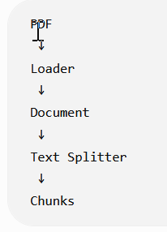
PDF ↓ Loader ↓ Document ↓ Text Splitter ↓ Chunks
Loader vs Embedding
Similarly: Loader Gets text
while: Embedding Converts text into a numerical vector
Loader vs RAG
A loader does not mean you have built RAG.
You could simply do:
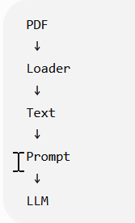
That's a basic document-aware LLM application.
RAG comes later:
Documents
↓
Loader
↓
Chunking
↓
Embeddings
↓
Vector DB
↓
Retrieval
↓
Relevant chunks
↓
Prompt + Context
↓
LLM

So don't call every document-based LLM application "RAG."
Our Project Management AI Assistant
Let's apply this to our continuous project. Suppose we have:
project_documents/
│
├── project_status.txt
├── risk_register.txt
└── release_notes.txt
Our first pipeline is:
Project Documents
↓
Loader
↓
Document Objects
↓
page_content
+ metadata
Later:
Document Objects
↓
Chunking
↓
Chunks
And eventually:
Chunks
↓
Embeddings
↓
PostgreSQL + pgvector
↓
Similarity Search
↓
RAG

A simple LangChain text loader could look like:
from langchain_community.document_loaders import TextLoader

loader = TextLoader("project_status.txt")

documents = loader.load()

print(documents)

The important part is: loader = TextLoader(...)
We're creating the loader. Then documents = loader.load()
Means Read the file and return the loaded document(s) objects.
Inspecting the Result
Instead of printing the entire object, we can inspect the important pieces:
- print(documents[0].page_content)
- print(documents[0].metadata)
Why documents[0]
This is worth understanding.
documents is a collection/list.
Conceptually:
documents
│
├── [0] → Document
├── [1] → Document
├── [2] → Document
└── ...
So documents[0]
The Architecture We Have Reached
Yesterday:-
User
↓
Prompt
↓
LLM
↓
Response
Today
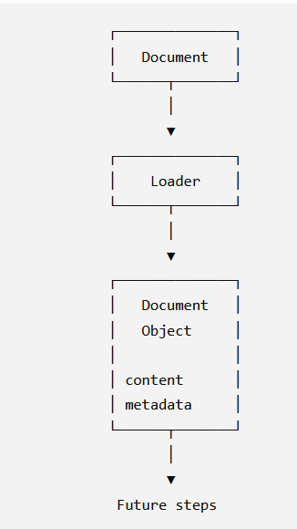
TPM Perspective
Suppose your AI architect tells you: "We'll implement a RAG system for the project documentation."
You should now be able to ask:
Documents
- What document types are we supporting?
- PDF?
- Word?
- Excel?
- HTML?
- Emails?
Ingestion
- How are documents loaded?
- Is ingestion manual or automatic?
- What happens when a document changes?
Metadata
- What metadata are we storing?
- Document name?
- Page number?
- Project?
- Version?
- Date?
You don't need to design the loader yourself as a TPM.
But you should understand what problem it solves and where it fits in the architecture.
What You DON'T Need to Learn Today
- Every LangChain loader
- PDF parsing internals
- OCR
- Document layout models
- Advanced metadata strategies
- Custom loaders
- Async document ingestion
- Enterprise document pipelines
Those are later/production topics. For today, remember only:
Loader = gets content from a source and:
Document = page_content + metadata
Today's Key Takeaways
- A document loader reads content from a source and brings it into our application.
- A Document Loader reads content from a file or other data source and brings it into the application as Document objects
- LangChain loaders commonly return Document objects containing page_content and metadata.
- Loader ≠ Text Splitter ≠ Embedding ≠ RAG; each performs a different job.
- One physical document can produce multiple Document objects.
- Metadata tells us about the content, such as source or page number.
- RAG retrieves relevant information from an external knowledge source and supplies that retrieved context to the LLM so the LLM can generate an answer based on it.

Day 4 — Chunking / Text Splitters
Chunking means breaking a large piece of text into smaller pieces called chunks.
Large Project Document
↓
Chunking
↓
┌───────────────┐
│ Chunk 1 │
├───────────────┤
│ Chunk 2 │
├───────────────┤
│ Chunk 3 │
├───────────────┤
│ Chunk 4 │
└───────────────┘
Instead of treating a 50-page document as one huge block, we create smaller meaningful pieces.
Why Do We Need Chunking?
There are several practical reasons.
1. Large documents
A document can be much larger than what we want to process in one operation.
2. Retrieval
Suppose the user asks: "Why is the payment gateway delayed?"
We don't want to retrieve the entire 50-page document.
We want something like:
Question Find relevant chunk "Payment gateway integration is delayed by 4 days..."
3. Embeddings
Later, we will create embeddings for chunks.
Instead of: 50-page document → 1 embedding
we generally want:
50-page document chunks embedding for each chunk
This makes semantic retrieval much more useful.
Simple Example
Suppose our document says:
Vehicle Insurance Project

The project is 75% complete.

Development is almost complete.

Payment gateway integration is delayed by 4 days.

Testing has started.

Two critical defects are open.

Production deployment is planned for 20 August.
We could split it conceptually into:
Chunk Size
Chunk 1:
Vehicle Insurance Project
The project is 75% complete.

Chunk 2:
Development is almost complete.
Payment gateway integration is delayed by 4 days.

Chunk 3:
Testing has started.
Two critical defects are open.

Chunk 4:
Production deployment is planned for 20 August.
Chunk Size A chunk size determines approximately how much text goes into each chunk.
Conceptually:
Small chunk
↓
Less information

Large chunk
↓
More information
But there is a trade-off. Too small
"Payment gateway"
We may lose important context.
Too large - Several pages of unrelated project information
We may retrieve lots of unnecessary information.
So the Goal is - Create chunks that contain enough information to preserve meaning while remaining small enough for effective retrieval.
Chunk Overlap
This is an important term. Sometimes we allow neighboring chunks to share some text.
Ex
Chunk 1:
The payment gateway integration started in July.
The external vendor initially provided the API...

Chunk 2:
The external vendor initially provided the API...
Integration testing is now delayed by four days.

The repeated part is the overlap. Why?
Because important information can sometimes sit at the boundary between two chunks.
Overlap helps preserve some continuity.
Loader vs Chunking — Final Distinction
LangChain Example
We'll use LangChain for the hands-on part.
A common splitter is: RecursiveCharacterTextSplitter
We can use it like this:
from langchain_text_splitters import RecursiveCharacterTextSplitter

text = """
Vehicle Insurance Project

The project is 75% complete.
Development is almost complete.
Payment gateway integration is delayed by 4 days.
Testing has started.
Two critical defects are open.
Production deployment is planned for 20 August.
"""

splitter = RecursiveCharacterTextSplitter(
chunk_size=100,
chunk_overlap=20
)

chunks = splitter.split_text(text)

for chunk in chunks:
print("-----")
print(chunk)
The important parameters are: chunk_size=100
Approximately controls how large each chunk should be. And chunk_overlap=20.
means neighboring chunks can share approximately 20 characters.
One Important Point
There is no single perfect chunk size for every application.
It depends on:
- Document type
- Content structure
- Retrieval requirements
- Embedding model
- Query type
- Evaluation results
TPM Perspective
This becomes a real project-management decision. If your developer says:
"We've implemented RAG."
Ask: "How are we chunking the documents?"
Then potentially:
- What is the chunk size?
- What is the overlap?
- Why were those values selected?
- Are we preserving headings?
- Are tables being handled correctly?
- Have we tested retrieval quality?
You don't need to dictate the numbers. Your role is to understand why the technical decision exists and whether it has been validated.
What You DON'T Need to Learn Today
Skip these for now:
- Advanced token-based splitting
- Semantic chunking
- Parent-child retrieval
- Hierarchical chunking
- Document structure-aware chunking
- Late chunking
- Advanced retrieval strategies
We'll come back to advanced techniques only if they become relevant.
Today's Exercise
Use the same project_status.txt from Day 3. Create a program that:
project_status.txt
↓
TextLoader
↓
Document
↓
RecursiveCharacterTextSplitter
↓
Chunks
Then print:
for i, chunk in enumerate(chunks):
print(f"\n--- Chunk {i+1} ---")
print(chunk.page_content)
If you are using split_documents(), the chunks will remain Document objects. If you use split_text(), you'll get strings.
Why not one 50-page chunk?
A huge chunk contains too much unrelated information. When we search for a specific question, retrieving the entire chunk gives the LLM unnecessary context.
Chunk size controls approximately how much text each chunk contains.
Chunk overlap intentionally repeats some text between neighboring chunks so that information at chunk boundaries is not completely separated.
Day 5 — Embeddings
So far we have:
Document
↓
Loader
↓
Document Object
↓
Chunking
↓
Chunks
Now we need to make those chunks searchable by meaning. That's where embeddings come in.

What Is an Embedding?
An embedding is a numerical representation of text that captures aspects of its meaning.
For example:- "Payment gateway is delayed."
is converted into something conceptually like: [0.21, -0.73, 0.15, 0.91, ...]
That list of numbers is called a vector. So
Text
↓
Embedding Model
↓
Vector
Important
Don't worry about what each individual number means.
For now:
Embedding => converting text into a numerical representation that can be compared based on semantic meaning.
Why Do We Need Embeddings?
Suppose our project document contains:
Embeddings allow us to represent two different text as vectors and compare their semantic similarity.
Why Do We Need Embeddings?
Suppose our project document contains: "Payment gateway integration is delayed by four days."
The user asks: "Why is the payment processing implementation late?"
Notice:
Document: payment gateway integration is delayed
Question: payment processing implementation is late
The exact words are different.A simple keyword search might struggle.
But the meaning is similar. Embeddings allow us to represent both as vectors and compare their semantic similarity.
Conceptually:
Document Chunk
"Payment gateway integration is delayed"
↓
Embedding [0.21, -0.73, ...]

User Question
"Why is payment processing late?" Embedding [0.19, -0.70, ...]
Because the vectors are relatively close, the system can identify the chunk as relevant.

What Is a Vector?
A vector is simply an ordered collection of numbers.
For example: [0.21, -0.73, 0.15, 0.91]
That's a very small example. Real embedding vectors usually have many more dimensions.
Semantic Search
This is where embeddings become powerful.
Semantic search means searching based on meaning, rather than requiring exact keyword matches.
Example:
Document
"The customer payment service is experiencing a delay."
User question
"Why is the payment system slow?"
The words aren't identical. But semantically they are related.
The embedding approach allows us to compare the meaning represented by their vectors.
Embedding Model
An embedding model is the model that converts text into vectors.
Conceptually:
Embedding Model
│
├── "Payment is delayed"
│ ↓
│ Vector A
│
└── "Payment processing is late"
↓
Vector B
Then we compare Vector A and Vector B.
Similarity
We need a way to determine: "How similar are these two vectors?"
There are different mathematical methods for doing this. One commonly used concept is cosine similarity. You don't need to learn the mathematics today.
Just understand:
Vector A
↕
Similarity calculation
↕
Vector B
Higher similarity generally means: The texts are more semantically related.
RAG Pipeline
Previously:
Documents
↓
Loader
↓
Chunks
Now:
Documents
↓
Loader
↓
Chunks
↓
Embedding Model
↓
Vectors
Tomorrow we'll introduce the place where these vectors are stored:
Vectors Vector Database

Very Important: Embedding ≠ LLM
Don't confuse the two.
LLM - Used primarily to generate/process responses.
Question + Context
↓
LLM
↓
Answer

Embedding Model- Used to convert text into vectors for similarity/search.
Text
↓
Embedding Model
↓
Vector

In a RAG system, we can use both.
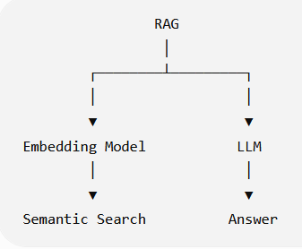
Example Using Our Project
Suppose we have these chunks:
Chunk 1:
Project is 75% complete.

Chunk 2:
Payment gateway integration is delayed by 4 days.

Chunk 3:
Two critical defects are open.

Chunk 4:
Production deployment is planned for 20 August.
We generate an embedding for each:
Chunk 1 → Vector 1
Chunk 2 → Vector 2
Chunk 3 → Vector 3
Chunk 4 → Vector 4
User asks: Why is the payment integration late?
We create an embedding for the question: Question → Query Vector
Then compare:
Query Vector
│
├── compare → Vector 1
├── compare → Vector 2 ← HIGH similarity
├── compare → Vector 3
└── compare → Vector 4
So: Chunk 2 is likely retrieved as relevant. This is the foundation of semantic retrieval.
TPM Perspective
This is where your architecture-review skills start becoming useful.
If an architect says: "We'll use embeddings for document search."
You should understand that the next questions are:
- Which embedding model?
- What content are we embedding?
- What is the embedding dimension?
- Where are embeddings stored?
- How are they searched?
- How do we measure retrieval quality?
- How much does embedding generation cost?
- What happens when a document changes?
You don't need to know the mathematical details behind the embedding model to ask these questions.
Cost Perspective: -
Embeddings can also consume API credits. Conceptually:
Documents
↓
Chunks
↓
Embedding API
↓
Vectors
If you have:
10 documents
×
100 chunks/document
=
1,000 chunks
you potentially need to generate embeddings for 1,000 pieces of text.
Therefore: Chunking decisions can indirectly affect embedding cost.
We will discuss this later
Chunk size
↓
Number of chunks
↓
Number of embeddings
↓
Embedding cost

What You DON'T Need to Learn Today
- Vector mathematics
- Linear algebra
- Neural network architecture
- How embedding models are trained
- Cosine similarity formula
- Euclidean distance formula
- Dimensionality reduction
- ANN algorithms
For today, remember: Text → Embedding Model → Vector
and: Similar meaning → Similar/nearby vectors
Today's Practical Exercise
Before making an API call, let's first do a conceptual exercise. Consider these three pieces of text:
A:
"The payment gateway integration is delayed by four days."
B:
"The payment processing implementation is running four days late."
C:
"The development team completed the login module."
And this user question: Why is the payment implementation late?"

Revision
An embedding is a numerical representation of text that captures aspects of its meaning.
Vector- Think of it as:
Text
↓
Embedding Model
↓
Embedding
↓
Vector = [0.21, -0.73, 0.15, ...]
One small distinction: embedding is the representation/process/result depending on context; the resulting numerical array is commonly called the embedding vector.
Chunking and embedding cost
higher number of chunks → higher number of embeddings
Larger number of chunks
↓
More chunks to embed
↓
More embedding input
↓
Potentially higher embedding cost
Also remember that number of chunks isn't the only cost factor; the amount of text/tokens being embedded matters too.
Day 5 Completed
DOCUMENT
↓
LOADER
↓
DOCUMENTS
↓
CHUNKING
↓
CHUNKS
↓
EMBEDDING MODEL
↓
VECTORS
Now we need somewhere to store those vectors and search them efficiently.
Day 6 — Vector Database # What is a Vector Database?
A Vector Database is a database/system designed to store vectors and efficiently perform similarity searches against them. For example:
Chunk:
"Payment gateway integration is delayed by 4 days."
↓
Embedding
↓
[0.21, -0.73, 0.15, 0.91, ...]
We need to store that vector along with the original information.
Conceptually:
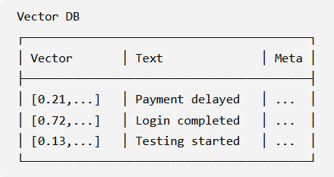
Why Can't We Just Use a Normal Database?
This is an important TPM-level question. You already use PostgreSQL, so think about this:
A traditional database is very good at queries like:
SELECT *
FROM projects
WHERE status = 'Delayed';
That's an exact/filter-based query.
But suppose the user asks: "Which project activity is causing the release to be late?"
We aren't necessarily looking for an exact keyword.
We want: Which stored text is semantically most similar to this question?
That's where vector similarity search comes in.
Normal Database vs Vector Search
Traditional database
User Query
↓
SQL / filters
↓
Exact/structured data
Example: status = 'Delayed'
Vector search
User Question
↓
Embedding
↓
Query Vector
↓
Similarity Search
↓
Relevant Chunks
Example Our vector database contains:
Chunk 1:
"The login module has been completed."

Chunk 2:
"Payment gateway integration is delayed by four days."

Chunk 3:
"Testing has started for the policy module."
Each chunk has an embedding. Now user asks:
Why is the project release delayed?
The application converts the question into an embedding:
Question Embedding Model Query Vector
Then the vector database compares that query vector against stored vectors.
Conceptually
Query Vector
│
├── Chunk 1 → similarity: low
├── Chunk 2 → similarity: HIGH
└── Chunk 3 → similarity: medium
The database returns Chunk 2.
This Is Retrieval
Now you should see why we call this Retrieval.
Question
↓
Query Embedding
↓
Vector Database
↓
Similarity Search
↓
Relevant Chunks
The vector database is helping us retrieve relevant information. And that gives us the "R" in: RAG = Retrieval-Augmented Generation
Where Does the Original Text Go?
This is important. We don't want to store only:
[0.21, -0.73, 0.15, ...]
For example:
Vector:
[0.21, -0.73, ...]

Text:
"Payment gateway integration is delayed by four days."

Metadata:
{
source: "project_status.pdf",
page: 5
}
Then when the vector search finds that vector, we can retrieve the corresponding text.
The Full Pipeline So Far:- We now have:
INGESTION
│
▼
Documents
│
▼
Loader
│
▼
Documents Object
│
▼
Chunking
│
▼
Chunks
│
▼
Embedding Model
│
▼
Vectors
│
▼
Vector Database

Then at query time:
USER QUESTION
│
▼
Embedding Model
│
▼
Query Vector
│
▼
Vector Database
│
▼
Similarity Search
│
▼
Relevant Chunks

PostgreSQL Can Also Be a Vector Database: - PostgreSQL can support vector search using pgvector.
Conceptually:
PostgreSQL
+
pgvector
↓
Store vectors
+
Perform vector similarity search
Vector Database vs Embedding Model
Don't mix these two. Embedding Model Converts: (Text → Vector)
Vector Database - Stores and searches:
- Vector → Store
- Vector → Similarity Search (The vector database is also responsible for searching those vectors for similarity)
TPM Perspective
If an architect proposes: "Let's use a vector database for our RAG application."
You should understand the key decisions:
- Which vector database?
- Why this database?
- Where will vectors be stored?
- How will similarity search work?
- How will metadata filtering work?
- How will documents be updated?
- What happens when a document is deleted?
- How will retrieval quality be measured?
- What is the expected query volume?
- What is the cost?
Again, you don't need to become the database engineer. You need to understand the architecture and trade-offs.
Today's Exercise
in this flow user provide a document first we (system ) load the loader based on the type of file. Loader will return the document object which we (system) pass to next step for splitting . in this step document will break into multiple chunks . After chunks we use embedding model and convert every chunk to vector and in last step we store that vector to vector database
Document
↓
Loader
↓
Document Object
↓
Splitting
↓
Chunks
↓
Embedding Model
↓
Vectors
↓
Vector Database
One important terminology refinement:
We don't normally say "we load the loader." Instead:
The application selects/creates the appropriate loader for the document type and uses it to load the document.
Day 7 — Complete RAG Flow
Suppose our company has this document: Project_Status.pdf
The document contains: Payment gateway integration is delayed by four days.
A user asks: Why is the payment integration late?
Now, We don't send the entire 50-page document to the LLM. Instead
Step 1 — User asks a question:- Why is the payment integration late?
Step 2 — Convert question to vector
Question
↓
Embedding Model
↓
Query Vector
Step 3 — Search Vector DB
Query Vector
↓
Vector Database
↓
Similarity Search
Step 4 — Retrieve relevant chunk
The database might return: "Payment gateway integration is delayed by four days."
Step 5 — Give the relevant context to the LLM
Now we construct something conceptually like:
Context:
Payment gateway integration is delayed by four days.

Question:
Why is the payment integration late?

Step 6 — LLM generates the answer
The payment integration is late because the payment gateway
integration is currently delayed by four days.

The Most Important Architecture Diagram So Far
USER
│
▼
Question
│
▼
Embedding Model
│
▼
Query Vector
│
▼
┌───────────────┐
│ Vector DB │
└───────┬───────┘
│
Similarity Search
│
▼
Relevant Chunks
│
▼
┌──────────────────┐
│ Prompt + Context │
└────────┬─────────┘
│
▼
LLM
│
▼
Answer
And separately, before users ask questions:
Documents
↓
Loader
↓
Chunking
↓
Embedding Model
↓
Vectors
↓
Vector Database
The Key TPM Interview Question
"Explain RAG in simple terms." You should now be able to answer:
"RAG, or Retrieval-Augmented Generation, allows an LLM application to use external knowledge such as company documents. Documents are loaded and split into chunks, the chunks are converted into embeddings and stored in a vector database. When a user asks a question, the question is also converted into an embedding, relevant chunks are retrieved using similarity search, and those chunks are provided as context to the LLM to generate the answer."
The one sentence to remember
RAG retrieves relevant external information using vector similarity search and gives that information to the LLM as context to generate a better answer.

Day 8. Start building the RAG pipeline in Python/LangChain.
Install the packages
pip install langchain
langchain-community
langchain-openai
langchain-text-splitters

For the vector store, we'll use Chroma initially because it is easy to understand locally:
pip install chromadb langchain-chroma
Since you're already working with LangChain, install
Load the document
Start with what you learned on Day 3:
from langchain_community.document_loaders import TextLoader

loader = TextLoader("project_status.txt")

documents = loader.load()

print("Number of documents:", len(documents))
print(documents[0].page_content)
print(documents[0].metadata)
At this point:
project_status.txt
↓
TextLoader
↓
documents

Add Chunking
Now add the Day 4 concept:
from langchain_text_splitters import RecursiveCharacterTextSplitter
text_splitter = RecursiveCharacterTextSplitter(
chunk_size=200,
chunk_overlap=30
)
chunks = text_splitter.split_documents(documents)
Now inspect them:
print("Number of chunks:", len(chunks))

for i, chunk in enumerate(chunks):
print(f"\n--- Chunk {i + 1} ---")
print(chunk.page_content)
print("Metadata:", chunk.metadata)
Our pipeline is now:
Document
↓
Loader
↓
Document Object
↓
Text Splitter
↓
Chunks
Generate Embeddings
Now we introduce what you learned on Day 5. Using LangChain:
from langchain_openai import OpenAIEmbeddings
Then
embeddings = OpenAIEmbeddings(
model="text-embedding-3-small"
)
Conceptually
Chunk
↓
OpenAI Embedding Model
↓
Vector
You don't need to manually call the embedding API yourself here. LangChain's OpenAIEmbeddings handles that interaction.
Store the Vectors
from langchain_chroma import Chroma
Then
vector_store = Chroma.from_documents(
documents=chunks,
embedding=embeddings,
collection_name="vehicle_insurance_project"
)

This single operation conceptually does:
Chunks
↓
Embedding Model
↓
Vectors
↓
Chroma Vector Store

Our First Complete Ingestion Pipeline
from langchain_community.document_loaders import TextLoader
from langchain_text_splitters import RecursiveCharacterTextSplitter
from langchain_openai import OpenAIEmbeddings
from langchain_chroma import Chroma
import config

# 1. Load document
loader = TextLoader("project_status.txt")
documents = loader.load()

print("Documents loaded:", len(documents))

# 2. Split document into chunks
text_splitter = RecursiveCharacterTextSplitter(
chunk_size=200,
chunk_overlap=30
)

chunks = text_splitter.split_documents(documents)

print("Chunks created:", len(chunks))

# 3. Create embeddings
#To access config value run this command
# pip install python-dotenv

embeddings = OpenAIEmbeddings(
model="text-embedding-3-small",
openai_api_key=config.Config.OPENAI_API_KEY

)

# 4. Store chunks + embeddings in vector database
vector_store = Chroma.from_documents(
documents=chunks,
embedding=embeddings,
collection_name="vehicle_insurance_project"
)

print("Documents successfully stored in vector database.")

The Important Architecture Distinction
There are actually two phases in a RAG system.
Phase 1 — Ingestion
Usually happens when documents are uploaded/updated:
Document
↓
Loader
↓
Chunking
↓
Embedding
↓
Vector DB

Phase 2 — Query
Happens when the user asks a question:
User Question
↓
Embedding
↓
Vector DB
↓
Similarity Search
↓
Relevant Chunks
↓
LLM
↓
Answer
So don't think of RAG as one single API call.
It's a pipeline with an ingestion phase and a query/retrieval phase.
One thing I want you to notice :- When this executes:
vector_store = Chroma.from_documents(
documents=chunks,
embedding=embeddings
)
you are not sending the user's question to the LLM. You're preparing the knowledge base.

Day 9 — Retrieval / Similarity Search
For this learning we will take this -Why is the payment gateway delayed?
and perform:
User Question
↓
Embedding
↓
Query Vector
↓
Chroma
↓
Similarity Search
↓
Relevant Chunk
And we'll inspect the actual chunk returned by the vector database.
For the retrieval and Similarity Search, we will use the vector store we created above.
Our question is -Why is the payment gateway delayed?
We already know the answer exists somewhere in our document: The payment gateway integration is delayed by 4 days.
But our application doesn't directly know which chunk contains that information. That's what retrieval does.
Load the Existing Vector Store
- Use the above program to
- Import Library
- Then load the document and split using splitter
- Then create the embedding model
- Create the vector store:
Perform Similarity Search
Now comes the new part:
query = "Why is the payment gateway delayed?"

results = vector_store.similarity_search(
query,
k=2
)
In this case important point is “similarity_search()” and k=2 . Here K=2, return the top 2 most relevant chunks.
See What Was Retrieved If you print the result then
for i, result in enumerate(results):
print(f"\n--- Result {i + 1} ---")
print(result.page_content)
print("Metadata:", result.metadata)
You should expect something similar to:
--- Result 1 ---

The project is 75% complete.
Development is almost complete.
Payment gateway integration is delayed by 4 days.
Testing has started.
Metadata: {'source': 'project_status.txt'}
The exact ranking can vary, but the chunk containing the payment gateway information should be highly relevant.
#$# What Actually Happened?
This single line: results = vector_store.similarity_search( query, k=2)
hides several operations. Conceptually:
"Why is the payment gateway delayed?"
│
▼
Embedding Model
│
▼
Query Vector
│
▼
Chroma Vector DB
│
▼
Similarity Comparison
│
▼
Top 2 Relevant Chunks
Important Point — We Did NOT Call the LLM
Notice something. Our code has: OpenAIEmbeddings(...) but there is no:
ChatOpenAI(...) AND client.responses.create(...)
Why? Because retrieval and generation are separate steps. Right now we're only asking:
Which chunks are relevant to this question?
We're not yet asking: "Generate an answer." SO below is the retrieval.
Question
↓
Embedding
↓
Vector DB
↓
Relevant Chunk

Retrieval vs Generation
Retrieval :- Question Find relevant information
Generation:-
Question + Relevant Information
↓
LLM
↓
Answer
RAG combines both:
RETRIEVAL
Question ───────→ Relevant Context
│
▼
GENERATION
│
▼
LLM
│
▼
Answer
What Does k=2 Mean?
Suppose your vector database contains 100 chunks.
And you ask
results = vector_store.similarity_search(
query,
k=2
)
Here you are asking for The top 2 most similar/relevant chunks. If k=5 then it will return top 5. This is called Top-K retrieval.
Why Not Retrieve Everything?
Suppose we have: 10,000 chunks and retrieve all 10,000. We would defeat the purpose of RAG.
The whole point is: out 10,000 chunks Find relevant ones top 3 or top 5.
This helps control:
- Context size
- LLM input tokens
- Cost
- Noise
- Response quality
similarity_search_with_score()
Since you have already seen this method in your LangChain learning, now is a good time to understand why it exists. You can do:
results = vector_store.similarity_search_with_score(
query,
k=2
)
Now each result contains something like: (Document(...), score)
You can inspect it:
for doc, score in results:
print("\n--- Result ---")
print(doc.page_content)
print("Score:", score)
Important caution : - Don't automatically assume:
Higher score = more similar
The interpretation depends on the vector store and distance metric being used.
For Chroma, the returned score is commonly a distance, so a lower distance generally indicates greater similarity.
This is why you should understand the semantics of the metric rather than blindly applying "higher is better."
Why Does This Matter in a Real Project?
Imagine your RAG system returns:
Result 1 → highly relevant
Result 2 → somewhat relevant
Result 3 → unrelated
If you blindly send all three to the LLM:
LLM Context
├── Relevant information
├── Somewhat relevant information
└── Unrelated information
the irrelevant information can reduce answer quality. So production RAG systems often need:
Retrieval
↓
Ranking / Filtering
↓
Relevant Context
↓
LLM

Day 9 ✅ Completed
INGESTION
│
Document → Loader → Chunks
│
▼
Embeddings
│
▼
Vector DB
│
│
QUERY
│
User Question → Embedding
│
▼
Similarity Search
│
▼
Relevant Chunks

Day 10 — Connect Retrieval to the LLM
We'll take the result you are already retrieving:
"The payment gateway integration is delayed by 4 days."
and pass it to the LLM along with the user's question. Conceptually:
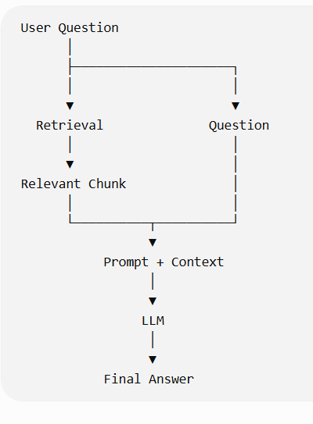
First, do it manually
Before using a LangChain RAG chain, I want you to understand exactly what's happening.
After your similarity search:
query = "Why is the payment gateway delayed?"

results = vector_store.similarity_search(
query,
k=1
)
Get the retrieved text: context = results[0].page_content
Now create a prompt:
prompt = f"""
Answer the user's question using only the provided context.

Context:
{context}

Question:
{query}
"""
Then send that prompt to the LLM. Since you've already worked with the OpenAI Responses API, you can use:
from openai import OpenAI

client = OpenAI()

response = client.responses.create(
model="gpt-5.6-luna",
input=prompt
)

print(response.output_text)

So the complete flow is now:
Question
↓
Similarity Search
↓
Relevant Chunk
↓
Build Prompt
↓
LLM
↓
Answer
• In your own words, explain why we passed context into the prompt.
context provide the additional information which LLM can use to provide the answer.
User Question
↓
Similarity Search
↓
Retrieved Chunk
↓
Context
↓
LLM

• What would happen if we removed the context from the prompt?
if you remove the context then their would be two scenario if the question is of generice type then LLM will provide answer based on his training data but if the question is particuallary related to any document or data which is not present in online then LLM will give response that he is not aware about this question
• Is the vector database generating the final answer? Why?
Vector DB- Finds/retrieves relevant information.
LLM- Uses the question + retrieved context to generate the final response.
Vector DB
↓
"What information is relevant?"

LLM
↓
"What answer should I generate using that information?"
What answer did the LLM return?
The context does not specify the reason for the payment gateway delay; it only states that the delay may affect the 20 August production deployment.
One Important RAG Lesson From Your Test
You just encountered something that is very important in production RAG:
Retrieval Quality → Answer Quality
Imagine:
Actual document
↓
10 chunks
↓
Vector Database
↓
Question
↓
Wrong chunk retrieved
↓
LLM
↓
Poor answer
The LLM may be working perfectly. The problem is that it was given the wrong context.
Therefore: RAG quality depends heavily on retrieval quality.
To handle this situation we can combine the context and then pass it to LLM
context = "\n\n".join(
result.page_content for result in results
)
Context = Chunk 1 + Chunk 2 Then Send it to LLM
prompt = f"""
Answer the user's question using only the provided context.

Context:
{context}

Question:
{query}
"""
One More Important Concept
You have now discovered why we don't simply say: "Use RAG."
In a real project, there are multiple quality stages:
Document
↓
Loading Quality
↓
Chunking Quality
↓
Embedding Quality
↓
Retrieval Quality
↓
Context Quality
↓
LLM Generation
↓
Final Answer
A problem at any earlier stage can affect the final answer. As a Technical PM, this is much more useful than simply knowing the definition of RAG.
# Day 11 — Retriever
Now we're going to make the code cleaner. So far, you have manually done:
results = vector_store.similarity_search(query, k=2)
But LangChain gives us a Retriever abstraction. The idea is:
Vector Store
↓
Retriever
↓
Relevant Documents

Instead of directly calling: vector_store.similarity_search()
We create :-
retriever = vector_store.as_retriever(
search_kwargs={"k": 2}
)
Now
results = retriever.invoke(
"Why is the payment gateway delayed?"
)
The retriever handles the retrieval operation for us.
Why do we need a Retriever?
Think of the responsibilities:
Vector Store
Stores vectors and provides search capabilities.
Retriever
Provides a standard interface for retrieving relevant documents.
So:
Vector Store
↓
as_retriever()
↓
Retriever
↓
invoke(question)
↓
Relevant Documents
First Retriever code
retriever = vector_store.as_retriever(
search_kwargs={"k": 2}
)

query = "Why is the payment gateway delayed?"

results = retriever.invoke(query)

for i, result in enumerate(results):
print(f"\n--- Result {i + 1} ---")
print(result.page_content)
print("Metadata:", result.metadata)
Notice something important: Previously:
vector_store.similarity_search(query, k=2)
Now :- retriever.invoke(query)
The Retriever is hiding the lower-level retrieval implementation.
Retriever
A Retriever provides a simple interface for retrieving relevant documents while hiding the underlying retrieval implementation.
Vector Store vs Retriever
The vector_store is not just responsible for initializing a vector variable.
Think of it this way:
Vector Store:
Chunks
↓
Embeddings
↓
Stores vectors + documents/metadata
↓
Can perform similarity search
Retriever
Question
↓
Retriever
↓
Asks the underlying vector store
↓
Returns relevant Documents
Vector Store = storage + vector search capability
Retriever = abstraction/interface used by the application to retrieve relevant documents
retriever.invoke(query)
internally it performs similarity_search and provides the result based on the k value
query
↓
retriever.invoke(query)
↓
Vector Store
↓
Similarity Search
↓
Top K Documents

# Day 12 — Retriever + Prompt + LLM
Until now, we've done these separately:
Retriever
↓
Relevant chunks
And
Prompt + Context
↓
LLM
↓
Answer
Now we're going to connect them:
User Question
↓
Retriever
↓
Relevant Chunks
↓
Context
↓
Prompt + Question + Context
↓
LLM
↓
Final Answer
Step 1 — Create the Retriever
We already know this:
retriever = vector_store.as_retriever(
search_kwargs={"k": 2}
)

Step 2 — Create the LLM
Using LangChain:
from langchain_openai import ChatOpenAI

llm = ChatOpenAI(
model="gpt-5.6-luna"
)

Step 3 — Create the Prompt :- We'll use ChatPromptTemplate:
from langchain_core.prompts import ChatPromptTemplate

prompt = ChatPromptTemplate.from_template("""
Answer the question using only the provided context.

Context:
{context}

Question:
{question}
""")
Notice the two variables: {context} and {question}
Step 4 — Retrieve the Context
For now, let's keep it explicit so you can see what's happening:
query = "Why is the payment gateway delayed?"

results = retriever.invoke(query)

context = "\n\n".join(
result.page_content
for result in results
)
Step 5 — Send Context + Question to the Prompt
formatted_prompt = prompt.invoke({
"context": context,
"question": query
})
Conceptually this becomes:
Answer the question using only the provided context.

Context:
The payment gateway integration is delayed by 4 days.
...

Question:
Why is the payment gateway delayed?
Step 6 — Send Prompt to LLM
response = llm.invoke(formatted_prompt)

print(response.content)
Now we have:
Retriever
↓
Context
↓
Prompt
↓
LLM
↓
Answer

