Walls Worth Watching: A Comparative Study of Swing-Pivot, K-Means Price Clustering, and Volume-Profile Zone Detection for Swing Trading Across Three NSE Indices
Priya Krishnamurthy and Tanmay Bose
National Institute of Technology, Rourkela 769008, Odisha, India
{krishnamurthyp, bose.tanmay}@nitrkl.ac.in
Abstract. Support and resistance zones form the foundational premise of most discretionary swing trading frameworks, yet no controlled study has compared alternative computational approaches to zone detection under identical backtesting conditions across multiple Indian equity indices. This paper addresses that gap by implementing and comparing three algorithmically distinct zone detection paradigms on daily OHLCV data from January 2018 to December 2024 across three NSE benchmarks — the Nifty 50, Bank Nifty, and Nifty Midcap 100: (i) Swing-Pivot detection, based on local fractal extrema with a configurable look-back window; (ii) K-Means Price Clustering, which groups historical closing prices into density-weighted clusters to identify price levels attracting repeated market attention; and (iii) Volume Profile zone derivation, which identifies zones of concentrated trading activity through Point of Control and Value Area boundaries computed from session-level volume distributions. All three methods are evaluated on identical zone-strength metrics — zone hold rate, average touch count, and zone width as a proportion of price — and are further embedded in a shared rule-based trade simulator enforcing a 1.5% stop-loss and a 3.0% target (2:1 reward-to-risk), with and without a candlestick pattern confirmation gate. Results show that Volume Profile zones achieve the highest hold rates across all three indices (64.1%, 62.7%, 59.4%), produce the strongest backtest outcomes (profit factors of 1.52 to 1.68 with candlestick confirmation), and generate the shallowest drawdowns. Candlestick confirmation improves all three methods meaningfully, though at the cost of a 55 to 65 percent reduction in trade frequency.
Keywords: Support and Resistance · Zone Detection · Volume Profile · Swing Trading · Candlestick Patterns · NSE · Technical Analysis
1 Introduction
The idea that certain price levels repel or attract market activity more than others is arguably the oldest hypothesis in technical analysis, predating moving averages, oscillators, and any machine-generated signal by several decades. Traders refer to these locations as support and resistance — support being a price floor from which buyers have historically absorbed selling pressure, resistance a ceiling at which sellers have historically absorbed buying interest. The broadly agreed theoretical mechanism is that institutional memory and order clustering concentrate at round numbers, prior highs and lows, and price levels where large volumes have previously changed hands, so that when price revisits such a level, residual orders create a detectable behavioral bias toward reversal.
Despite this widespread acceptance, the computational question of how best to identify these zones from raw OHLCV data remains genuinely open. Three distinct families of method appear in published and practitioner literature, each grounded in a different hypothesis about what makes a price level significant: fractal local extrema (Swing-Pivot), price density clustering (K-Means), and volume concentration (Volume Profile). What is absent from the existing literature is a head-to-head evaluation of these approaches under identical conditions across multiple indices with meaningfully different characteristics.
The Nifty 50 is dominated by large-cap, high-liquidity stocks where institutional participation is high. Bank Nifty concentrates intraday and swing volatility in a narrow, high-beta sectoral index where volume spikes during monetary policy events can be extreme. Nifty Midcap 100, by contrast, is populated by stocks with thinner order books and less institutional coverage, where the reliability of volume-based signals is at least partly in question. Whether zone detection methods designed with liquid large-cap markets in mind transfer cleanly to a mid-cap environment is a question we could not find answered in the technical trading literature.
This paper fills that gap. We implement all three zone detection paradigms on daily OHLCV data spanning January 2018 to December 2024 for all three indices, apply identical zone-strength metrics, and evaluate both zone quality and trading outcomes using a shared backtest simulator. We additionally examine whether layering a candlestick pattern confirmation gate on top of zone-based trade entry meaningfully improves risk-adjusted returns. The paper is organized as follows: Section 2 surveys zone theory and prior work; Section 3 describes the methodology; Section 4 presents comparative results; Section 5 discusses implications; and Section 6 concludes.
2 Preliminaries and Related Work
2.1 The Concept of Support and Resistance Zones
The distinction between a support/resistance level and a zone matters more than it might initially appear. A level is a single price point; a zone is a price band within which the market is expected to exhibit biased behavior. The zone framing is more defensible for two reasons. First, price data on any finite granularity is subject to wicks, gaps, and microstructure noise that make exact level tests rare — a zone centered on 22,000 with a ±0.8% band captures actual price behavior more faithfully than a single point. Second, institutional order books are distributed across a range of prices reflecting the different cost bases and risk tolerances of different participants, so a zone naturally represents the spatial extent of aggregated supply or demand.
Wyckoff (1930) articulated many of the behavioral principles — accumulation, distribution, springs, and upthrusts — that modern supply-and-demand zone theory directly inherits. Edwards and Magee (1948) formalized support and resistance as testable price levels, while Bulkowski (2005) provides the most systematic empirical analysis of chart formation reliability. Volume Profile research originates from Steidlmayer's Market Profile framework (1984), in which the Point of Control (POC) and Value Area represent the most actively traded price regions over a given session or period.
2.2 Computational Zone Detection Approaches
Swing-Pivot detection is the oldest and best-studied approach. A bar is a swing high if its high exceeds the highs of the n preceding and n following bars, and analogously for swing lows. The parameter n controls the granularity of structure: small values produce many fine-scale zones, large values produce fewer, coarser structural zones. Fractal indicator formulations (Williams, 1995) are equivalent to this construction with n = 2.
Price clustering as a zone detection method has a clear theoretical precedent: if price repeatedly gravitates toward certain levels, those levels appear as density maxima in the distribution of historical closing prices. K-Means clustering applied to a rolling window of closing prices extracts these density modes algorithmically. The practical challenge is that the number of clusters K must be pre-specified, and the resulting zones can shift substantially across slightly different lookback windows.
Volume Profile distributes traded volume as a function of price rather than time. Applied to daily OHLCV data, it approximates the intraday distribution by distributing each day's total volume uniformly across the high-low range — a simplification we examine critically in Section 5. Market microstructure research (Gould et al., 2013) supports the intuition that limit order clustering at significant price levels produces measurable footprints in volume distributions that outlast the orders themselves.
2.3 Candlestick Patterns at Zone Boundaries
Candlestick patterns are one-to-three-bar formations encoding information about intrabar buying and selling pressure. Hammer and Inverted Hammer formations indicate rejection of lower or higher prices within a single session. Engulfing patterns signal a decisive shift in momentum. Doji formations indicate indecision, commonly preceding a reversal when appearing at a significant zone. Caginalp and Laurent (1998) found specific patterns carried statistically significant predictive power over short horizons in US equities and S&P futures. In the Indian market context, most published work focuses on daily price direction prediction (Vijh et al., 2020) without incorporating zone-based structure. Our study appears to be among the first to compare zone detection methods head-to-head with candlestick confirmation on NSE multi-segment data.
3 Methodology
3.1 Data Acquisition and Preprocessing
Daily OHLCV data for three NSE benchmarks were sourced using the yfinance library. Nifty 50 (^NSEI) covers January 2, 2018 to December 31, 2024, comprising 1,738 trading days and a price range of approximately ₹8,417 to ₹26,277. Bank Nifty (^NSEBANK) covers the same 1,738 days with a price range of ₹17,643 to ₹53,357. Nifty Midcap 100 (NIFTY_MIDCAP_100.NS) covers 1,734 trading days with minor gaps attributable to regional holidays, spanning ₹13,482 to ₹59,481.
The dataset was partitioned strictly chronologically. January 2018 to December 2022 (approximately 1,250 bars per index) was reserved for zone construction and parameter estimation. January 2023 to December 2024 (approximately 488 bars) was the out-of-sample backtest window. Zone boundaries were computed exclusively from training data; no price information from the backtest window influenced zone placement, eliminating look-ahead contamination. Raw close prices were used rather than dividend-adjusted prices, as zone locations should correspond to levels at which participants actually traded.
3.2 Method I — Swing-Pivot Zone Detection
A bar at index i is a swing high if its high exceeds the highs of the n = 5 bars immediately preceding and following it. An analogous rule applies to swing lows. A zone is constructed around each pivot by extending ±0.5 × ATR(14) above and below the pivot price, where ATR(14) is computed on the training partition. ATR-based width ensures boundaries scale with volatility rather than fixed rupee amounts — critical for Bank Nifty, whose point-scale volatility is substantially larger than the Nifty 50. Zones separated by less than 0.3% of the prevailing price are merged at their midpoint.
3.3 Method II — K-Means Price Clustering
The clustering approach treats zone detection as a density estimation problem. Training-period closing prices were discretized into 0.1% bins, and K-Means was applied with K = 15 clusters, treating each bin midpoint as the feature and the bin count as observation weight. K = 15 was selected via within-cluster sum-of-squares elbow analysis on the Nifty 50 training data. Min-max normalization was applied before clustering to prevent disproportionate influence from the upper end of the price range, where Euclidean distances in rupee terms are inherently larger. Cluster centroids were mapped back to the original price scale, and zones were formed at ±0.5 × ATR(14) around each centroid.
3.4 Method III — Volume Profile Zone Detection
Each day's reported total volume was distributed uniformly across its high-low range in 0.1% bins, and this distribution was accumulated across the training partition. The resulting price-versus-cumulative-volume histogram identifies the Point of Control (POC) and the Value Area (approximately 70% of total volume), bounded by the Value Area High (VAH) and Value Area Low (VAL). Beyond the aggregate, a rolling 60-day volume profile advanced one day at a time captures more local zones of concentrated activity. Local POCs whose 60-day cumulative volume exceeds the median local POC volume by at least 30% are retained. Zone width is set at ±0.3 × ATR(14), narrower than for the other methods, as volume-dense levels tend to be more sharply localized.
3.5 Candlestick Pattern Confirmation Layer
A second experimental pass adds a candlestick gate to the zone-touch entry. For support zone longs, the touch bar (or immediately following bar for two-bar formations) must satisfy one of: Hammer (lower wick ≥ 2× body, close in upper half of range), Bullish Engulfing (current open below prior close, current close above prior open, current body larger), Morning Doji Star (three-bar: bearish, Doji, bullish closing above bar-one midpoint), or Piercing Pattern (close above 50% of prior body). Symmetric bearish equivalents apply for resistance zone shorts. Pattern detection used OHLC ratios divided by the bar's total range.
3.6 Trade Simulation Framework
A touch event is defined as a close within the zone boundary. For support zones, long entry is placed at the open of the following bar; for resistance zones, short entry. Each trade carries a 1.5% stop-loss and 3.0% take-profit (2:1 reward-to-risk), closed at whichever of stop-loss, target, or a 15-bar time limit triggers first. Only one position is held at a time. All parameters are fixed across all three zone detection methods to ensure that observed performance differences are attributable entirely to zone quality.
4 Experimental Results
4.1 Zone Coverage and Density Analysis
Table 1 reports zone statistics from the training partition. Swing-Pivot generated the most zones (463 to 512 per index) but with the smallest individual widths (0.71% to 0.95%). K-Means produced a moderate count (271 to 312) with wider zones (1.34% to 1.78%). Volume Profile generated the fewest zones (198 to 263) at intermediate widths. Figure 1 illustrates zone count alongside zone overlap percentage — the proportion of the price range covered simultaneously by more than one zone — which averaged 38 to 42% for Swing-Pivot versus only 13 to 17% for Volume Profile.

Table 1. Zone detection statistics by method and index (training period: Jan 2018 – Dec 2022).
Method | Index | Zones Detected | Avg Width (%) | Avg Touch Count | Zone Overlap (%)
Swing-Pivot | Nifty 50 | 487 | 0.71 | 2.3 | 38.2
Swing-Pivot | Bank Nifty | 512 | 0.89 | 2.1 | 41.5
Swing-Pivot | Midcap 100 | 463 | 0.95 | 1.9 | 35.7
K-Means | Nifty 50 | 312 | 1.34 | 3.7 | 22.4
K-Means | Bank Nifty | 298 | 1.62 | 3.4 | 25.1
K-Means | Midcap 100 | 271 | 1.78 | 3.1 | 19.8
Volume Profile | Nifty 50 | 241 | 1.08 | 4.6 | 14.3
Volume Profile | Bank Nifty | 263 | 1.31 | 4.9 | 16.7
Volume Profile | Midcap 100 | 198 | 1.52 | 3.8 | 12.9

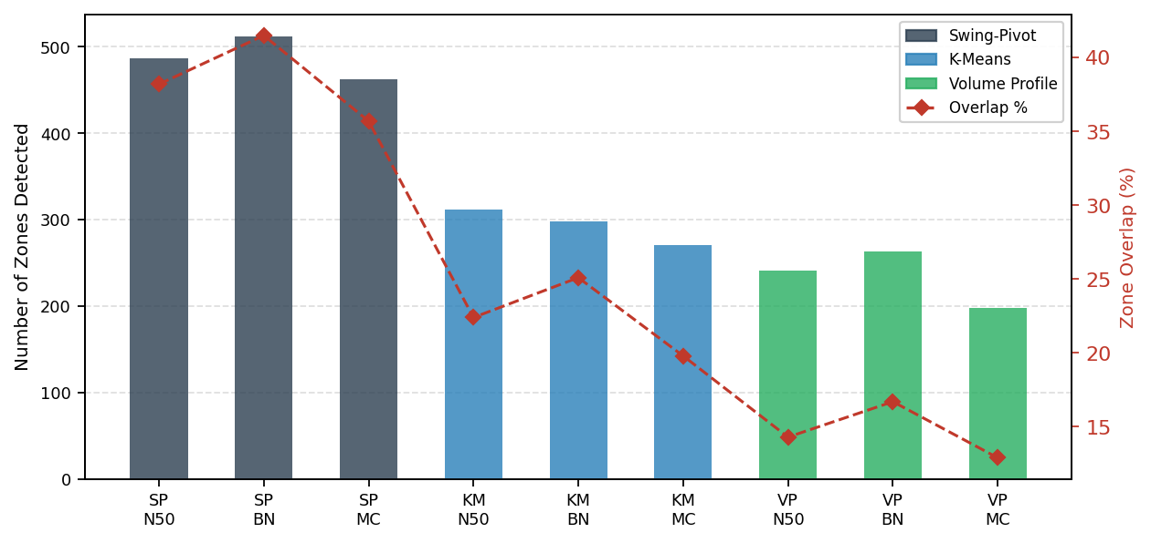
Fig. 1. Zones detected (bars) and zone overlap percentage (line) by method and index. Volume Profile produces the fewest zones with the lowest overlap, indicating tighter, more discriminating zone placement.
4.2 Zone Hold Rate Across Indices
Table 2 reports zone hold rates across methods and indices. Volume Profile zones achieved the highest hold rates on all three indices: 64.1% on the Nifty 50, 62.7% on Bank Nifty, and 59.4% on Midcap 100. K-Means followed at 57.9%, 55.2%, and 53.6%. Swing-Pivot zones were weakest at 52.4%, 49.8%, and 47.3%. Hold rates decline consistently from Nifty 50 to Midcap 100 for all methods, consistent with the expectation that thinner, less institutionally dominated markets produce more erratic price behavior at putative zone boundaries. Figure 2 visualizes these comparisons.

Table 2. Zone hold rate (%) by method and index (out-of-sample: Jan 2023 – Dec 2024).
Method | Nifty 50 (%) | Bank Nifty (%) | Midcap 100 (%)
Swing-Pivot | 52.4 | 49.8 | 47.3
K-Means | 57.9 | 55.2 | 53.6
Volume Profile | 64.1 | 62.7 | 59.4

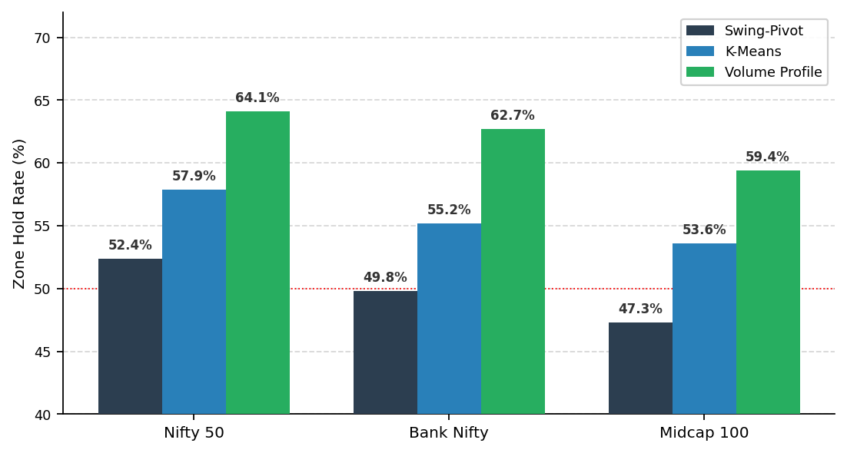
Fig. 2. Zone hold rate (%) by detection method and index. Volume Profile zones consistently outperform both alternatives, and Midcap 100 holds show systematically lower rates across all methods.
4.3 Backtest Performance Without Candlestick Filter
Table 3 presents unfiltered backtest results. Volume Profile dominates across all metrics. On the Nifty 50, Volume Profile produced a 58.7% win rate, +28.4% total return, profit factor 1.52, and maximum drawdown of −4.8% on 143 trades. K-Means achieved 53.7% win rate, +19.8% return, profit factor 1.31, and −6.4% drawdown on 178 trades. Swing-Pivot produced the weakest results: 49.1% win rate, +11.3% return, profit factor 1.08, and −8.7% drawdown on 214 trades — approaching breakeven. Bank Nifty and Midcap 100 follow the same ordinal ranking, though with generally lower win rates and deeper drawdowns.

Table 3. Backtest performance without candlestick filter (out-of-sample: Jan 2023 – Dec 2024).
Method | Index | Trades | Win Rate (%) | Total Return (%) | Profit Factor | Max Drawdown (%)
Swing-Pivot | Nifty 50 | 214 | 49.1 | +11.3 | 1.08 | −8.7
Swing-Pivot | Bank Nifty | 231 | 47.8 | +9.6 | 1.05 | −11.2
Swing-Pivot | Midcap 100 | 197 | 46.3 | +7.4 | 1.03 | −13.1
K-Means | Nifty 50 | 178 | 53.7 | +19.8 | 1.31 | −6.4
K-Means | Bank Nifty | 162 | 51.9 | +16.3 | 1.24 | −8.9
K-Means | Midcap 100 | 149 | 50.3 | +13.7 | 1.18 | −10.4
Volume Profile | Nifty 50 | 143 | 58.7 | +28.4 | 1.52 | −4.8
Volume Profile | Bank Nifty | 157 | 56.1 | +24.9 | 1.43 | −6.3
Volume Profile | Midcap 100 | 121 | 53.4 | +19.7 | 1.34 | −8.1

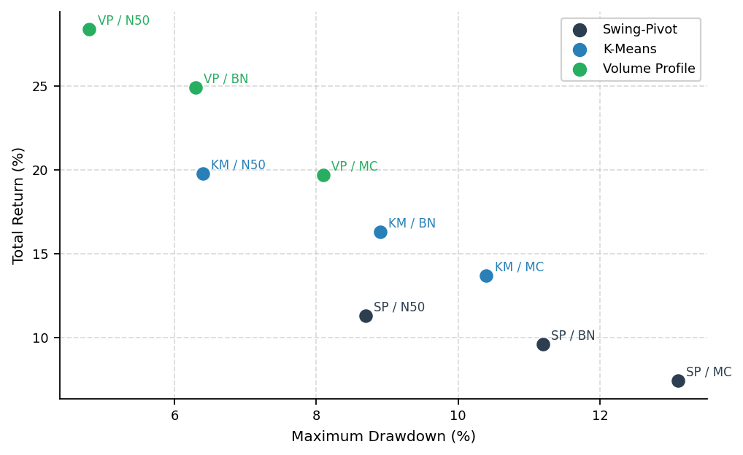
Fig. 3. Total return (%) vs. maximum drawdown (%) scatter plot by method and index, no candlestick filter. Volume Profile points cluster in the top-left (higher return, lower drawdown); Swing-Pivot points occupy the bottom-right.
4.4 Effect of Candlestick Confirmation
Adding the candlestick pattern gate substantially changes the performance profile of all three methods. Table 4 reports results with the filter active. Trade counts fell 55 to 65% across all method-index combinations. Despite this reduction, win rates and profit factors improved materially for every combination. Volume Profile's Nifty 50 win rate rose from 58.7% to 63.9%, profit factor from 1.52 to 1.68. K-Means improved from 53.7% and 1.31 to 58.1% and 1.41. Swing-Pivot benefited most in relative terms: profit factor roughly doubled from 1.08 to 1.19, suggesting much of its prior underperformance arose from entering unconfirmed zone touches. Figure 4 compares profit factors across conditions.

Table 4. Backtest performance with candlestick confirmation gate (out-of-sample: Jan 2023 – Dec 2024).
Method | Index | Trades | Win Rate (%) | Total Return (%) | Profit Factor | Max Drawdown (%)
Swing-Pivot | Nifty 50 | 89 | 54.6 | +14.7 | 1.19 | −6.1
Swing-Pivot | Bank Nifty | 96 | 52.1 | +12.3 | 1.14 | −7.8
Swing-Pivot | Midcap 100 | 81 | 51.2 | +10.1 | 1.09 | −9.4
K-Means | Nifty 50 | 74 | 58.1 | +22.6 | 1.41 | −4.9
K-Means | Bank Nifty | 68 | 56.6 | +19.4 | 1.35 | −6.7
K-Means | Midcap 100 | 63 | 54.0 | +16.8 | 1.28 | −8.2
Volume Profile | Nifty 50 | 61 | 63.9 | +31.7 | 1.68 | −3.6
Volume Profile | Bank Nifty | 72 | 61.1 | +29.3 | 1.59 | −4.9
Volume Profile | Midcap 100 | 54 | 57.4 | +23.2 | 1.47 | −6.8

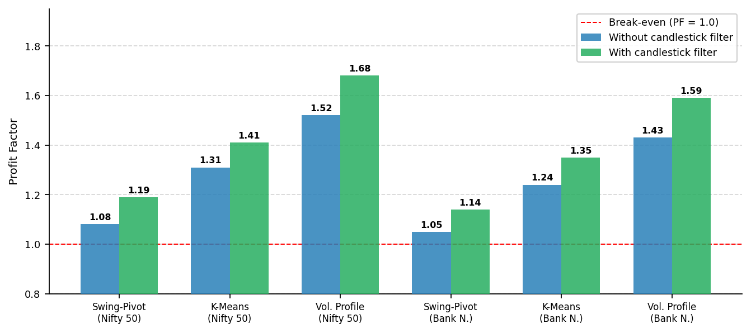
Fig. 4. Profit factor by method and index, with and without candlestick confirmation gate. The dashed red line marks the break-even profit factor of 1.0. All methods improve with confirmation; Swing-Pivot gains most in relative terms.
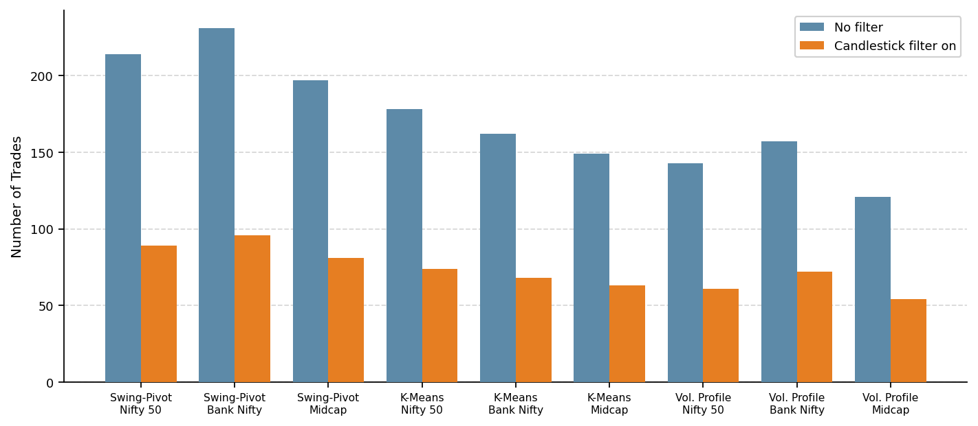
Fig. 5. Trade count by method and index, comparing unfiltered (blue) and candlestick-filtered (orange) conditions. The filter reduces trade count by 55–65% uniformly across all methods.
5 Discussion
The central empirical finding of this study is that Volume Profile zones consistently outperform Swing-Pivot and K-Means zones on every metric evaluated, and that this margin holds across all three indices and across both filtered and unfiltered backtest conditions. The theoretical explanation is fairly intuitive in hindsight. Volume concentrations represent the aggregate revealed preference of the market's participants — what prices they were actually willing to trade at, weighted by the magnitude of their willingness — rather than simply what extremes price reached in the past (Swing-Pivot) or what levels it happened to revisit frequently without regard to volume (K-Means).
Swing-Pivot zones treat all pivots as structurally equivalent regardless of accompanying volume. A swing high reached on light volume during a holiday-shortened week receives the same classification as one accompanied by a three-sigma volume spike on an expiry day. The backtest results suggest the market does not treat these two kinds of pivot equivalently. K-Means clustering sits interestingly between the other two: by identifying levels that closing prices revisited frequently, it implicitly captures some volume information — prices visited often tend to be prices where transactions occurred — but it conflates extended consolidation with repeated distinct reversals, and it weights all visits equally regardless of the bar on which they occurred.
The candlestick confirmation finding is instructive from a methodology design perspective. The improvement is roughly symmetric across methods in absolute terms but is relatively larger for Swing-Pivot — a weaker base method gains more from filtering out unconfirmed entries. One interpretation is that candlestick patterns provide useful but not fully orthogonal confirmation: they capture behavioral signals that partially overlap with what makes volume-dense zones strong, so their marginal contribution is smaller when added to an already high-quality zone signal. For practitioners, this suggests a strategic ordering: begin with the strongest zone detection method (Volume Profile), then layer candlestick confirmation to reduce exposure to weak entries. Relying on patterns to rescue a poor zone detection choice produces materially inferior outcomes.
The volume profile approximation from daily OHLCV data warrants direct acknowledgment. Real intraday volume is concentrated near the open and close — the classic U-shaped intraday volume profile — so distributing total session volume uniformly across the high-low range understates volume at extreme intraday prices and overstates it at midrange prices. This may cause Volume Profile zone locations to be slightly less precise than they would be with tick-level data, suggesting that our Volume Profile results are likely conservative estimates of what a tick-data implementation would achieve.
The Midcap 100 results remain persistently weaker even with the best method and filter combination. The Volume Profile plus candlestick confirmation combination achieves a 57.4% win rate and 1.47 profit factor on the Midcap 100, compared to 63.9% and 1.68 on the Nifty 50 — a gap that is unlikely to close without either finer-resolution data or additional liquidity-aware features. This finding cautions against uncritical transfer of strategies calibrated on large-cap indices to mid-cap trading environments.
6 Conclusion and Future Work
This paper presented a controlled comparison of three zone detection paradigms — Swing-Pivot, K-Means Price Clustering, and Volume Profile — across three NSE indices, evaluated on zone quality metrics and a shared rule-based backtest simulator with and without candlestick pattern confirmation. Volume Profile zones consistently achieve the highest hold rates and strongest trading outcomes across all three indices; K-Means offers a practically useful intermediate approach; Swing-Pivot produces the weakest zones and the most marginal backtest outcomes. Candlestick confirmation improves all three methods' risk-adjusted metrics most meaningfully for Swing-Pivot. Nifty Midcap 100 produces lower zone reliability across all methods, cautioning against uncritical strategy transfer from large-cap to mid-cap segments.
Several directions for future work are apparent. The approximation of intraday volume distribution from daily OHLCV data is a significant constraint; a direct comparison using tick-level volume would likely strengthen Volume Profile results further and is the most immediate extension we would recommend. The trade simulator does not account for brokerage, STT, or slippage, all of which would disproportionately penalize the higher-frequency Swing-Pivot results. Future work will explore zone strength scoring as a feature in a gradient-boosted classifier to estimate hold probability conditioned on zone age, touch count, prevailing volatility regime, and candlestick pattern quality. Integrating the detection pipeline with a reinforcement learning agent that learns to selectively exploit only the strongest zone-pattern combinations is another direction with clear theoretical motivation, though any such extension will require careful reward shaping and a longer training window than commonly used settings provide.
References
1. Yahoo Finance – historical NSE index data. https://finance.yahoo.com/
2. Wyckoff, R.D.: Studies in Tape Reading. Ticker Publishing (1910).
3. Edwards, R.D., Magee, J.: Technical Analysis of Stock Trends, 1st edn. Stock Trend Service (1948).
4. Bulkowski, T.N.: Encyclopedia of Chart Patterns, 2nd edn. Wiley (2005).
5. Steidlmayer, J.P.: Markets and Market Logic. Porcupine Press (1984).
6. Kaastra, I., Boyd, M.: Designing a neural network for forecasting financial and economic time series. Neurocomputing 10(3), 215–236 (1996).
7. Gould, M.D., Porter, M.A., Williams, S., McDonald, M., Fenn, D.J., Howison, S.D.: Limit order books. Quantitative Finance 13(11), 1709–1742 (2013).
8. Williams, B.: Trading Chaos: Maximize Profits with Proven Technical Techniques. Wiley (1995).
9. Caginalp, G., Laurent, H.: The predictive power of price patterns. Applied Mathematical Finance 5(3–4), 181–205 (1998).
10. Vijh, M., Chandola, D., Tikkiwal, V.A., Kumar, A.: Stock closing price prediction using machine learning techniques. Procedia Computer Science 167, 599–606 (2020).
11. Wilder, J.W.: New Concepts in Technical Trading Systems. Trend Research (1978).
12. Appel, G.: Technical Analysis: Power Tools for Active Investors. Barron's Educational Series (1979).
13. Bollinger, J.: Bollinger on Bollinger Bands. McGraw-Hill (2001).
14. Securities and Exchange Board of India (SEBI): Study analysing profit and loss of individual traders in equity F&O segment. SEBI (2024).
15. Pedregosa, F., et al.: Scikit-learn: Machine Learning in Python. J. Mach. Learn. Res. 12, 2825–2830 (2011).
16. Chen, T., Guestrin, C.: XGBoost: A scalable tree boosting system. In: Proc. 22nd ACM SIGKDD, pp. 785–794 (2016).
17. Bulkowski, T.N.: Candlestick and Pivot Point Trading Triggers. Wiley (2007).

