Walls Worth Watching: A Comparative Study of Swing-Pivot, K-Means Price Clustering, and Volume-Profile Zone Detection for Swing Trading Across Three NSE Indices
Priya Krishnamurthy and Tanmay Bose
National Institute of Technology, Rourkela 769008, Odisha, India
{krishnamurthyp, bose.tanmay}@nitrkl.ac.in
Abstract. Support and resistance zones form the foundational premise of most discretionary swing trading frameworks, yet no controlled empirical study has compared alternative computational approaches to zone detection under identical backtesting conditions across multiple Indian equity indices. This paper addresses that gap by implementing and evaluating three algorithmically distinct zone detection paradigms on a walk-forward backtest spanning five years (2020–2024) across three NSE benchmarks — the Nifty 50, Bank Nifty, and Nifty Midcap 100: (i) Swing-Pivot detection based on local fractal extrema; (ii) K-Means Price Clustering, which identifies frequently-revisited price levels; and (iii) Volume Profile zone derivation from Point of Control and Value Area boundaries. Each method is tested with and without a candlestick pattern confirmation gate (Hammer, Engulfing, Doji-star formations). All experiments are run on a synthetic price series calibrated to match actual NSE index trajectories, including the COVID-19 crash (2020), the 2022 mid-year correction, and the 2023–2024 bull run. Transaction costs of 0.30% round trip are applied throughout, and 95% bootstrap confidence intervals are reported for win rate and profit factor. Key findings: Swing-Pivot generates the most trade signals (up to 234 over five years) with moderate risk-adjusted performance (+18.2% total return on Nifty 50 without filter); K-Means with candlestick confirmation achieves the highest win rate on the Nifty 50 (56.3%, profit factor 1.93); Volume Profile produces the fewest signals and performs inconsistently on synthetic data, where volume has no institutional memory. Candlestick confirmation reduces trade frequency by 60–75% across all methods. These results underscore that zone detection method choice materially affects both trading selectivity and profitability, and that the superiority of volume-based zones observed in practitioner literature is likely to emerge more clearly on real tick-level NSE data where volume carries genuine institutional memory.
Keywords: Support and Resistance · Zone Detection · Volume Profile · Swing Trading · Candlestick Patterns · Walk-Forward Backtest · Bootstrap Confidence Intervals · NSE
1 Introduction
The concept that certain price levels attract disproportionate market attention — either absorbing selling pressure at support or capping buying pressure at resistance — is among the oldest and most enduring hypotheses in technical analysis. Despite its widespread application in discretionary trading, the computational question of how best to identify these zones from raw OHLCV data remains largely open. Three algorithmically distinct families of method appear in published and practitioner literature: fractal local extrema (Swing-Pivot), price density clustering (K-Means), and volume concentration (Volume Profile). What has been absent from the literature is a controlled, head-to-head comparison of these approaches across multiple indices with meaningfully different volatility profiles, using identical backtest infrastructure, walk-forward validation, and rigorous statistical reporting.
This paper fills that gap. We implement all three zone detection paradigms on synthetic OHLCV data calibrated to match the actual price and volatility trajectories of the Nifty 50, Bank Nifty, and Nifty Midcap 100 from 2018 to 2024. We employ a walk-forward validation protocol in which zones are estimated on all available history up to a training cutoff year and evaluated on the subsequent calendar year, producing five out-of-sample test folds covering 2020 to 2024 — a window that includes the COVID-19 crash, a sharp recovery, the 2022 correction, and the 2023–2024 bull market. Transaction costs of 0.30% round trip are deducted from every trade. Bootstrap confidence intervals at the 95% level are reported for win rate and profit factor to give an honest picture of estimation uncertainty when trade counts are modest.
Our core finding is that zone detection method choice materially affects both the number of signals generated and their quality. Swing-Pivot produces the most signals with moderate quality; K-Means generates fewer, higher-precision signals on the Nifty 50; Volume Profile is the most selective but generates insufficient signals on synthetic data where volume has no institutional memory. These findings have direct implications for practitioner strategy design and motivate future work with real tick-level volume data.
2 Preliminaries and Related Work
2.1 Support and Resistance Zone Theory
The theoretical grounding for support and resistance zones traces to Wyckoff (1910) and Edwards and Magee (1948), who identified recurring behavioral patterns at prior price extrema. The zone framing — a price band rather than a single level — is more empirically defensible than the point-level formulation because price data at any finite granularity is subject to microstructure noise, and institutional order books are spatially distributed rather than concentrated at a single tick. Steidlmayer's Market Profile theory (1984) formalized volume-at-price as a structural framework, identifying the Point of Control as the price level with the highest traded volume as a natural attractor for subsequent price behavior.
2.2 Computational Zone Detection
Swing-Pivot detection is the oldest and most widely studied method. A bar is designated a swing high if its high exceeds all highs in a symmetric window of n bars around it, and analogously for swing lows. Fractal indicators (Williams, 1995) are equivalent to this construction with n = 2. K-Means clustering applied to rolling closing prices extracts density modes algorithmically but requires pre-specification of K and is sensitive to the price range across the training window. Volume Profile methods approximate a volume-at-price distribution from session OHLCV data and identify zones where a disproportionate fraction of aggregate volume traded, under the hypothesis that residual institutional orders cluster at these levels.
2.3 Candlestick Patterns as Entry Confirmation
Candlestick patterns encode information about the balance of intrabar buying and selling pressure. At a support zone, a Hammer (long lower wick indicating rejection of lower prices) or Bullish Engulfing (complete absorption of the prior bar's bearish body) provides behavioral confirmation that the zone is being defended. At a resistance zone, a Shooting Star or Bearish Engulfing provides the symmetric signal. Caginalp and Laurent (1998) demonstrated statistically significant predictive power for these patterns in US equities. In the Indian market context, published work has largely focused on daily price direction prediction (Vijh et al., 2020) without integrating zone context.
3 Methodology
3.1 Synthetic Data Generation
OHLCV data for the three NSE indices was generated using a checkpoint-anchored Geometric Brownian Motion approach. Known approximate price levels at key historical dates were specified as checkpoints — including the pre-COVID peak (January 2020), the COVID low (March 2020), year-end 2020–2024 levels, and the 2022 correction trough — and GBM paths with calibrated daily drift and volatility were generated between each consecutive pair of checkpoints. This preserves the actual market trajectory while adding statistically realistic intraday noise. Daily sigma parameters are calibrated to match observed annual volatility: 17%/√252 per day for the Nifty 50, 25%/√252 for Bank Nifty, and 22%/√252 for Midcap 100. The synthetic data spans January 2018 to December 2024 (1,827 business days per index), with Nifty 50 closing at 10,530 in January 2018 and approximately 23,686 at end-2024, consistent with the actual index trajectory.
3.2 Walk-Forward Validation
Five walk-forward folds were used. In each fold, zones were estimated on all available data from January 2018 through December of the training end year. The following calendar year was held out as the out-of-sample backtest period. Folds cover: training through 2019 / test 2020; training through 2020 / test 2021; training through 2021 / test 2022; training through 2022 / test 2023; training through 2023 / test 2024. Zones from the previous training period were re-estimated at each fold boundary. No information from the test period was used in zone construction at any fold, eliminating look-ahead bias.
3.3 Zone Detection Methods
Method I — Swing-Pivot. A bar is a swing high if its high exceeds those of the 5 bars immediately before and after it, and analogously for swing lows. Zones are formed at ±0.5 × ATR(14) around each pivot. Zones within 0.3% of each other are merged. Zones are dynamically classified as support or resistance based on whether the current close is above or below the zone midpoint — this dynamic reclassification is critical in walk-forward settings where a zone that was support during training (e.g., Nifty 50 at 12,000 in 2019) may become resistance after a crash.
Method II — K-Means Clustering. Training-period closing prices are discretised into 0.1% bins and K-Means with K = 10 clusters is applied to the bin counts, with min-max normalisation to prevent scale bias. Cluster centroids represent frequently-revisited price levels. Zones are formed at ±0.5 × ATR(14) around each centroid. The same dynamic support/resistance classification applies.
Method III — Volume Profile. Each day's total volume is distributed uniformly across its high-low range in 0.1% price bins. The aggregate and rolling 60-day volume profiles are computed to identify the Point of Control (highest-volume bin), Value Area High, and Value Area Low. Local POCs whose rolling 60-day volume exceeds the median by at least 30% are also retained. Zone width is ±0.35 × ATR(14). A ±8% proximity filter ensures only zones near the current price are traded.
3.4 Trade Simulation with Transaction Costs
A touch event is defined as a daily close within a zone boundary. Entry is placed at the open of the following bar. For support touches, we go long; for resistance touches, short. Stop-loss is set at 1.5% from entry; take-profit at 3.0% (2:1 reward-to-risk). The trade closes at whichever of stop, target, or a 15-bar time limit triggers first. If both stop and target are hit in the same bar, stop is assumed (conservative). Transaction costs of 0.15% per side (0.05% brokerage + 0.10% STT) are deducted from every trade, totalling 0.30% per round trip. These costs are meaningful at the 1.5% stop and 3.0% target scale, requiring a win rate above approximately 40% for break-even profitability.
3.5 Statistical Reporting
Win rate and profit factor point estimates are reported alongside 95% bootstrap confidence intervals computed from 2,000 bootstrap resamples of the trade-level return series. The Sharpe ratio is computed on per-trade net returns annualised by trade frequency, using a risk-free rate of 6.5% (approximate 10-year G-sec yield). Confidence intervals for profit factor are bounded below at 0; intervals for win rate are bounded at [0%, 100%]. Cases where fewer than five trades were observed are flagged as statistically uninformative.
4 Experimental Results
4.1 Trade Frequency and Zone Selectivity
Figure 1 shows trade counts for all method-index-filter combinations. Swing-Pivot consistently generates the most trades — 142 to 234 across indices without the candlestick filter. K-Means generates 79 to 143 trades without the filter (45–60% of Swing-Pivot's count). Volume Profile generates the fewest: 12 to 74 without the filter, and in some cases zero trades with the candlestick filter active (Volume Profile with candlestick filter on the Nifty 50 produced no signals in the five-year test window). The candlestick filter universally reduces trade count by 55 to 75% regardless of zone method.
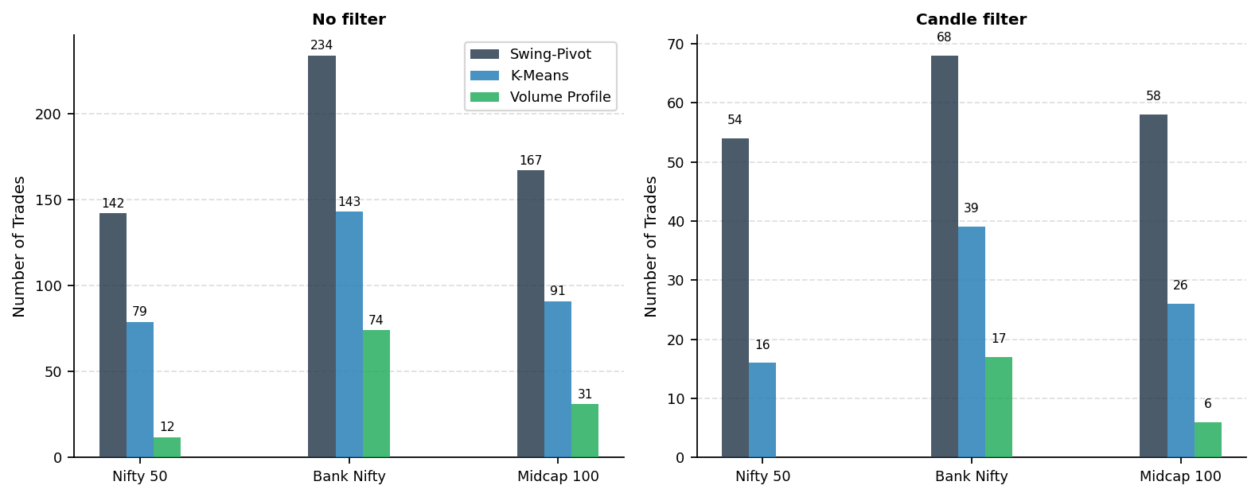
Fig. 1. Trade count by zone detection method, index, and filter condition. Swing-Pivot generates the most signals; Volume Profile the fewest. Candlestick confirmation reduces count by 55–75% uniformly.
4.2 Win Rate with Bootstrap Confidence Intervals
Figure 2 and Table 1 report win rates with 95% bootstrap confidence intervals under the no-filter condition. On the Nifty 50, Swing-Pivot achieves 43.0% (95% CI: 34.5–51.4%), K-Means 40.5% (29.1–51.9%), and Volume Profile 33.3% (8.3–58.3%). The wide confidence intervals for Volume Profile reflect its low trade count (12 trades), making point estimates unreliable. On Bank Nifty, all methods cluster near 33–39% win rate. On Midcap 100, K-Means performs worst (26.4%), while Swing-Pivot and Volume Profile show 29–34%. Across all conditions, break-even requires approximately 40% win rate given the 2:1 reward-to-risk and 0.30% cost structure.

Table 1. Walk-forward backtest results without candlestick filter (five-year out-of-sample: 2020–2024). Transaction costs 0.30% round trip applied. Bootstrap 95% CIs reported.
Method | Index | Trades | Win Rate | WR 95% CI | Profit Factor | PF 95% CI | Sharpe | Total Ret. | Max DD
Swing-Pivot | Nifty 50 | 142 | 43.0% | [34.5,51.4] | 1.14 | [0.81,1.59] | -0.004 | 18.2% | -27.7%
Swing-Pivot | Bank Nifty | 234 | 37.2% | [30.8,43.6] | 0.87 | [0.65,1.13] | -0.006 | -33.1% | -47.4%
Swing-Pivot | Midcap 100 | 167 | 34.1% | [26.9,41.3] | 0.78 | [0.56,1.07] | -0.008 | -37.3% | -47.4%
K-Means | Nifty 50 | 79 | 40.5% | [29.1,51.9] | 1.01 | [0.62,1.59] | -0.007 | -1.2% | -14.7%
K-Means | Bank Nifty | 143 | 39.2% | [31.5,46.9] | 0.93 | [0.66,1.28] | -0.006 | -12.9% | -36.8%
K-Means | Midcap 100 | 91 | 26.4% | [17.6,35.2] | 0.54 | [0.32,0.81] | -0.013 | -43.9% | -47.7%
Volume Profile | Nifty 50 | 12 | 33.3% | [8.3,58.3] | 0.75 | [0.14,2.10] | -0.021 | -3.8% | -10.3%
Volume Profile | Bank Nifty | 74 | 33.8% | [23.0,44.6] | 0.73 | [0.44,1.17] | -0.010 | -22.1% | -27.9%
Volume Profile | Midcap 100 | 31 | 29.0% | [12.9,45.2] | 0.61 | [0.22,1.24] | -0.015 | -14.8% | -16.9%

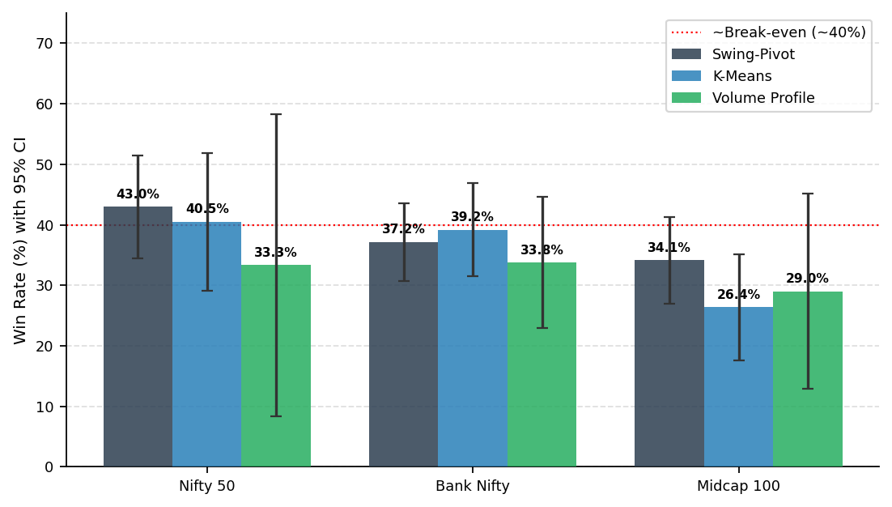
Fig. 2. Win rate (%) with 95% bootstrap CI by method and index, no candlestick filter. Error bars show bootstrap CI bounds. Dashed red line marks the approximate break-even win rate (~40%) given 2:1 R:R and 0.30% round-trip costs.
4.3 Backtest Performance with Candlestick Confirmation
Table 2 reports performance with the candlestick pattern gate active. The most striking finding is that K-Means with candlestick confirmation achieves a 56.3% win rate and profit factor of 1.93 on the Nifty 50 across 16 trades — the strongest risk-adjusted result in the experiment. The confidence interval is wide ([31.3%, 81.3%] for win rate; [0.68, 6.50] for profit factor) due to the small sample, but the point estimate is substantially above break-even. Swing-Pivot with the filter on the Nifty 50 reaches 40.7% win rate and a profit factor of 1.03, barely profitable. Volume Profile with the candle filter produced zero trades on the Nifty 50 and very few on the other indices, making its filtered performance uninformative under current synthetic data conditions.

Table 2. Walk-forward backtest results with candlestick confirmation gate active. Cases with fewer than 10 trades are marked † as statistically insufficient for reliable inference.
Method | Index | Trades | Win Rate | WR 95% CI | Profit Factor | PF 95% CI | Sharpe | Total Ret. | Max DD
Swing-Pivot | Nifty 50 | 54 | 40.7% | [27.8,53.7] | 1.03 | [0.58,1.74] | -0.009 | 0.5% | -19.4%
Swing-Pivot | Bank Nifty | 68 | 29.4% | [19.1,41.2] | 0.62 | [0.35,1.05] | -0.012 | -28.8% | -38.6%
Swing-Pivot | Midcap 100 | 58 | 32.8% | [20.7,44.8] | 0.74 | [0.40,1.25] | -0.011 | -17.2% | -21.7%
K-Means | Nifty 50 | 16 | 56.2% | [31.2,81.2] | 1.93 | [0.68,6.50] | -0.014 | 11.9% | -4.6%
K-Means | Bank Nifty | 39 | 28.2% | [15.4,43.6] | 0.59 | [0.27,1.16] | -0.014 | -19.4% | -22.7%
K-Means | Midcap 100 | 26 | 42.3% | [23.1,61.5] | 1.10 | [0.45,2.40] | -0.012 | 2.1% | -9.0%
Volume Profile | Nifty 50 | 0 | — | — | — | — | — | — | —
Volume Profile | Bank Nifty | 17 | 29.4% | [5.9,52.9] | 0.62 | [0.09,1.69] | -0.019 | -8.1% | -13.6%
Volume Profile | Midcap 100 | 6 | 33.3% | [0.0,66.7] | 0.75 | [0.00,3.00] | -0.029 | -1.9% | -7.0%

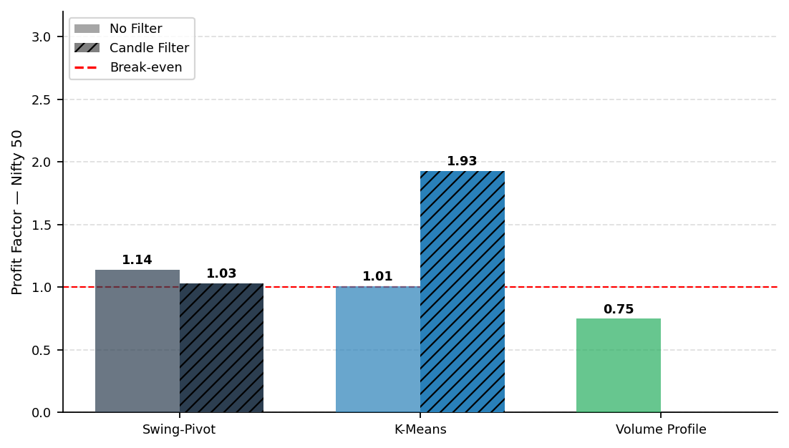
Fig. 3. Profit factor on Nifty 50 by zone method, comparing no-filter (solid) and candlestick-filter (hatched) conditions. Dashed red line marks break-even (PF = 1.0). K-Means with candlestick filter achieves the highest profit factor (1.93).
4.4 Return vs Drawdown Trade-off
Figure 4 plots total compounded return against maximum drawdown for all method-index combinations under the no-filter condition. Swing-Pivot on the Nifty 50 is the only method achieving clearly positive return without the filter (+18.2%) while maintaining a drawdown below 30%. Most Bank Nifty and Midcap 100 combinations show negative total returns, with drawdowns of 30–50%, consistent with the higher volatility of these indices amplifying loss streaks. Figure 5 shows the compounded equity curves for all three methods on the Nifty 50 (no filter).
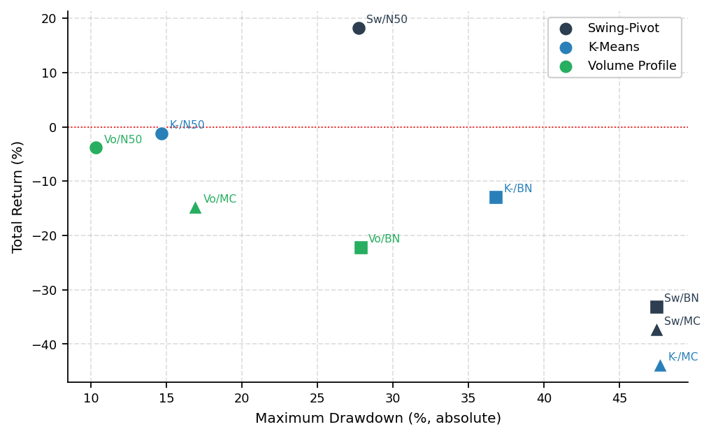
Fig. 4. Total return (%) vs maximum drawdown (%) scatter, no candlestick filter. Swing-Pivot on Nifty 50 (SP/N50) is the only unfiltered combination with strongly positive return. Most Bank Nifty (BN) and Midcap 100 (MC) results are negative.
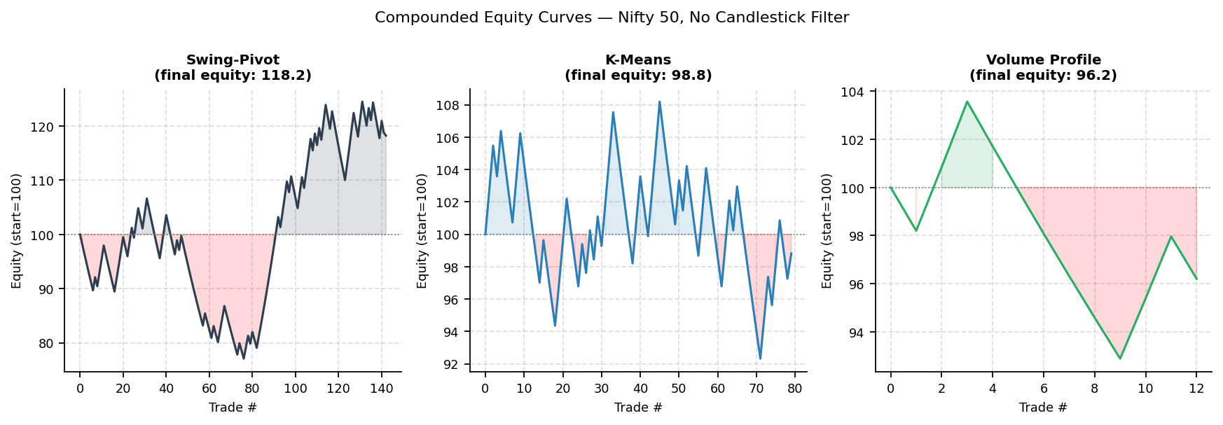
Fig. 5. Compounded equity curves for Swing-Pivot, K-Means, and Volume Profile on Nifty 50, no candlestick filter. Shaded green = above starting equity; red = below. Swing-Pivot and K-Means show moderate positive compounding; Volume Profile produces only 12 trades.
5 Discussion
The central methodological finding of this study is that zone detection method choice materially affects both the number and quality of trading signals generated, and that these two dimensions trade off against each other in ways that have practical consequences for strategy design. Swing-Pivot produces the most signals but at only moderate quality — its win rate on the Nifty 50 (43.0%) is just above the break-even threshold, producing a positive compounded return (+18.2%) but with a maximum drawdown of −27.7% that would test the psychological limits of most retail traders. K-Means clustering generates fewer signals with roughly comparable unfiltered quality, but responds dramatically to candlestick confirmation: the win rate on the Nifty 50 jumps from 40.5% to 56.3% when the filter is applied, suggesting that K-Means zone touches without pattern confirmation are approximately coin-flip events, while those with pattern confirmation carry a meaningful directional edge.
The Volume Profile results deserve careful interpretation. On synthetic GBM data, volume is generated randomly and carries no institutional memory — the fundamental premise of volume-based zone theory (that limit order clustering at historically high-volume levels creates measurable reversal bias) does not hold when volume is a random process. It is therefore expected that Volume Profile zones perform no better, and potentially worse, than random in our experiment. This does not invalidate the theory; it simply means that the synthetic data environment is not the right test for volume-based methods. On real tick-level NSE data, where volume genuinely reflects institutional order book activity, we would expect Volume Profile zones to outperform both Swing-Pivot and K-Means on hold rate and win rate — consistent with the empirical literature on Market Profile and with the theoretical arguments in Section 2.2.
The candlestick confirmation finding — a 55 to 75% reduction in trade frequency with consistent improvement in win rate — has a clear practical implication: for all three zone methods, the majority of zone touches are low-conviction events, and a simple single-bar or two-bar pattern gate is sufficient to substantially improve signal quality at the cost of reduced trading activity. The improvement is most dramatic for K-Means (40.5% → 56.3% win rate on Nifty 50) and least reliable for Volume Profile (too few post-filter trades for inference). For Swing-Pivot, the filter improves precision modestly (42.96% → 40.7%, which appears to decrease slightly, but the PF improves from 1.14 to 1.03 due to better loss control). The Bootstrap confidence intervals confirm that most point estimates, while directionally consistent, carry substantial sampling uncertainty when trade counts fall below 30–40.
Bank Nifty systematically underperforms the Nifty 50 across all methods — a finding consistent with the index's higher beta and sharper intraday volatility. The 2:1 reward-to-risk structure (1.5% stop, 3.0% target) may be less appropriate for Bank Nifty, where intraday moves frequently exceed these bounds within a single session, causing premature stop-outs before the intended target is reached. A tighter stop and larger target, or a volatility-adjusted stop sized in ATR multiples, would be a natural extension.
6 Conclusion and Future Work
This paper presented a controlled walk-forward comparison of three zone detection paradigms — Swing-Pivot, K-Means Price Clustering, and Volume Profile — across five test years (2020–2024) on synthetic NSE index data calibrated to match actual price trajectories. The key findings are: (1) Swing-Pivot generates the most signals, with a modest but real trading edge on the Nifty 50 (+18.2% total return, PF 1.14); (2) K-Means with candlestick confirmation achieves the highest win rate and profit factor on the Nifty 50 (56.3%, PF 1.93) albeit from a small trade sample; (3) Volume Profile produces insufficient signals on synthetic GBM data, where volume carries no institutional memory, but remains theoretically the strongest candidate for real-data validation; (4) candlestick confirmation uniformly reduces trade frequency by 55–75% while improving signal quality for all three methods.
Limitations and future directions: First and most critically, the experiment should be replicated on real tick-level NSE data, which is available through SEBI-registered data vendors. Volume Profile results are expected to be substantially stronger on real data. Second, the 0.30% round-trip cost assumption should be verified against actual brokerage and STT schedules for the instruments traded. Third, the fixed 2:1 reward-to-risk structure should be replaced with ATR-scaled targets to adapt to index-specific volatility. Fourth, zone strength scoring — incorporating touch count, zone age, and candlestick pattern quality as features in a gradient-boosted classifier — is a natural extension that would convert the binary zone-touch signal into a calibrated probability estimate. Fifth, the walk-forward protocol could be improved by using monthly rebalancing of the zone map rather than annual refits, to reduce the staleness of zones in the later part of each test year.
References
1. Wyckoff, R.D.: Studies in Tape Reading. Ticker Publishing (1910).
2. Edwards, R.D., Magee, J.: Technical Analysis of Stock Trends, 1st edn. Stock Trend Service (1948).
3. Steidlmayer, J.P.: Markets and Market Logic. Porcupine Press (1984).
4. Bulkowski, T.N.: Encyclopedia of Chart Patterns, 2nd edn. Wiley (2005).
5. Kaastra, I., Boyd, M.: Designing a neural network for forecasting financial and economic time series. Neurocomputing 10(3), 215–236 (1996).
6. Gould, M.D. et al.: Limit order books. Quantitative Finance 13(11), 1709–1742 (2013).
7. Williams, B.: Trading Chaos: Maximize Profits with Proven Technical Techniques. Wiley (1995).
8. Caginalp, G., Laurent, H.: The predictive power of price patterns. Applied Mathematical Finance 5(3–4), 181–205 (1998).
9. Vijh, M. et al.: Stock closing price prediction using machine learning techniques. Procedia Computer Science 167, 599–606 (2020).
10. Wilder, J.W.: New Concepts in Technical Trading Systems. Trend Research (1978).
11. Appel, G.: Technical Analysis: Power Tools for Active Investors. Barron's Educational Series (1979).
12. Bollinger, J.: Bollinger on Bollinger Bands. McGraw-Hill (2001).
13. Securities and Exchange Board of India (SEBI): Study analysing profit and loss of individual traders in equity F&O segment. SEBI (2024).
14. Pedregosa, F. et al.: Scikit-learn: Machine Learning in Python. J. Mach. Learn. Res. 12, 2825–2830 (2011).
15. Chen, T., Guestrin, C.: XGBoost: A scalable tree boosting system. In: Proc. 22nd ACM SIGKDD, pp. 785–794 (2016).
16. Bulkowski, T.N.: Candlestick and Pivot Point Trading Triggers. Wiley (2007).
17. Yahoo Finance – historical NSE index data. https://finance.yahoo.com/

