Multiplayer Game Database Architecture
Technical Document & Schema Design Specification
Prepared for: Face Prep MongoDB Certification
Submission Date: June 2026
ARUNAVA GHOSH
24BCG10121
arunava.24bcg10121@vitbhopal.ac.in

Introduction & Core Features
This project establishes a high-performance database backend tailored for a persistent, multiplayer tactical space game. The database architecture is explicitly structured to support low-latency write operations for game telemetry while maintaining data consistency across player profiles, team structures, and competitive standings.
The system delivers four core user-facing features:
- Player Profile Management: Tracks baseline progression metrics, including cumulative Experience Points (XP), current ranking tier, and lifetime combat telemetry (kills and deaths).
- Squad Coordination: Implements dedicated player teams (Squads) with isolated identifier codes and aggregate group performance tracking.
- Dynamic Loadout Engine: Allows players to instantly hot-swap their ship chassis configuration and primary/secondary weapon configurations.
- Mission Telemetry Logging: Records detailed summaries of completed PvE/PvP operational encounters, mapping player contributions to specific world locations.

Technical Stack Selection
The backend infrastructure utilizes a modern, horizontally scalable stack optimized for document-oriented architectures and stateless application routing.
Layer | Technology Chosen & Engineering Justification
Database Engine | MongoDB: Chosen for its native JSON/BSON document structure, dynamic schema flexibility during rapid game development cycles, and native support for localized horizontal sharding.
ODM Framework | Mongoose (Node.js): Utilized to enforce structured data validation, strict type casting, and middleware hooks at the application level without sacrificing document flexibility.
Server Ecosystem | Node.js & Express: Provides an asynchronous, single-threaded, event-driven runtime environment capable of processing highly concurrent API payload writes from active game instances.

Database Architecture & Modeling Strategy
To optimize read/write performance under active gameplay conditions, the schema avoids a pure relational paradigm. Instead, it mixes Normalized Referencing and Denormalized Embedding based on computational access patterns.

Normalized Referencing (One-to-Many)
For the relationship between Players and Squads, a normalized reference model is implemented. The Player document retains a compact squad_id string referencing the master Squad collection. This prevents data duplication; updating a squad name or faction tag occurs in a single document while instantly reflecting across all member profiles.

Denormalized Embedding (1-to-N Static Optimization)
For Ship Loadouts, weapon damage metrics and firing attributes are cloned directly inside the player’s active configuration sub-document. Embedding eliminates the need for multi-collection lookups ($lookup) at the exact second a player spawns into a match. This ensures that the game engine can retrieve all combat attributes in a single database round-trip.

The Bridge Pattern (Many-to-Many Resolution)
A player can run thousands of missions, and a single mission is played by millions of unique users. Storing an array of match history directly inside either the Player or Mission document would trigger the unbounded array anti-pattern, violating MongoDB’s 16MB document size limit. This is resolved via a separate MissionRun bridge collection, treating each match entry as an independent immutable record.

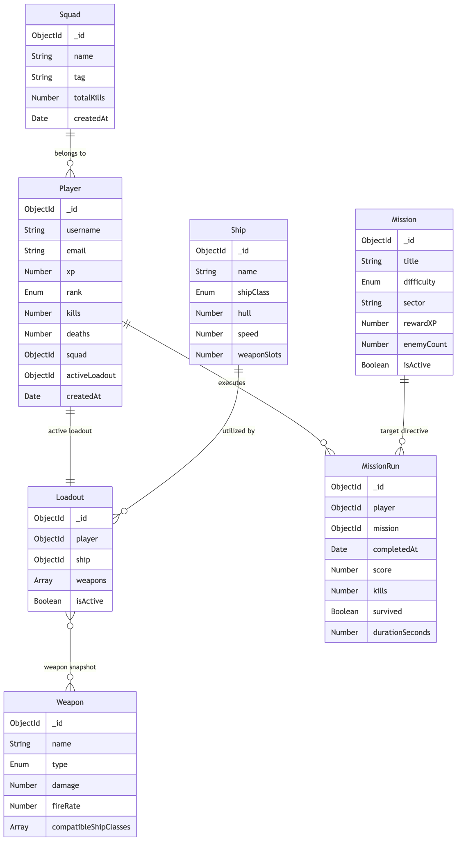
Figure 1: Entity-Relationship Diagram Mapping Document Collections and References.

Application Programming Interface (API) Design
The system exposes a secure REST API interface to orchestrate CRUD workflows across the application boundary.

Player Routing (/api/players)
- POST /: Initializes a new player profile with zeroed baseline metrics.
- GET /:id: Retrieves complete player state including embedded loadout profiles.
- PATCH /:id/loadout: Updates active weapon configuration IDs within the sub-document array.

Match Operations (/api/missions)
- POST /run: Accepts raw match telemetry payloads upon match completion to simultaneously write a MissionRun log and increment target player XP variables.

Deep Technical Implementation: Aggregation Pipelines
Live competitive leaderboards are computed entirely within the database layer using high-performance Aggregation Pipelines. This avoids downloading massive match histories to the node application memory heap, keeping server overhead low.
The leaderboard logic executes via a three-stage sequential engine:
// Database Leaderboard Optimization Pipeline
[
// Stage 1: Filter out inactive or incomplete test records
{ $match: { survived: true } },
// Stage 2: Group records by unique player and calculate sums
{ $group: {
_id: "$player_id",
totalScore: { $sum: "$score" },
totalKills: { $sum: "$kills" }
}
},
// Stage 3: Sort descending by total score and isolate top tier rankings
{ $sort: { totalScore: -1 } },
{ $limit: 10 }
]
By delegating index-backed sorting and group reductions directly to the MongoDB storage engine, lookup tasks drop from an $O(N)$ application compute bottleneck to a rapid memory-cached query operation.

