ARUNAVA GHOSH

24BCG10121
API="http://localhost:3000/api"
# Triggers the seed script to flush DB and populate initial data
curl -X POST $API/seed
# Create a new player
curl -s -X POST $API/players \
-H "Content-Type: application/json" \
-d '{"username": "EchoActual", "email": "echo@void.sys", "xp": 0}'
# Fetch all players to verify
curl -s -X GET $API/players
echo "5. Formation Operations (Squads)"
# Create a squad
curl -s -X POST $API/squads \
-H "Content-Type: application/json" \
-d '{"name": "Phantom Squadron", "tag": "PHNM"}'
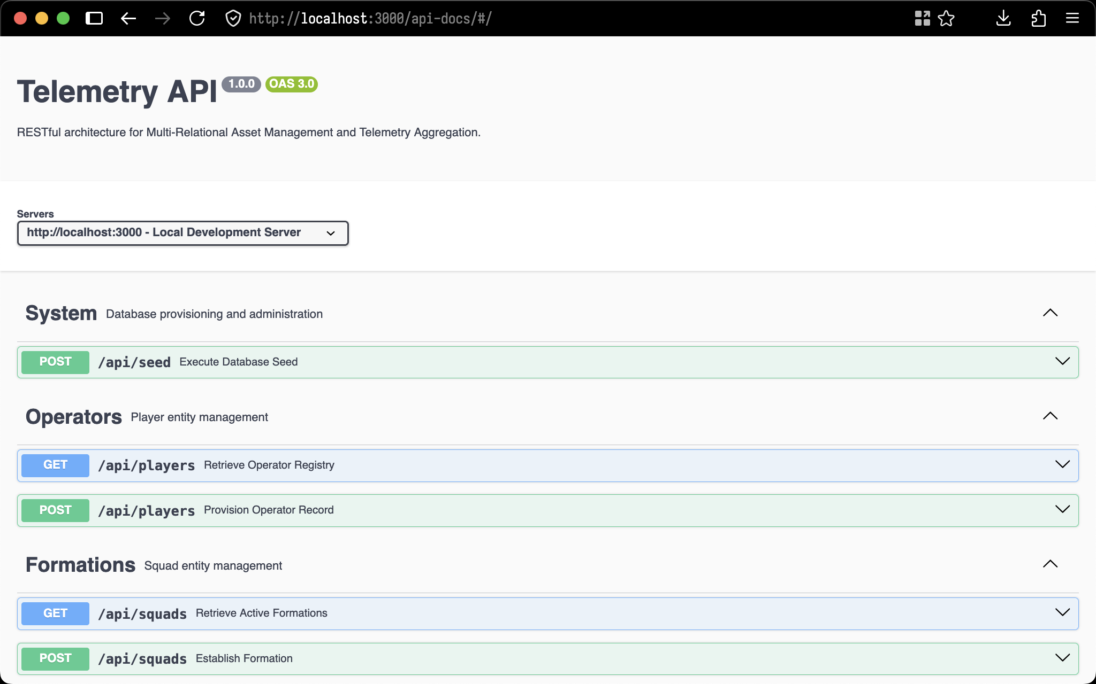
swagger

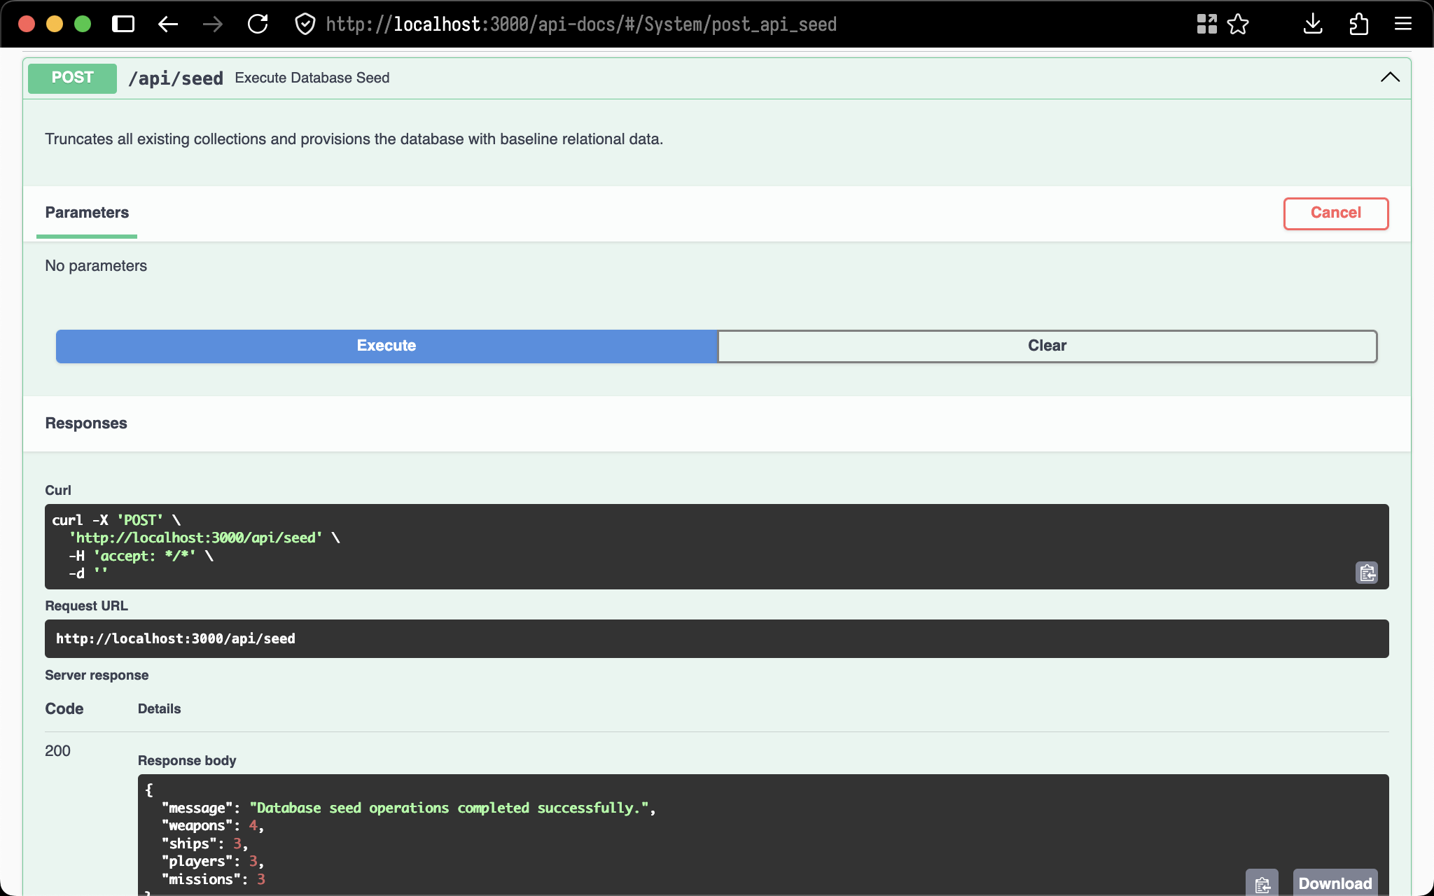
POST /api/seed

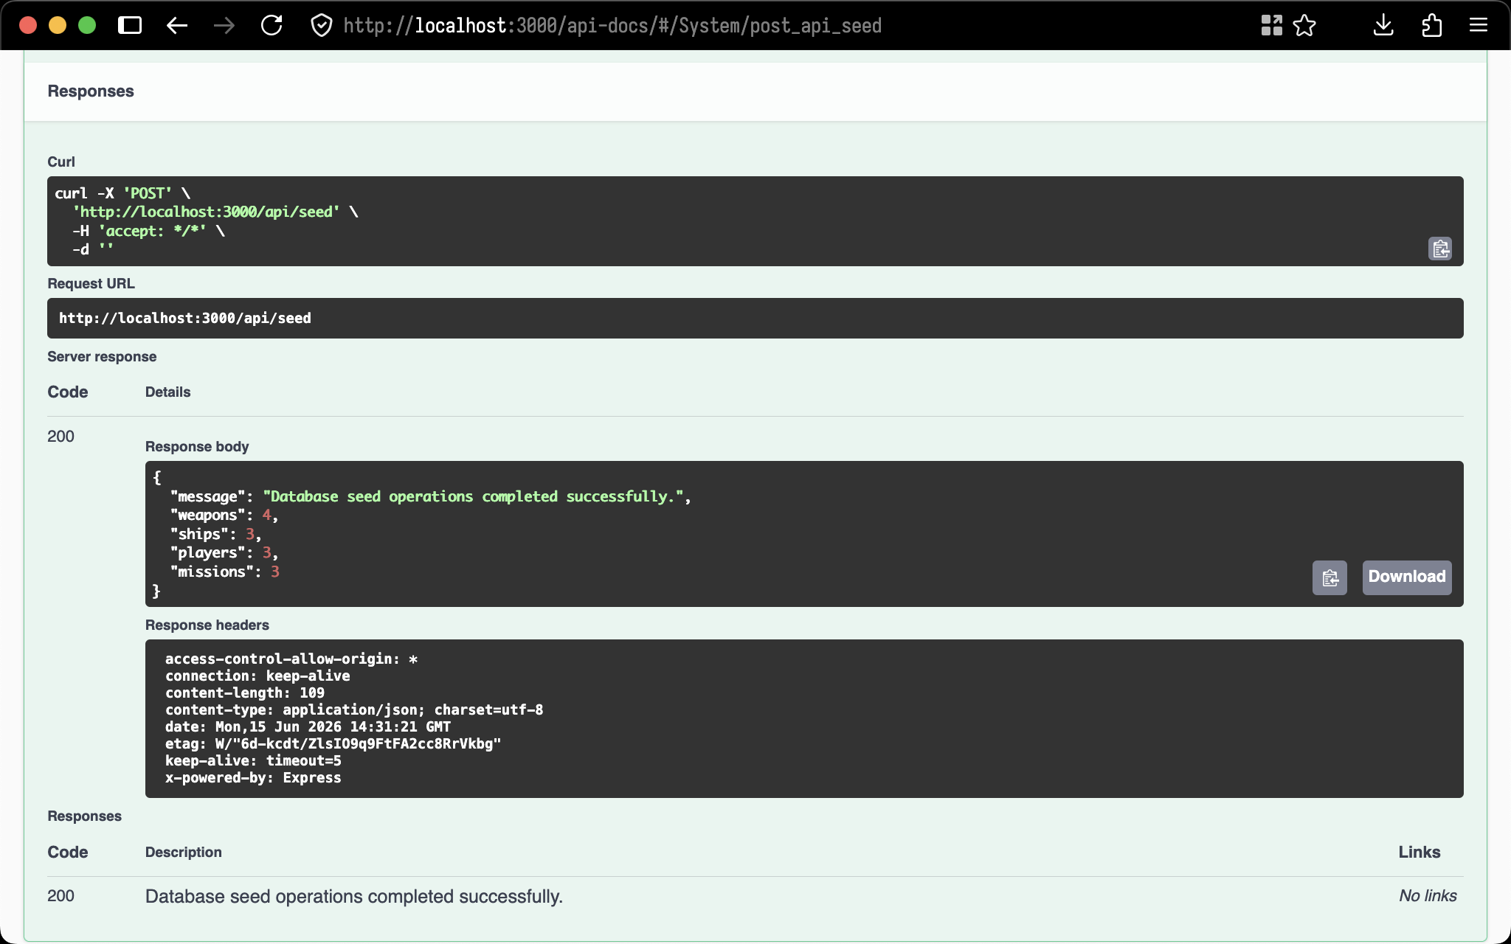
200 Response

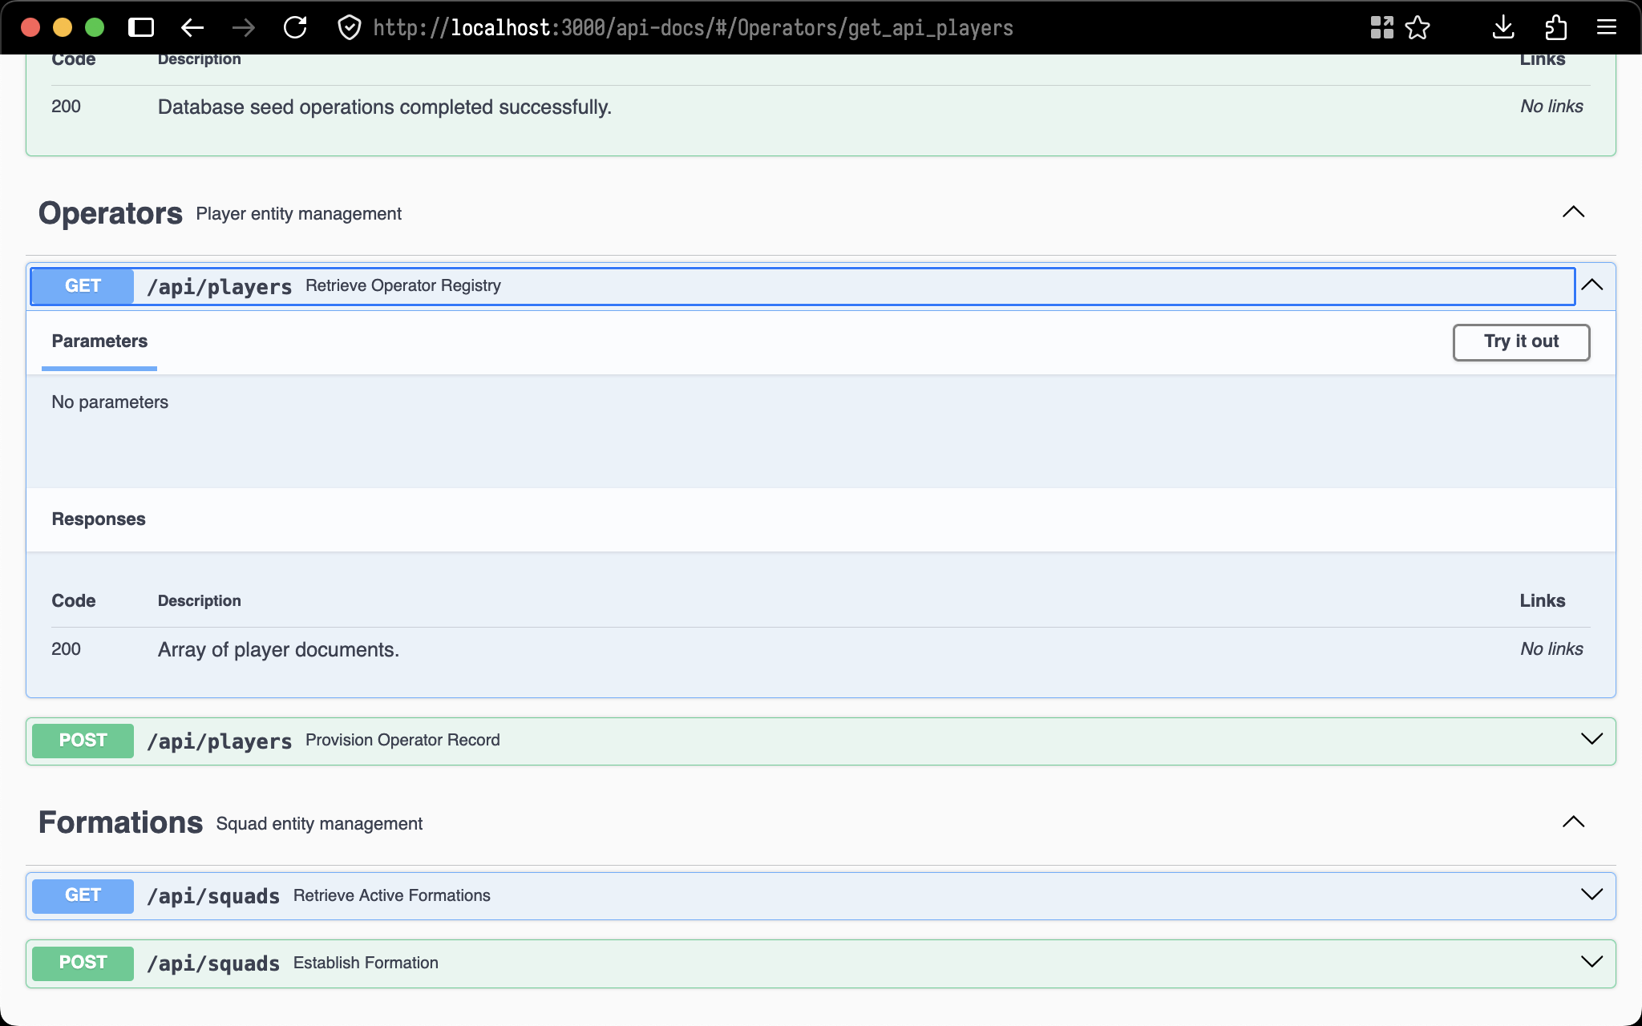
GET /api/players

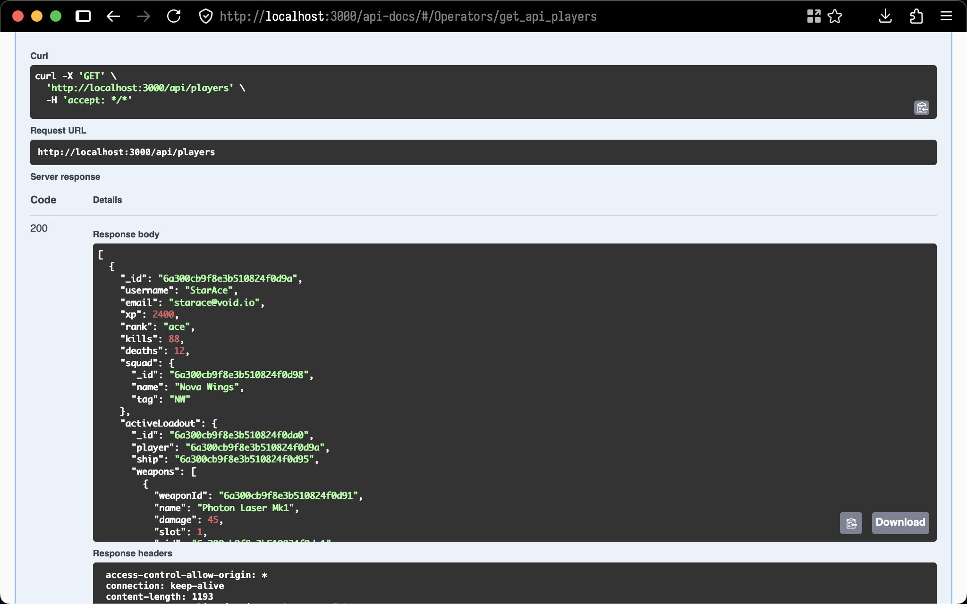
200 Response

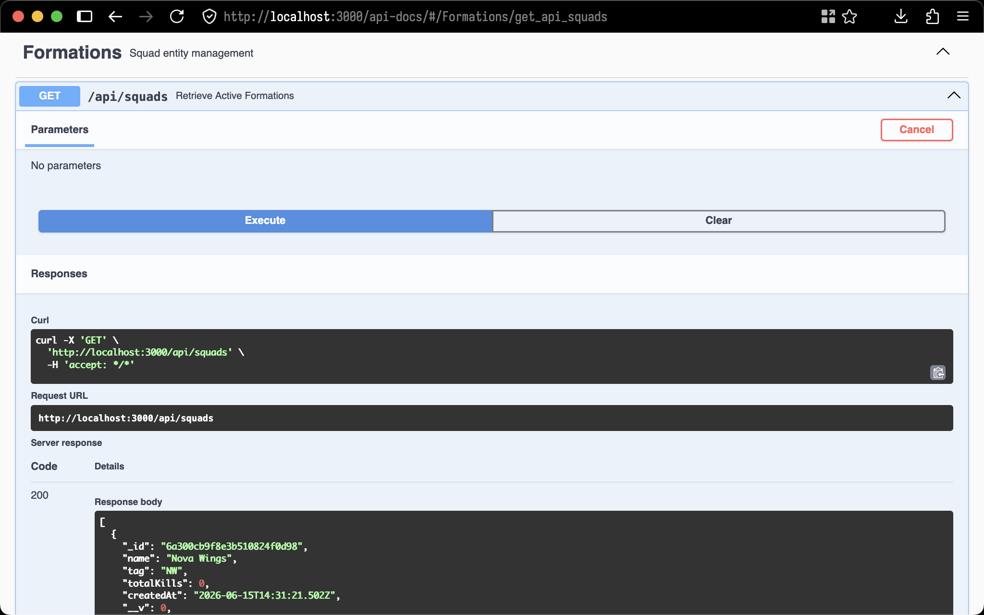
GET /api/squads

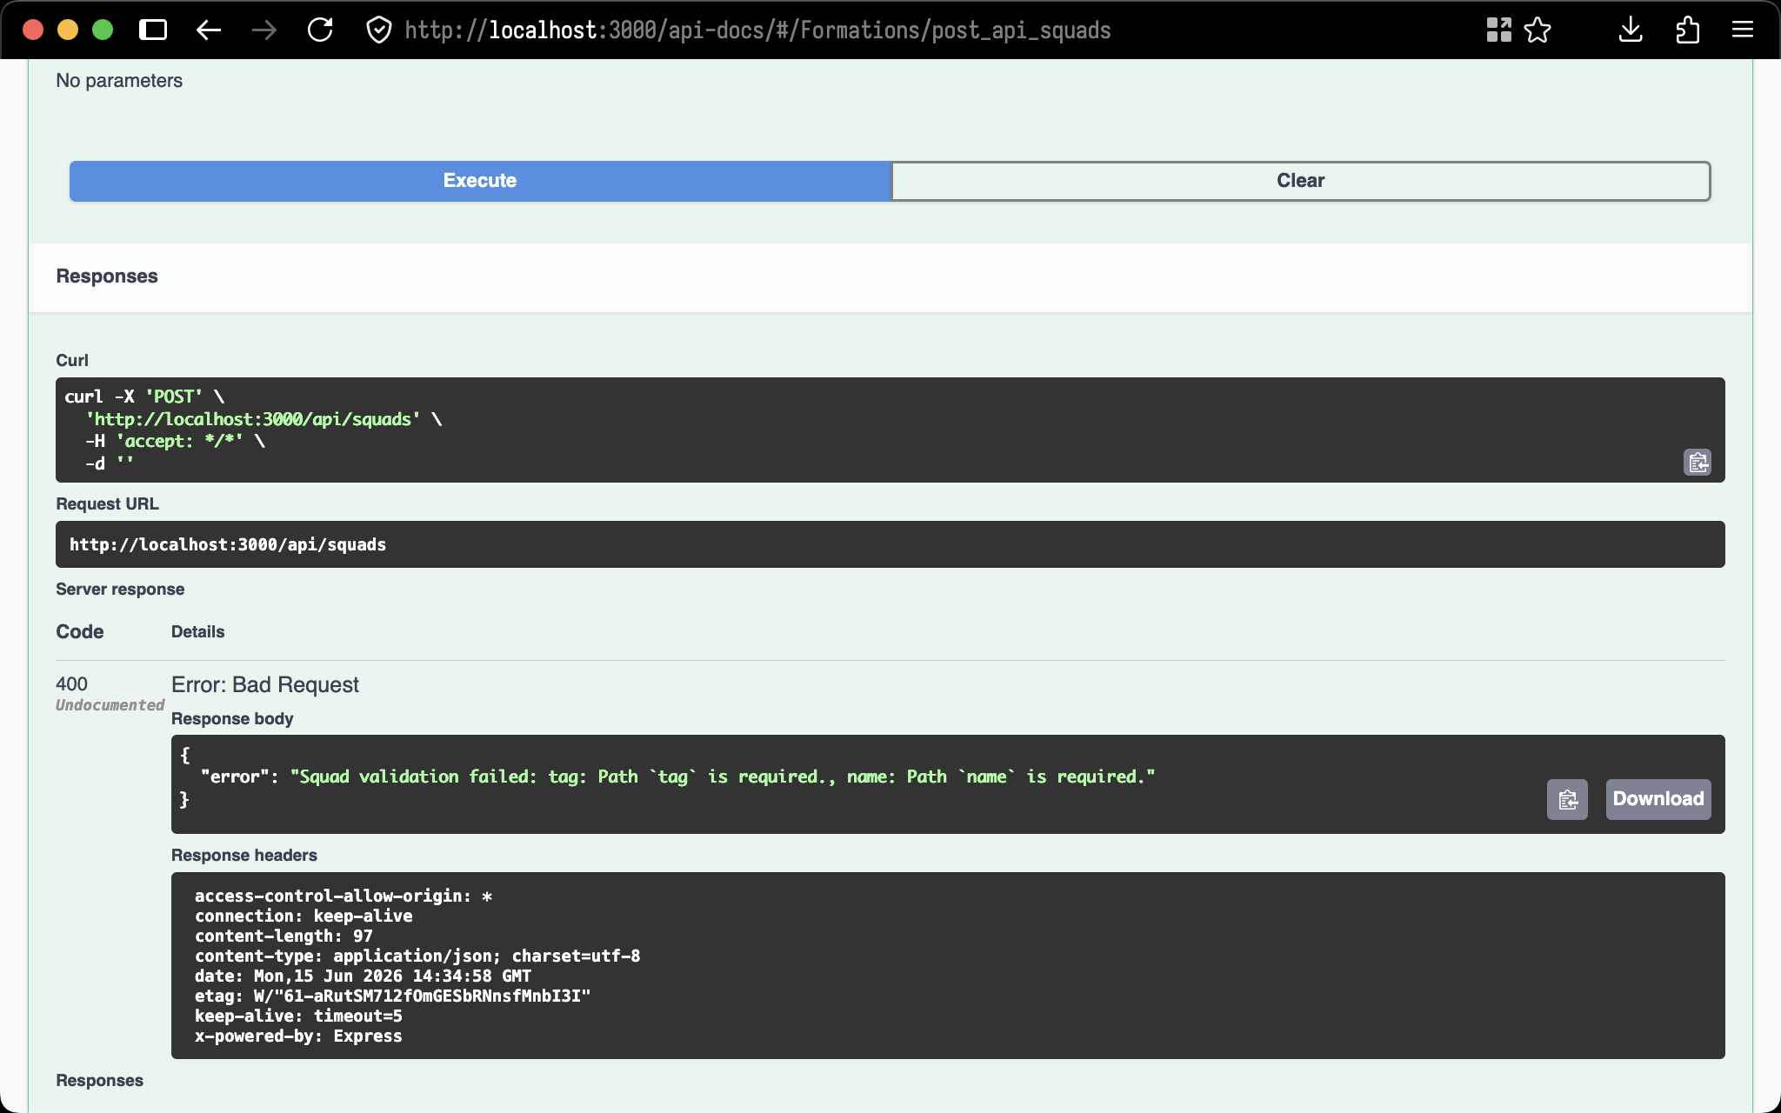
POST /api/squads (error handing)

