**PL/SQL - Hands-on Solutions**

**EXERCISE 1: CONTROL STRUCTURES:**

**Scenario 1:** The bank wants to apply a discount to loan interest rates for customers above 60 years old.

**Question:** Write a PL/SQL block that loops through all customers, checks their age, and if they are above 60, apply a 1% discount to their current loan interest rates.

**Solution:**

SET SERVEROUTPUT ON;

DECLARE

v_customer_id NUMBER;

v_dob DATE;

v_age NUMBER;

BEGIN

FOR cust IN (SELECT CustomerID, DOB FROM Customers) LOOP

v_customer_id := cust.CustomerID;

v_dob := cust.DOB;

v_age := FLOOR(MONTHS_BETWEEN(SYSDATE, v_dob) / 12);

IF v_age > 60 THEN

UPDATE Loans

SET InterestRate = InterestRate - 1

WHERE CustomerID = v_customer_id;

DBMS_OUTPUT.PUT_LINE('Discount applied for Customer ID: ' || v_customer_id);

END IF;

END LOOP;

END;

/

**OUTPUT :**

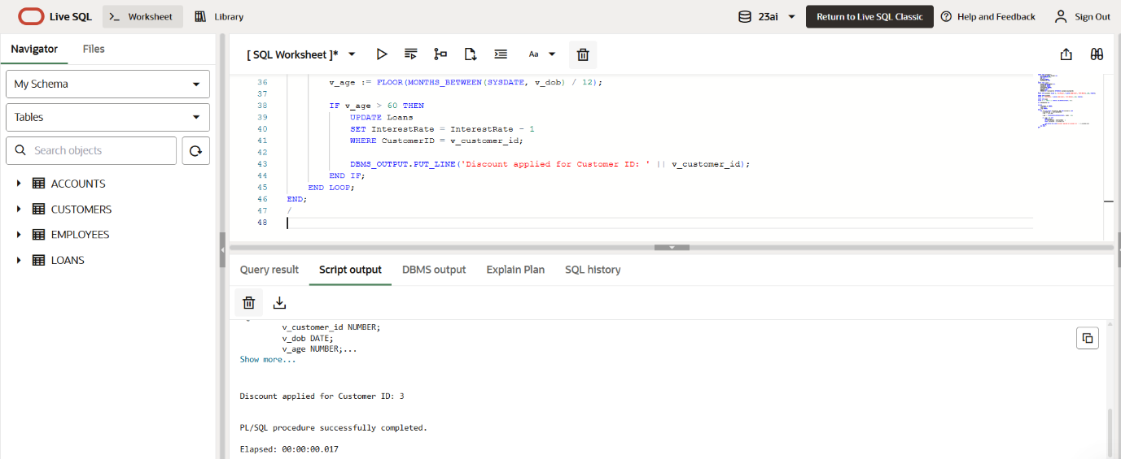

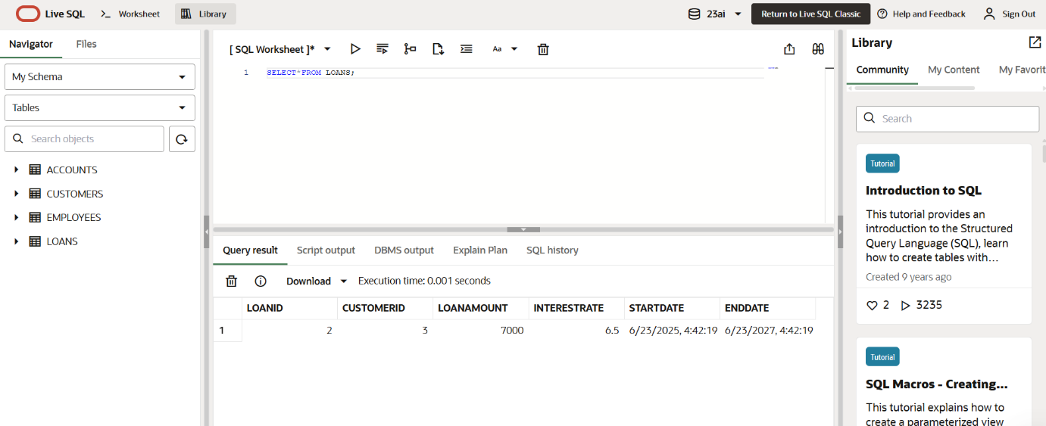

**Scenario 2:** A customer can be promoted to VIP status based on their balance.

**Question:** Write a PL/SQL block that iterates through all customers and sets a flag IsVIP to TRUE for those with a balance over $10,000.

**Solution:**

SET SERVEROUTPUT ON;

DECLARE

v_customer_id Customers.CustomerID%TYPE;

v_balance Customers.Balance%TYPE;

BEGIN

FOR cust IN (SELECT CustomerID, Balance FROM Customers) LOOP

v_customer_id := cust.CustomerID;

v_balance := cust.Balance;

IF v_balance > 10000 THEN

UPDATE Customers

SET IsVIP = 'TRUE'

WHERE CustomerID = v_customer_id;

DBMS_OUTPUT.PUT_LINE('Customer ID ' || v_customer_id || ' marked as VIP.');

END IF;

END LOOP;

END;

/

**OUTPUT :**

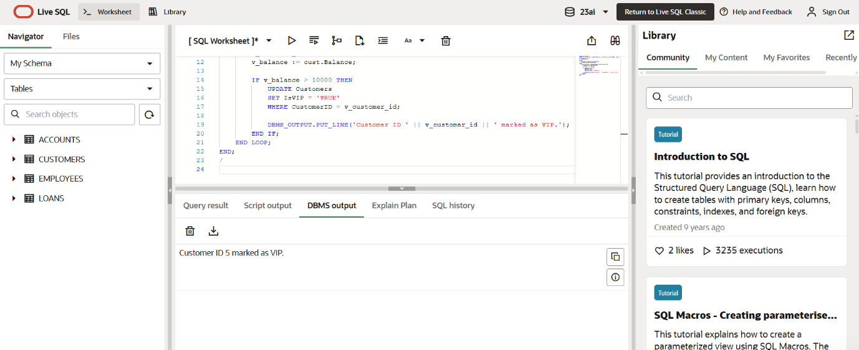

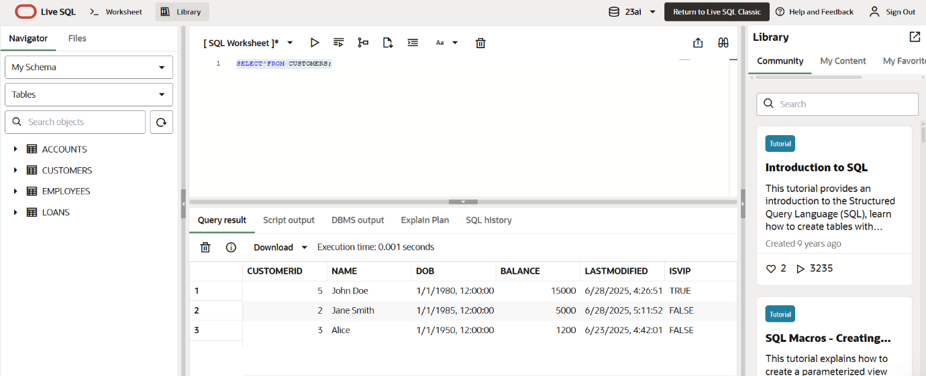

**Scenario 3:** The bank wants to send reminders to customers whose loans are due within the next 30 days.

**question:** Write a PL/SQL block that fetches all loans due in the next 30 days and prints a reminder message for each customer.

**SOLUTION:**

SET SERVEROUTPUT ON;

DECLARE

v_cust_id Loans.CustomerID%TYPE;

v_due_date Loans.EndDate%TYPE;

BEGIN

FOR loan_rec IN (

SELECT CustomerID, EndDate

FROM Loans

WHERE EndDate BETWEEN SYSDATE AND SYSDATE + 30

) LOOP

v_cust_id := loan_rec.CustomerID;

v_due_date := loan_rec.EndDate;

DBMS_OUTPUT.PUT_LINE('Reminder: Loan for Customer ID ' || v_cust_id ||

' is due on ' || TO_CHAR(v_due_date, 'YYYY-MM-DD'));

END LOOP;

END;

/

**OUTPUT :**

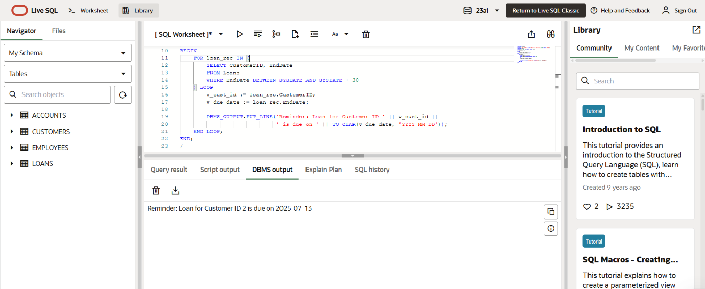

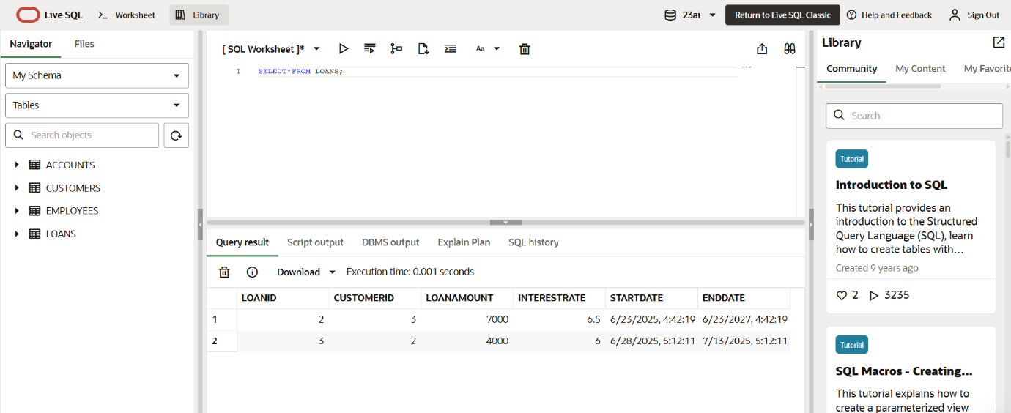

**EXERCISE 3: STORED PROCEDURES:**

**Scenario 1:** The bank needs to process monthly interest for all savings accounts.

**Question:** Write a stored procedure **ProcessMonthlyInterest** that calculates and updates the balance of all savings accounts by applying an interest rate of 1% to the current balance.

**SOLUTION :**

CREATE OR REPLACE PROCEDURE ProcessMonthlyInterest AS

BEGIN

FOR acc IN (

SELECT AccountID, Balance

FROM Accounts

WHERE AccountType = 'Savings'

) LOOP

UPDATE Accounts

SET Balance = Balance + (acc.Balance * 0.01)

WHERE AccountID = acc.AccountID;

DBMS_OUTPUT.PUT_LINE('Interest applied to Account ID: ' || acc.AccountID);

END LOOP;

END;

/

BEGIN

ProcessMonthlyInterest;

END;

/

**OUTPUT :**

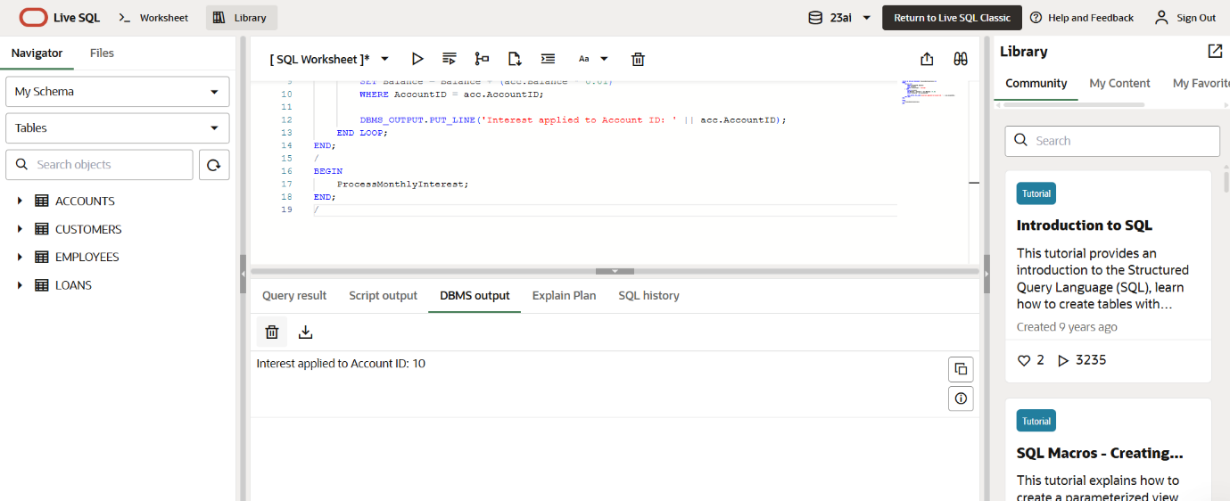

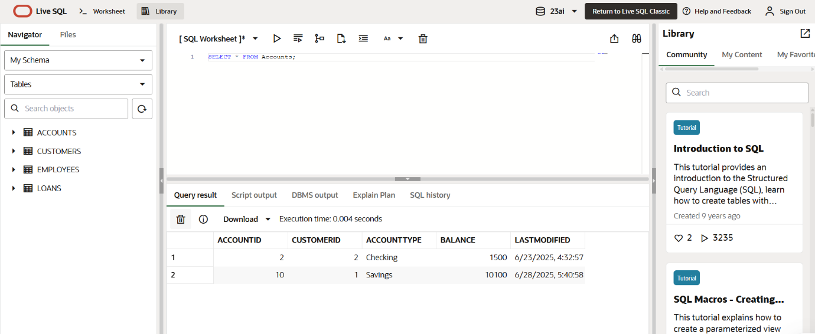

**Scenario 2:** The bank wants to implement a bonus scheme for employees based on their performance.

**Question:** Write a stored procedure **UpdateEmployeeBonus** that updates the salary of employees in a given department by adding a bonus percentage passed as a parameter.

**SOLUTION :**

CREATE OR REPLACE PROCEDURE UpdateEmployeeBonus (

p_department IN VARCHAR2,

p_bonus_percent IN NUMBER

) AS

BEGIN

UPDATE Employees

SET Salary = Salary + (Salary * p_bonus_percent / 100)

WHERE Department = p_department;

DBMS_OUTPUT.PUT_LINE('Bonus applied to Department: ' || p_department);

END;

/

BEGIN

UpdateEmployeeBonus('IT', 10);

END;

/

**OUTPUT :**

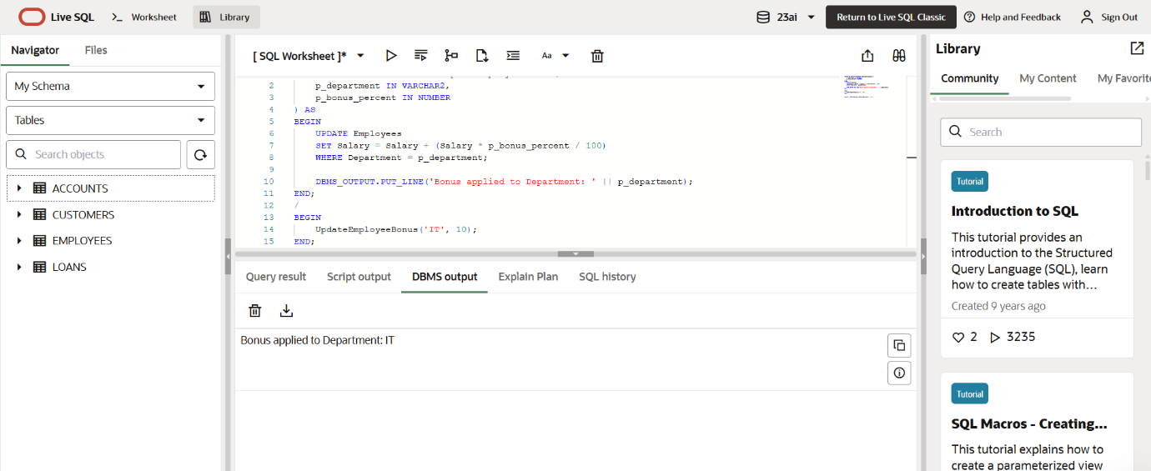

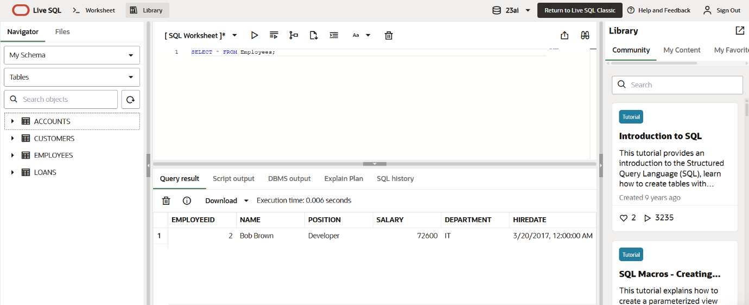

**Scenario 3:** Customers should be able to transfer funds between their accounts.

**Question:** Write a stored procedure **TransferFunds** that transfers a specified amount from one account to another, checking that the source account has sufficient balance before making the transfer.

**SOLUTION :**

CREATE OR REPLACE PROCEDURE TransferFunds (

p_from_account IN NUMBER,

p_to_account IN NUMBER,

p_amount IN NUMBER

) AS

v_balance NUMBER;

BEGIN

SELECT Balance INTO v_balance

FROM Accounts

WHERE AccountID = p_from_account;

IF v_balance >= p_amount THEN

UPDATE Accounts

SET Balance = Balance - p_amount

WHERE AccountID = p_from_account;

UPDATE Accounts

SET Balance = Balance + p_amount

WHERE AccountID = p_to_account;

DBMS_OUTPUT.PUT_LINE('₹' || p_amount || ' transferred from Account ' ||

p_from_account || ' to Account ' || p_to_account);

ELSE

DBMS_OUTPUT.PUT_LINE('Transfer failed: Insufficient balance in Account ' || p_from_account);

END IF;

END;

/

BEGIN

TransferFunds(10, 11, 500);

END;

/

**OUTPUT :**



