**WEEK - 7 HANDSON SOLUTION**

**EXERCISE -1 :**

Create a first React file Cricket App.

**SOLUTION :**

**PROGRAM :**

**App.js :**

import React from 'react';

import ListofPlayers from './ListofPlayers';

import IndianPlayers from './IndianPlayers';

function App() {

  const flag = true; // ✅ change to false to view IndianPlayers component

  return (

    <div className="App">

      <h1>🏏 Cricket Application</h1>

      {flag ? <ListofPlayers /> : <IndianPlayers />}

    </div>

  );

}

export default App;

**IndianPlayers.js :**

import React from 'react';

const IndianPlayers = () => {

  const oddTeam = ['Virat', 'Dhoni', 'Gill', 'Shreyas', 'Kuldeep'];

  const evenTeam = ['Rohit', 'Jadeja', 'Rahul', 'Bumrah', 'Surya'];

  const [player1, player2, ...restPlayers] = oddTeam;

  const T20players = ['Rohit', 'Virat'];

const RanjiTrophy = ['Rahane', 'Pujara'];

  const allPlayers = [...T20players, ...RanjiTrophy];

  return (

    <div>

      <h2>Odd Team</h2>

      <ul>

        {oddTeam.map((p, i) => <li key={i}>{p}</li>)}

      </ul>

      <h2>Even Team</h2>

      <ul>

        {evenTeam.map((p, i) => <li key={i}>{p}</li>)}

      </ul>

      <h3>Destructured Players:</h3>

      <p>Player1: {player1}</p>

      <p>Player2: {player2}</p>

      <h3>Merged T20 + Ranji Trophy Players:</h3>

      <ul>

        {allPlayers.map((p, i) => <li key={i}>{p}</li>)}

      </ul>

    </div>

  );

};

export default IndianPlayers;

**Listof\Players.js :**

import React from 'react';

const ListofPlayers = () => {

  const players = [

    { name: 'Virat', score: 85 },

    { name: 'Rohit', score: 45 },

    { name: 'Dhoni', score: 90 },

    { name: 'Jadeja', score: 60 },

    { name: 'KL Rahul', score: 74 },

    { name: 'Bumrah', score: 68 },

    { name: 'Gill', score: 80 },

    { name: 'Surya', score: 55 },

    { name: 'Shreyas', score: 95 },

    { name: 'Kuldeep', score: 64 },

    { name: 'Shami', score: 71 }

  ];

  const below70 = players.filter(player => player.score < 70);

  return (

    <div>

      <h2>All Players</h2>

      <ul>

        {players.map((p, i) => (

          <li key={i}>{p.name} - {p.score}</li>

        ))}

      </ul>

      <h2>Players with Score Below 70</h2>

      <ul>

        {below70.map((p, i) => (

          <li key={i}>{p.name} - {p.score}</li>

        ))}

      </ul>

    </div>

  );

};

export default ListofPlayers;

**OUTPUT :**

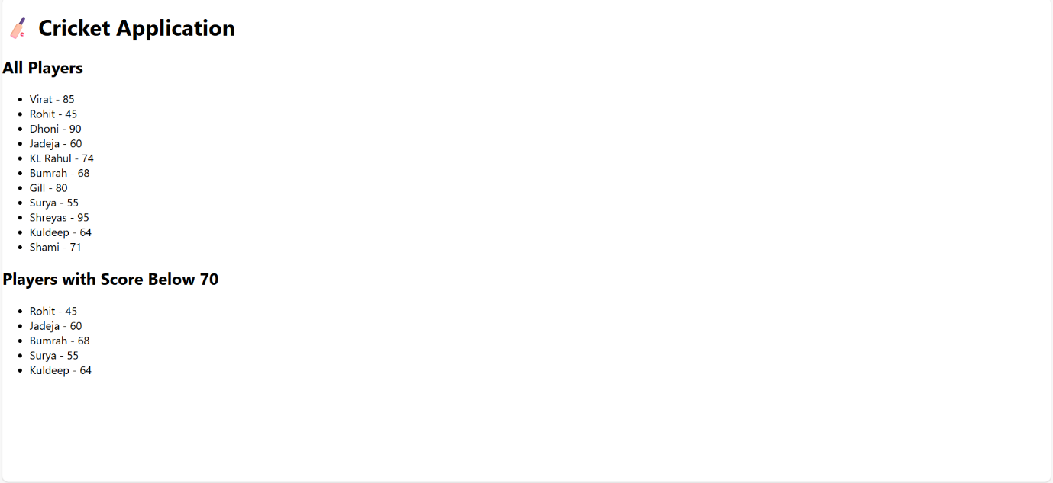

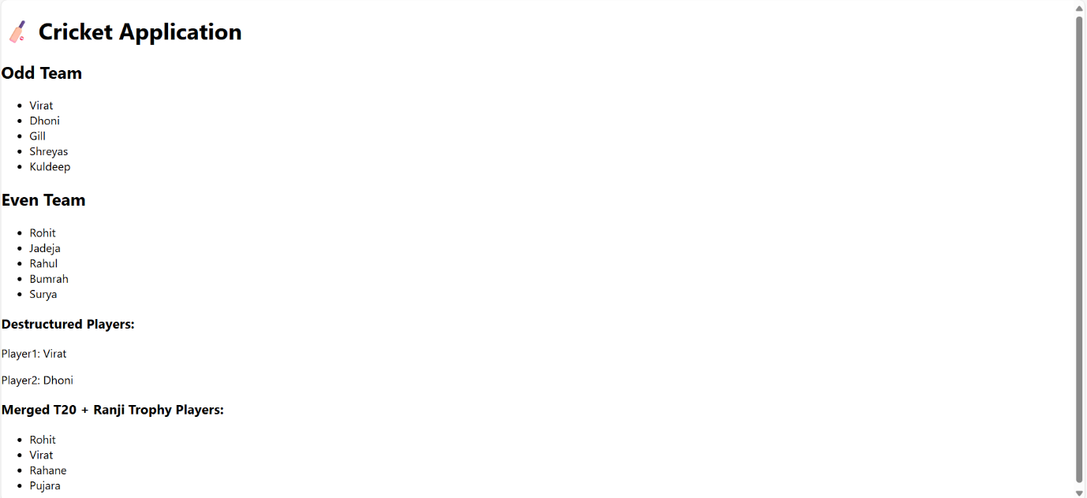

**EXERCISE - 2 :**

Create a Offices Pacerental app .

**PROBLEM STATEMENT :**

Create a React Application named “officespacerentalapp” which uses React JSX to create elements, attributes and renders DOM to display the page.

**SOLUTION :**

**App.js :**

import React from 'react';

function App() {

  const offices = [

    {

      name: "Tech Park One",

      rent: 55000,

      address: "123 MG Road, Bangalore",

      image: "https://via.placeholder.com/300x200?text=Office+1"

    },

    {

      name: "GreenField Workspace",

      rent: 75000,

      address: "44 Anna Salai, Chennai",

      image: "https://via.placeholder.com/300x200?text=Office+2"

    },

    {

      name: "Sky Tower Offices",

      rent: 60000,

      address: "56 Gachibowli, Hyderabad",

      image: "https://via.placeholder.com/300x200?text=Office+3"

    }

  ];

  return (

    <div style={{ padding: '20px', fontFamily: 'Arial' }}>

      <h1>🏢 Office Space Rental App</h1>

      {offices.map((office, index) => {

        const rentStyle = {

          color: office.rent < 60000 ? 'red' : 'green',

          fontWeight: 'bold'

        };

        return (

          <div key={index} style={{ border: '1px solid #ccc', padding: '10px', margin: '10px' }}>

            <img src={office.image} alt={office.name} style={{ width: '300px', height: '200px' }} />

            <h2>{office.name}</h2>

            <p style={rentStyle}>Rent: ₹{office.rent}</p>

            <p>Address: {office.address}</p>

          </div>

        );

      })}

    </div>

  );

}

export default App;

**Index.js :**

import React from 'react';

import ReactDOM from 'react-dom/client';

import './index.css';

import App from './App';

import reportWebVitals from './reportWebVitals';

const root = ReactDOM.createRoot(document.getElementById('root'));

root.render(

<React.StrictMode>

<App />

</React.StrictMode>

);

reportWebVitals();

<div style={{ textAlign: 'center' }}>

<h2>Welcome to the Home page of Student Management Portal</h2>

</div>

);

}

export default Home;

**OUTPUT :**

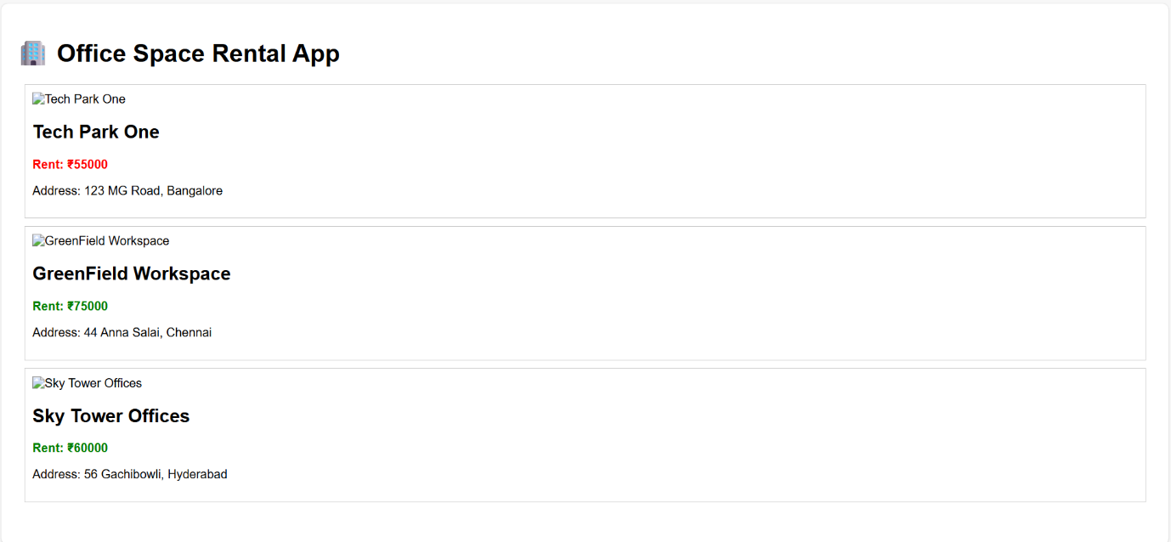

**EXERCISE - 3 :**

Create a react app for Event examples app .

**PROBLEM STATEMENT :**

Create a React Application “eventexamplesapp” to handle various events of the form elements in HTML.

1. Create “Increment” button to increase the value of the counter and “Decrement” button to decrease the value of the counter. The “Increase” button should invoke multiple methods.
   1. To increment the value
   2. Say Hello followed by a static message.

**SOLUTION :**

**App.js :**

import React, { useState } from 'react';

import CurrencyConvertor from './CurrencyConvertor';

function App() {

  const [count, setCount] = useState(0);

  const increment = () => {

    setCount(count + 1);

    sayHello();

  };

  const sayHello = () => {

    alert("Hello! Static message displayed.");

  };

  const decrement = () => {

    setCount(count - 1);

  };

  const sayWelcome = (msg) => {

    alert(`Welcome Message: ${msg}`);

  };

  const handleClick = () => {

    alert("I was clicked using synthetic event!");

  };

  return (

    <div style={{ padding: '20px', fontFamily: 'Arial' }}>

      <h1>🎯 React Event Examples</h1>

      <h2>1. Counter</h2>

      <p>Count: {count}</p>

      <button onClick={increment}>Increment</button>{' '}

      <button onClick={decrement}>Decrement</button>

      <h2>2. Welcome Button</h2>

      <button onClick={() => sayWelcome("Welcome to Event Handling!")}>Say Welcome</button>

      <h2>3. Synthetic Event</h2>

      <button onClick={handleClick}>Click Me</button>

      <h2>4. Currency Convertor</h2>

      <CurrencyConvertor />

    </div>

  );

}export default App;

**Index.js :**

import React from 'react';

import ReactDOM from 'react-dom/client';

import './index.css';

import App from './App';

import reportWebVitals from './reportWebVitals';

const root = ReactDOM.createRoot(document.getElementById('root'));

root.render(

  <React.StrictMode>

    <App />

  </React.StrictMode>

);

reportWebVitals();

**Index.js :**

import React, { useState } from 'react';

function CurrencyConvertor() {

  const [rupees, setRupees] = useState('');

  const [euros, setEuros] = useState(null);

  const handleSubmit = () => {

    if (isNaN(rupees) || rupees.trim() === '') {

      alert("Enter valid rupee amount");

      return;

    }

    const euro = (parseFloat(rupees) / 90).toFixed(2);

    setEuros(euro);

  };

  return (

    <div>

      <input

        type="text"

        placeholder="Amount in INR"

        value={rupees}

        onChange={(e) => setRupees(e.target.value)}

      />

      <button onClick={handleSubmit}>Convert</button>

      {euros && <p>💶 Euros: €{euros}</p>}

    </div>

  );

}

export default CurrencyConvertor;

**OUTPUT :**

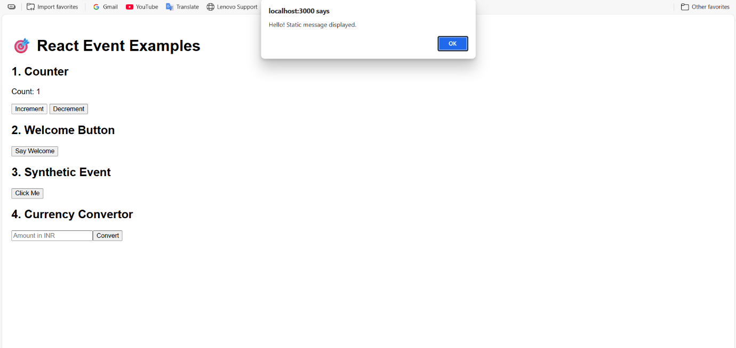

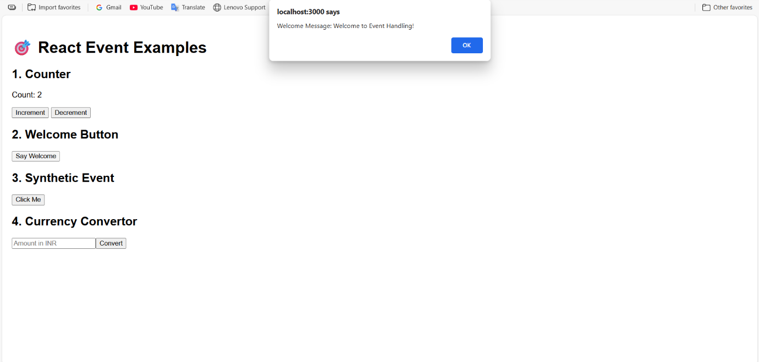

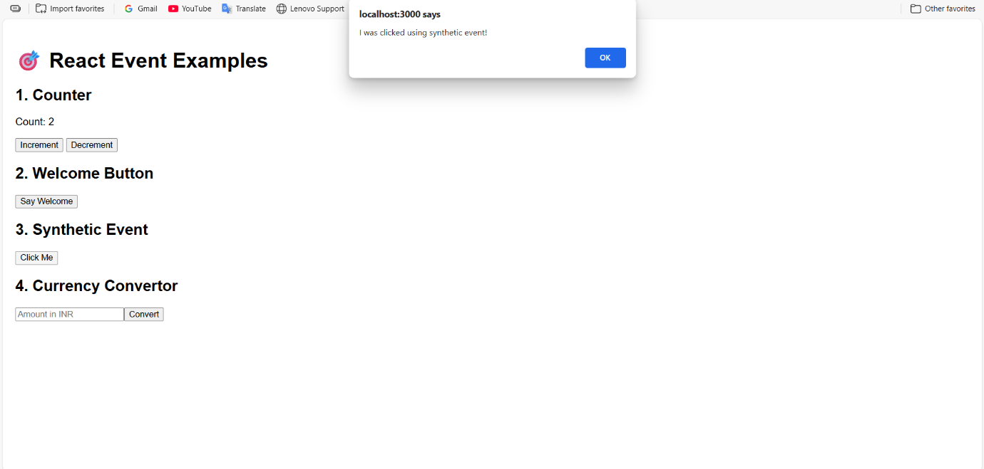

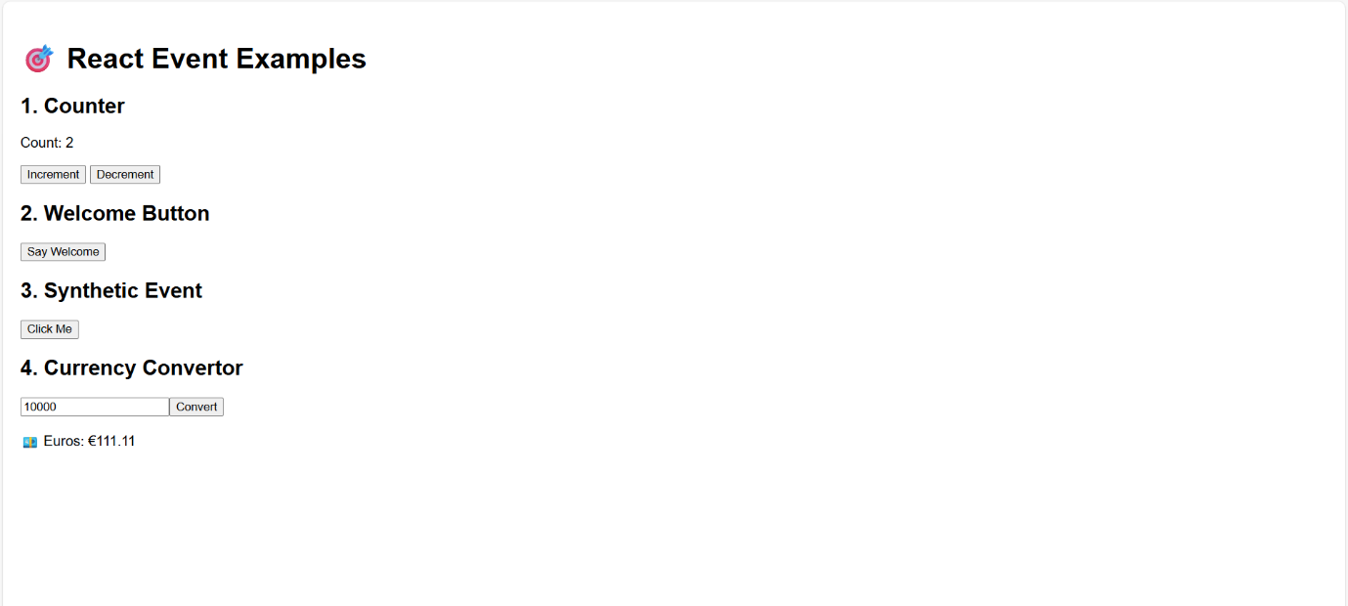

**EXERCISE - 4 :**

Create a React Application named “ticketbookingapp” where the guest user can browse the page where the flight details are displayed whereas the logged in user only can book tickets.

The Login and Logout buttons should accordingly display different pages. Once the user is logged in the User page should be displayed. When the user clicks on Logout, the Guest page should be displayed.

**SOLUTION :**

**App.js :**

import React, { useState } from 'react';

function GuestPage() {

  return (

    <div>

      <h2>Welcome, Guest!</h2>

      <p>Browse available flights below:</p>

      <ul>

        <li>Flight A - 9:00 AM</li>

        <li>Flight B - 12:30 PM</li>

        <li>Flight C - 7:45 PM</li>

      </ul>

    </div>

  );

}

function UserPage() {

  return (

    <div>

      <h2>Welcome, User!</h2>

      <p>You can now book your flight:</p>

      <button>Book Flight</button>

    </div>

  );

}

function App() {

  const [isLoggedIn, setIsLoggedIn] = useState(false);

  const toggleLogin = () => setIsLoggedIn(prev => !prev);

  let pageContent = isLoggedIn ? <UserPage /> : <GuestPage />;

  return (

    <div className="App">

      <h1>✈️ Ticket Booking Portal</h1>

      <button onClick={toggleLogin}>

        {isLoggedIn ? 'Logout' : 'Login'}

      </button>

      {pageContent}

    </div>

  );

}

export default App;

**Index.js:**

import React from 'react';

import ReactDOM from 'react-dom/client';

import './index.css';

import App from './App';

import reportWebVitals from './reportWebVitals';

const root = ReactDOM.createRoot(document.getElementById('root'));

root.render(

<React.StrictMode>

<App />

</React.StrictMode>

);

reportWebVitals();;

**ReportWebVital.js :**

const reportWebVitals = onPerfEntry => {

  if (onPerfEntry && onPerfEntry instanceof Function) {

    import('web-vitals').then(({ getCLS, getFID, getFCP, getLCP, getTTFB }) => {

      getCLS(onPerfEntry);

      getFID(onPerfEntry);

      getFCP(onPerfEntry);

      getLCP(onPerfEntry);

      getTTFB(onPerfEntry);

    });

  }

};

export default reportWebVitals;

**OUTPUT :**

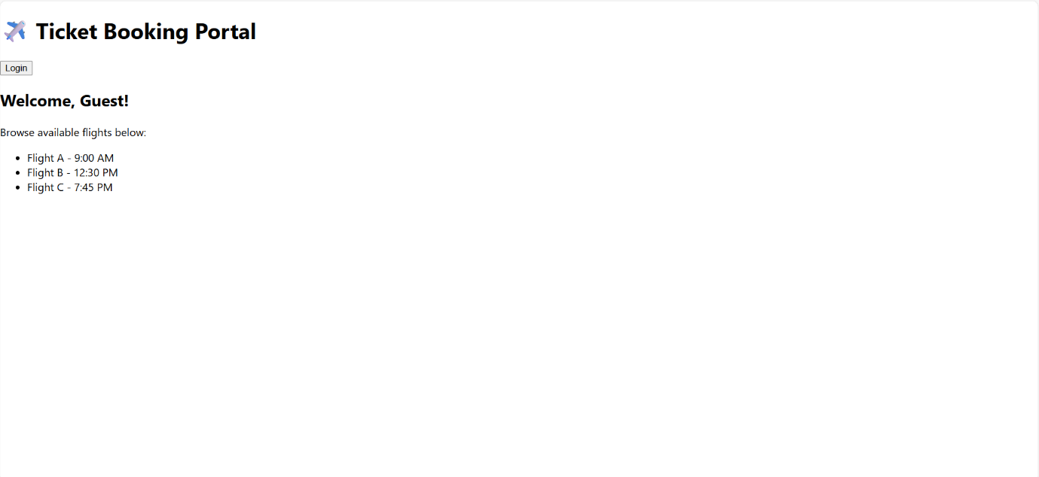

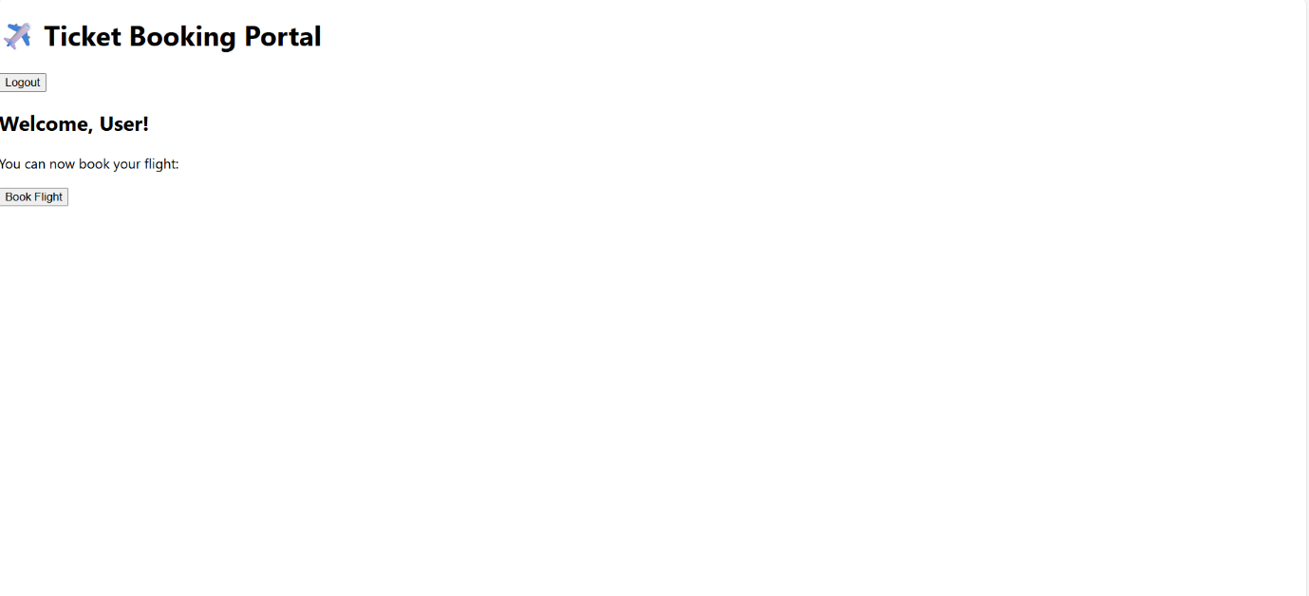

**EXERCISE - 5 :**

Create a react app for Blogger App.

**PROBLEM STATEMENT :**

Create a React App named “bloggerapp” in with 3 components.

1. Book Details
2. Blog Details
3. Course Details

Implement this with as many ways possible of Conditional Rendering.

**SOLUTION :**

**App.js:**

import React, { useState } from 'react';

import BookDetails from './BookDetails';

import BlogDetails from './BlogDetails';

import CourseDetails from './CourseDetails';

function App() {

  const [view, setView] = useState("book");

  // Using function return

  function getComponent() {

    if (view === "book") return <BookDetails />;

    else if (view === "blog") return <BlogDetails />;

    else if (view === "course") return <CourseDetails />;

    else return <p>No View Selected</p>;

  }

  return (

    <div className="App">

      <h1>📘 Blogger App</h1>

      <div style={{ marginBottom: "10px" }}>

        <button onClick={() => setView("book")}>Book</button>

        <button onClick={() => setView("blog")}>Blog</button>

        <button onClick={() => setView("course")}>Course</button>

      </div>

      {/* 1. Ternary operator */}

      {view === "book" ? <p>You selected Book</p> : null}

      {/* 2. Logical && */}

      {view === "blog" && <p>Blog view selected</p>}

      {/* 3. Function with if-else inside */}

      {getComponent()}

    </div>

  );

}

export default App;

**Index.js :**

import React from 'react';

import ReactDOM from 'react-dom/client';

import './index.css';

import App from './App';

import reportWebVitals from './reportWebVitals';

const root = ReactDOM.createRoot(document.getElementById('root'));

root.render(

  <React.StrictMode>

    <App />

  </React.StrictMode>

);

reportWebVitals();

**Blog details.js :**

function BlogDetails() {

  return (

    <div>

      <h3>📝 Blog Details</h3>

      <p>Blog: Learning React Step-by-Step</p>

      <p>Author: Jane Smith</p>

    </div>

  );

}

export default BlogDetails;

**Book details.js :**

function BookDetails() {

  return (

    <div>

      <h3>📚 Book Details</h3>

      <p>Title: React for Beginners</p>

      <p>Author: John Doe</p>

    </div>

  );

}

export default BookDetails;

**Course details.js :**

function CourseDetails() {

  return (

    <div>

      <h3>🎓 Course Details</h3>

      <p>Course: Full Stack Developer</p>

      <p>Duration: 3 Months</p>

    </div>

  );

}

export default CourseDetails;

**OUTPUT :**

