|  |  |  |  |
| --- | --- | --- | --- |
| Term | Project Name | Project Sponsor / Professor | Doc. Revision |
| 2021 | Localization of Autonomous Delivery Vehicle via Wi-Fi | Self-Funded / Dr. Rogers | 9 |

Project Description

## Project Background:

This past year there was a rise in interest in autonomous home delivery vehicles to alleviate the strain on human delivery drivers and prevent the spread of COVID-19. However, there are many challenges in the functionality of these vehicles, such as inaccurate location and loss of signal quality indoors. This prevents prompt and accurate delivery to the consumer wherever they are.

## Problem Statement:

To meet the challenge of inaccurate location data, a method of localization will be developed through the combined usage of GPS and Wi-Fi on a board with moving directional antennas.

## Objectives/Scope:

## Investigate, develop and test a robust WiFi localization algorithm using Received Signal Strength Indication (RSSI) combined with Angle of Arrival (AoA) to discern the distance from a WiFi Access Point (AP).

## Create and test a functional WiFi localization module that accurately defines its position relative to an initial GPS position using servo-mounted directional antennas.

## With data received relative to the GPS position, implement a user interface that maps its position over time.

## Build a portable software library for easy duplication and modification.

## Deliverables:

* A platform that gathers Wi-Fi and GPS location data via GPS and servo-controlled Wi-Fi antennas
* A CPU that controls and analyzes the above data to estimate the module’s position relative to the APs and GPS.
* A chart displayed on compatible screen that displays location data and estimated position

## Expected Project Benefits:

## Allows a device to estimate its location in any place with a known layout, such as a picker robot in a warehouse

## Would assist in locating autonomous delivery or commuter vehicles in a crowded city.

## Core Team Members:

* Erik Floden - Project Lead
* John Thomas - Treasurer

Strategy & Approach

## Assumptions & Constraints:

## Assume that WiFi APs are in sight of the module as well as correctly polarized.

## The module will be tested in an open area to reduce effects of shadowing.

## Testing done outside will be under good weather to avoid RF nullification in rain/snow.

## Initial placement of APs to the module will be known to accurately model the localization data.

## Issues & Risks:

## Antennas with a wide directional characteristic will pick up multiple APs and skew data.

## GPS may be blocked by indoor walls and reflections, preventing useful data from being gathered.

## Localization algorithm may be too complex to realize in a physical system.

## Received signal strength may be too low to gain useful data or too high such that it saturates the transceiver.

Customer Needs:

|  |  |
| --- | --- |
| **Will Deliver** | **G** |
| **Will Not Deliver** | R |
| **At Risk** | Y |

|  |  |  |
| --- | --- | --- |
| **Objective** | **Description / Measure** | **Status** |
| **Positional Accuracy** | Board locates itself within 1 meter of its actual location |  |
| **Delivery Time** | Board must perform all calculations and output the module’s position with a 2 minute period. |  |
| **Board Size Limits** | Board must fit in a 30x30x30cm box |  |
| **Cost of Board** | Board must not cost more than $1000 |  |
| **GPS Usage** | Board employs GPS to provide location data within 4 meters outdoors |  |
| **Antenna Specification** | Board has a maximum of five directional yagi uda antennas mounted on servos to mimic |  |
| **GUI** | Board has a GUI that displays location data |  |
| **Power Consumption** | Board consumes a maximum of 20 W |  |
| **Wi-Fi FCC Specifications (Opportunistic)** | Meets or exceeds FCC requirements for emissions |  |
| **Parallel Processing (Opportunistic)** | Utilizes PyCUDA to move antennas and process RSSI data in parallel |  |

Project Flexibility Matrix:

|  |  |  |  |
| --- | --- | --- | --- |
|  | Flexibility | | |
|  | Least | Moderate | Most |
| Scope |  |  |  |
| Schedule |  |  |  |
| Resources ($ + People) |  |  |  |

System Level Design:

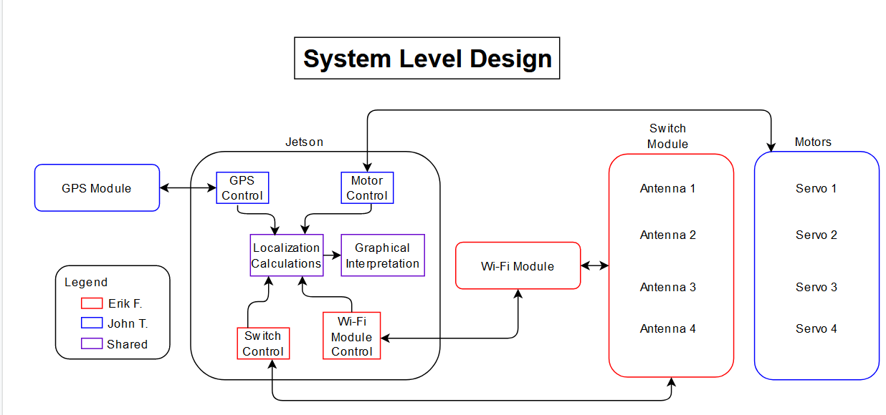

Work Breakdown Structure:



