|  |  |  |  |
| --- | --- | --- | --- |
| Term | Project Name | Project Sponsor / Professor | Doc. Revision |
| 2021 | Localization of Autonomous Delivery Vehicle via Wi-Fi | Self-Funded | 6 |

Project Description

## Project Background:

This past year there was a rise in interest in autonomous home delivery vehicles to alleviate the strain on human delivery drivers and prevent the spread of COVID-19. However, there are many challenges in the functionality of these vehicles, such as inaccurate location and loss of signal quality indoors. This prevents prompt and accurate delivery to the consumer wherever they are.

## Problem Statement:

To meet the challenge of inaccurate location data, a method of localization will be developed through the combined usage of GPS and Wi-Fi on a board with moving directional antennas.

## Objectives/Scope:

## 

## 

## Deliverables:



## Expected Project Benefits:

## [Will you be able to sell it? Does it fill a niche in the market that is not currently being filled?

## How much money will you make by designing and producing something like this? ]

## 

## Core Team Members:

* Erik Floden - Project Lead
* John Thomas - Treasurer

Strategy & Approach

## Assumptions & Constraints:

## [What key assumptions are you making or constraints that will impact your project if the assumption fails or the constraint is not removed?]

## 

## Issues & Risks:

## [These are the biggest challenges the team will face in delivering the project

## List 3-6 of them]

## 

## 

## 

## 

|  |  |
| --- | --- |
| Will Deliver | G |
| Will Not Deliver | R |
| At Risk | Y |

Customer Needs:

|  |  |  |
| --- | --- | --- |
| Objective | Description / Measure | Status |
| Positional Accuracy | Board locates itself within 1 meter of its actual location |  |
| Delivery Time | Board must perform all calculations within 2 minutes |  |
| Board Size Limits | Board must fit in a 30x30x30cm box |  |
| Cost of Board | Board must not cost more than $1000 |  |
| GPS Usage | Board employs GPS to provide location data within 4 meters |  |
| Antenna Specification | Board has a maximum of five antennas |  |
| GUI | Board has a GUI that displays location data |  |
| Power Consumption | Board consumes a maximum of 20 W |  |
| Wi-Fi FCC Specifications (Opportunistic) | Meets or exceeds FCC requirements for emissions |  |
| Parallel Processing (Opportunistic) | Uses CUDA to process data in parallel |  |

Project Flexibility Matrix:

|  |  |  |  |
| --- | --- | --- | --- |
|  | Flexibility | | |
|  | Least | Moderate | Most |
| Scope |  |  | 🗸 |
| Schedule | 🗸 |  |  |
| Resources ($ + People) |  | 🗸 |  |

System Level Design:

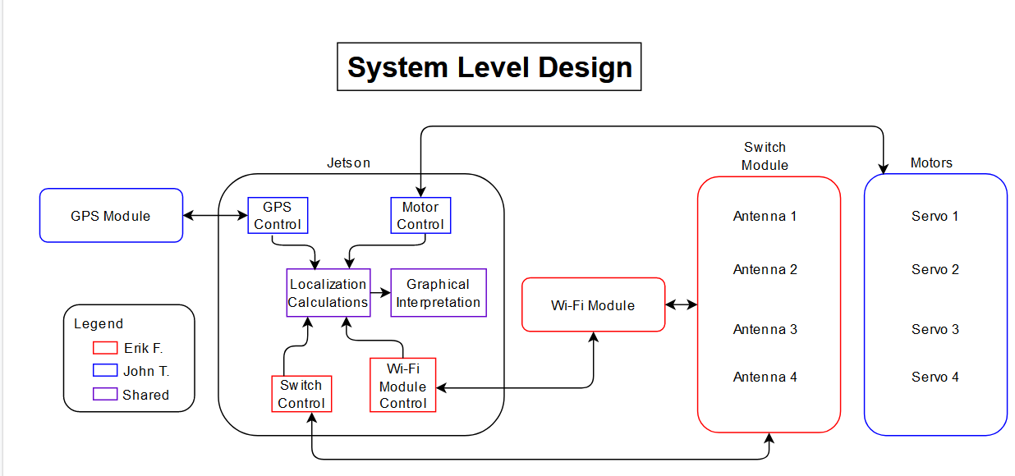

Work Breakdown Structure:

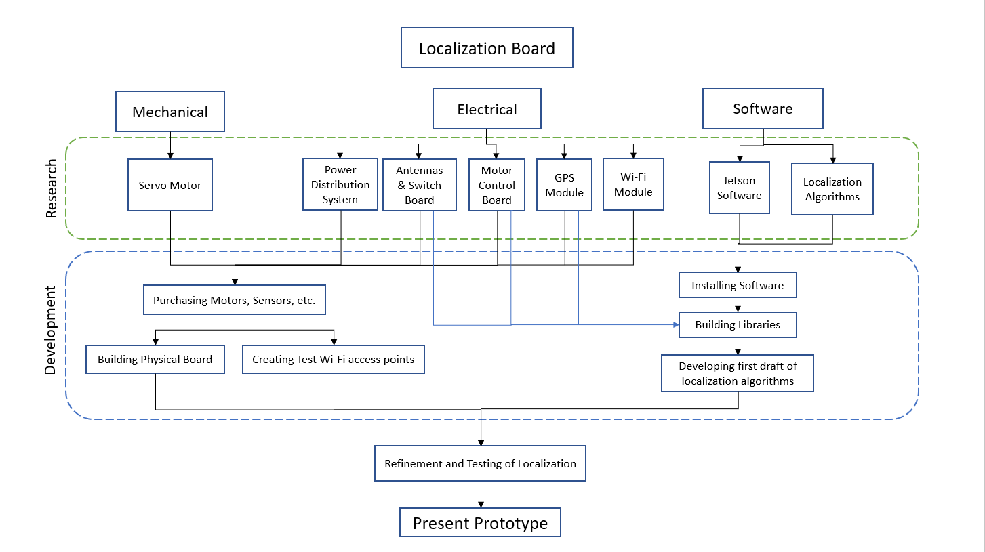

References: (If Required)

