|  |  |  |  |
| --- | --- | --- | --- |
| Term | Project Name | Project Sponsor / Professor | Doc. Revision |
| 2021 | Localization of Autonomous Delivery Vehicle via Wi-Fi | Self-Funded / Dr. Rogers | 7 |

Project Description

## Project Background:

This past year there was a rise in interest in autonomous home delivery vehicles to alleviate the strain on human delivery drivers and prevent the spread of COVID-19. However, there are many challenges in the functionality of these vehicles, such as inaccurate location and loss of signal quality indoors. This prevents prompt and accurate delivery to the consumer wherever they are.

## Problem Statement:

To meet the challenge of inaccurate location data, a method of localization will be developed through the combined usage of GPS and Wi-Fi on a board with moving directional antennas.

## Objectives/Scope:

## 

## 

## Deliverables:

* A platform that gathers Wi-Fi and GPS location data via GPS and servo-controlled Wi-Fi antennas
* A microcontroller than controls and analyzes the above data to estimate position
* A chart displayed on compatible screen that displays location data and estimated position

## Expected Project Benefits:

## Allows a device to estimate its location in any place with a known layout, such as a picker robot in a warehouse

## Would assist in locating autonomous delivery or commuter vehicles in a crowded city

## Core Team Members:

* Erik Floden - Project Lead
* John Thomas - Treasurer

Strategy & Approach

## Assumptions & Constraints:

## [What key assumptions are you making or constraints that will impact your project if the assumption fails or the constraint is not removed?]

## 

## Issues & Risks:

## Antennas may have too wide a view to resolve multiple access points

## GPS may be blocked by indoor walls and reflections, preventing useful data from being gathered

## Localization algorithm may be too complex to realize in a physical system

## Received signal strength may be too low to gain useful data

|  |  |
| --- | --- |
| Will Deliver | G |
| Will Not Deliver | R |
| At Risk | Y |

Customer Needs:

|  |  |  |
| --- | --- | --- |
| Objective | Description / Measure | Status |
| Positional Accuracy | Board locates itself within 1 meter of its actual location |  |
| Delivery Time | Board must perform all calculations within 2 minutes |  |
| Board Size Limits | Board must fit in a 30x30x30cm box |  |
| Cost of Board | Board must not cost more than $1000 |  |
| GPS Usage | Board employs GPS to provide location data within 4 meters |  |
| Antenna Specification | Board has a maximum of five antennas |  |
| GUI | Board has a GUI that displays location data |  |
| Power Consumption | Board consumes a maximum of 20 W |  |
| Wi-Fi FCC Specifications (Opportunistic) | Meets or exceeds FCC requirements for emissions |  |
| Parallel Processing (Opportunistic) | Uses CUDA to process data in parallel |  |

Project Flexibility Matrix:

|  |  |  |  |
| --- | --- | --- | --- |
|  | Flexibility | | |
|  | Least | Moderate | Most |
| Scope |  |  | 🗸 |
| Schedule | 🗸 |  |  |
| Resources ($ + People) |  | 🗸 |  |

System Level Design:

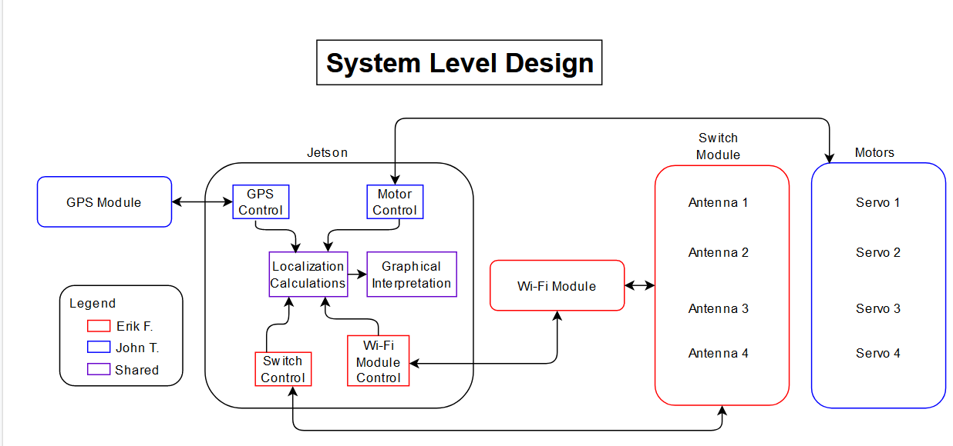

Work Breakdown Structure:

