Rapport de POO
Test du premier paragraphebold and some italic.

Heading, level 1
Intense quote
- first item in unordered list
- first item in ordered list
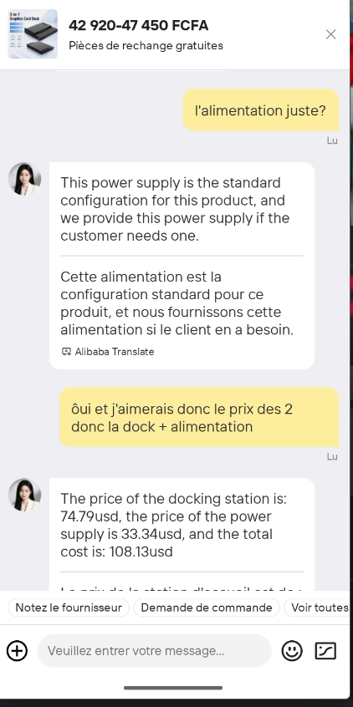
Qty | Id | Desc
3 | 101 | Spam
7 | 422 | Eggs
4 | 631 | Spam, spam, eggs, and spam

