**PROJECT**

Name- Ravish Dagar

Sap-500061767

Roll No-96

* Aim- Design a Chess Board on blender.
* Procedure-

1. Add a new mesh cube.
2. Give it a shape of a chess board and apply 7 loop-cuts horizontally and vertically to make 64 squares.
3. Now, assign the diagonal squares from the left to “black” and give it the color black. Assign the diagonal squares from right side to “white” and give it white color.

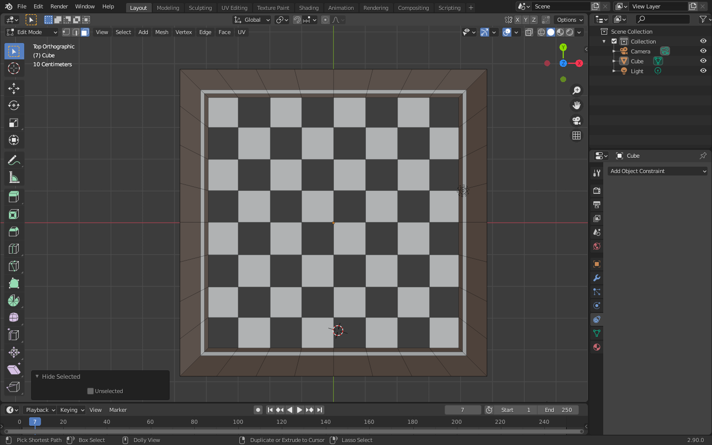

1. Hence, chess board is created.
2. Now, add a new mesh cylinder (with 16 vertices) to the chess board and shape it to the size of chess pieces.
3. Now, shape the cylinder like a “Pawn” just like shape of an original chess “Pawn”, and assign it to all the other squares (where required) as well, by making a duplicate of it.

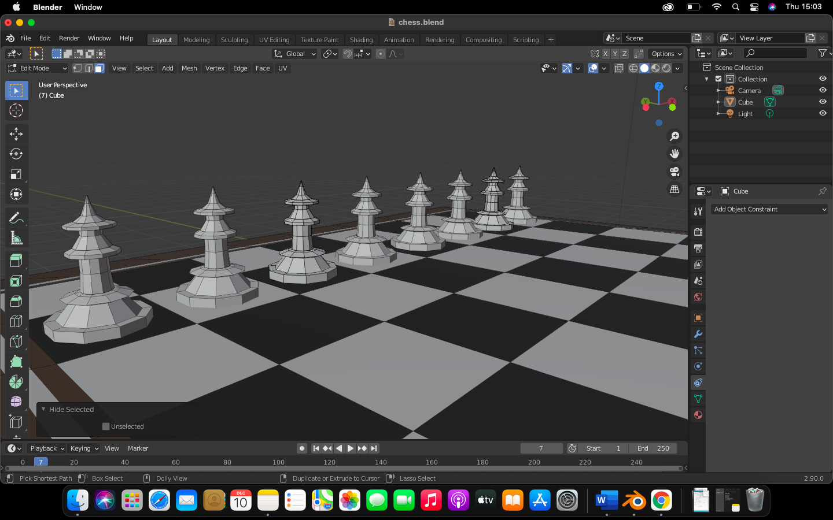

1. Now, add a new mesh cylinder and shape it like a “Rook” and do same as point “6”.

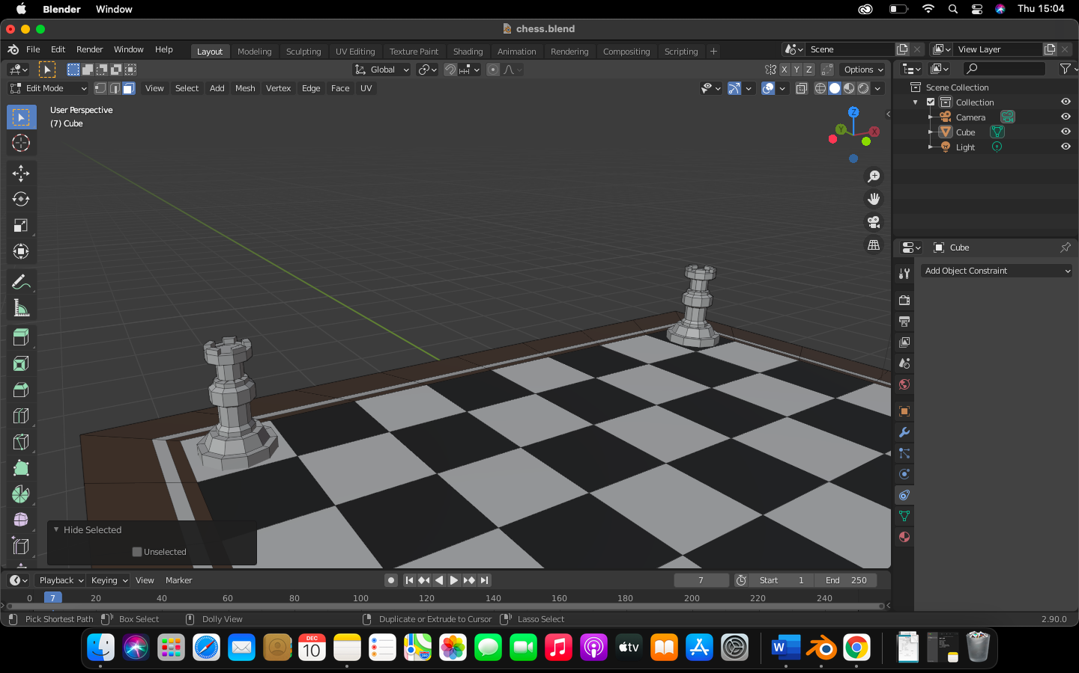

1. Now, add a new mesh cylinder and shape it like a “Knight” and do same as point “6”.

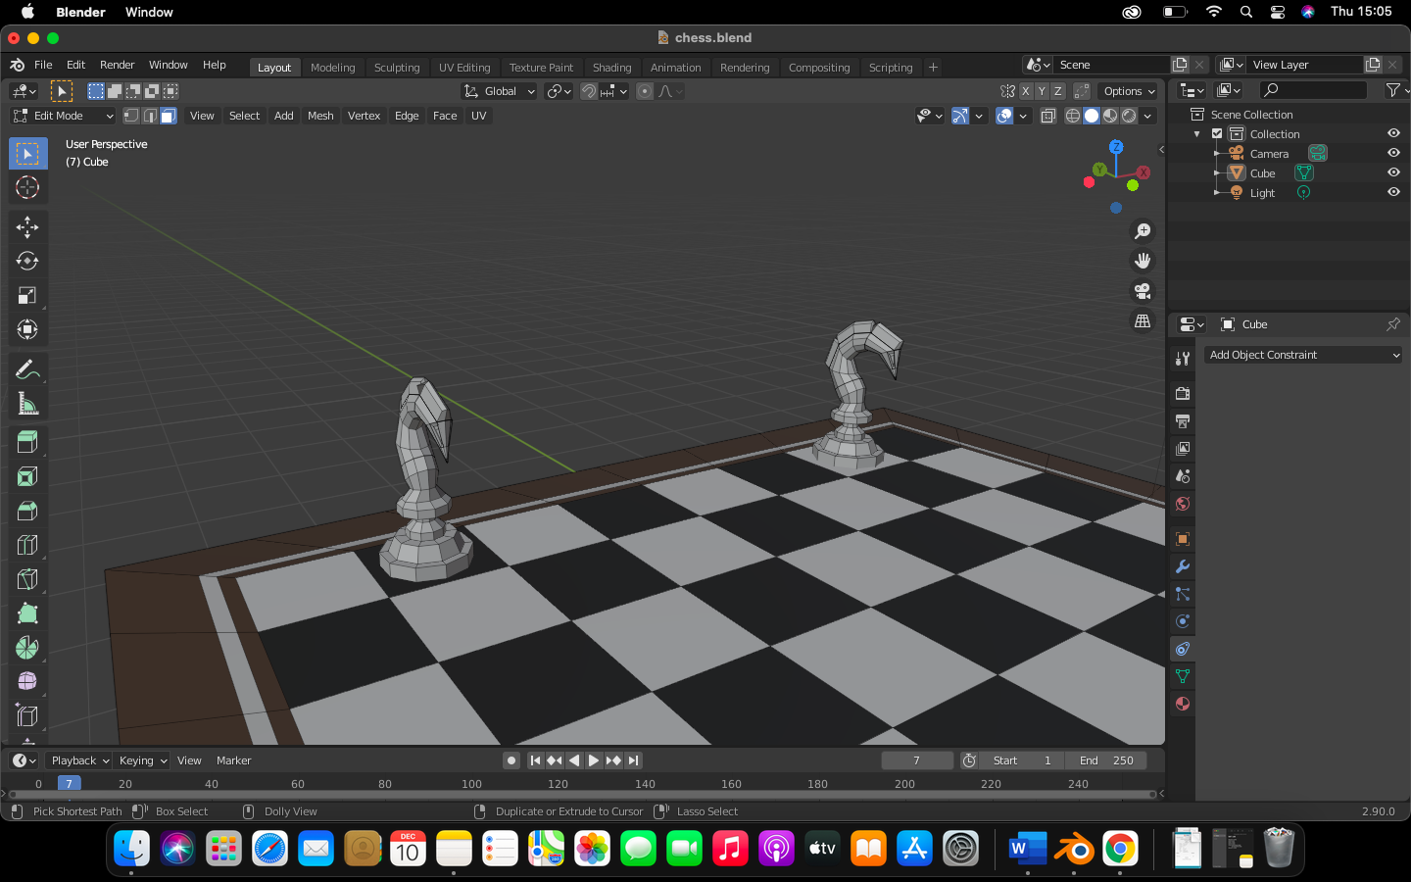

1. Now, add a new mesh cylinder and shape it like a “Bishop” and do same as point “6”.

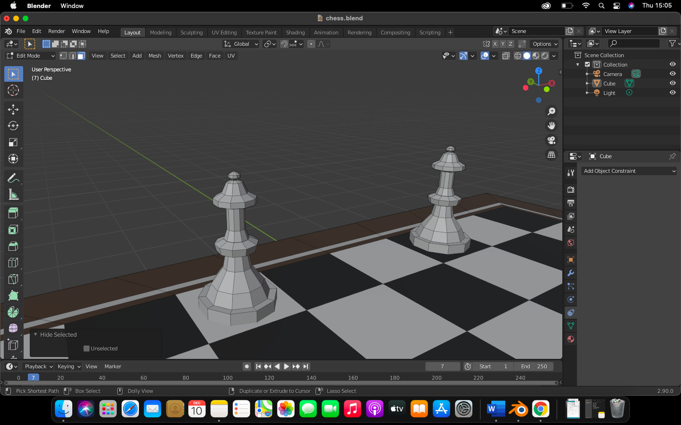

1. Now, add a new mesh cylinder and shape it like a “Queen” and do same as point “6”.

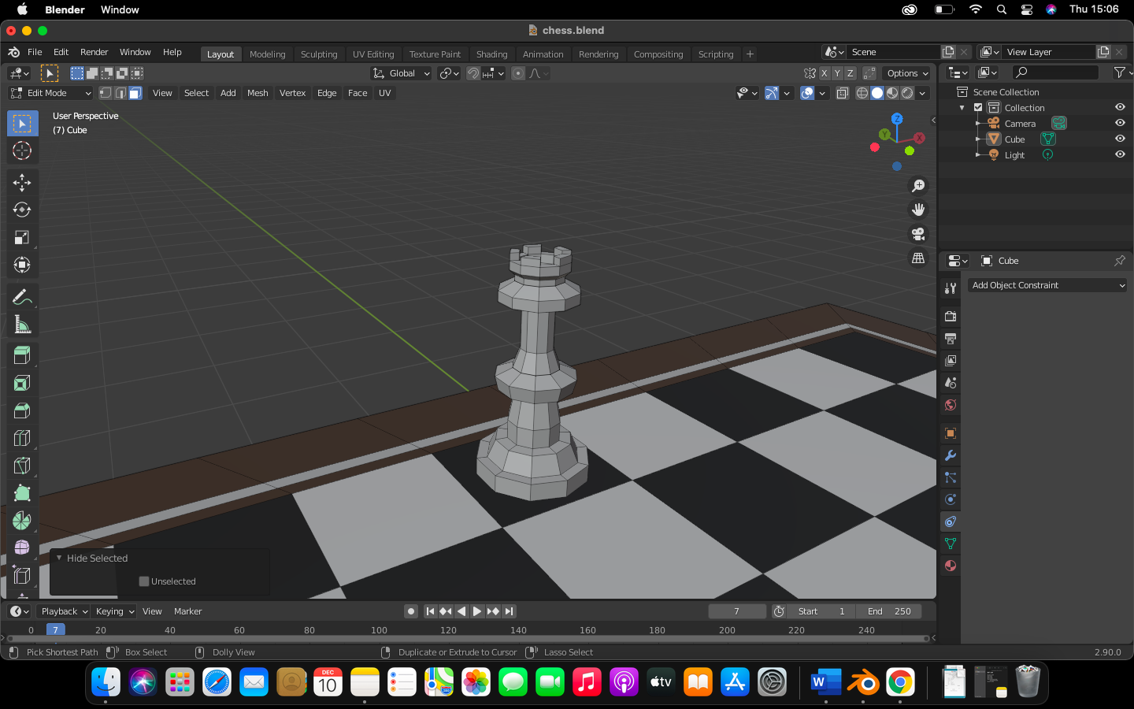

1. Now, add a new mesh cylinder and shape it like a “King” and do same as point “6”.

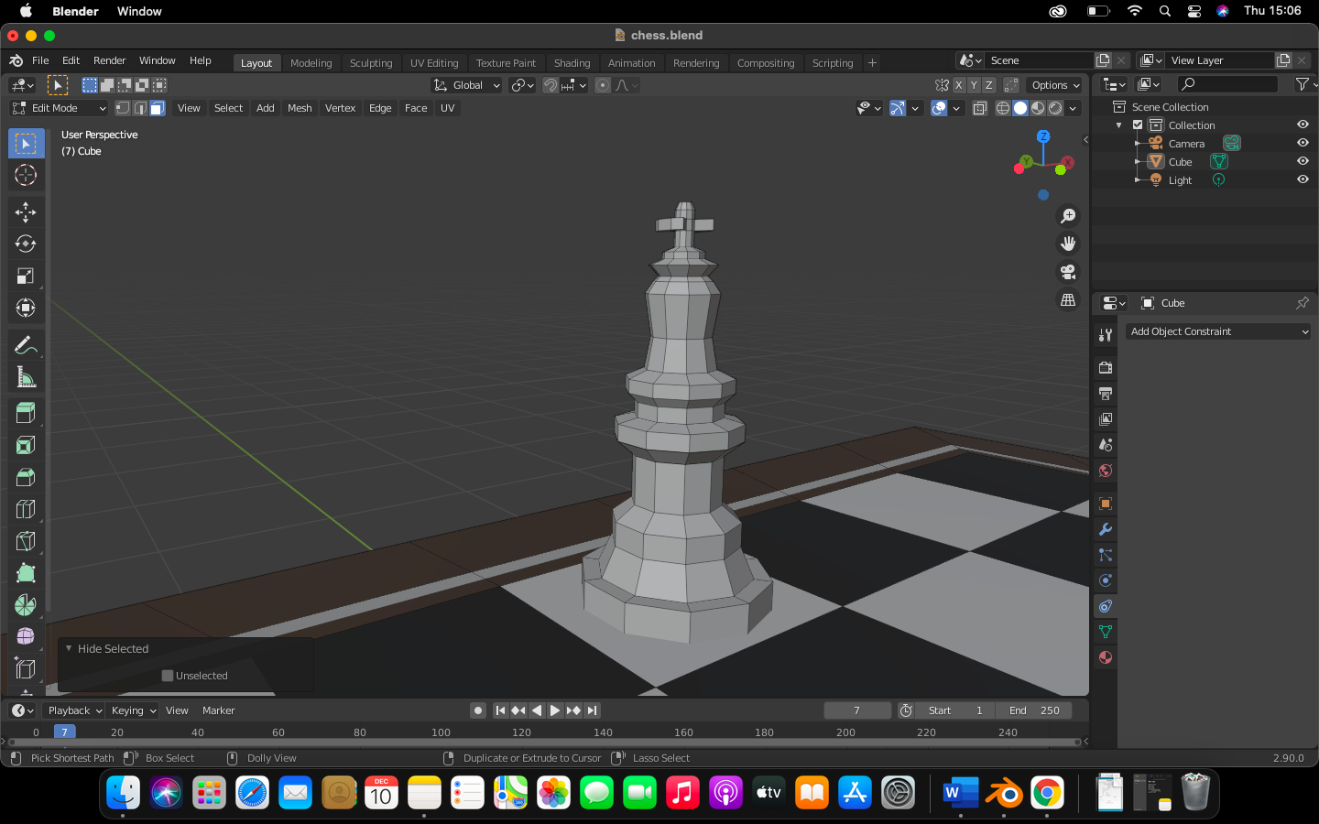

1. Now assign the color black to one set of the group and apply white color to other set of the group.

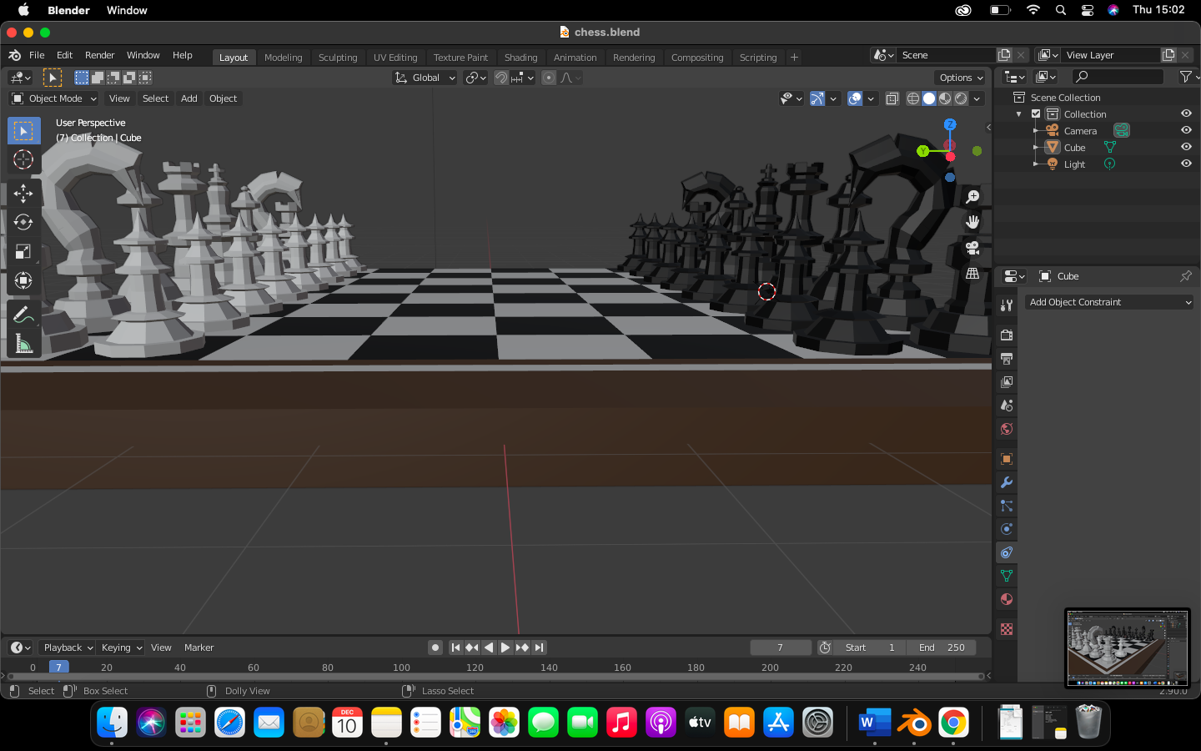

1. Hence, chess board is completed.

