Project Report

On

# CUTM COURIER Management System

ACKNOWLEDGEMENT

We take this occasion to thank God, almighty for blessing us with his grace and taking our Endeavour to a successful culmination. We extend our sincere and heartfelt thanks to our esteemed guide, Mr. Hema Kumar for providing us with the right guidance and advice at the crucial junctures and for showing us the right way. We extend our sincere thanks to our respected head of the division, for allowing us to use the facilities available. We would like to thank the other faculty members also, at this occasion. Last but not the least, we would like to thank friends for the support and encouragement they have given us during the course of our work.

DECLARATION

# I am Jammu SK Hema Shri pursuing the Engineering in Centurion University of Technology and Management, Vizianagaram (AP). I hereby declare that the project entitled “CUTM Courier Management System” has been completed by us during the 2nd Semester as per partial completion of B-Tech (CSE) and also for the credits. I have taken up this project to satisfy my eagerness in exploring the field of Web Designing and to complete the course Database Creation and Management, after the completion of the project I have realized that it has come true.

Date: 12th August 2021  
Place: Vizianagaram   
NAME: - JSK Hema Shri

ABSTRACT

In modern age, as the time increase, needs & requirements of the person are also increased. They want more facility & try to do their tasks quickly & within time. But they cannot get all the things at the nearest market or area, so they have to import the things from any place in the world.

Within the country, the things can be imported through post services but it consumes thyhe time & sometimes problem of damage or missing occur. Where as in the international market, the one way is shipping. But is also requires more time.

INTRODUCTION

The courier services are one of the solutions of these problems. It is used to send some things to any person in the world within time.

The courier company has number of branches, which are spread over the country or the world. So that when a person wants to send things, he has to contact at nearest courier service branch. The courier company creates the schedule & gives internal/external service work as destination office or source office. The source office branch receives the order means consignments & sends it to the destination courier branch. The company has certain rules according to tee weight.

Using the courier services person can easily send his/her parcel to other person in the particular destination within the time. Now days, 50% of the companies of the world uses the services of various Courier Company.

**SYSTEM REQUIREMENTS**

**Software Environment:**

Software Environment is a technical specification of requirement of software product. This specifies the environment for development, operation and maintenance of the product.

Technology used:

* MYSQL
* Http
* Http Basics
* PHP
* HTML
* JAVASCRIPT

Client opens a connection

# CLIENT

##### WEB SERVER

Client Sends Request

. Server Responds

Connectgion Closed

**WORKING ENVIRONMENT**

**Hardware Configuration:**

Processor : INTEL I7 10th GEN, 3GHz-3.9GHz

RAM : 8 GB (DDR4) RAM

Hard Disk Drive : 20 GB HDD

Software Configuration:

Operating System : Windows xp, Vista,7 or any one

Web server : Apache, MySQL

Web Browser : Chrome/Mozilla/Internet Explorer5.0

Designing Tool : HTML

Server Side Scripting : PHP

Client Side Scripting : MYSQL

ER DIAGRAM

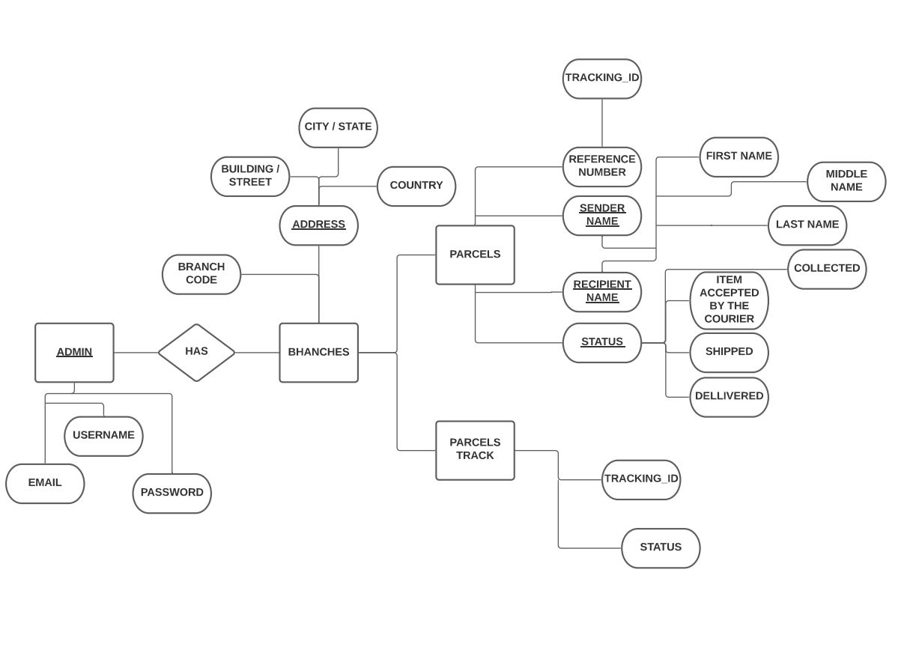

DATABASE DESIGN

Database is an integrated collection of data and provides a centralized access to the data and makes possible to treat data as a separate resource. Usually, centralized data managing software is called a Relational Database Management System (RDBMS). The most significant different between RDBMS and other type of Data Management is the separation of data as seen by the program and data as store of on the direct access storage device. This is the difference between logical and physical data.

Data Dictionary:

The efficiency of an application developed using RDBMS mainly depend upon the database tables, the fields in each table and the way the tables are opened using the contents in them to retrieve the necessary information. Hence a careful selection of tables and their fields are imperative.

The database tables used in this system are created keeping the above points in mind. The tables used are given below.

MYSQL Table Structure

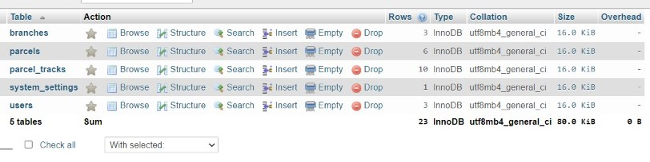

SCREENS (Project Screen Shots)

Admin Login

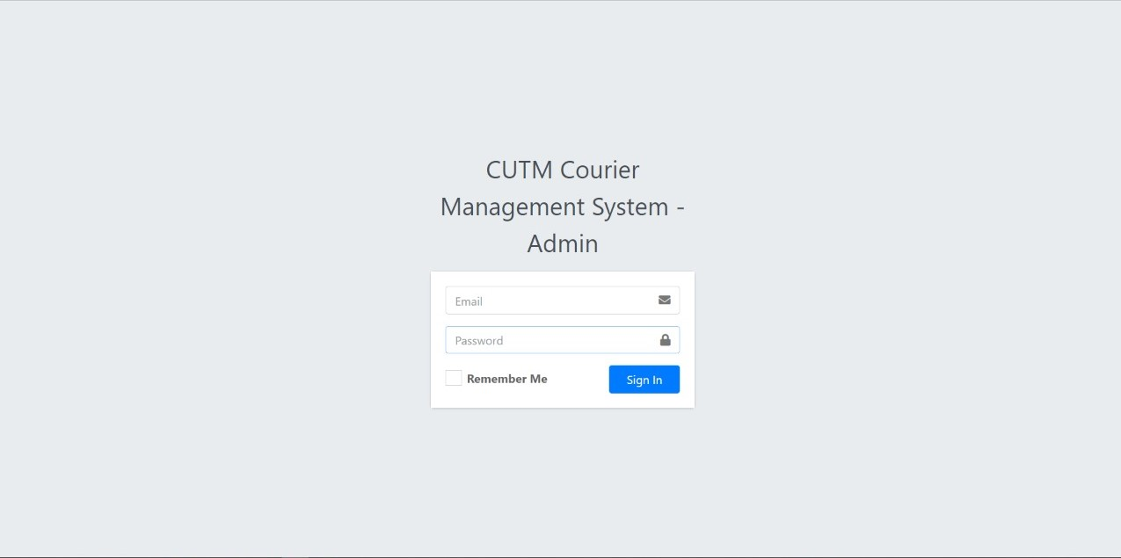

Dashboard

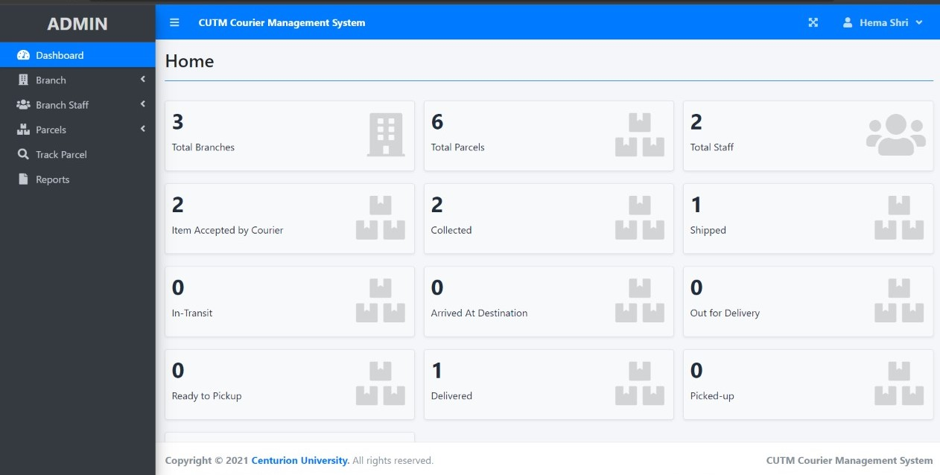

Branches page

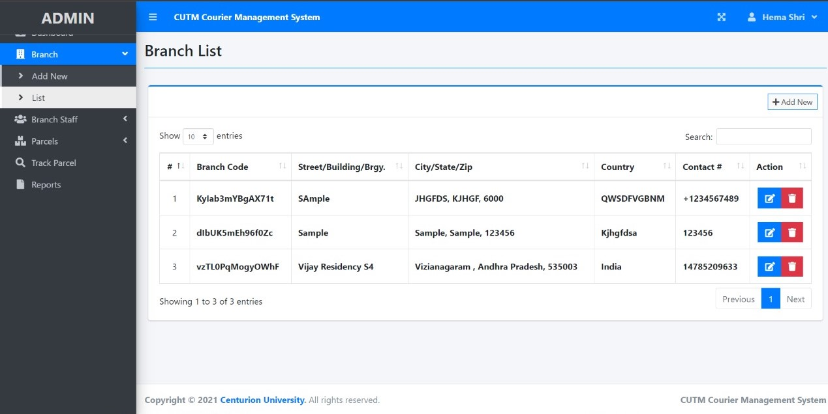

Staff page

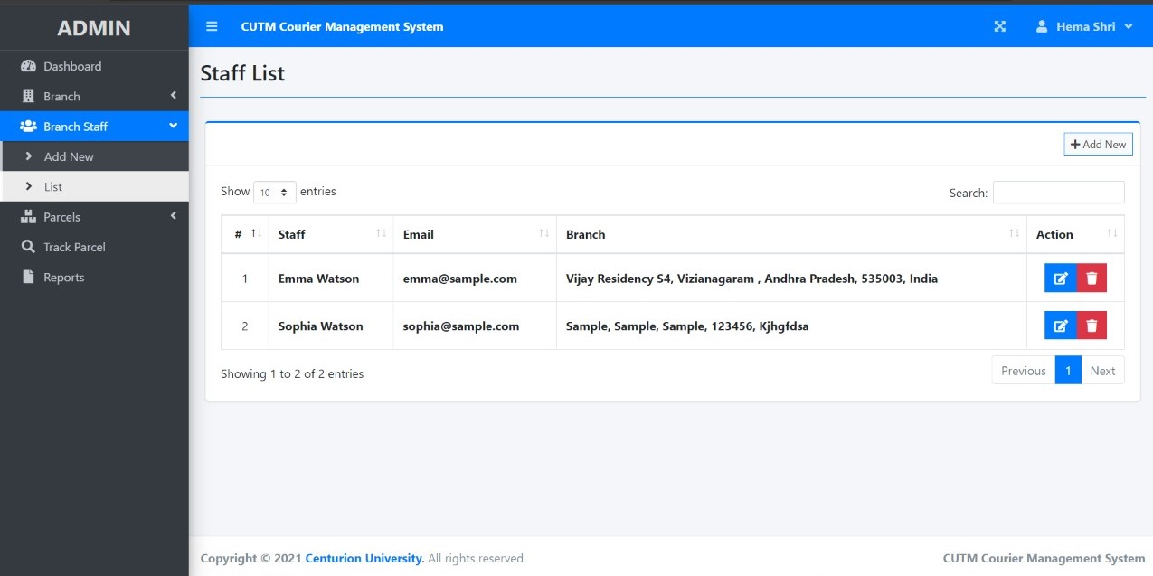

Parcel List page

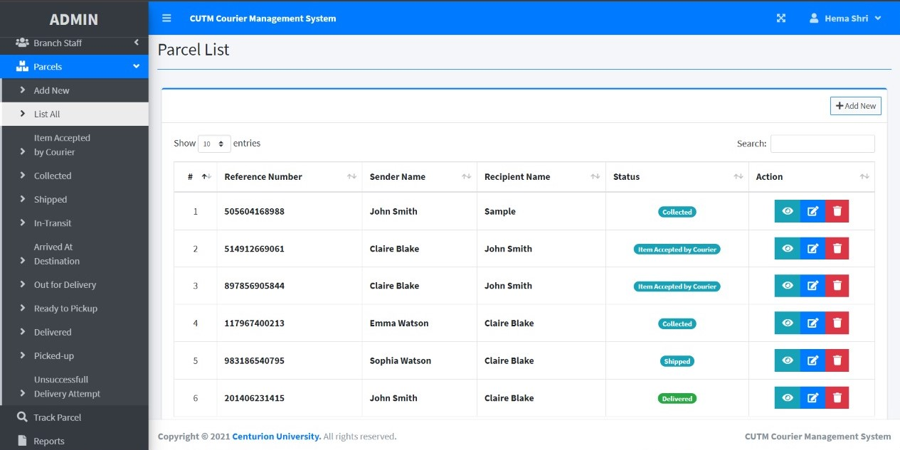

Tracking page

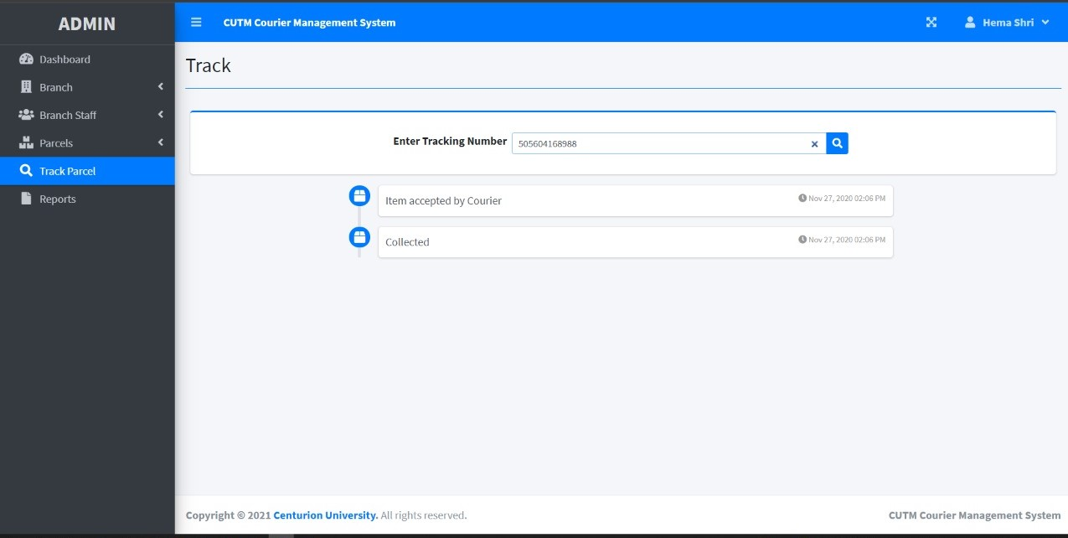

IMPLEMENTATION AND EVALUATION

During the software-testing phase each module of software is thoroughly tested for bugs and for accuracy of output. The system developed is very user-friendly and the detailed documentation is also given to the user as online help wherever necessary. The implementation phase normally ends with the formal test involving all the components.

The entire system was developed using the PHP, HTML, JavaScript, Personal Web Server, and MYSQL as back end. The HTML is used to design the web page. The Personal Web Server is used to understand the client’s request and to send response to them. The JAVASCRIPT are used for client-side validations so that the user can enter only appropriate input in the input fields. The MYSQL is the back end tool where the database resides.

Hence the design of the entire system is user-friendly and simple the implementation has been quite easy.

CONCLUSION

This project has given me an ample opportunity to design, code, and test and implements an application. This has helped in putting into practice of various Software Engineering principles and Database Management concepts like maintaining integrity and consistency of data. Further, this has helped me to learn more about MYSQL, PHP, HTML, JAVASCRIPT, and Personal Web Server.

I thank my guide for his invaluable contribution in guiding me throughout the project. I also thank my parents and friends who have supported and motivated me to complete this project successfully.

BIBLIOGRAPHY

Reference Books and journal

* PHP and MySQL web development
* The complete reference PHP

Referring online manual from website

•[**www.php.net**](http://www.php.net)

**•**[**www.tutorialpoints.com**](http://www.tutorialpoints.com/)

**•**[**www.w3school.com**](http://www.w3school.com/)