**Software Requirements Specification**

# Version 1.0;

# 18 February 2018

Campus In and Out

**Submitted in partial fulfillment of the requirements of CS223 Software Engineering**

**This work is based upon the submissions of course Software Engineering (CS223). The students who submitted this team project were:**

**Ashutosh Kumar Jatav(B16CS004)**

**Chetan Prakash Meena(B1CS006)**



List of Figures

1.0. Introduction

1.1. Purpose

1.2. Scope of Project

1.3. Constraints

1.4. Assumptions and Dependencies

1.5. Glossary

1.6. References

1.7. Overview of Document

2.0. Overall Description

2.1 System Environment

2.2. Functional Requirements Specification

2.2.1 Use case Diagram

2.2.2 Sequence Diagram

2.2.3 Class Diagram

2.2.4 Activity Diagram

2.3 User Characteristics

3.0. Requirements Specification

3.1. Functional Requirements

3.1.1. Enter

3.1.2. Exit

3.1.3. Add Entry

3.1.4. Add Exit

3.1.5. View Entries

3.1.6. Login

3.1.7. Logout

3.1.8. Change User Password

3.1.9. Add User

3.1.10. Remove User

3.1.11. Update Database

3.2 Detailed Non-Functional Requirements

**1.0. Introduction**

**1.1. Purpose**

The purpose of this document is to provide a detailed description of the development and operation of the campus in and out management. It will illustrate the purpose and complete declaration for the development of software. It will also explain system constraints, user interface, and the response of the system to any external factors. This document is primarily meant for the client, but will also be used by the developers as a scale measure to gauge them progress.

**1.2. Scope of Project**

This software system will be designed to increase the security of the institute and managing who and for how much time the person can stay inside the campus. Someone should not use our campus for some kind of shortcut so someone not belonging to the campus can enter into the campus for a valid reason only and then he/she can get off the campus through the same gate he/she used to get into the campus other gates will not be opened for them to get out.

Students are only allowed to get in/out of the campus till 2:00 AM so the student who wants to get in should have some special kind of permission otherwise the student luggage will be checked as it should not have any kind of alcohol, etc. and then will be allowed to get into the hostel he/she will be given a special room where the student will spend his/her night and the student will not be allowed to get out after 2:00 AM till 6:00 AM.

**1.3 Constraints**

1. Permission according to the purpose of the person to get inside.
2. Guard must be present at the gate.

**1.4 Assumptions and Dependencies**

1. Every person has Id either an Institute Id or a valid Personal Id.
2. Only one Admin.
3. Initially all the Institute members are inside the Institute and Non Institute members are outside the campus.
4. Institute member’s vehicle are initially green colored.
5. Special Guest’s vehicles are registered before they have entered.
6. Guard will check ID card very carefully.

**1.5 Glossary**

|  |  |
| --- | --- |
| Person | One who wants to enter into the campus |
| Institute Member | Student, Institute Workers, Security guard, Faculty |
| Non Institute Member | Anyone not belonging to the Institute Member |
| Invalid Time | Time at which a particular actor is not generally allowed to get in/out |

**1.6. References**

IEEE. IEEE Std 830-1998 IEEE Recommended Practice for Software Requirements

Specifications. IEEE Computer Society, 1998.

http://www.cse.chalmers.se/~feldt/

http://aakashtechsupportdocs.readthedocs.org/

**1.7 Overview of Document**

The rest of the document is designed in the following way:

**2.0. Overall Description**

***2.1. System Requirement***

Windows operating systems or Linux based operating systems

**2.2. Functional Requirements and Specification**

**2.2.1 Usecase Diagram**

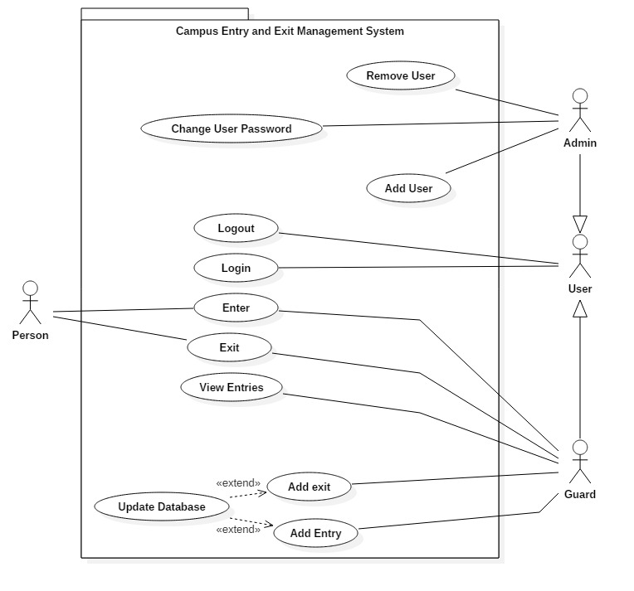

**2.2.2. Sequence Diagram**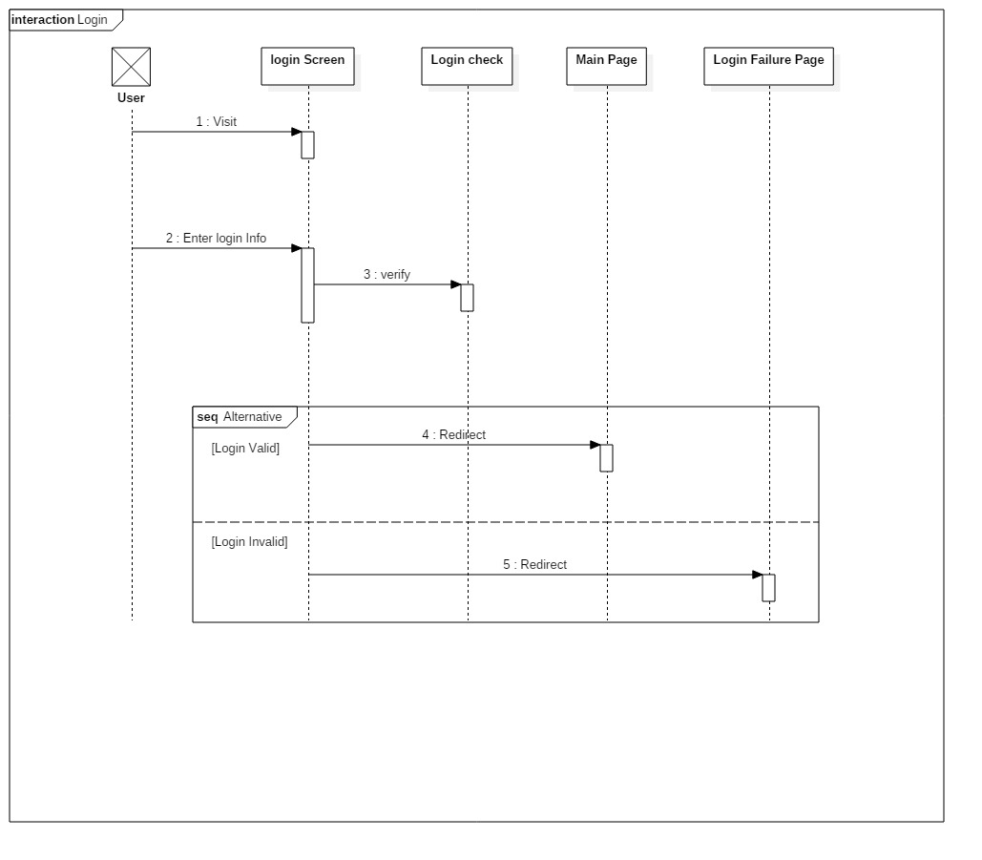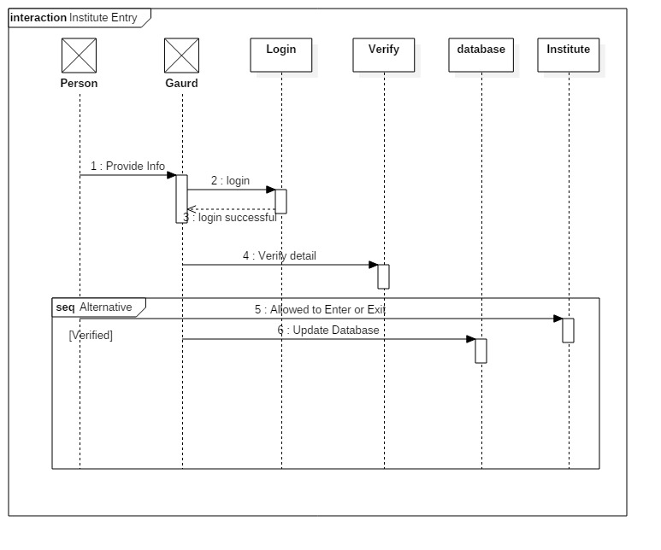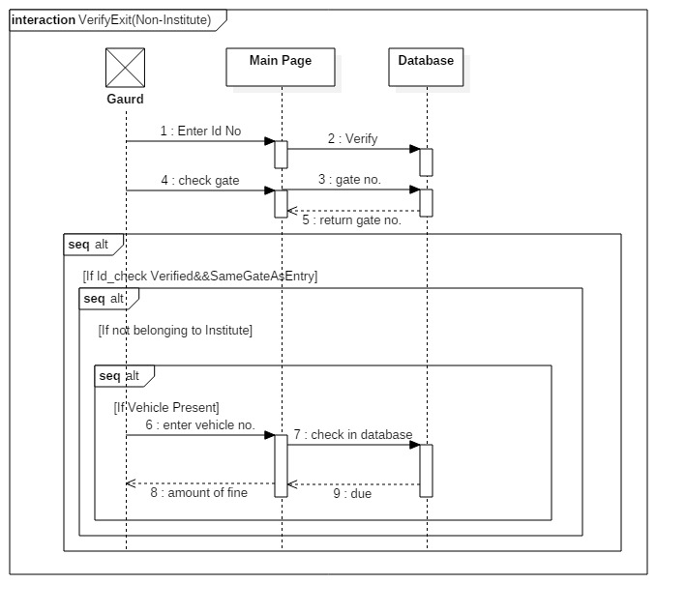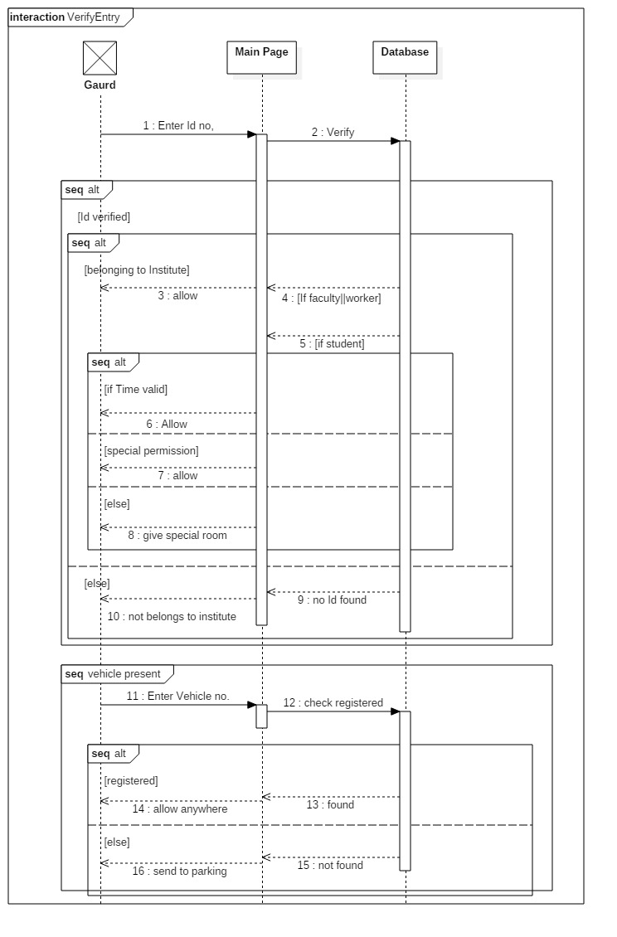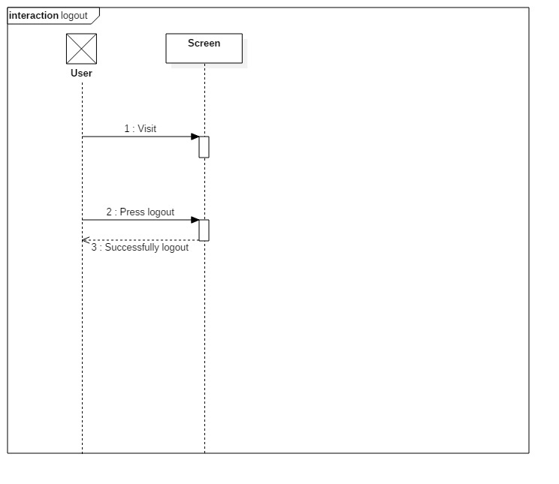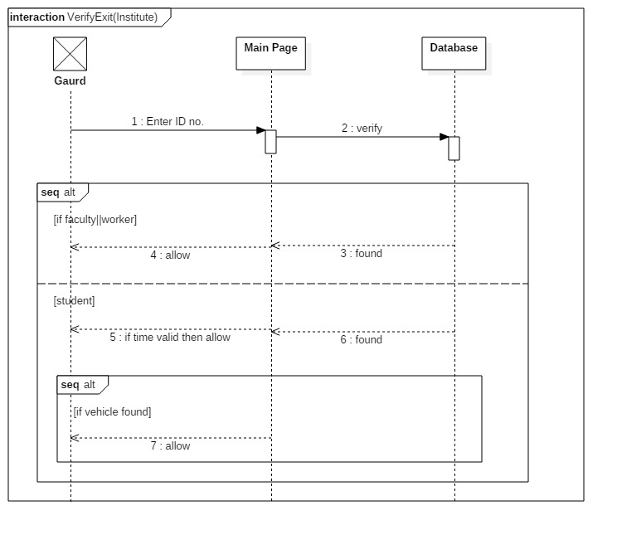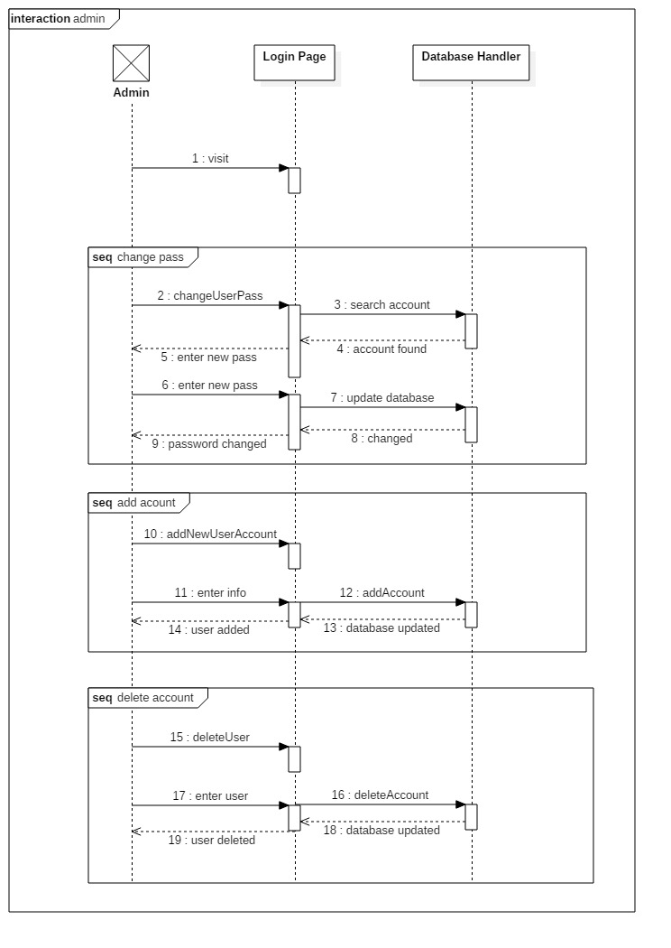

**2.2.3. Class Diagram**

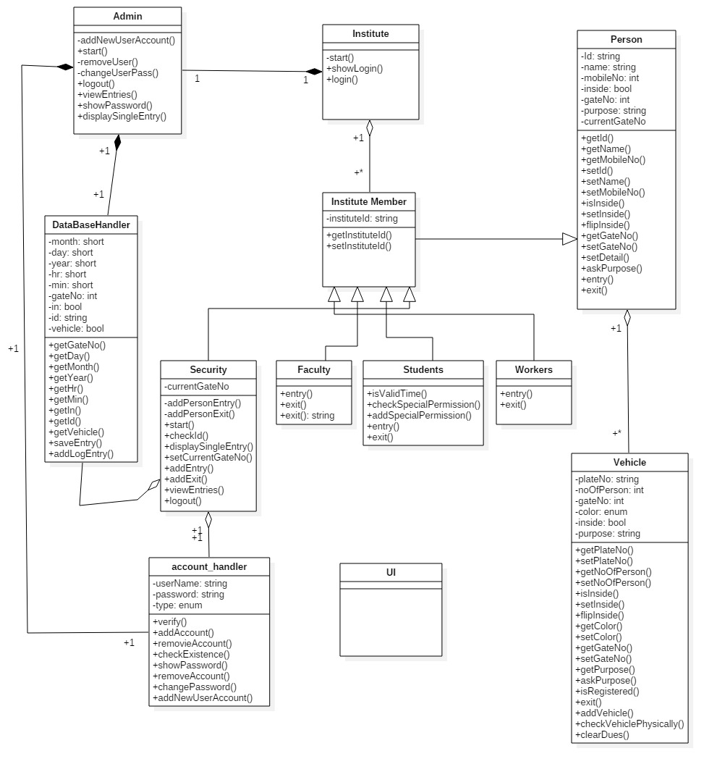

**2.2.4. Activity Diagram**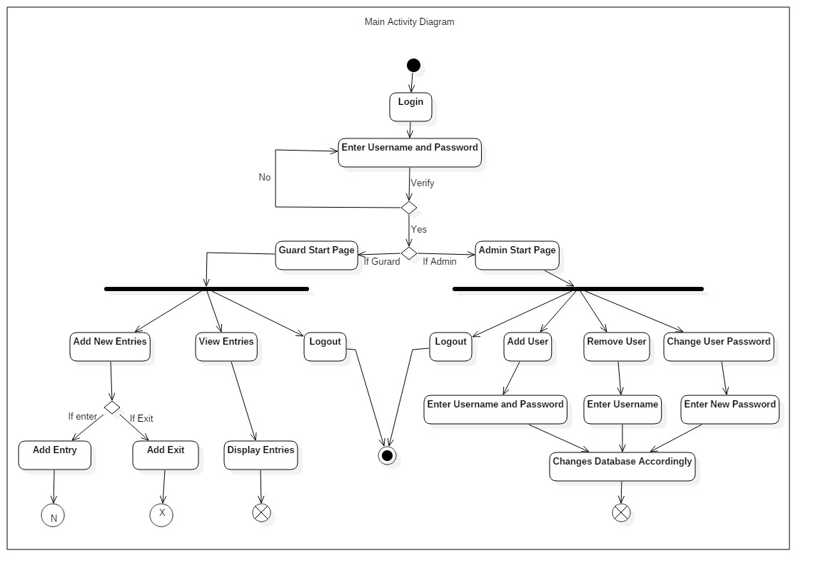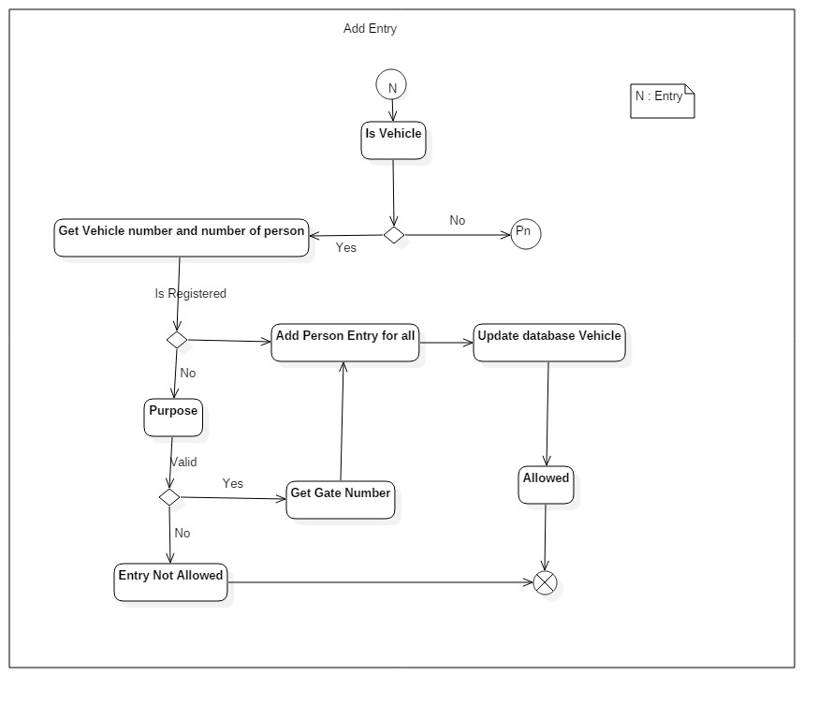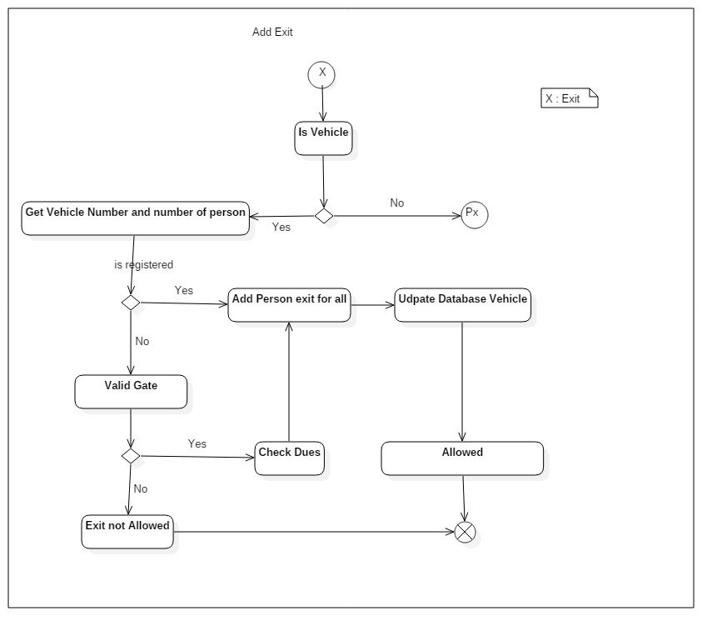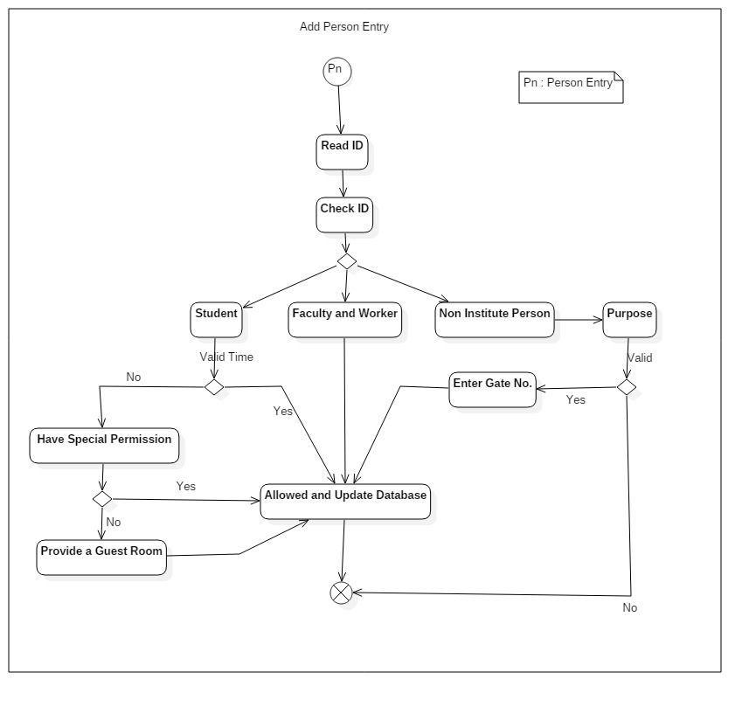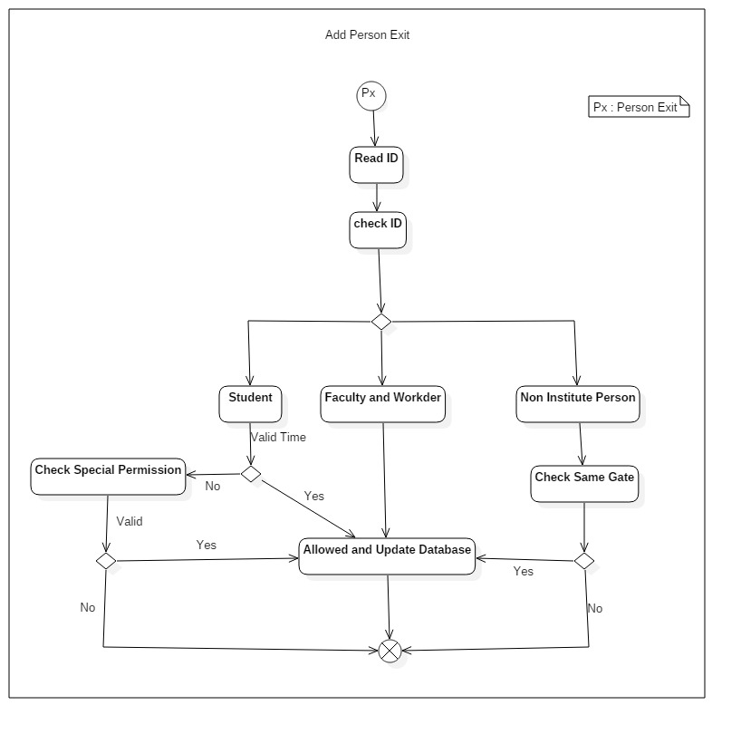

***2.3 User Characteristics***

There is only two type of user can use this software, and that are security guards and Admin.

The Security Guards will use this software to maintain and improve security of the campus by allowing what kind of person/vehicle will enter into the campus and for what amount of time some vehicles should be allowed into the campus.

Guard will also define a color for kind of Vehicle like if someone vehicle is banned from the campus then that vehicle is marked as black listed and guard will not allow such kind of vehicle to enter.

Guard will also make sure that the vehicle is only allowed to exit through the gate from which it enters the Institute except the registered vehicles.

Admin can add new users, remove existing users and change their password.

**3.0. Requirements Specification**

**3.1. Functional Requirements**

**3.1.1. Enter**

|  |  |
| --- | --- |
| Use Case Name | Enter |
| Trigger | When Person wants to Enter the Institute |
| Precondition | 1. Security Guard is present at the door with software 2. Person has ID either Institute or Non-institute ID (Adhar) |
| Basic Path | Person came to the Institute Gate and he wants to enter the Institute |
| Alternative Paths | No alternative path |
| Post Condition | Either he/she is allowed to enter the Institute or not |
| Exception Path | No |
| Other | No |

**3.1.2. Exit**

|  |  |
| --- | --- |
| Use Case Name | Exit |
| Trigger | When Person wants to Exit the Institute |
| Precondition | 1. Security Guard is present at the door with software 2. Person has ID (Institute or Non-institute) |
| Basic Path | Person came to the Institute Gate and he wants to enter the Institute |
| Alternative Paths | No alternative path |
| Post Condition | Either he/she is allowed or not |
| Exception Path | No |
| Other | No |

**3.1.3. Add Entry**

|  |  |
| --- | --- |
| Use Case Name | Add Enter |
| Trigger | When someone wants to enter the Institute |
| Precondition | Person has ID |
| Basic Path | 1. If person has vehicle, then count no. of person and check the vehicle is registered or not. 2. For non-registered vehicle asked for purpose and then note down gate number 3. Enter the detail of each Person in the vehicle if allowed and directed the vehicle to go in the parking region 4. Update database accordingly |
| Alternative Paths | If Person has not vehicle:   1. Check ID 2. For faculty, worker, student and non-institute person are allowed 3. Check for special permission in case if student wants exit in invalid time 4. Note down the gate no. for non-institute person 5. If allowed update database |
| Post Condition | Either entry is recorded or not |
| Exception Path | No |
| Other | Special guest vehicle are registered day before he/she came |

**3.1.4. Add Exit**

|  |  |
| --- | --- |
| Use Case Name | Add Exit |
| Trigger | When someone wants to exit the Institute |
| Precondition | Person has ID |
| Basic Path | 1. If person has vehicle, then count no. of person and check the vehicle is registered or not. 2. For non-registered vehicle check gate then check due 3. Enter the detail of each Person in the vehicle 4. Update database accordingly |
| Alternative Paths | If Person has not vehicle:   1. Check ID 2. For faculty, worker, student and non-institute person are allowed 3. For non-institute person check the gate no. 4. Check for special permission in case if student wants exit in invalid time 5. If allowed update database |
| Post Condition | Either exit is recorded or not |
| Exception Path | No |
| Other | Special guest vehicle are registered day before he/she came |

**3.1.5. View Entries**

|  |  |
| --- | --- |
| Use Case Name | View Entries |
| Trigger | When guard wants to check the previous entries |
| Precondition | Account should be login |
| Basic Path | 1. Guard enter the detail of the entries 2. Result generated on the screen |
| Alternative Paths | No |
| Post Condition | Either entries are found or not |
| Exception Path | No |
| Other | Entries are view by Date, Name and ID. |

**3.1.6. Login**

|  |  |
| --- | --- |
| Use Case Name | Login |
| Trigger | User want to login |
| Precondition | Login screen must be appeared |
| Basic Path | 1.Enter Username  2.Enter Password  3.Verfiy |
| Alternative Paths | No |
| Post Condition | If logged in, then redirected to main page  Else redirected to login failure page |
| Exception Path | No |

**3.1.7. Logout**

|  |  |
| --- | --- |
| Use Case Name | Logout |
| Trigger | User wants to logout his account |
| Precondition | He must be logged in |
| Basic Path | Click on logout Button |
| Alternative Paths | No |
| Post Condition | The account is logout and Login screen appear |
| Exception Path | No |
| Other | No |

**3.1.8. Change User Password**

|  |  |
| --- | --- |
| Use Case Name | Change User Password |
| Trigger | When Admin wants to change user password |
| Precondition | Admin is logged in |
| Basic Path | 1. Select username 2. Enter new password 3. Confirm new password 4. Database is updated |
| Alternative Paths | Change the file |
| Post Condition | Either password is changed or not |
| Exception Path | No |
| Other | No |

**3.1.9. Add User**

|  |  |
| --- | --- |
| Use Case Name | Add User |
| Trigger | When Admin wants to add new User |
| Precondition | Admin must be logged in |
| Basic Path | 1. Enter new username 2. Check whether it is already existing or not 3. Provide the password then confirm it 4. Update database |
| Alternative Paths | Directly change in the file |
| Post Condition | New User is added |
| Exception Path | No |
| Other | No |

**3.1.10. Remove User**

|  |  |
| --- | --- |
| Use Case Name | Remove User |
| Trigger | When Admin wants to remove a user |
| Precondition | Admin must be logged in |
| Basic Path | 1. Select username 2. Delete username 3. Update database |
| Alternative Paths | Remove from the file |
| Post Condition | User is removed |
| Exception Path | No |
| Other | No |

* + 1. **Update Database**

|  |  |
| --- | --- |
| Use Case Name | Update Database |
| Trigger | 1.Person enter or exit.  2.User want to see previous detail |
| Precondition | User must be Logged in |
| Basic Path | 1.Check whether person want to enter or exit, or user want to see detail  2.Check whether person is already in/out.  3.If wants to enter than ‘inside = true’ otherwise ‘inside = false’ |
| Alternative Paths | Admin can also change the database forcefully |
| Post Condition | Database is updated |
| Exception Path | No |
| Other | ‘inside’ is a variable which store whether a person is inside a campus or not |

**3.2 Detailed Non-Functional Requirements**

The computer must be connected to internet or LAN so it can sync the data to the database properly and the system should function properly.