

Web shopping

* **Faculty: Ho Hoan Kiem**
* **Batch:**
* **Team Member:**
  + - * **Nguyen Van Thanh**
      * **Tran Thanh Gian**

**Ho Chi Minh City, July 10 2019**

Table of Contents

1. Review 1

* **Problem Definition.......................................................................................01**
* **Customer Request Specification.................................................................02**

1. Review 2

* ***Use Case Diagram* 04**
* ***Class Diagram* 15**
* ***Sequence Diagram* 16**
* ***ERD* 18**
* ***Entity Description* 19**
* ***Table Relationship Diagram* 26**

1. Review 3

* Interface Design……………………………………………………………27
* Site Map…………………………………………………………………….51
* Report ………………………………………………………………………53
* Tasksheet…………………………………………………………………...56

REVIEW 1

Problem Definition

1. **The Object Of The Project**

This project aims to create an e-commerce website. Online purchases will be used by users who have valid username and password. This project provides the following features:

* View, delete, edit, post products
* View, delete, edit, post categories
* View orders
* Buy products
* View, edit shopping cart
* Payment for purchases

Customer Request   
 Specification

1. **Functional Requirements**

Following is a list of functionalities of the system. More functionalities that you find appropriate can be added to this list.

* Guest can register a customer account.
* Guest can view products and select products by category.
* Guest can search products.
* Guest can add products to cart but cannot checkout.
* Guest must have a valid User Id and password to login to the system.
* After logging in, customer will be presented with a list of products.
* Customer can add products to the shopping.
* Customer can search products.
* Customer view, delete, edit their shopping cart.
* Customer checkout for orders.
* Customer can check order status.
* Admin login to web admin with a valid account.
* Admin can add, view, delete and edit products
* Admin can add, view, delete and edit categories
* Admin view and confirm orders

# Hardware/ Software Requirements

By adding new technologies such as ASP.NET 3.5, AJAX, Web Service and 3-tier architecture, the web site becomes more interactive with users, security and easily updated.

1. **System Requirement**

* **For Users**
  + **Hardware**
    - CPU: Pentium IV 2.0 GHz or higher
    - RAM: 512 MB or higher
  + **Software**
    - OS: Windows 7/XP Professional/Server 2003…
    - Browser: Internet Explorer 8.0 or higher
* **For Software Developers**
  + **Hardware**
    - CPU: Pentium IV 2.0 GHz or higher
    - RAM: 512 MB or higher
  + **Software**
    - OS: Windows XP Professional/Server 2003…
    - Environment: Microsoft .NET Framework 3.5
    - Database Management System: Microsoft SQL Server 2008
    - IDE: Microsoft Visual Studio 2010
    - Web Server: Internet Information Services (IIS) JSP / Servlets Dev. Kit

|  |  |  |
| --- | --- | --- |
| **Date: July 10, 2019** | **Prepared by Project Group 4**  **Team Leader:** | **Approved by**  **Mr Ho Hoan Kiem** |
| **Signature** |  |  |

REVIEW 2

**USE CASE DIAGRAM**

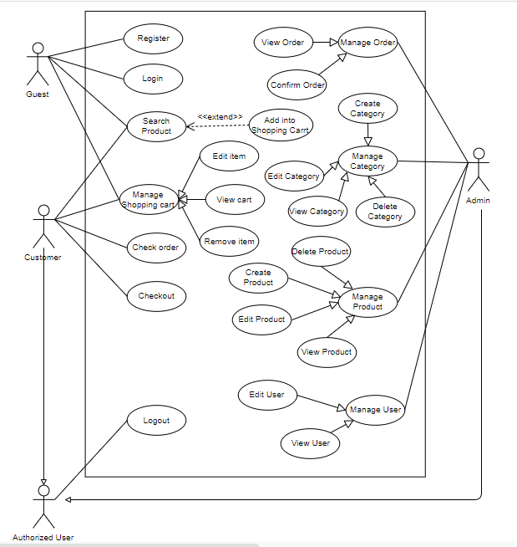

**USE CASE DESCRIPTION**

1. **Actor:**

* **Guest:** They can register to become an authorized user. They can use all function in the website but cannot checkout, manage and maintain this website
* **Customers:** They are authorized user. They can use all function in the website, but cannot manage and maintain this web site.
* **Website administrators:** The person(s) that manage and maintain this web site.

1. **Usecase:**

|  |  |
| --- | --- |
| **Usecase** | Register |
| **Short Description** | Register account to become a member of the web site. |
| **Pre-Conditions** |  |
| **Post-Conditions** |  |
| **Main flow** | -Guest must provide mandatory information :   * Username. * Password. * Confirm Password. * Email.   -Guest clicks on Register button.  -System checks the information which guest provided  -System create new account for guest that registers to this website.  _Guest becomes a member of this website. |
| **Alternative flow(s)** | _If guest clicks on the Reset button, all the field will be reset.  _If the mandatory information that guest provided, is missed or not exactly, system notifys the error. All cases are :   * Username has existed in Database. * Password is less than 6 characters or more than 30 characters. * Confirm Password and Password are not the same. * Email is valid. * Any fields are blank.   _System must be insert the date that guest register to become member.  _If server notifys any error when it’s processing, system must be write report into Log file. |

|  |  |
| --- | --- |
| **Usecase** | Login |
| **Short Description** | Log in website to use any function of member. |
| **Pre-Conditions** |  |
| **Post-Conditions** |  |
| **Main flow** | _Guest inputs the login information :   * Username. * Password.   _Guest clicks on the Login button.  _System check the Login ID and Password.  _If Login ID and Password are valid, system will move member to Homepage.  _ If a wrong password is given thrice in succession, that account will be locked and the customer will not be able to use it. When an invalid password is entered a warning is given to the user that his account is going to get locked. |
| **Alternative flow(s)** | _If Login ID field or Password field is invalid form or blank when guest clicks on the “Login” button, system will notify the error.  _If server notifies any error when it’s processing, system must be write report into Log file. |

|  |  |
| --- | --- |
| **Use case** | View Products |
| **Short Description** | View products |
| **Pre-Conditions** |  |
| **Post-Conditions** |  |
| **Main flow** | -The Website will show products and the information for each product include: Image, Title and buy |
| **Alternative flow(s)** |  |

|  |  |
| --- | --- |
| **Use case** | Search Products |
| **Short Description** | Search products |
| **Pre-Conditions** |  |
| **Post-Conditions** |  |
| **Main flow** | -User will input the search information:   * Search   -User click Button Search, the website will show all product match with the search information |
| **Alternative flow(s)** |  |

|  |  |
| --- | --- |
| **Use case** | Buy Products |
| **Short Description** | Search products |
| **Pre-Conditions** |  |
| **Post-Conditions** |  |
| **Main flow** | -Button Buy in each Product  -If User click Button Buy, this Product will be added into shopping cart with the quantity is one. |
| **Alternative flow(s)** |  |

|  |  |
| --- | --- |
| **Usecase** | Select Category |
| **Short Description** | Edit member’s information. |
| **Pre-Conditions** |  |
| **Post-Conditions** |  |
| **Main flow** | -Each Category is a link.  -User click Category, so the website will show products with that Category |
| **Alternative flow(s)** |  |

|  |  |
| --- | --- |
| **Usecase** | View Item in Shopping Cart |
| **Short Description** | View Item in Shopping Card |
| **Pre-Conditions** |  |
| **Post-Conditions** |  |
| **Main flow** | The website will show all products that you select.  You can see title, image, quantity and price with each product.  You can also see the total |
| **Alternative flow(s)** |  |

|  |  |
| --- | --- |
| **Usecase** | Edit Item in Shopping Cart |
| **Short Description** | Edit Item in Shopping Card |
| **Pre-Conditions** |  |
| **Post-Conditions** |  |
| **Main flow** | If User press Button +, this website will plus 1 quantity of that product and calculate price.  If User press Button --, this website will minus 1 quantity of that product and calculate price. |
| **Alternative flow(s)** |  |

|  |  |
| --- | --- |
| **Usecase** | Delete Items in Shopping Cart |
| **Short Description** | Delete Items in Shopping Card |
| **Pre-Conditions** |  |
| **Post-Conditions** |  |
| **Main flow** | If User press Button “Empty Cart”, shopping will be detele all products in the shopping card |
| **Alternative flow(s)** |  |

|  |  |
| --- | --- |
| **Usecase** | Check Order |
| **Short Description** | Check Order |
| **Pre-Conditions** |  |
| **Post-Conditions** |  |
| **Main flow** | -Website will show you that your order has been delivered or not |
| **Alternative flow(s)** |  |

----------------

|  |  |
| --- | --- |
| **Usecase** | Manage Customers |
| **Short Description** | Manage all information about customer. |
| **Pre-Conditions** |  |
| **Post-Conditions** |  |
| **Main flow** | _Manage all information of customer. |
| **Alternative flow(s)** | _If server notifies any error when it’s processing, system must be write report into Log file. |

|  |  |
| --- | --- |
| **Usecase** | Manage Products |
| **Short Description** | Manage all information about products. |
| **Pre-Conditions** |  |
| **Post-Conditions** |  |
| **Main flow** | _Manage all information of product. |
| **Alternative flow(s)** | _If server notifies any error when it’s processing, system must be write report into Log file. |

|  |  |
| --- | --- |
| **Usecase** | Manage Categories |
| **Short Description** | Manage all information about categories. |
| **Pre-Conditions** |  |
| **Post-Conditions** |  |
| **Main flow** | _Manage all information of categories. |
| **Alternative flow(s)** | _If server notifies any error when it’s processing, system must be write report into Log file. |

|  |  |
| --- | --- |
| **Usecase** | Manage Orders |
| **Short Description** | Manage all information about orders |
| **Pre-Conditions** |  |
| **Post-Conditions** |  |
| **Main flow** | _Manage all information of customer. |
| **Alternative flow(s)** | _If server notifies any error when it’s processing, system must be write report into Log file. |

**CLASS DIAGRAM**

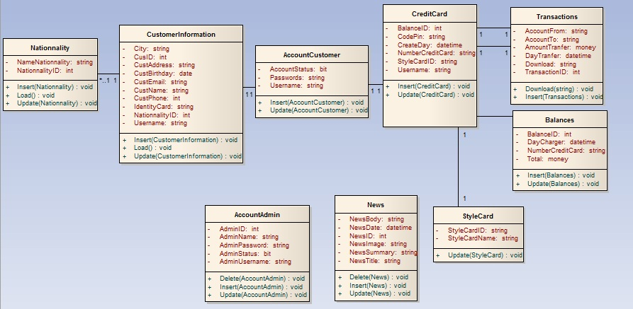

**ENTITY RELATIONSHIP DIAGRAM (ERD)**  
 **Note:  
  
  
ENTITY DESCRIPTION**

Have

Have

Belong

Have

Nationality

Customer  
Information

Account  
Customer

Account  
Admin

Style  
Card

News

Credit  
Card

Transaction

CountHitPage

Contain

Entity

Entity Relationship

One to  
 many relationship

**1.User :**

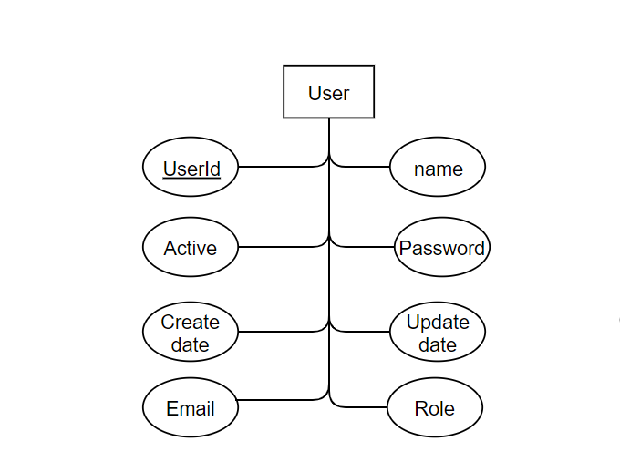

**2.Order :**

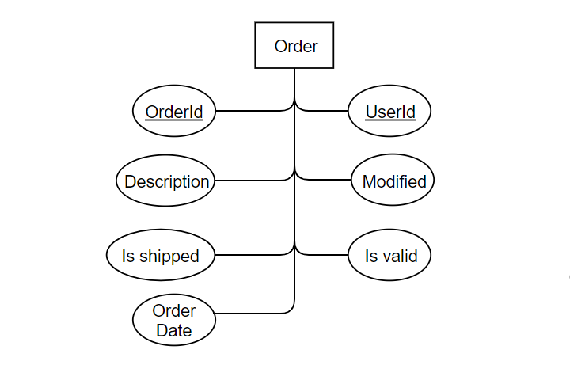

**3.Order Detail :**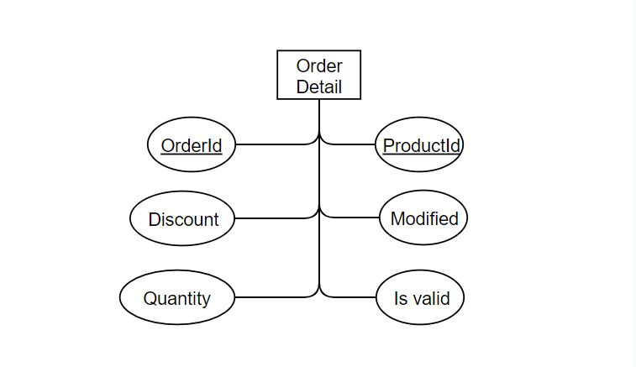

**4.Product :**

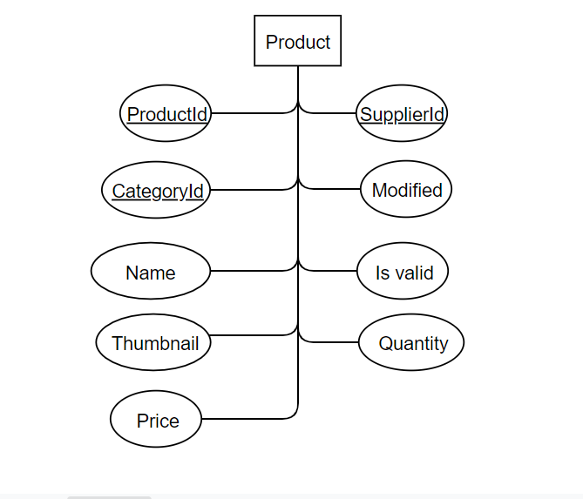

**5.Supplier :**

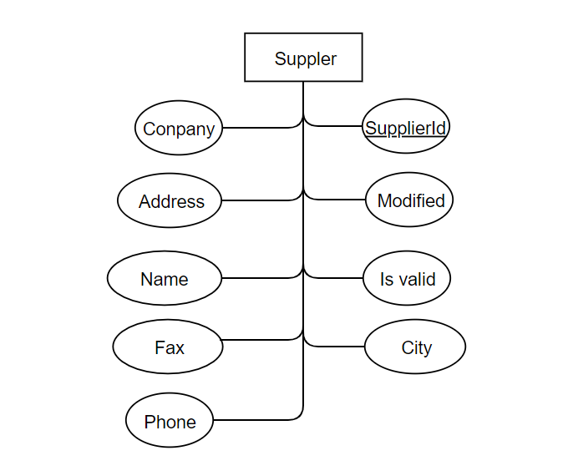

**6.Category :**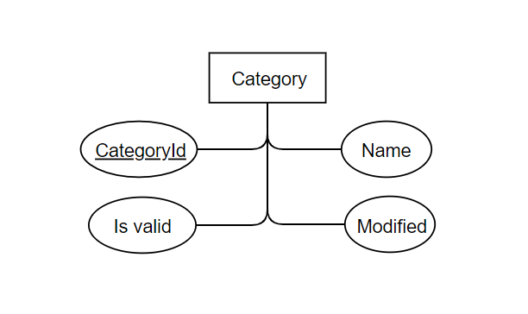

**TABLE DESIGN**

1. **User :**

|  |  |  |  |  |  |
| --- | --- | --- | --- | --- | --- |
| **No** | **Column Name** | **Data Type** | **Size** | **Check** | **Description** |
| 1 | **🗝**Id | Int | Identity | Not Null | ID |
| 2 | Name | Varchar | 9 | Null | Name user |
| 3 | Password | Varchar | 30 | Null | Password user |
| 4 | Active | Bit |  | Null | Is active |
| 5 | Create date | Datetime | 50 | Null | Create date |
| 6 | Update date | Datetime | 100 | Null | Update date |
| 7 | Email | Varchar | 15 | Null | Email User |
| 8 | Role | Varchar |  | Null | Role |

1. **Order:**

|  |  |  |  |  |  |
| --- | --- | --- | --- | --- | --- |
| **No** | **Column Name** | **Data Type** | **Size** | **Check** | **Description** |
| 1 | **🗝**Id | Int | Identity | Not Null | ID |
| 2 | UserId | Int | 9 | Null | User ID |
| 3 | Description | Varchar | 30 | Null | Description |
| 4 | Modified | Datetime |  | Null | Modified |
| 5 | Is shipped | Bit | 50 | Null | Is shipped |
| 6 | Order Date | Datetime | 100 | Null | Order Date |
| 7 | Is valid | Bit | 15 | Null | Is valid |

1. **Order Detail:**

|  |  |  |  |  |  |
| --- | --- | --- | --- | --- | --- |
| **No** | **Column Name** | **Data Type** | **Size** | **Check** | **Description** |
| 1 | **🗝**Id | Int | Identity | Not Null | ID |
| 2 | ProductId | Int | 9 | Null | Product ID |
| 3 | Discount | Float | 30 | Null | Discount |
| 4 | Modified | Datetime |  | Null | Modified |
| 5 | Quantity | Int | 50 | Null | Quantity |
| 6 | Is valid | Bit | 15 | Null | Is valid |

1. **Product:**

|  |  |  |  |  |  |
| --- | --- | --- | --- | --- | --- |
| **No** | **Column Name** | **Data Type** | **Size** | **Check** | **Description** |
| 1 | **🗝**Id | Int | Identity | Not Null | ID |
| 2 | Name | Varchar | 9 | Null | Name Product |
| 3 | Price | Float | 30 | Null | Price |
| 4 | Is valid | Bit |  | Null | Is valid |
| 5 | Modified | Datetime | 50 | Null | Modified |
| 6 | Quantity | Int | 100 | Null | Quantity |
| 7 | Thumbnail | Varchar | 15 | Null | Thumbnail |
| 8 | Supplier Id | Int |  | Not Null | Supplier Id |
| 9 | Category Id | Int |  | Not Null | Category Id |

1. **Supplier:**

|  |  |  |  |  |  |
| --- | --- | --- | --- | --- | --- |
| **No** | **Column Name** | **Data Type** | **Size** | **Check** | **Description** |
| 1 | **🗝**Id | Int | Identity | Not Null | ID |
| 2 | Company | Varchar | 9 | Null | Company |
| 3 | Address | Varchar | 30 | Null | Address |
| 4 | Is valid | Bit |  | Null | Is valid |
| 5 | Modified | Datetime | 50 | Null | Modified |
| 6 | Name | Varchar | 100 | Null | Name |
| 7 | Fax | Varchar | 15 | Null | Fax |
| 8 | Phone | Varchar |  | Null | Phone |
| 9 | City | Varchar |  | Not Null | City |

1. **Category:**

|  |  |  |  |  |  |
| --- | --- | --- | --- | --- | --- |
| **No** | **Column Name** | **Data Type** | **Size** | **Check** | **Description** |
| 1 | **🗝**Id | Int | Identity | Not Null | ID |
| 2 | Name | Varchar | 9 | Null | Name Product |
| 3 | Is valid | Bit |  | Null | Is valid |
| 4 | Modified | Datetime | 50 | Null | Modified |

**TABLE RELATIONSHIP DIAGRAM**

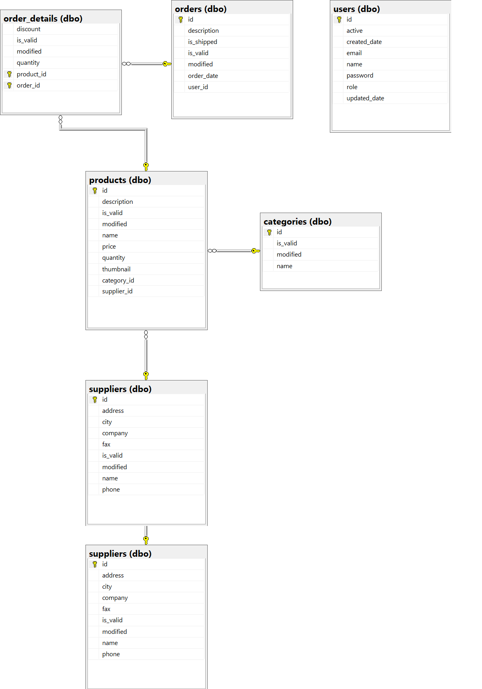

|  |  |  |
| --- | --- | --- |
| **Date: Sep 20, 2012** | **Prepared by Project Group 4**  **Team Leader:** | **Approved by**  **Mr. Ho Hoan Kiem** |
| **Signature** |  |  |

REVIEW 3

**INTERFACE DESIGN**

1. **Home Page**



|  |  |  |  |  |  |
| --- | --- | --- | --- | --- | --- |
| **Name** | **Type** | **Event** | **Validation** | **Description** | **Status** |
| User Name | TextBox |  | String, not null | Input Customer’s user name |  |
| Password | TextBox |  | String, not null, | Input Customer’s password |  |
| Remember Me | Check Box |  | Stick | Remember Customer next time |  |
| Login | Button |  | Click | Choose Login |  |
| Forgot your Password | Hyperlink |  | Click | When Customer forgot password, they can help service supply again. |  |
| Create an Account | Hyperlink |  | Click | Create New Account when Customer like to create. |  |

1. **Login:**

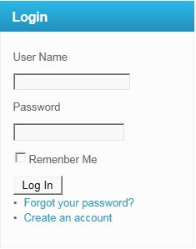

|  |  |  |  |  |  |
| --- | --- | --- | --- | --- | --- |
| **Name** | **Type** | **Event** | **Validation** | **Description** | **Status** |
| User Name | TextBox |  | String, not null | Input Customer’s user name |  |
| Password | TextBox |  | String, not null, | Input Customer’s password |  |
| Remember Me | Check Box |  | Stick | Remember Customer next time |  |
| Login | Button |  | Click | Login |  |

**3.Create Account Customer:**

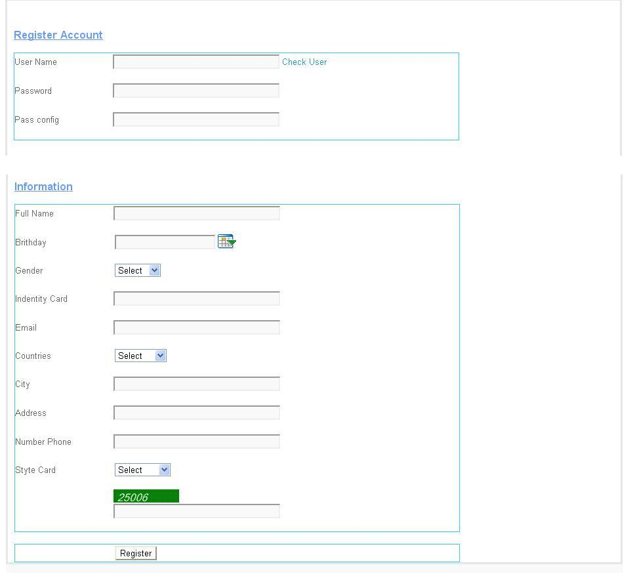

|  |  |  |  |  |  |
| --- | --- | --- | --- | --- | --- |
| **Name** | **Type** | **Event** | **Validation** | **Description** | **Status** |
| UserName | TextBox | Onchange | String, not null | Input UserName Customer |  |
| Password | TextBox |  | String, not null, | Input Customer’s New password |  |
| Config Password | TextBox |  | String,not null | Input Customer’s Config Password |  |
| Full Name | TextBox |  | String, not null | Input Full Name Customer |  |
| Birthday | BasicDate picker |  | Date,not null | Input BirthDay customer |  |
| Gender | DropdownList |  | Select Male,female | Input Male,Female |  |
| Identity Card | TextBox |  | Number, not null | Input Number Identity card |  |
| Email | TextBox |  | String ,not null, have Validation | Input Email Customer |  |
| Countries | Dropdownlist |  | Select | Input Countries Customer |  |
| City | TextBox |  | String, not null | Input City Customer |  |
| Address | TextBox |  | String, not null | Input Address Customer |  |
| Phone Number | TextBox |  | Number,not null | Input Phone Number Customer |  |
| Styte Card | DropDownList |  | Select | Input Styte Card Customer |  |
| CapChar | TextBox |  |  | Input number follow Image at above Text Box |  |
| Register | Button |  | Click | Register Customer |  |

**4.Forgot Password:**

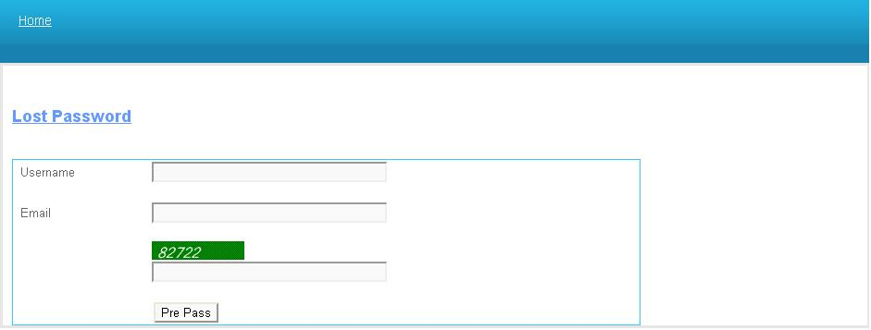

|  |  |  |  |  |  |
| --- | --- | --- | --- | --- | --- |
| **Name** | **Type** | **Event** | **Validation** | **Description** | **Status** |
| UserName | TextBox |  | String,not null | Input UserName Customer |  |
| Email | TextBox |  | String ,not null, have Validation | Input Email Customer |  |
| CapChar | TextBox |  |  | Input number follow Image at above Text Box |  |

**5.Change Password:**

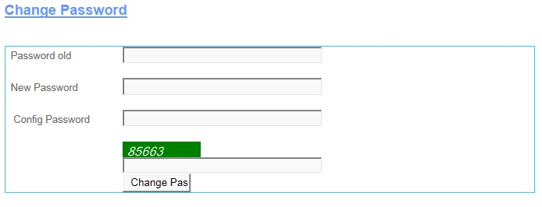

|  |  |  |  |  |  |
| --- | --- | --- | --- | --- | --- |
| **Name** | **Type** | **Event** | **Validation** | **Description** | **Status** |
| Password Old | TextBox |  | String, not null | Input Customer’s Password old |  |
| New Password | TextBox |  | String, not null, | Input Customer’s New password |  |
| Config Password | TextBox |  | String,not null | Input Customer’s Config Password |  |
| CapChar | TextBox |  |  | Input number follow Image at above Text Box |  |
| Change Password | Button |  | Click | Change Password |  |

**6.Change CodePin:**

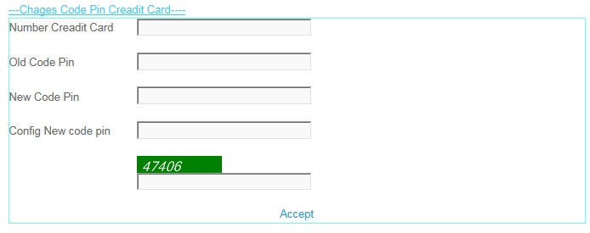

|  |  |  |  |  |  |
| --- | --- | --- | --- | --- | --- |
| **Name** | **Type** | **Event** | **Validation** | **Description** | **Status** |
| Number Credit Card | TextBox |  | int, not null | Input Customer’s Number Credit Card |  |
| Old Code Pin | TextBox |  | int, not null, | Input Customer’s Old Code Pin |  |
| New Code Pin | TextBox |  | int,not null | Input Customer’s New Code Pin |  |
| Config New Code Pin | TextBox |  | int, not null | Input Customer’s Config New Code Pin |  |
| CapChar | TextBox |  | int ,not null | Input number follow Image at above Text Box |  |
| Accept | LinkButton |  | Click | Accept Change code Pin . |  |

**7.Create Information:**

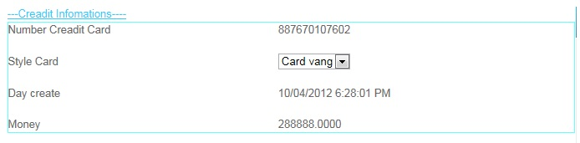

|  |  |  |  |  |  |
| --- | --- | --- | --- | --- | --- |
| **Name** | **Type** | **Event** | **Validation** | **Description** | **Status** |
| Number Credit Card | Label |  | Read Only | View Number Credit Card |  |
| Style Card | Drop Down List |  | Select | View and select Card |  |
| Day Create | Label |  | Read Only | View Day Create |  |
| Money | Label |  | Read Only | View Money |  |

**8.Edit Account User:**

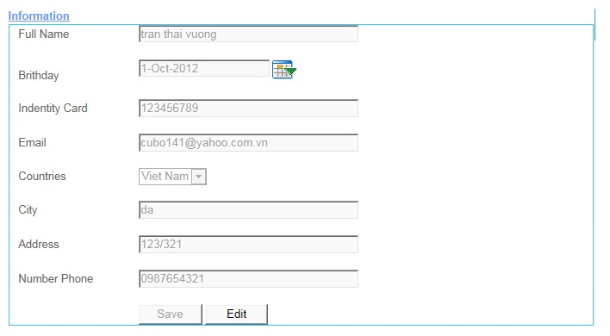

|  |  |  |  |  |  |
| --- | --- | --- | --- | --- | --- |
| **Name** | **Type** | **Event** | **Validation** | **Description** | **Status** |
| Full Name | TextBox |  | String, not null | Input Full Name |  |
| Birthday | TextBox |  | DatetTime | Input DateTime |  |
| Calendar Tool | Calendar |  | Select | Select Date on Calendar |  |
| Identity Card | TextBox |  | Int , not null | Input identity Card |  |
| Email | TextBox |  | String ,not null, have Validation | Input Customer’s Email |  |
| Country | DropDownList |  | Select | Select country |  |
| Address | TextBox |  | Int, not null | Input Customer’s Address |  |
| Number Phone | TextBox |  | Int, not null | Input Customer’s Number Phone |  |
| Save | Button |  | Click | click save edit enable |  |
| Edit | Button |  | Click | click edit Save unenable |  |

**9.Transaction:**

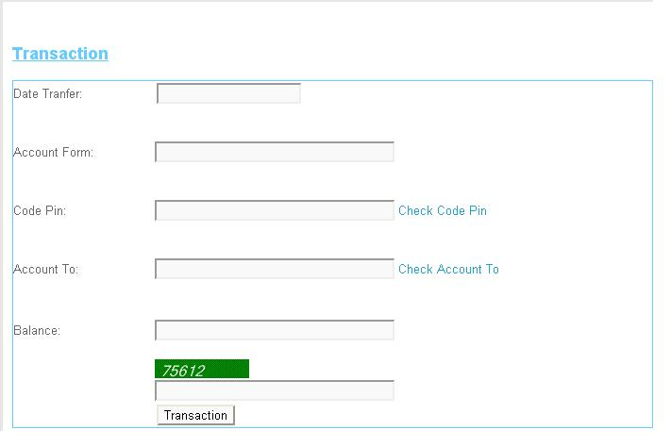

|  |  |  |  |  |  |
| --- | --- | --- | --- | --- | --- |
| **Name** | **Type** | **Event** | **Validation** | **Description** | **Status** |
| Date Tranfer | TextBox |  | DateTime, not null | Input Date Tranfer |  |
| Account From | TextBox |  | DatetTime | Input Account From |  |
| Code Pin | TextBox |  | Int, not null and Valiadaton | Input Code Pin |  |
| Account To | TextBox |  | DateTime, not null and Validation | Input Account To |  |
| Balance | TextBox |  | String ,not null, have Validation | Input Customer’s Balance |  |
| Transaction | Button |  | Click | Transaction |  |
| Check CodePin | LinkButton |  | Click | Check Codepin inval or not inval.. |  |
| Check Account To | LinkButton |  | Click | Check Account Inval or Not inval |  |
| CapChar | TextBox |  | int ,not null | Input number follow Image at above Text Box |  |

**10.Transaction Admin:**

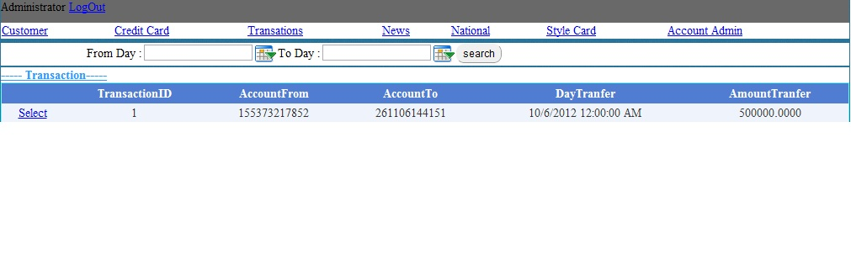

|  |  |  |  |  |  |
| --- | --- | --- | --- | --- | --- |
| **Name** | **Type** | **Event** | **Validation** | **Description** | **Status** |
| Log Out | LoginStatus |  | Click | Click Log Out |  |
| From Day | BasicdatePicker |  | Date time | Input From Date tranfer |  |
| To Day | BasicDatePicker |  | Date Time | Input To Date Tranfer |  |
| Transaction | Drop Down List |  | Select inform | Select Transaction |  |
| List Transaction | Grid view |  | Read Only | View inform Transaction |  |
| Select | LinkButton |  | Select | Select then view Detail |  |

**11.View Transaction:**

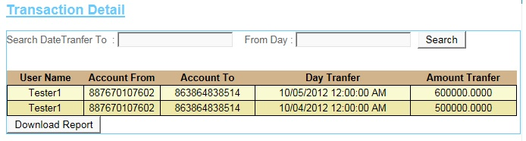

|  |  |  |  |  |  |
| --- | --- | --- | --- | --- | --- |
| **Name** | **Type** | **Event** | **Validation** | **Description** | **Status** |
| Search Date Transfer To | TextBox |  | DateTime , not null | Input DateTime |  |
| From Day | TextBox |  | DateTime , not null | Input DateTime |  |
| Search | Button |  | Click | Search |  |
| Transaction Detail | GridView |  | Read Only | View Inform of Detail’s Transaction |  |
| DownLoad Report | Button |  | Click | DownLoad Report |  |

**12.News:**

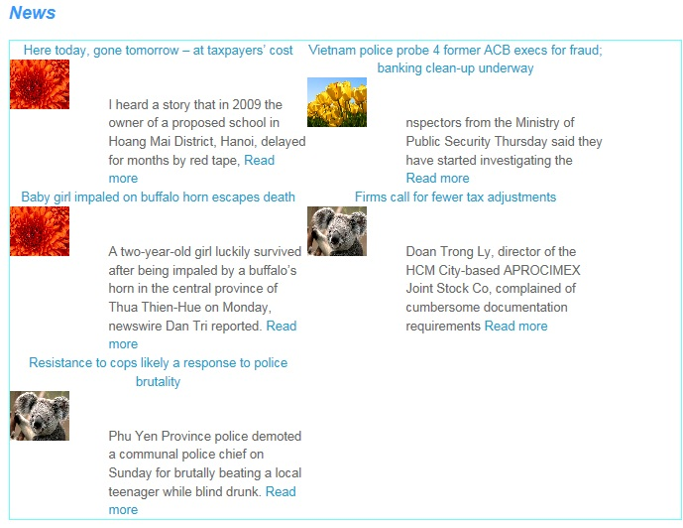

**13.AdminLogin:**

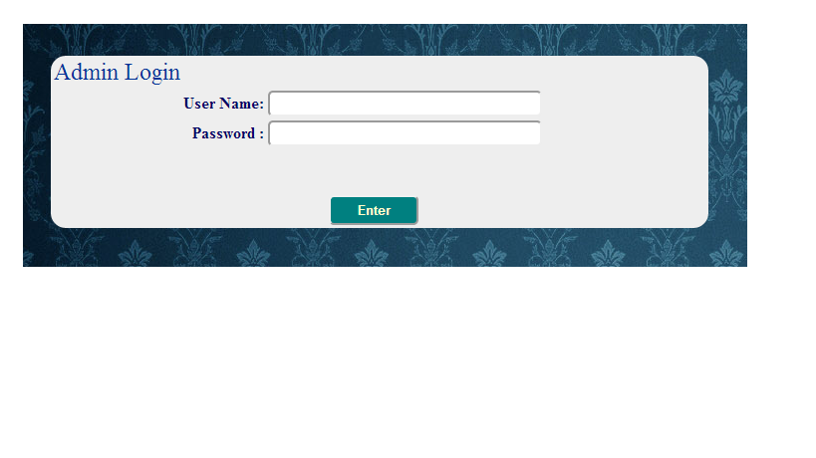

|  |  |  |  |  |  |
| --- | --- | --- | --- | --- | --- |
| **Name** | **Type** | **Event** | **Validation** | **Description** | **Status** |
| User Name | TextBox |  | String, not null | Input Admin’s user name |  |
| Password | TextBox |  | String, not null, | Input Admin’s password |  |
| Enter | Button |  | Click |  |  |

**14.AccountAdmin:**

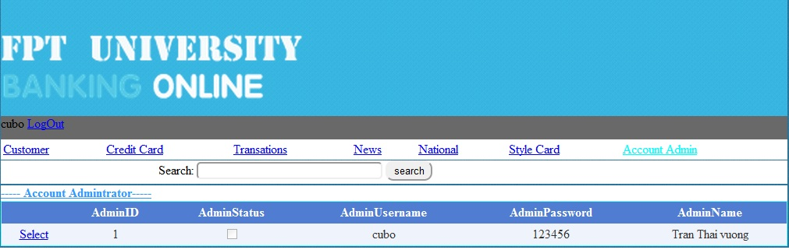

|  |  |  |  |  |  |
| --- | --- | --- | --- | --- | --- |
| **Name** | **Type** | **Event** | **Validation** | **Description** | **Status** |
| Search | TextBox | Onkeydown | String, | Search Admin’s Usernmae |  |
| Select Object | Hyperlink |  |  |  |  |
| DetailView1 | DetailsView |  |  | Select Account Admin |  |
| Select | Linbutton |  |  | Select Details Account Admin |  |

**15.AccountCustomer:**

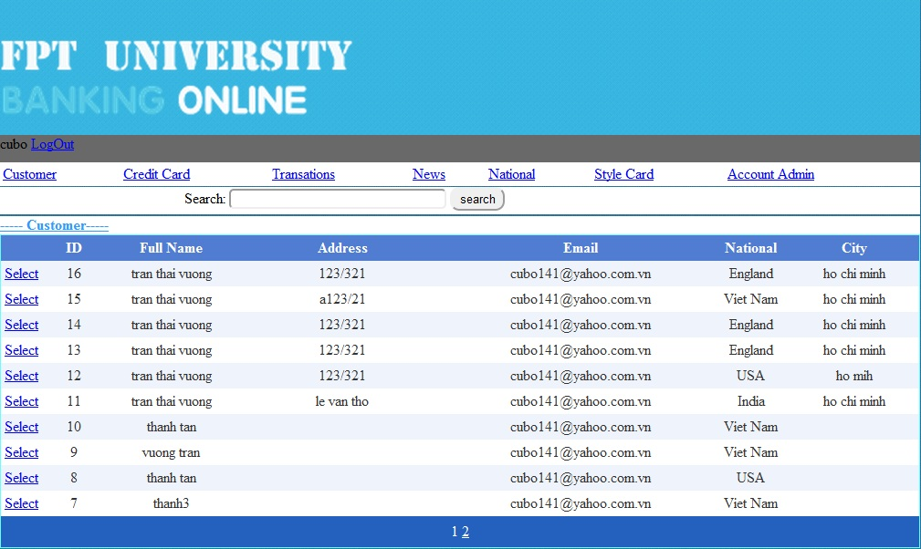

|  |  |  |  |  |  |
| --- | --- | --- | --- | --- | --- |
| **Name** | **Type** | **Event** | **Validation** | **Description** | **Status** |
| Search | TextBox |  | String | Search Customer’s Username |  |
| Select Object | Hyperlink |  |  |  |  |
| GridviewAccountCustomer | Gridview |  |  | Select Account Customer |  |
| Select | Linbutton |  |  | Select Details Account Customer |  |

**16.CreditCard:**

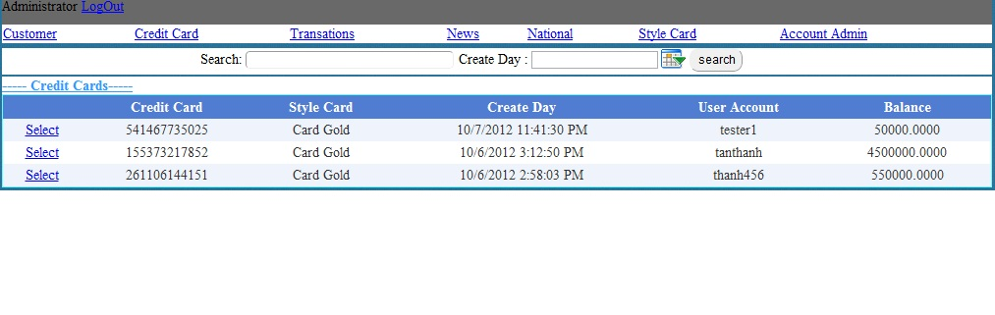

|  |  |  |  |  |  |
| --- | --- | --- | --- | --- | --- |
| **Name** | **Type** | **Event** | **Validation** | **Description** | **Status** |
| Search | TextBox | OnKeyDown | String | Search UserName |  |
| Select Object | Hyperlink |  |  |  |  |
| GvCreditCard | Gridview |  |  | Select ListCreditCard |  |
| Select | Linbutton |  |  | Select Details CreditCard |  |

**17.StyleCard:**

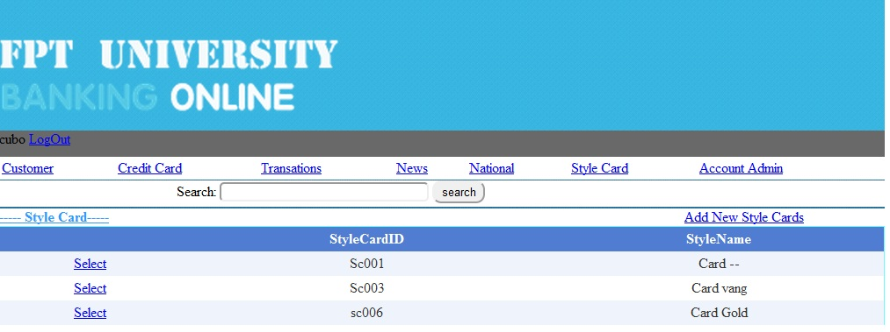

|  |  |  |  |  |  |
| --- | --- | --- | --- | --- | --- |
| **Name** | **Type** | **Event** | **Validation** | **Description** | **Status** |
| Search | TextBox | OnkeyDown | String | Search Style CardName |  |
| Select Object | Hyperlink |  |  |  |  |
| GvStyleCard | Gridview |  |  | Select Style Card |  |
| Select | Linbutton |  |  | Select Details Style Card |  |

**18.News:**

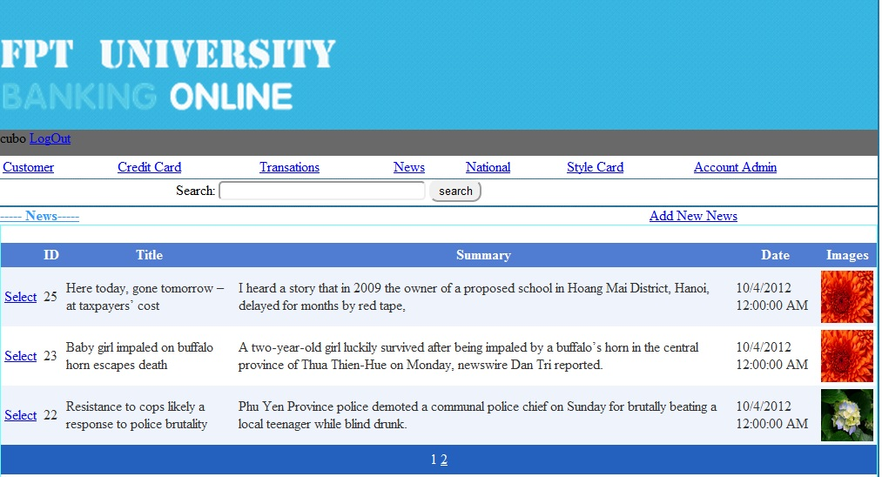

|  |  |  |  |  |  |
| --- | --- | --- | --- | --- | --- |
| **Name** | **Type** | **Event** | **Validation** | **Description** | **Status** |
| Search | TextBox | Onkeydown | String | Search Title News |  |
| Select Object | Hyperlink |  |  | Go Add new News |  |
| GvNews | Gridview |  |  | Select News |  |
| Select | Linbutton |  |  | Select Details News |  |

**19.National:**

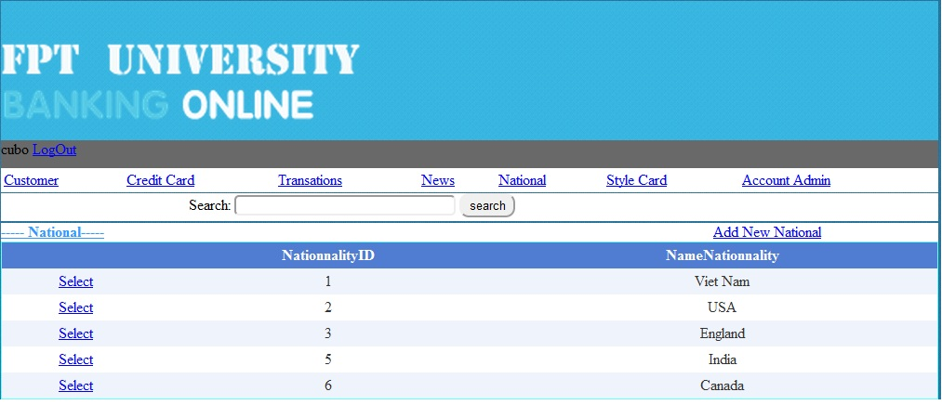

|  |  |  |  |  |  |
| --- | --- | --- | --- | --- | --- |
| **Name** | **Type** | **Event** | **Validation** | **Description** | **Status** |
| Search | TextBox | onKeydown | String | Search Name Nationality |  |
| Select Object | Hyperlink |  |  |  |  |
| Gv Nationality | Gridview |  |  | Select Nationality |  |
| Select | Linbutton |  |  | Select Details Nationality |  |

**20.Details Account Admin:**

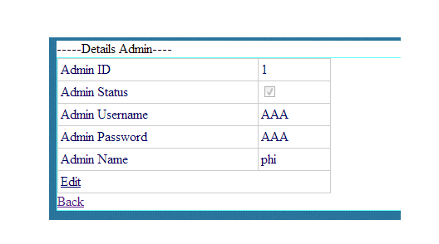

|  |  |  |  |  |  |
| --- | --- | --- | --- | --- | --- |
| **Name** | **Type** | **Event** | **Validation** | **Description** | **Status** |
| Edit | LinkButton |  |  | Edit Account Admin |  |
| Back | LinkButon |  |  | Back to MainAdmin.aspx |  |
| DetailsView1 | DetailsView |  |  | Select Details Admin |  |

**21.Details Account Customer:**

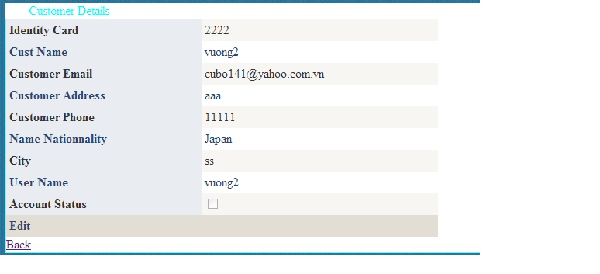

|  |  |  |  |  |  |
| --- | --- | --- | --- | --- | --- |
| **Name** | **Type** | **Event** | **Validation** | **Description** | **Status** |
| Edit | LinkButton |  |  | Edit Account Customer |  |
| Back | LinkButon |  |  | Back to MainAdmin.aspx |  |
| DetailsView1 | DetailsView |  |  | Select Customer Information |  |

**22.Details Credit Card:**

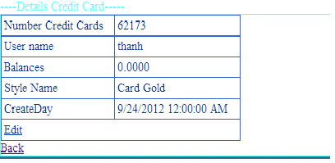

|  |  |  |  |  |  |
| --- | --- | --- | --- | --- | --- |
| **Name** | **Type** | **Event** | **Validation** | **Description** | **Status** |
| Edit | LinkButton |  |  | Edit Balance of Customer |  |
| Back | LinkButon |  |  | Back to MainAdmin.aspx |  |
| DetailsView1 | DetailsView |  |  | Select Details Credit Card of |  |

**23.Details Style Card:**

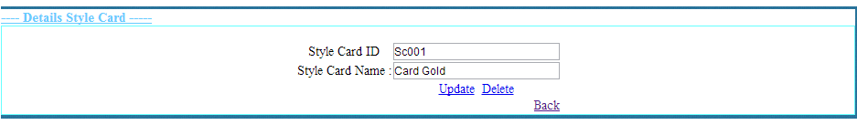

|  |  |  |  |  |  |
| --- | --- | --- | --- | --- | --- |
| **Name** | **Type** | **Event** | **Validation** | **Description** | **Status** |
| txtStyleCardID | TextBox |  | String,Not null | Input Style CardID |  |
| txtStyleCardName | TextBox |  | String,Not null | Input Style Card Name |  |
| Update | LinkButton |  |  | Update Style Card |  |
| Delete | LinkButton |  |  | Delete Style Card |  |
| Back | LinkButtom |  |  | Back to MainAdmin.aspx |  |

**24.News:**

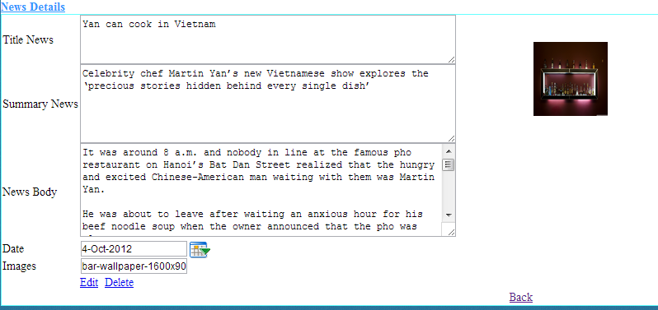

|  |  |  |  |  |  |
| --- | --- | --- | --- | --- | --- |
| **Name** | **Type** | **Event** | **Validation** | **Description** | **Status** |
| txtTitle News | TextBox |  | String,Not null | Input Title News |  |
| txtSummary News | TextBox |  | String,Not null | Input Summary News |  |
| txtNews Body | TextBox |  | String,Not null | Input News Body |  |
| txtDay | BasicDatePicker |  | Datetime,Not null | Input Datetime |  |
| txtImages | TextBox |  | String ,Not null | Input Images |  |
| Edit | LinkButton |  |  | Update Style Card |  |
| Delete | LinkButton |  |  | Delete Style Card |  |
| Back | LinkButtom |  |  | Back to MainAdmin.aspx |  |

**24.Details Nationality:**

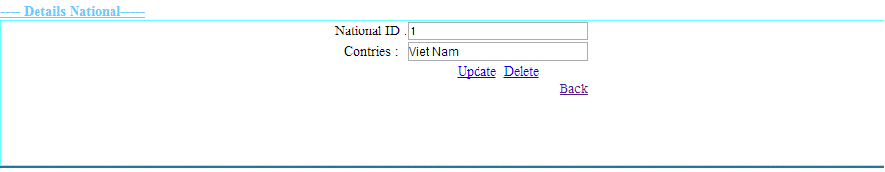

|  |  |  |  |  |  |
| --- | --- | --- | --- | --- | --- |
| **Name** | **Type** | **Event** | **Validation** | **Description** | **Status** |
| txtID | TextBox |  | String,Not null | Input CardID |  |
| txtNationalityName | TextBox |  | String,Not null | Input Nationality |  |
| Update | LinkButton |  |  | Update Nationality |  |
| Delete | LinkButton |  |  | Delete Nationality |  |
| Back | LinkButtom |  |  | Back to MainAdmin.aspx |  |

**Support:**

**+ Connected**

* **Gold :**

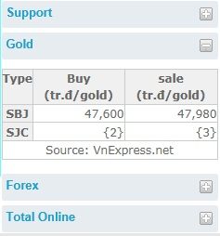

* **Forex :**

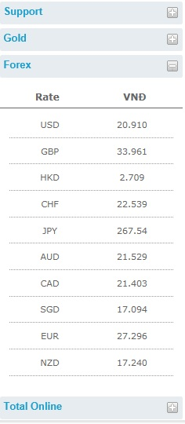

**+Disconnection**

* **Gold :**

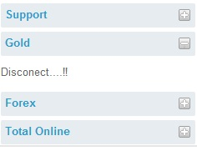

* **Forex :**

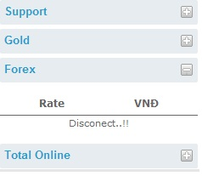

**+Total Online**

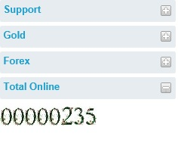

**TASK SHEET**

|  |  |  |  |  |  |  |
| --- | --- | --- | --- | --- | --- | --- |
| **Project Group FFG** | | **Project Title**  **Laptop Shop Online** | | **Date of Preparation** | | **Activity Plan Prepared by**  **Le Hoang Hai** |
| **No** | **Task Title** | | **Planned Start Date** | **Planned Completed Date** | **Team Mate Names** | **Status** |
| 1 | Login Customer | | Sep 10, 2012 | Oct 10, 2012 |  |  |
| 2 | Search admin evevnt onkeydown | |  |
| 3 | Change CodePin Credit Card | |  |
| 4 | Load News Masterpage Customer | |  |
| 5 | Design Masterpage Customer | |  |
| 6 | Register Customer | |  |  |
| 7 | Change Password | |  |
| 8 | Forget Password | |  |
| 9 | Credit card Infomation | |  |
| 10 | Your`s Profile | |  |
| 11 | Login Admin | |  |  |
| 12 | Edit Credit Card | |  |
| 13 | Edit Style Card | |  |
| 14 | Edit National | |  |
| 15 | Masterpage Admin | |  |
| 16 | Edit Status Customer | |  |  |
|  |
| 17 | Show Transaction | |  |
| 18 | Edit Balance | |  |
| 19 | Add, Edit, Delete news | |  |
| 20 | Customer Transaction | |  |  |
| 21 | Detail Transaction | |  |
| 22 | Download Report Transaction | |  |
| 23 | Create Report | |  |
| 25 | Contact | |  |
| 26 | Search Report | |  |
| 27 | Design Masterpage Customer | |  |

|  |  |  |
| --- | --- | --- |
| **Date: Oct 10, 2012** | **Prepared by Project Group 4**  **Team Leader:** | **Approved by**  **Mr. Ho Hoan Kiem** |
| **Signature** |  |  |