CYBERSECURITY
INTERNSHIP TECHNICAL REPORT
Security Log Analysis • Password Strength Evaluation • Basic Website Security Review

Report detail | Information
Prepared by | Shardul Shinde
Organization | CodeElevate
Program | Cyber Security Analyst Internship
Report date | 29 October 2026
Report type | Internship practical-work report
Assessment scope | Three beginner-level cybersecurity tasks

CONFIDENTIALITY NOTE
This report documents educational exercises and limited browser-based observations. It is not a comprehensive penetration test, independent security audit, or certification of any system.

Document Control
Field | Details
Author | Shardul Shinde
Version | 1.0 — internship submission draft
Prepared on | 29 October 2026
Intended audience | CodeElevate internship reviewer / mentor
Evidence basis | Task 1 sample-log output; Task 2 sample-password checks; user-reported browser observations for Google.com
Important evidence note | Screenshots and source files should be attached/retained by the student. This report does not claim to have independently executed the scripts or verified unseen screenshots.

Executive Summary
This report consolidates three practical cybersecurity exercises completed or documented during the CodeElevate Cyber Security Analyst Internship. Task 1 demonstrates parsing sample authentication logs, counting failed logins by source IP, and flagging an IP when failures meet a configured threshold. Task 2 describes a local password-strength checker that evaluates basic composition rules and returns a strength category with suggestions. Task 3 records a limited, passive browser inspection of https://www.google.com, where the student reported that HTTPS loaded, Chrome indicated a secure/valid certificate, and the main document response included X-Frame-Options: SAMEORIGIN.
The first two tasks are controlled learning exercises using synthetic sample data. Task 3 is intentionally limited to ordinary browser inspection. No active scanning, exploitation, fuzzing, authentication testing, or intrusive probing is included. Because Google.com is a third-party public website and no explicit authorization for a formal security assessment was established, Task 3 must not be represented as an authorized penetration test.
Task | Outcome documented | Evidence status
1 — Security Log Analyzer | Five failed attempts from 192.0.2.10 meet the configured alert threshold of 5; 198.51.100.8 has two failures and is below threshold. | Output screenshot reportedly saved in a Word document; retain .py and sample log files.
2 — Password Strength Checker | Checks length, uppercase, lowercase, digit, and special character; illustrative outcomes: weak, medium, strong. | Script and test evidence should be retained; report uses the previously described sample cases.
3 — Basic Website Security Review | HTTPS and browser certificate status reported as secure/valid; X-Frame-Options: SAMEORIGIN observed. | Based on student-reported browser observations; remaining headers were not confirmed.

1. Introduction
The purpose of the internship tasks is to practice foundational security analysis: recognizing repeated failed logins, applying basic password-quality rules, and locating selected web security controls in a browser response. The work emphasizes repeatable steps, evidence-based reporting, safe test data, and clear limitations.

1.1 Objectives
- Build a small Python utility that summarizes failed authentication events by IP address.
- Build a local password-strength checker that gives users basic feedback without collecting or storing real passwords.
- Learn to inspect HTTPS/certificate status and selected HTTP response headers using Chrome DevTools.
- Document methods, results, risks, limitations, and practical recommendations in a professional format.
- Keep all testing within the limits of the supplied tasks and avoid unauthorized or intrusive activity.

1.2 Scope and Out-of-Scope Activities
In scope:
- Offline analysis of fictional/sample log entries.
- Local evaluation of sample passwords only.
- Normal browser inspection of the Google.com main document response and Chrome connection details, as reported by the student.
Out of scope:
- Any unauthorized access, exploitation, vulnerability scanning, brute force, fuzzing, or denial-of-service activity.
- Testing login forms or user accounts on Google.com or any third-party service.
- Review of server-side source code, internal infrastructure, APIs, or other endpoints not covered by the browser observation.
- Any claim that the target is fully secure or that a comprehensive penetration test was performed.

1.3 Tools and Materials
Task | Tools / materials
Task 1 | Python 3; security_log_analyzer.py; sample_logs.txt; terminal output screenshot.
Task 2 | Python 3; password_checker.py; standard Python string handling and getpass input helper, if present in the submitted implementation.
Task 3 | Google Chrome; Chrome DevTools Network panel; main document request Headers view; student-recorded observations.

Implementation details in this report reflect the task workflow and prior-described script behavior. Confirm the final submitted source files match these descriptions before submission.

2. Task 1 — Security Log Analyzer

2.1 Objective
Create a Python script named security_log_analyzer.py that reads a sample log file, identifies failed login events, counts failures by source IP address, flags IP addresses with five or more failed attempts, and prints a concise summary.

2.2 Methodology
- Create a sample log file named sample_logs.txt containing fictional authentication events.
- Read the file line by line and identify entries marked as failed login attempts.
- Extract the source IP address associated with each failed attempt.
- Count failures per IP address, for example using a counter/dictionary.
- Compare each count against the alert threshold (5 failures).
- Print a summary that distinguishes flagged IP addresses from those below the threshold.

2.3 Sample Data and Results
The documented sample uses non-routable documentation IP ranges, which are appropriate for fictional examples. The previously recorded sample summary was:
Source IP (sample) | Failed attempts | Threshold | Interpretation
192.0.2.10 | 5 | 5 | Flagged — meets the threshold.
198.51.100.8 | 2 | 5 | Not flagged — below the threshold.
192.0.2.15 | Successful events only in the described sample | 5 failed attempts | Successful events are not counted as failures.

2.4 Security Significance
Repeated failed authentication attempts may indicate a mistyped password, a misconfigured client, password spraying, or brute-force behavior. The script highlights a simple threshold-based signal; it does not determine intent or prove an attack.

2.5 Limitations
- The result depends on the sample log format and the accuracy of the parser.
- A fixed threshold may generate false positives or miss low-and-slow activity.
- The script does not enrich IP addresses, correlate events across hosts, or validate whether an event is malicious.
- The sample output is not evidence of real attacks against a production system.

2.6 Recommendations
- Validate malformed lines and handle missing or unexpected fields safely.
- Make the threshold configurable and include a timestamp in the summary.
- Add unit tests for failed logins, successful logins, malformed entries, and multiple IP addresses.
- For a real environment, correlate alerts with account, host, time window, MFA, and other security telemetry before taking action.

2.7 Evidence to Attach
Attach the saved terminal-output screenshot and retain both security_log_analyzer.py and sample_logs.txt in the submission repository. Suggested caption: “Figure 1. Security Log Analyzer output showing per-IP failed-login counts and the configured threshold alert.”
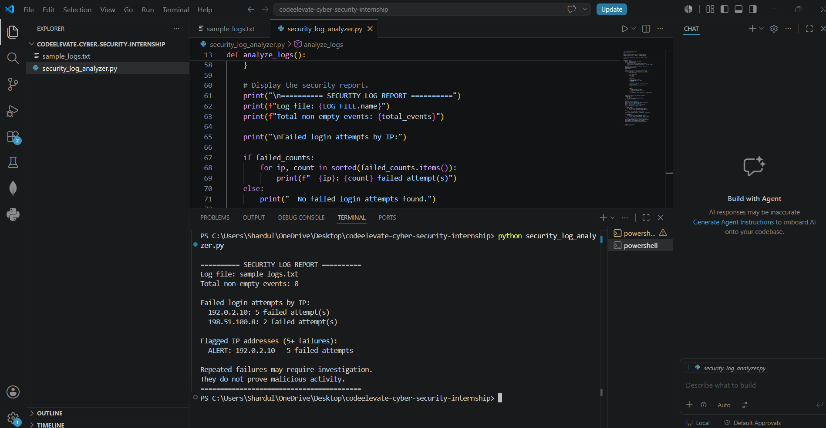
Figure 1. Security Log Analyzer execution and summary output.
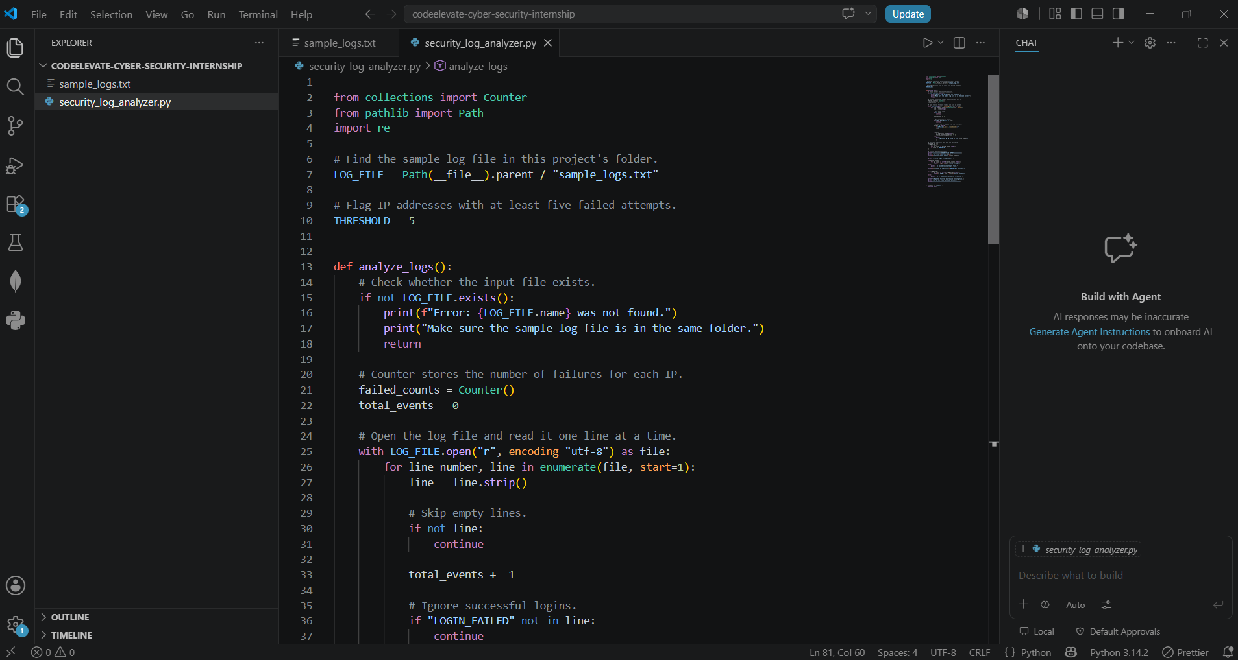
Figure 2. Security Log Analyzer source code.
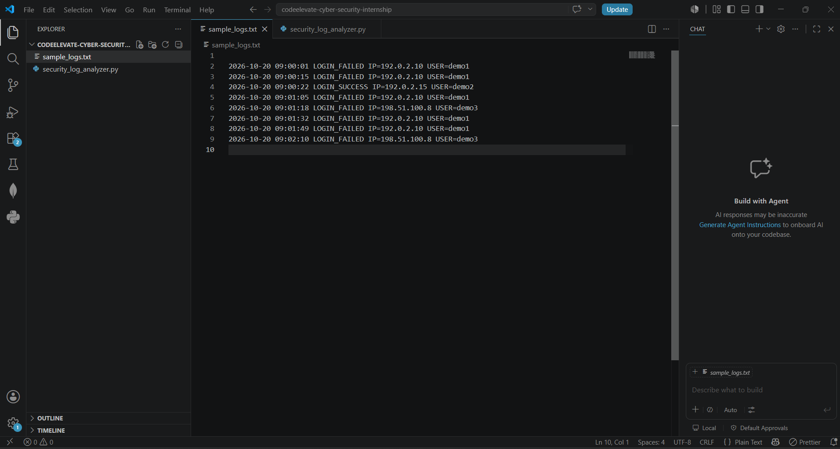
Figure 3. Sample authentication log entries used for the exercise.

3. Task 2 — Password Strength Checker

3.1 Objective
Create password_checker.py to accept a sample password, check basic length and character-category criteria, classify the result as WEAK, MEDIUM, or STRONG, and provide suggestions for improvement. Only synthetic sample passwords should be used for the internship demonstration.

3.2 Checks Described
Check | Rule described in the implementation
Length | At least 12 characters for the strongest category; 8 characters is the minimum length used in the medium-category rule.
Uppercase | Contains at least one uppercase letter.
Lowercase | Contains at least one lowercase letter.
Digit | Contains at least one numeric digit.
Special character | Contains at least one punctuation/special character.

The previously described classification logic returns STRONG when the password is at least 12 characters and passes all five checks; MEDIUM when the length is at least 8 characters and at least three checks pass; otherwise WEAK. The exact implementation should be reviewed against the submitted script before final submission.

3.3 Illustrative Test Cases
Test input (synthetic only) | Expected category described | Reason / note
cat | WEAK | Too short and lacks the required character variety.
BlueSky123 | MEDIUM | At least 8 characters and includes uppercase, lowercase, and digits; it does not meet all strong-category criteria.
RiverStone!482 | STRONG | At least 12 characters and includes uppercase, lowercase, digits, and a special character.

These values are examples for the local demonstration only. Do not reuse them as personal passwords. The report does not claim that these are real credentials.

3.4 Security Significance
A strength checker can help demonstrate why longer passwords and varied character classes can be useful. However, composition checks are only a basic heuristic: they do not measure whether a password is common, reused, exposed in a breach, or easy to guess based on personal information.

3.5 Privacy and Safety
- Use only synthetic test values in screenshots and demonstrations.
- Do not collect, transmit, or store passwords entered by users.
- If the script uses Python's getpass module, verify that typed input is not echoed in a compatible terminal; this is a display feature, not a substitute for secure handling.
- Do not log entered password strings or include them in the report.

3.6 Limitations and Recommendations
- A character-category score does not guarantee resistance to guessing or credential stuffing.
- Prefer long, unique passwords or passphrases and use a password manager.
- Where supported, enable multi-factor authentication.
- Consider checking against a locally maintained list of common passwords without transmitting user input to an external service.
- Add automated tests for boundary lengths (7, 8, 11, 12 characters), all character categories, Unicode input, and empty input.

3.7 Evidence to Attach
Include a screenshot of the script run with the synthetic examples and the source file password_checker.py. Ensure no personal or real password appears in the screenshot.
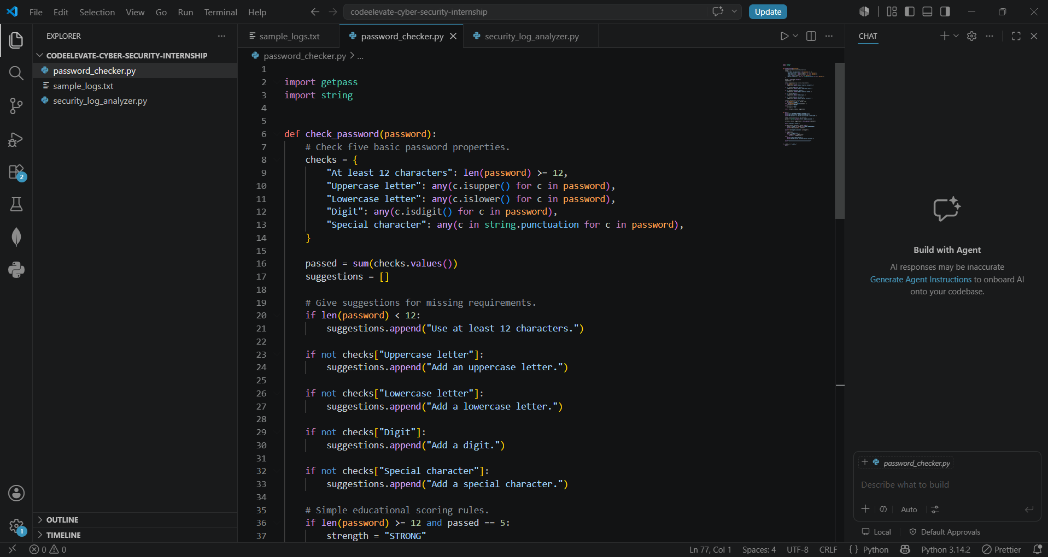
Figure 4. Password Strength Checker source code and validation rules.
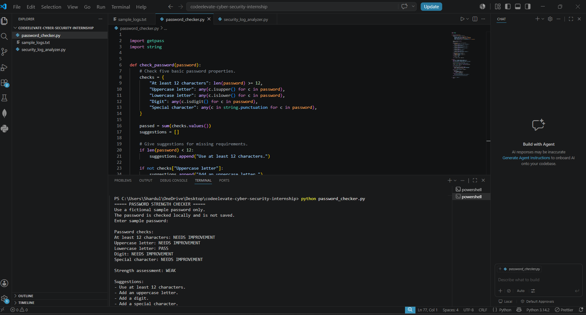
Figure 5. Password checker run showing sample password evaluation.
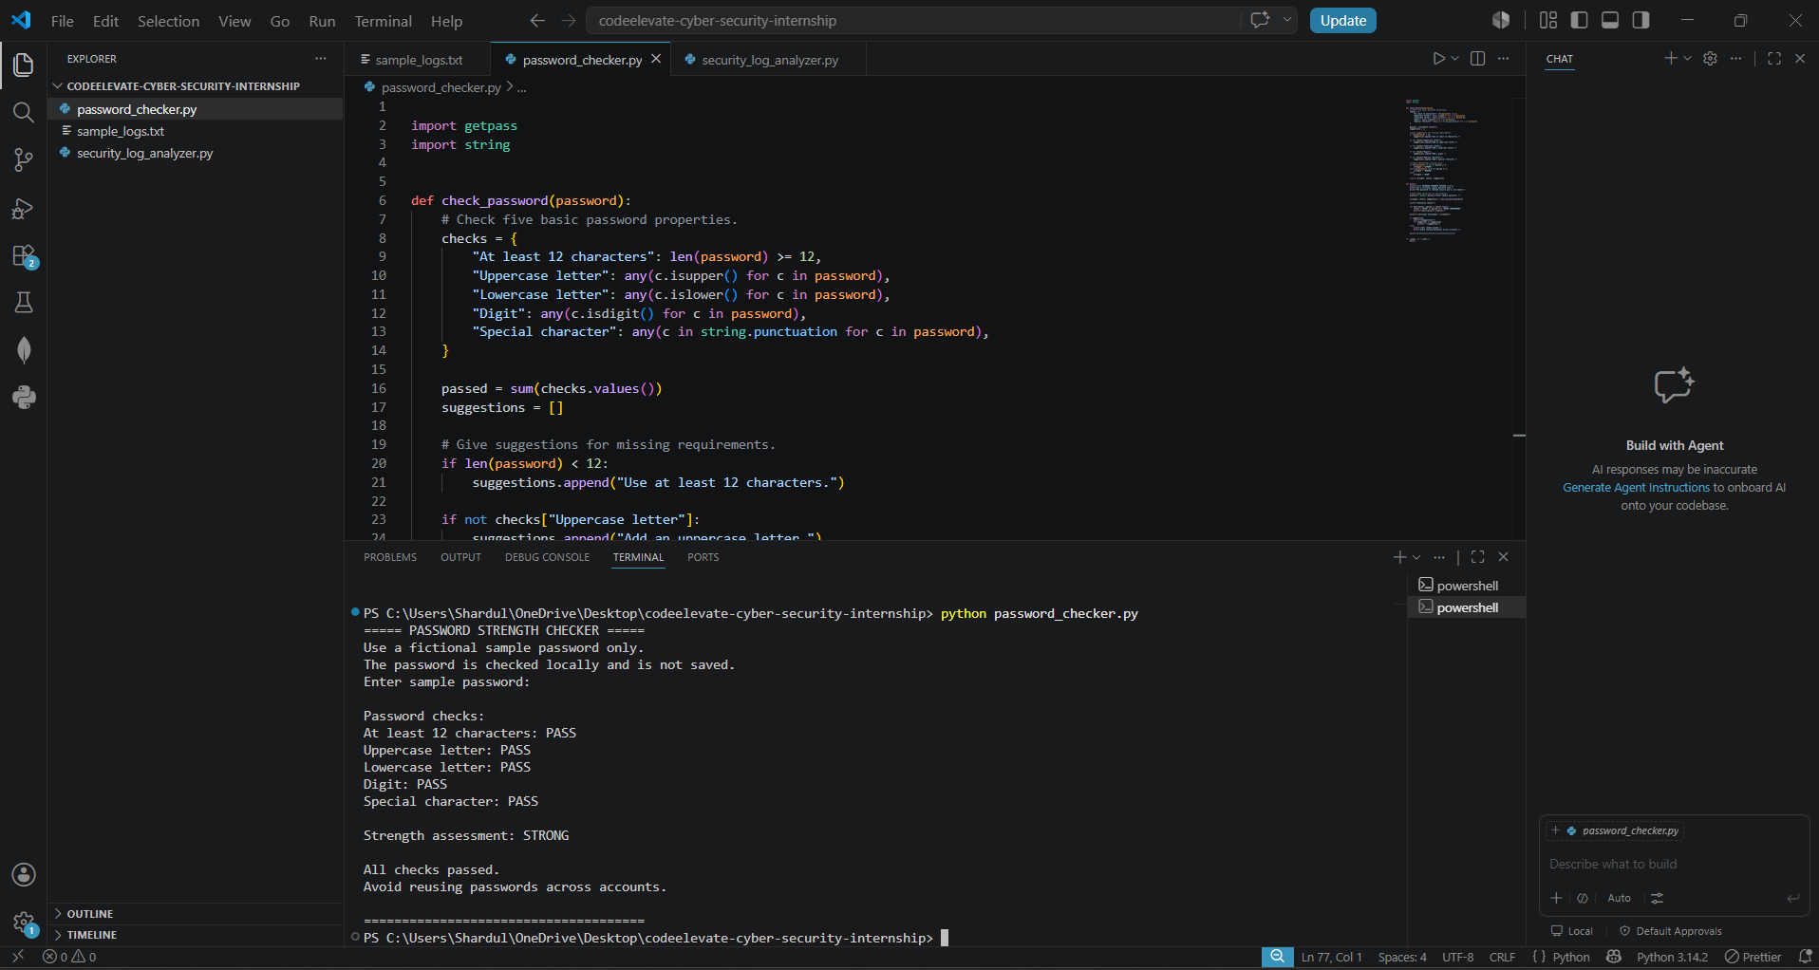
Figure 6. Additional password checker test output using synthetic examples.

4. Task 3 — Basic Website Security Review

4.1 Objective
Practice locating HTTPS/connection status and selected HTTP security response headers using Chrome DevTools. The target used for this exercise was https://www.google.com, and the work was limited to passive observation of a normal browser page load.

4.2 Authorization and Scope Qualification
Important limitation: Google.com is a third-party public website. The work documented here was ordinary browser observation only; explicit authorization for a formal security assessment was not established. Therefore, this task must be described as a limited passive educational review, not as an authorized penetration test. No active scanning, exploit attempts, request manipulation, or probing was performed as part of the described workflow.

4.3 Methodology
- Open https://www.google.com in Chrome.
- Observe that the page loads using HTTPS.
- Open Chrome's site/connection information and observe the displayed connection/certificate status.
- Open Chrome DevTools → Network and select the main document request named www.google.com.
- Inspect the Headers panel and locate the Response Headers section.
- Record only values actually observed; do not copy Set-Cookie values or other sensitive session information.

4.4 Observations
Item | Observed result | Evidence basis / interpretation
Target URL | https://www.google.com | Target selected for browser-only observation.
HTTPS | Page reported to load using HTTPS | Student-reported browser observation; not a full TLS assessment.
Certificate / connection status | Chrome reportedly indicated secure/valid | Browser UI observation only; certificate chain details and TLS configuration were not independently audited.
X-Frame-Options | SAMEORIGIN | Student reported this exact value under Response Headers for the main document request.
Strict-Transport-Security | Not confirmed | The user did not report a verified value; do not conclude absent.
Content-Security-Policy | Not confirmed | The user did not report a verified value; do not conclude absent.
X-Content-Type-Options | Not confirmed | The user did not report a verified value; do not conclude absent.
Referrer-Policy | Not confirmed | The user did not report a verified value; do not conclude absent.
Permissions-Policy | Not confirmed | The user did not report a verified value; do not conclude absent.

4.5 Interpretation of X-Frame-Options
The observed value SAMEORIGIN instructs compatible browsers to allow the page to be framed only when the framing page has the same origin. This helps mitigate clickjacking by preventing cross-origin framing. It is a protective configuration for the inspected response, but it does not prove that every clickjacking risk or every website security issue is eliminated. A Content-Security-Policy frame-ancestors directive is also relevant when assessing framing policy.

4.6 Findings and Severity
ID | Finding | Severity | Basis
WEB-01 | X-Frame-Options: SAMEORIGIN was observed. | Informational / positive control | This value provides a browser framing restriction for the inspected response.
WEB-02 | HTTPS and a secure/valid connection status were reported in Chrome. | Informational / positive observation | Browser status only; no independent TLS or certificate-chain assessment was performed.
WEB-03 | Other selected security headers were not confirmed in the available notes. | Not rated | Insufficient evidence to classify these headers as missing or to claim a vulnerability.

4.7 Recommendations for a Properly Authorized Assessment
- For a formal assessment, select a system you own or a target explicitly included in written authorization and the relevant program scope.
- If the website owner is reviewing its own configuration, verify security headers across representative HTML responses, redirects, and relevant application routes.
- Review Content-Security-Policy, Strict-Transport-Security, X-Content-Type-Options, Referrer-Policy, Permissions-Policy, and framing controls against the application's requirements and current guidance.
- Do not treat a missing header alone as proof of exploitability; assess the header's purpose, response type, and compensating controls.
- Preserve screenshots with the URL, selected request, and relevant header visible; redact cookies, identifiers, and private data.

4.8 Limitations
- The results depend on one browser, one observed page load, and the selected main document response.
- The full response-header list was not documented; five of the selected headers remain unconfirmed rather than proven absent.
- No automated scanning, vulnerability exploitation, source-code review, authenticated testing, or infrastructure testing was performed.
- The observation does not establish overall security, compliance, or absence of vulnerabilities.

4.9 Evidence to Attach
Attach a screenshot of the main document request's Response Headers showing X-Frame-Options: SAMEORIGIN, plus a separate screenshot of the browser's connection/certificate status if available. Avoid including Set-Cookie values or session-related details.
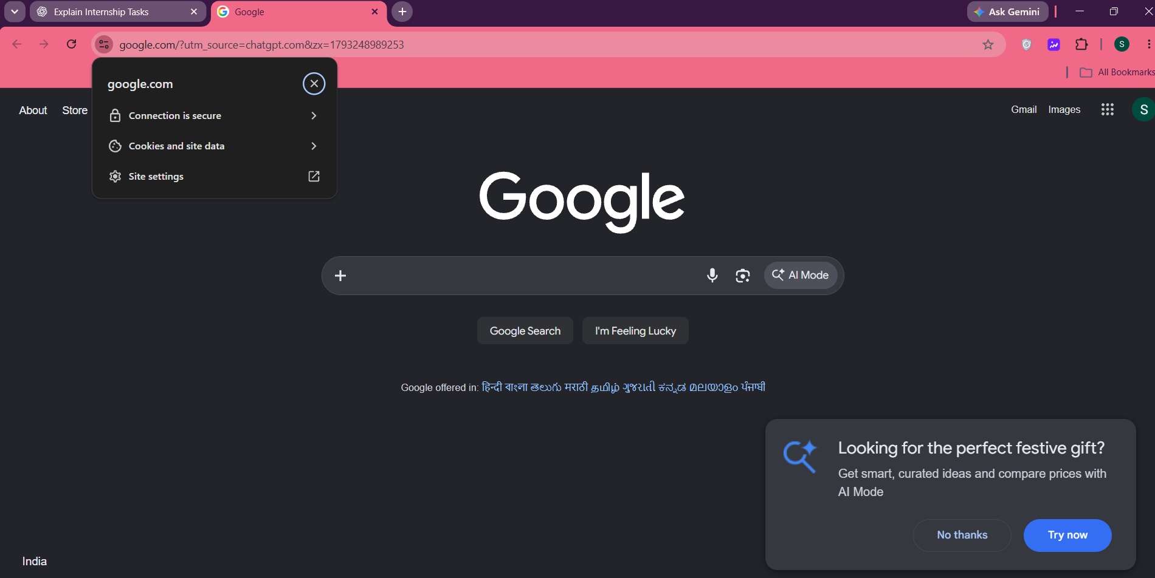
Figure 7. Chrome site information panel for the Google.com page.
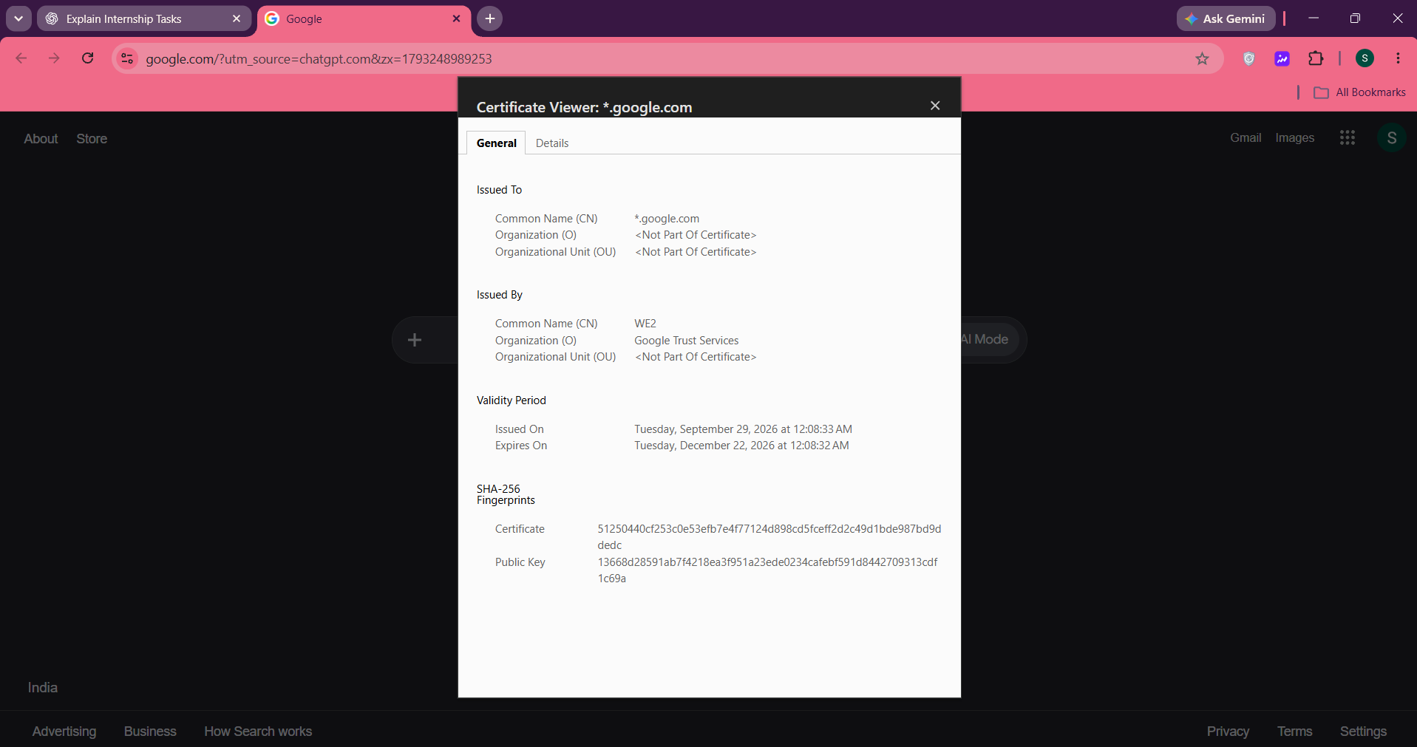
Figure 8. Browser certificate details viewed during the passive observation.
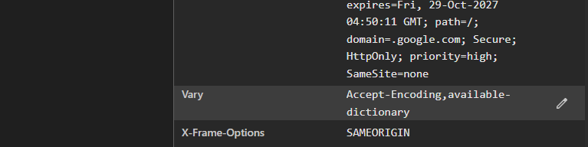
Figure 9. Response-header evidence showing X-Frame-Options: SAMEORIGIN.

5. Overall Results and Learning Outcomes
- Practiced basic event parsing and threshold-based identification of repeated failed logins.
- Applied simple password-quality checks and learned the limitations of composition-based scoring.
- Learned to identify a main document request in Chrome DevTools and inspect response headers.
- Practiced separating observed evidence from assumptions and documenting limitations.
- Reinforced safe handling of sample data and avoidance of unauthorized testing.

6. Conclusion
The three tasks provide a foundation in defensive security analysis, secure credential habits, and web configuration observation. The Security Log Analyzer demonstrates a simple, explainable alerting rule; the Password Strength Checker demonstrates basic password feedback; and the browser-based review demonstrates how to find a selected response header. The results should be understood within their stated limitations: sample logs are not production telemetry, password scoring is heuristic, and the Google.com review is a limited passive observation rather than a formal penetration test.

7. Submission Checklist
- security_log_analyzer.py is included and runs against sample_logs.txt.
- sample_logs.txt contains only fictional/sample events.
- password_checker.py is included and tested with synthetic values only.
- website_security_report.md is created if required by the task instructions, with observations and limitations accurately recorded.
- This consolidated report is reviewed for accuracy and updated if the source code or observed results differ.
- Task 1 and Task 2 terminal screenshots and Task 3 browser screenshots are attached with figure captions.
- README.md explains the purpose, safe test data, how to run each script, and limitations.
- No real passwords, tokens, cookies, private logs, or personal information are included in the repository.
- The GitHub repository is accessible to the intended reviewer and contains the expected files.

Appendix A — Suggested Repository Structure
codeelevate-cyber-security-internship/
├── security_log_analyzer.py
├── sample_logs.txt
├── password_checker.py
├── website_security_report.md
├── README.md
└── evidence/
├── task1_log_analyzer_output.png
├── task2_password_checker_tests.png
├── task3_https_certificate.png
└── task3_response_headers.png

Appendix B — References
- OWASP, HTTP Headers Cheat Sheet: https://cheatsheetseries.owasp.org/cheatsheets/HTTP_Headers_Cheat_Sheet.html
- OWASP Web Security Testing Guide, HTTP Security Header Misconfigurations: https://owasp.org/www-project-web-security-testing-guide/latest/4-Web_Application_Security_Testing/02-Configuration_and_Deployment_Management/14-Other_HTTP_Security_Header_Misconfigurations
- MDN Web Docs, X-Frame-Options: https://developer.mozilla.org/en-US/docs/Web/HTTP/Reference/Headers/X-Frame-Options
- Python documentation, getpass — Portable password input: https://docs.python.org/3/library/getpass.html
References support general explanations of HTTP security headers and password-input behavior. They do not independently verify the target website's current configuration.

