**Work-Case №2**

***1. Встановіть на своїй домашній робочій станції гіпервізор ІІ типу – Virtual Box, VMWare Workstation, Hyper-V (або інший на Ваш вибір).***

For use in this work, the Oracle Virtual Box hypervisor was chosen as the most convenient and accesible hypervisor.

***2. Опишіть набір базових дій в встановленому Вами гіпервізорі:***

1) To create a new virtual machine, you need to click the "create" button in the main menu of the hypervisor, name it, select its type and version, allocate RAM, create/connect a virtual disk.



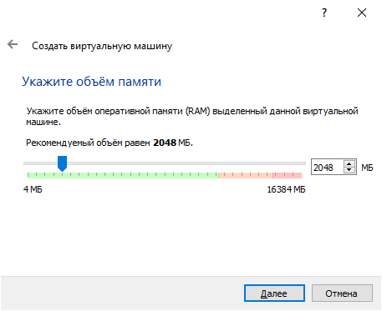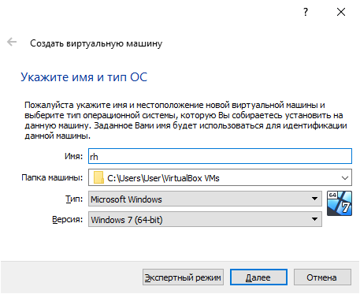

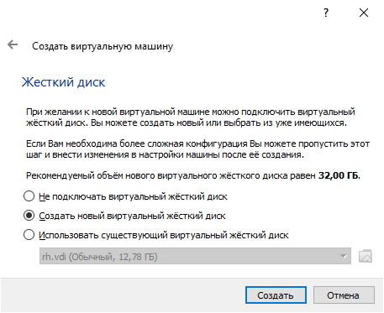

2) In order to change the equipment available for the virtual machine, you need to click "settings" and change the necessary parameters (tabs display, audio, media, etc.)

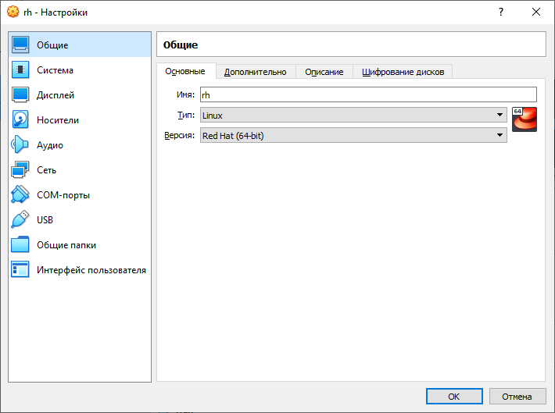

3) To configure the network, you need to open "settings" and go to the "Network" tab, where you can change network adapters and their settings.

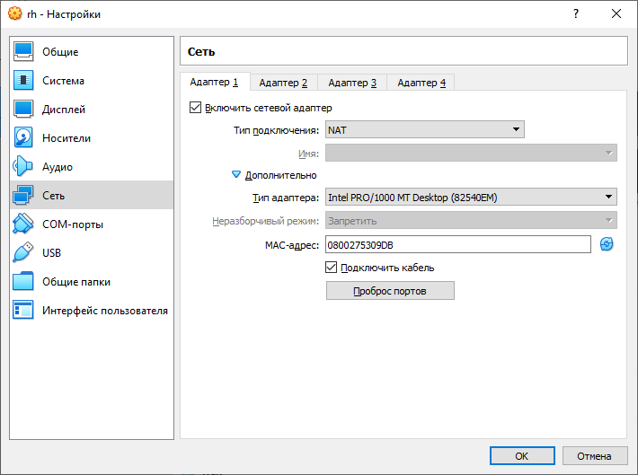

4) To connect a flash drive to a virtual machine, you need to start the virtual machine, open the "devices" tab and select the device you need. (I used my phone as an example)

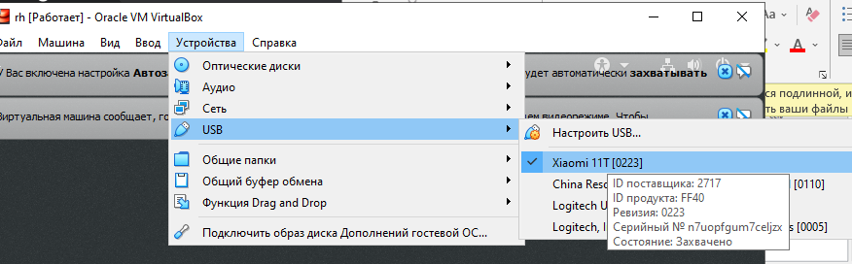

***3) Встановіть в вашому гіпервізорі операційну систему GNU/Linux CentOS (або інший зручний Вам дистрибутив) у базовій конфігурації з графічною оболонкою.***

I have selected CentOS 7. To install it, you need to boot the iso image of the operating system, open it, create a virtual machine and select the mounted iso image as the boot disk, after which the installation of CentOS 7 beg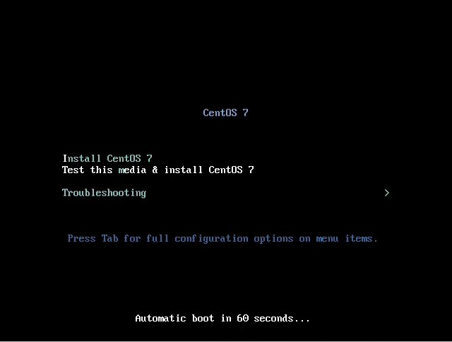ins.

During the installation process, it is necessary to select a virtual disk as a place for OS, create a user account and set a root password. After the installation is complete, you need to select the bootloader, log in to your account. The operating system is installed and ready to work.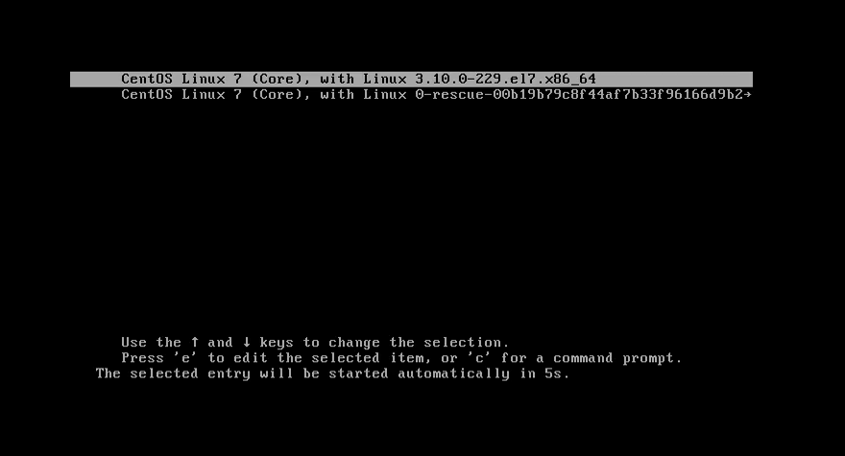

***4. Створіть другу віртуальну машину та виконайте для неї наступні дії:***

1) The process of installing CentOS without a built-in GUI is identical, except that after installing the OS, we see the console instead of the GUI.

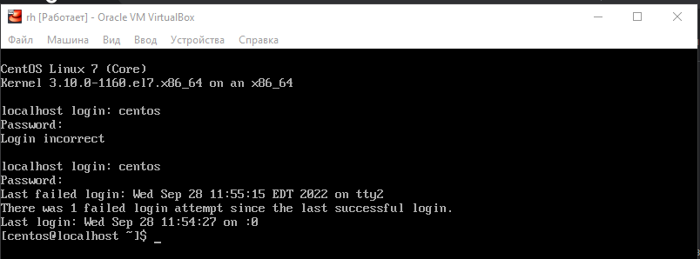

2) To install the GNOME graphical shell on a virtual machine, several actions must be taken. First, we need to connect the Internet to our virtual machine. Run the **nmtui** command, then select "IPv4 CONFIGURATION - AUTOMATIC", turn on "Automatically connect". Close the window, enter the **systemctl restart network** command. Restart the OS, check the connection with the **nmcli d** command.

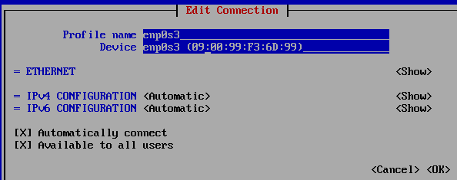

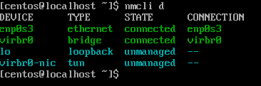

Now, execute the command **sudo yum group list hidden**, find the name of the required object in the list - in our case, it is GNOME. Execute command **sudo yum group install GNOME**, after which the installation of the GNOME graphical shell will begin. After the installation is complete, enter the **systemctl set-default graphical.target** command to start in graphical mode, restart the OS with the **reboot** command. The graphical shell is installed.

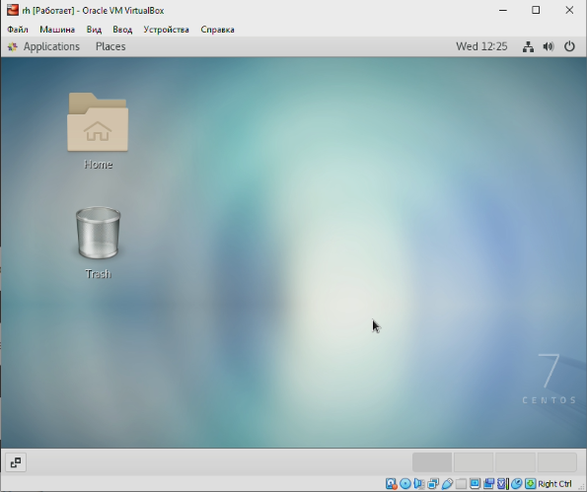

3) The process of installing another graphical shell is almost identical to the previous point. KDE was chosen as the second graphical shell. Comparison of GNOME and KDE:

GNOME is generally regarded as streamlined and less resource-intensive than KDE, but, on the other hand, KDE offers a more user-friendly environment, especially for those used to Windows as an operating system. For example, GNOME no longer offers users a true “minimize” option for open panels – something that Windows-acclimated users will likely miss – while KDE does. GNOME operates on a 6-month release cycle that sees a new version released twice each year. KDE utilizes a dual release schedule that differentiates between major and minor releases; major releases generally take around 5 months from announcement to release, while minor ones take roughly 2 months. KDE is best choice for customization – you can change theme, color, workspace effects, window management, and more without the need for any particular application/extension. As for GNOME, you do not get a lot of out-of-the-box controls. Instead, you will have to rely on GNOME Tweaks or extensions to make some changes. But, yes, you can customize the experience to a good extent. Also, GNOME offers extensions to add more functionality to your current configuration - You can head to GNOME’s shell extension website to explore options. GNOME extensions make it easy to do a bunch of stuff. There are all kinds of extensions to improve your workflow and make things easy. On the other hand, KDE offers a bag full of add-ons, widgets, and application add-ons as well. Unlike GNOME’s inconvenient way of adding extensions from a browser (using another browser extension), you can access KDE’s add-ons using the Discover software center directly.

If you want simplicity, performance, and numerous options, KDE should be an obvious choice.

If you want a modern look and do not mind the different layout) GNOME can be a fantastic variant.