**Work-Case №3**

***1. В робочому середовищі віртуальної машини Virtual Box, VMWare***

***Workstation (або інший на Ваш вибір) необхідно виконати:***

*Готував матеріал студент Нестолій Н.*

OS cloning. To clone the OS in the Oracle VM Virtual Box hypervisor, you need to click on the name of the virtual machine, select "clone", select the name and path, select the type of cloning.

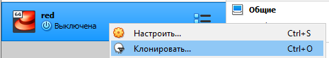

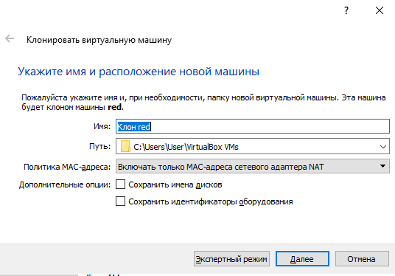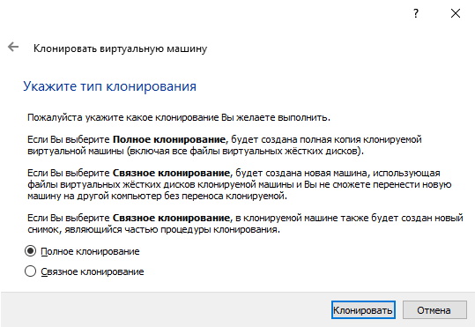

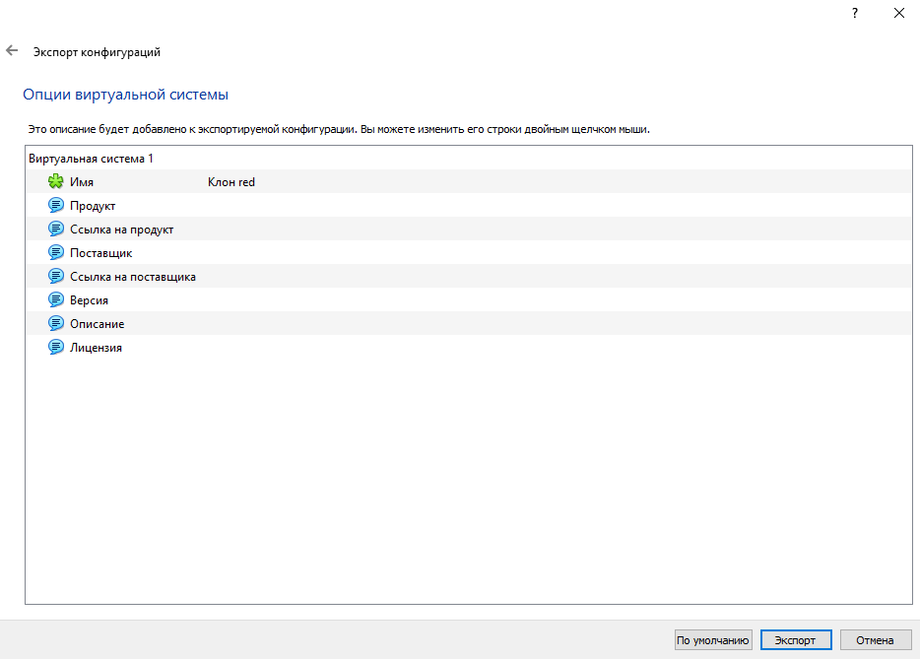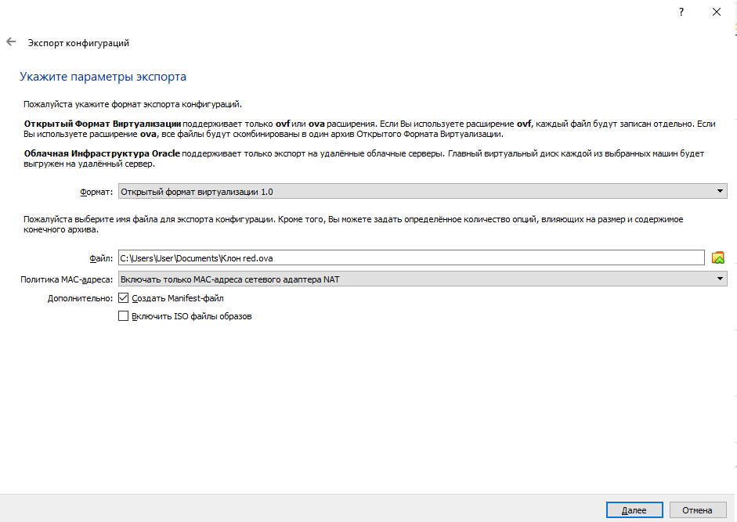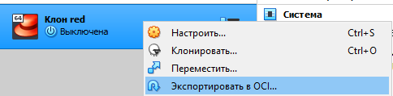 Export cloned OS. In order to export the OS, it is necessary to click on the virtual machine and select "Export to OCI", select the virtualization format, set the name of the exported file and click "export".

***2. В ході роботи одна робоча віртуальна машина може взаємодіяти з іншою. Для цього необхідно між ними розгорнути мережу. Опишіть які типи організації мережевих з’єднань підтримуються в середовищі віртуальних машин, в чому особливість кожного з них:***

*Готувала матеріал студентка Усенко С.*

1) Network Address Translation (NAT) is the simplest way of accessing an external network from a virtual machine. Usually, it does not require any configuration on the host network and guest system. For this reason, it is the default networking mode in Oracle VM VirtualBox.

A virtual machine with NAT enabled acts much like a real computer that connects to the Internet through a router. The router, in this case, is the Oracle VM VirtualBox networking engine, which maps traffic from and to the virtual machine transparently. In Oracle VM VirtualBox this router is placed between each virtual machine and the host. This separation maximizes security since by default virtual machines cannot talk to each other.

The disadvantage of NAT mode is that, much like a private network behind a router, the virtual machine is invisible and unreachable from the outside internet. You cannot run a server this way unless you set up port forwarding.

2)Bridged Networking. With bridged networking, Oracle VM VirtualBox uses a device driver on your host system that filters data from your physical network adapter. This driver is therefore called a net filter driver. This enables Oracle VM VirtualBox to intercept data from the physical network and inject data into it, effectively creating a new network interface in software. When a guest is using such a new software interface, it looks to the host system as though the guest were physically connected to the interface using a network cable. The host can send data to the guest through that interface and receive data from it. This means that you can set up routing or bridging between the guest and the rest of your network.

3) Host-only networking can be thought of as a hybrid between the bridged and internal networking modes. As with bridged networking, the virtual machines can talk to each other and the host as if they were connected through a physical Ethernet switch. As with internal networking, a physical networking interface need not be present, and the virtual machines cannot talk to the world outside the host since they are not connected to a physical networking interface.

When host-only networking is used, Oracle VM VirtualBox creates a new software interface on the host which then appears next to your existing network interfaces. In other words, whereas with bridged networking an existing physical interface is used to attach virtual machines to, with host-only networking a new loopback interface is created on the host. And whereas with internal networking, the traffic between the virtual machines cannot be seen, the traffic on the loopback interface on the host can be intercepted.

Host-only networking is particularly useful for preconfigured virtual appliances, where multiple virtual machines are shipped together and designed to cooperate. For example, one virtual machine may contain a web server and a second one a database, and since they are intended to talk to each other, the appliance can instruct Oracle VM VirtualBox to set up a host-only network for the two. A second, bridged, network would then connect the web server to the outside world to serve data to, but the outside world cannot connect to the database.

4) Internal Networking is similar to bridged networking in that the VM can directly communicate with the outside world. However, the outside world is limited to other VMs on the same host which connect to the same internal network.

Even though technically, everything that can be done using internal networking can also be done using bridged networking, there are security advantages with internal networking. In bridged networking mode, all traffic goes through a physical interface of the host system.

Internal networks are created automatically as needed. There is no central configuration. Every internal network is identified simply by its name. Once there is more than one active virtual network card with the same internal network ID, the Oracle VM VirtualBox support driver will automatically wire the cards and act as a network switch. The Oracle VM VirtualBox support driver implements a complete Ethernet switch and supports both broadcast/multicast frames and promiscuous mode.

***3. Розгорніть мережу між вашою робочою ОС та її клоном (завдання 1):***

*Готував матеріал студент Титов О.*

1) Базові networking commands.

- ifconfig (interface configurator) command is used to initialize an interface, assign IP Address to interface and enable or disable interface on demand.

- Ping (Packet INternet Groper) command is the best way to test connectivity between two nodes. Whether it is Local Area Network (LAN) or Wide Area Network (WAN).

- traceroute is a network troubleshooting utility that shows the number of hops taken to reach a destination also determines packets traveling path. Below we are tracing the route to the global DNS server IP Address and able to reach destination also shows the path of that packet is traveling.

- Netstat (Network Statistic) command displays connection info, routing table information, etc. To display routing table information use option as -r.

- nslookup command is also used to find out DNS-related queries. The following examples show A Record (IP Address) of tecmint.com.

- route command also shows and manipulates the ip routing table. To see the default routing table in Linux, type the following command.

- host command to find a name to IP or IP to name in IPv4 or IPv6 and also query DNS records.

- ARP (Address Resolution Protocol) is useful to view/add the contents of the kernel’s ARP tables. To see the default table use the command as.

- ethtool is a replacement for mii-tool. It is to view, setting speed and duplex of your Network Interface Card (NIC). You can set duplex permanently in /etc/sysconfig/network-scripts/ifcfg-eth0 with ETHTOOL_OPTS variable.

- The Nmcli and Nmtui tools are used to configure network settings and also used to manage network devices, create, modify, activate/deactivate, and delete network connections in Linux systems.

*Готував матеріал студент Нестолій Н.*

2) In order for both virtual machines to be on the same network and have access to the Internet, you need to go to the settings and change your connection type to bridged in the "network" tab. Demonstration of work:

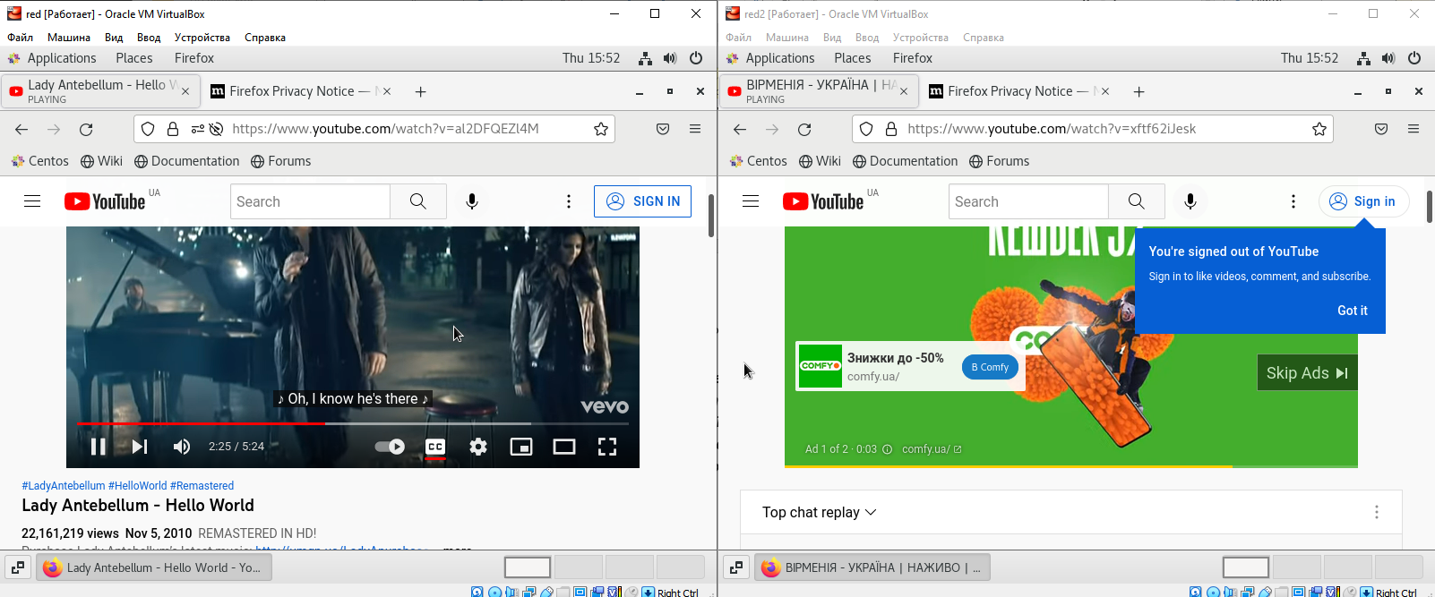

3) Exchange of messages between two OS. To test the communication between the two OSes, I used the **ifconfig** command, checked the IP addresses of the virtual machines, then pinged from one machine to the other - everything works without problems. For a final check, I used the netcat command - first on one machine I typed **nc -l 55555**, on the other - **nc 192.168.0.15 55555**, which allowed me to use the text field as some kind of lan messenger.

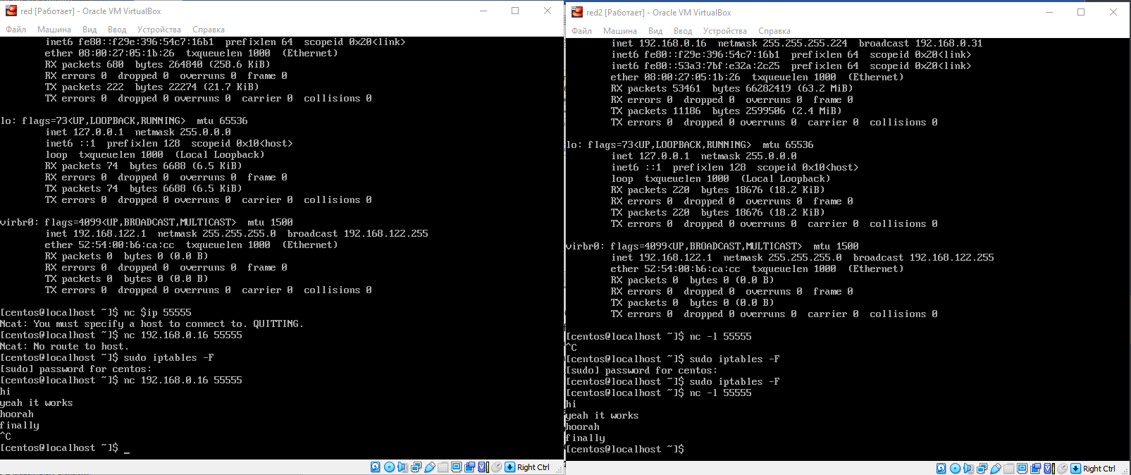

4) Network folder. To create a network folder on centOS 7, you need to use the Samba program, which is available in the standard centOS repository. Execute the command to install Samba - sudo yum install samba samba-client. After completion installation, start Samba services and enable their automatic start when the OS boots (**sudo systemctl start smb.service , sudo systemctl start nmb.service , sudo systemctl enable smb.service , sudo systemctl enable nmb.service**)To create a new user named josh, use the following command:

**sudo useradd -M -d /samba/josh -s /usr/sbin/nologin -G sambashare josh**

Create the user’s home directory and set the directory ownership to user josh and group sambashare:

**sudo mkdir /samba/josh**

**sudo chown josh:sambashare /samba/josh**

The following command will add the setgid bit to the /samba/josh directory so the newly created files in this directory will inherit the group of the parent directory. This way, no matter which user creates a new file, the file will have group-owner of sambashare. For example, if you don’t set the directory’s permissions to 2770 and the sadmin user creates a new file the user josh will not be able to read/write to this file.

**sudo chmod 2770 /samba/josh**

**sudo smbpasswd -a josh**

You will be prompted to enter and confirm the user password. Once the password is set, enable the Samba account by typing:

**sudo smbpasswd -e josh**

Now you can use command line or GUI interface to access shared folder:

Command line:

The syntax to access a Samba share is:

**mbclient //samba_hostname_or_server_ip/share_name -U username**

(my example)

**smbclient //192.168.0.16/josh -U josh**

GUI:

Open Files and click on “Other Locations” in the sidebar. In “Connect to Server”, enter the address of the Samba share in the following format smb://samba_hostname_or_server_ip/sharename. You will be prompted to enter the username and password. Enter them, click «connect». Now you can see files on this server.

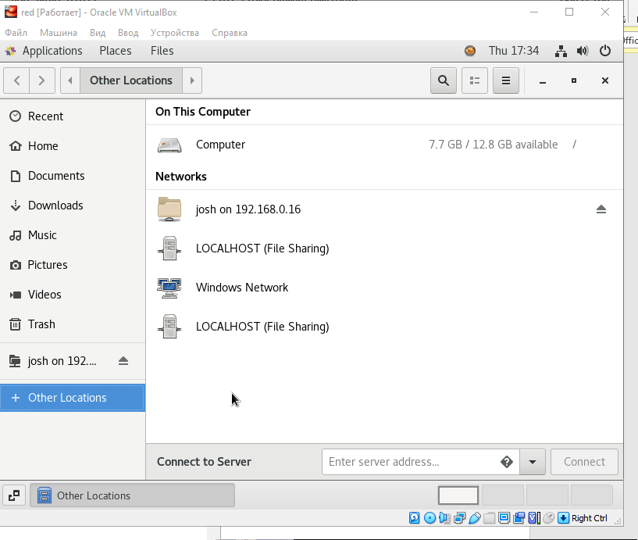

***4. Яким чином можна організувати обмін інформацією між вашою основною ОС (наприклад Windows) та віртуальними ОС? Скопіюйте довільний аудіо-файл з вашої основної ОС на робочий стіл віртуальної ОС та її клона. Як зробити зворотну дію, коли треба документ з робочого столу віртуальної ОС скопіювати до вашої основної робочої ОС?***

VirtualBox presents a shared folder on the host computer as a shared network drive or as a special extension of the file system to the guest computer’s operating system. So you’ll want to designate that folder on the bare metal computer for it to use.

You can assign different shared folders to each virtual machine guest. It can be a folder that already exists or it can be one you’ve created especially for this purpose. In either case, once you’ve decided which folder you want to share with the virtual machine, we have to select and mount it. Click on the Devices menu and then Shared Folders>Shared Folder Settings.

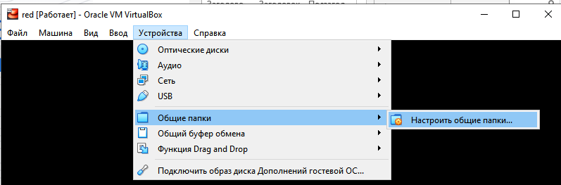

In this settings menu, click the blue icon to add a new shared folder. Select the folder path dropdown and choose other. Choose the folder you want to share and click Select Folder. Select auto-mount and then click OK. Then click OK again. You have created shared folder that will be detected and work without any problems on most OS. However, to use this on CentOS, you should do some extra steps.

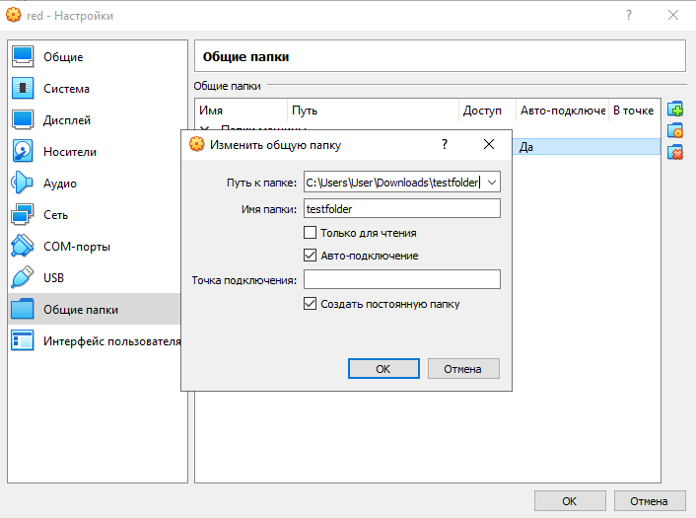

First, you must install the Guest Additions. Without installing this software, your guest will not be able to recognize the necessary vboxsf file system. After pressing this button, boot OS, check your file manager and run the new ISO file. Once the installation is completed, use command line to add your user to the vboxsf group

**sudo usermod -aG vboxsf $(whoami)**

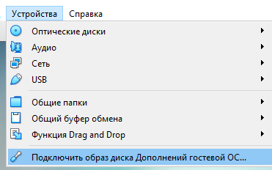

Next, you need to mount the shared folder with the command command **sudo mount -t vboxsf testfolder**. Reboot your OS, now you can see shared folder between your host OS and guest OS. OracleVM shared folder works in both ways – you can add files from guest Os to host os and vice verca.

