**Work-Case №4**

***1. В ході роботи досить часто виникає необхідність встановлювати нові програми та додатки. Для цього необхідно в терміналі вміти працювати з менеджерами пакетів:***

*Готувала матеріал студентка Усенко С.*

*- Дайте розгорнуте визначення таким поняттям як «пакет» та «репозиторій».*

A Linux repository is a storage location that contains essential and popular software for different Linux distributions and, each distribution has its own official repositories (also called standard-repositories). You can manage many packages (software) supported by your distribution and your system can install software from it.

A package is a compressed software archive file that contains all the files that comes with a software application delivers any kind of functionality, this can be any kind of command line utility,GUI application or a software library.

*- Надайте короткий огляд існуючих менеджерів пакетів у Linux. Охарактеризуйте їх основні можливості.*1) DPK ( Debian Package Management System) - Dpkg is a base package management system for the Debian Linux family, it is used to install, remove, store and provide information about .deb packages. It is a low-level tool and there are front-end tools that help users to obtain packages from remote repositories and/or handle complex package relations

2) APT (Advanced Package Tool) - more advanced front-end for dpkg (Debian Package), the lowest-level package management system for Debian-based Linux distributions. APT is a powerful command-line package management tool providing an interface for better interactive usage. As with dpkg, APT can install, remove, and build packages.The advanced functionality of APT is that it can update your packages and automatically install dependencies. It is able to automatically install and configure programs for UNIX-like operating systems from both pre-compiled packages and source codes. It also provides command-line tools for searching, managing, and querying information about packages.

3) RPM (Red Hat Package Manager) - is the Linux Standard Base packing format and a base package management system created by RedHat. Being the underlying system, there several front-end package management tools that you can use with it.  
  
4) YUM (Yellow Dog Updater) - most popular choice as front-end for RPM, the basic package management software for RHEL operating systems. YUM was designed to make it easier to work with distribution updates by keeping track of dependencies between packages. The command-line interface is used to work with YUM, but there are tools that provide a graphical interface for the YUM functionality. YUM allows users to configure automated software updates and dependency resolution. The YUM manager works with package repositories from the distribution manufacturer or third-party authors. It is possible to create local or offline copies of the repositories or access them via the Internet.

5) DNF (Dandified Packaging Tool) - a package manager that installs, updates, and removes packages on RPM-based Linux distributions. It is a more advanced version of the YUM manager and intended to be the replacement for YUM in RPM-based systems. DNF was created to improve YUM in terms of performance, quality of resolving dependency conflicts, and simplified integration with other applications. DNF was introduced in Fedora 18. Now, it is the default package manager of Fedora 22, CentOS8, and RHEL8.

***2. Визначте який менеджер пакетів використовує ваш дистрибутив Linux. Опишіть основні команди для роботи з ним:***

*Готував матеріал студент Нестолій Н.*

*- Пошук, скачування та установка необхідних пакетів, яких у Вашій системі немає (зі сховища по замовчуванню, з нового репозиторію тощо).*

On centos 7 using YUM, downloading and installing of needed packages is really easy. To list all available packages, use command **yum list** available. If you trying to find something certain, use **yum search [your package]**. If you want to install something from the default repositories, simply use **yum install [something].** If you want to install something from the local files, use **yum localinstall [downloaded package]**.

*- Перегляд інформації про встановлені та доступні пакети.*

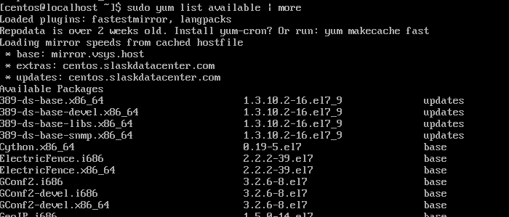To check installed packages, use **yum list installed** command. If you want to check packages, available for installation, use **yum list available** command.

*- Видалення непотрібних або застарілих пакетів.*

To remove any installed package, use **yum remove [package]**. If you want to remove group of packages, use **yum group remove [group]**. You can also remove package with all dependences using **autoremove** – **yum autoremove [package]**. -   
*- Оновлення менеджера пакетів.*

First of all, you need to check if there are any available updates with **yum check-update**. 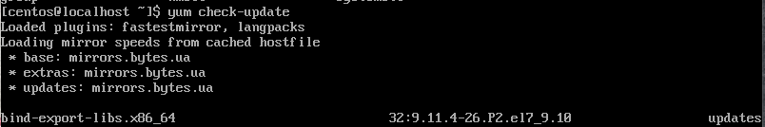

After that, you can use **yum update** to update every package of your package manager or **yum update [some package]** to update some part of it. 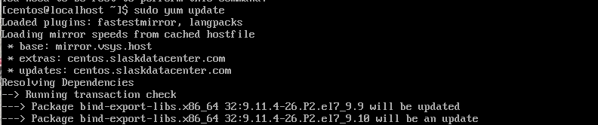

***3. Встановіть у терміналі через менеджер пакетів на свою систему:***

*- Новий відео- чи аудіоплейер.*

On my example, I will install VLC player. First of all, I need to install EPEL repository, which has a variety of different packages, using **sudo yum install epel-release.**

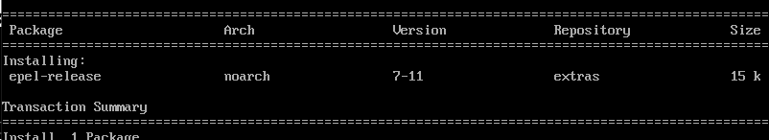

After that, I installed RPM Fusion to get access to third-party packages, using **sudo yum install** [**https://download1.rpmfusion.org/free/el/rpmfusion-free-release-7.noarch.rpm**](https://download1.rpmfusion.org/free/el/rpmfusion-free-release-7.noarch.rpm).

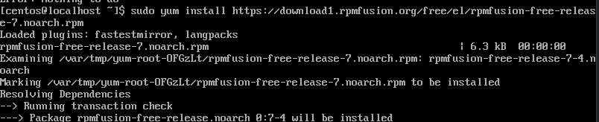

Finally, im able to install VLC packages simply by using **sudo yum install vlc** due to RPM.

After that, i have restarted my virtual machine and launched it in graphical mode. VLC player can be found under the **Applications,** **Sound & Video**. 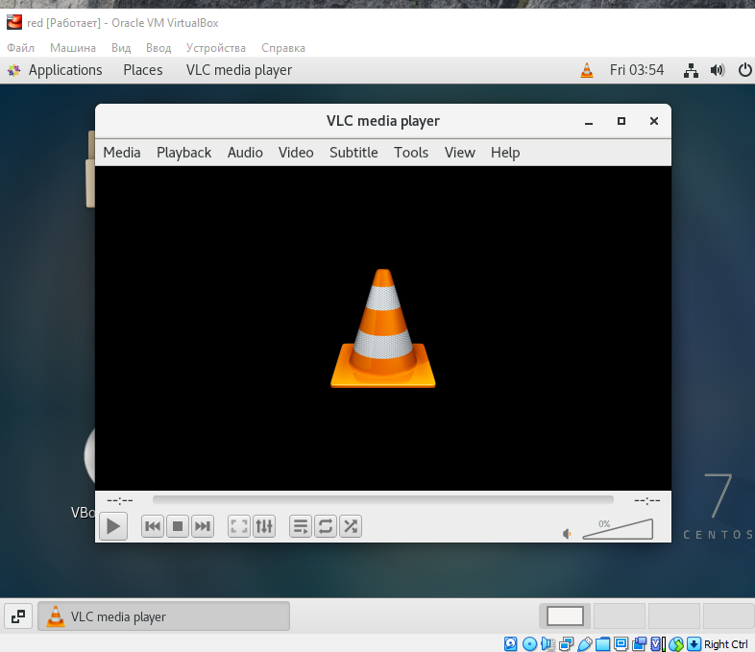

*- Середовище для мови програмування, що ви вивчаєте.*

We are studying C++ using Visual Studio Code, so I will try to install it on CentOS 7. Process of installing is slightly different due to age of this operational system, so:

First of all, we need to import Microsoft GPG key using **sudo rpm --import** [**https://packages.microsoft.com/keys/microsoft.asc**](https://packages.microsoft.com/keys/microsoft.asc). After that, we need to to create repo and change it contents using   
**sudo sh -c 'echo -e"[code]\nname=Visual StudioCode\nbaseurl=https://packages.microsoft.com/yumrepos/vscode\nenabled=1\ngpgcheck=1\ngpgkey=https://packages.microsoft.com/keys/microsoft.asc" > /etc/yum.repos.d/vscode.repo'**

Then update the package cache and install the package using **yum check-update** and **sudo yum install code** 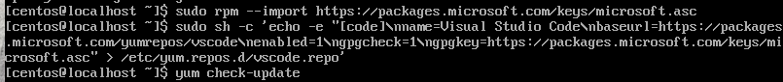

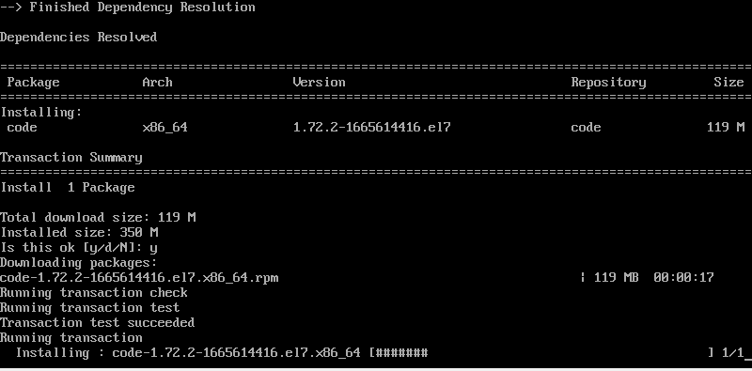

Now we can restart our virtual machine, launch it in the graphical mode and check Visual Studio in **Applications**, under **Programming**:

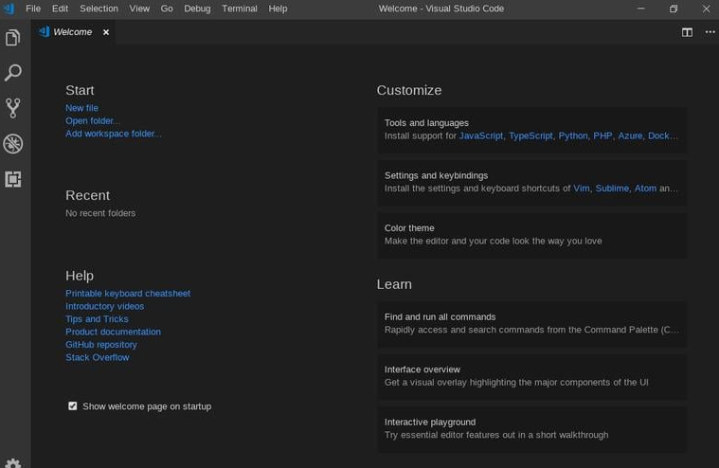

***4. Яким чином можна встановити нові програми через магазини додатків та менеджери пакетів у графічному середовищі. Наведіть свої приклади.***

*Готував матеріал студент Титов О.*

On linux, apps and programs are installed much like on the android or iOS – you can use different software distribution programs to install games, video and audio players, programs and other software. Different distributions of linux have different programs: For example, on Ubuntu its Ubuntu Software Centre: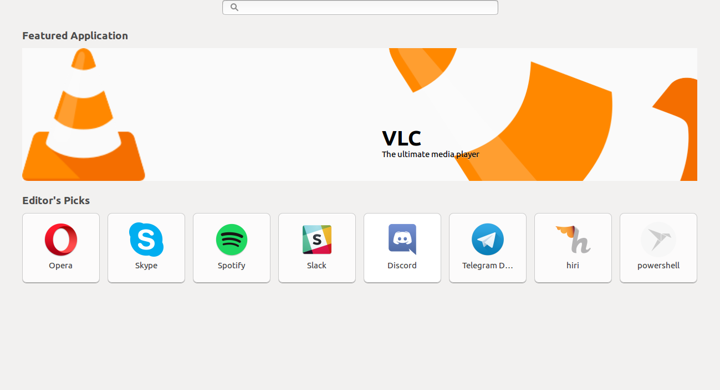

Process of downloading and installing is really simple and straightforward: find your program using search bar, select it, click on «install» - process of downloading and installing is automatic, you don’t need to change everything. After app has been installed, you can launch it and use as you would normally do on Windows or any other OS.