Programming Fundamentals- Fall 2025

Space Xtrive
User Interface Report



Version 1.0

Submitted By: 2025-CS-1(Section _A)
Instructor: Sir Kamran Mustafa

Department of Computer Science
University of Engineering and Technology Lahore

Contents
Project Details 3
Project Summary 3
Project Features 3
Interfaces Details 4
Main Menu 4
Start New Game 4
Continue Game 6
View Instructions 8
Exit Game 9
Game Interface 11
Player Movement 11
Combat System 15
Pause Menu 19
Game Over Screen 22
Purpose of The Screen 22
Input/Output 22
Validation 22
Screenshot 23
Victory Screen 24
Purpose of The Screen 24
Input/Output 24
Validation 25
Screenshot 26
Appendix 27
Color Code Reference 27
Keyboard Control Summary 27
File I/O Format 28

Project Details

Project Summary
Space Xtrive is a Windows console-based, single-player action-shooter game developed in C++. The project demonstrates comprehensive game development principles including state management, collision detection, real-time input handling, and persistent data storage through file I/O operations.
The game follows a player character navigating through a scrolling battlefield while collecting coins to earn points and defeating three progressively advancing enemies across three difficulty levels. Players control a spaceship character and must eliminate enemy spacecraft to progress through levels. Each level introduces additional enemies with increasingly complex movement patterns, requiring players to develop adaptive combat strategies.
The core gameplay loop involves simultaneous management of player movement, enemy positioning, projectile trajectories, collision detection, and score tracking at a 50 FPS refresh rate. The game maintains state consistency through automatic save functionality, allowing players to pause, exit, and resume their progress seamlessly.
The project utilizes Windows API for console manipulation, including cursor positioning, color management, and event handling. Dynamic data structures (vectors and 2D arrays) manage up to 100 concurrent projectiles per entity. The game implements a modular architecture with 40+ functions, each handling specific responsibilities such as rendering, collision detection, input validation, and game state persistence.
Technical Highlights: - Real-time game loop with fixed timestep mechanics - AABB (Axis-Aligned Bounding Box) collision detection - Sprite-based rendering with ASCII art assets - Frame-based animation system with configurable delays - CSV-based save game serialization - Three-tier level progression system with enemy health tracking - Invincibility mechanics with visual feedback - Comprehensive input validation and error handling
This project serves as a capstone for fundamental C++ programming concepts, integrating object-oriented principles, memory management, data structures, and system-level API usage into a cohesive, interactive application.

Project Features
- Three-Level Progression System: Progressive difficulty with additional enemies unlocked at each level
- Real-Time Combat: Dual projectile systems (player bullets and enemy fire) with frame-based movement
- Animated Coin System: Four-frame coin animation with collision-based scoring mechanism
- Player Health Management: 100 HP starting health with damage mechanics (20 HP per collision, 10 HP per enemy bullet)
- Invincibility System: 3-second post-respawn invincibility with blinking visual effect
- Save/Load Functionality: Persistent game state storage supporting mid-game pauses and session resumption
- Multi-Enemy AI: Three distinct enemy types with unique movement patterns (horizontal, diagonal-bouncing, advanced diagonal)
- Console-Based UI: Color-coded interface with dynamic score/health/level display
- Keyboard Controls: Arrow key movement with SPACE firing and ESC pause
- Input Validation: Comprehensive input verification with user-friendly error handling
- Instructions Menu: In-game tutorial explaining controls and objectives
- Main Menu Navigation: Options for new game, continue previous session, view help, or exit
- Dynamic Rendering: Real-time sprite updates with collision-aware display management
- Audio Feedback: Bell character sound effect on coin collection

Interfaces Details

Main Menu
The Main Menu is the entry point to Space Xtrive, presented immediately after the welcome screen. It provides users with four primary options to control their gaming experience.

Start New Game

Purpose of The Menu
The “Start New Game” option initializes a fresh gameplay session with default parameters. Selecting this option resets all game variables to their initial state, clears previous progress, and launches a new game arena from Level 1 with a player positioned at the center-bottom of the screen.
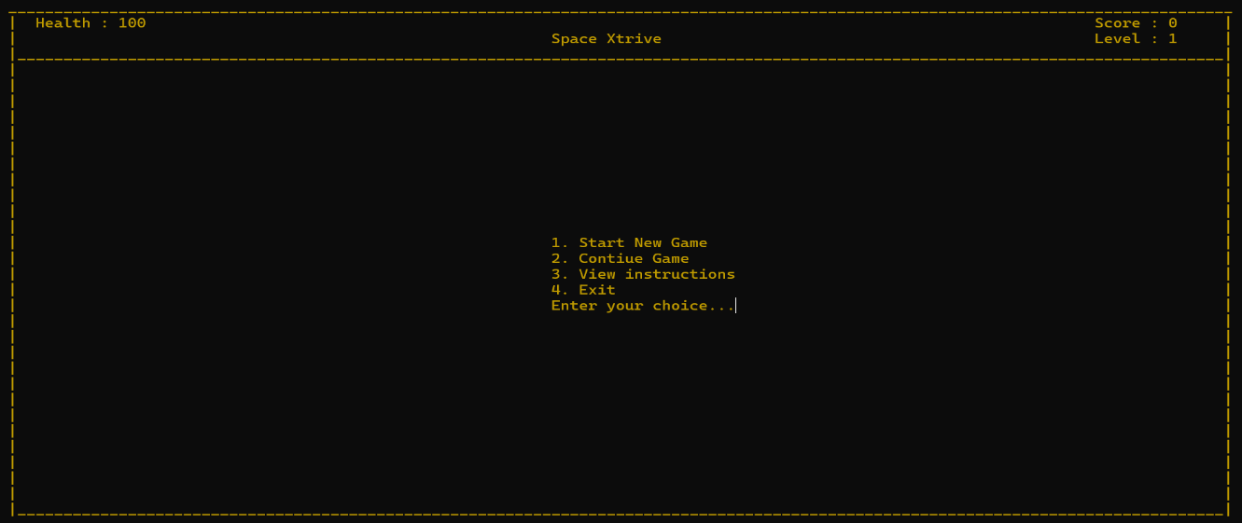

Input/Output
Input Format:
User Input: 1 (Integer selection from main menu)
Output Format:
Console Screen:
[Maze border and arena displayed]
[Player character rendered at center-bottom]
[Score: 0 Level: 1 Health: 100]
[Game ready for input]
Console Display After Selection:

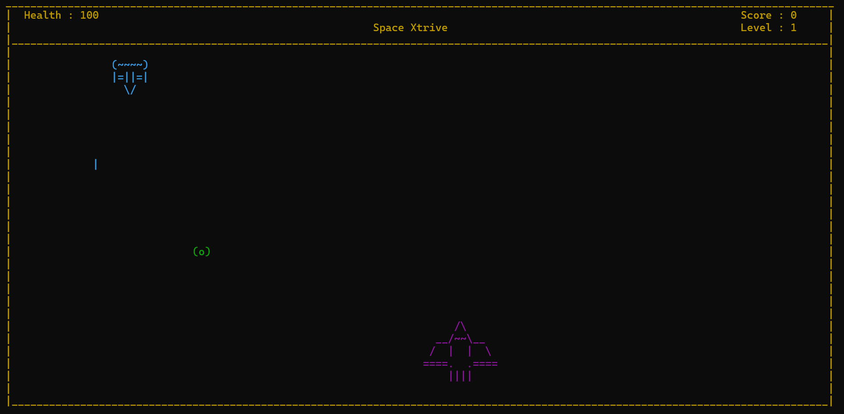

Validation
Input Validation Rules: 1. Input must be integer value “1” 2. No alphabetic or special characters accepted 3. Empty input triggers re-prompt with error message 4. Input range: Must be between 1-4 (valid menu options) 5. Non-numeric characters rejected with: “Invalid Input! Please enter a number between 1 and 4”
Behavior on Wrong Input: - Scenario 1 (Non-integer input): “Please enter numbers only” displayed; cursor repositioned for retry - Scenario 2 (Out of range): “Please select option between 1 and 4” displayed; menu re-displays - Scenario 3 (Empty input): “Please enter a valid choice” displayed; cursor awaits new input
Variable Initialization on Successful Selection:
px = width / 2 [Player X-position]
py = height - 3 [Player Y-position]
health = 100 [Full health]
score = 0 [Reset score]
level = 1 [Level 1]
enemy1Health = 5, enemy2Health = 5, enemy3Health = 5
level2reached = false, level3reached = false
All bullet arrays reset to INT_MIN [Disabled state]

Continue Game

Purpose of The Menu
The “Continue Game” option loads a previously saved game session from file storage (game.txt). This feature enables players to resume gameplay at the exact state they left off, preserving player position, enemy positions, health, current level, and accumulated score.

Input/Output
Input Format:
User Input: 2 (Integer selection from main menu)
Output Format:
File Read Operation:
[Reads line 10 from game.txt containing saved state]
[Parses comma-separated values: px,py,ex1,ey1,ex2,ey2,ex3,ey3,level,health,score,e1hp,e2hp,e3hp]
Console Output:
[Game arena displays with restored positions]
[Score, Level, Health reflect saved values]
[All enemies positioned at saved coordinates]
Example Save File Format (game.txt line 10):
25,40,1,4,15,12,35,18,2,75,8,5,3,5
Meaning: Player at (25,40), Level 2, Health 75, Score 8
Enemy1 at (1,4) [5 HP], Enemy2 at (15,12) [3 HP], Enemy3 at (35,18) [5 HP]
Display After Successful Load:
==========================================
Space Xtrive - Game Resumed
==========================================
| |
| |
| Enemy1: [###] Spawned at (1,4)|
| |
| Enemy2: [###] Spawned at(15,12)|
| |
| [Coin: +] |
| |
| [Player Sprite] |
| |
|_____________________________________|
Score: 8 Level: 2 Health: 75
==========================================

Validation
Pre-Load Validation: 1. File existence check: Does “game.txt” exist in directory? 2. Line 10 availability: Is there a 10th line in file? 3. Data format verification: Does line contain exactly 14 comma-separated integers? 4. Range validation for each parsed value: - px, py: Within console bounds - level: Between 1-3 - health: Between 0-100 - Scores and health values: Non-negative integers
Error Handling & Behavior:
Error Scenario | Message | Outcome
File not found | “Save file not found. Starting new game…” | Defaults to Start New Game
Corrupted data | “Save file corrupted. Data mismatch.” | Defaults to Start New Game
Invalid level | “Level data corrupted. Resetting to Level 1” | Level reset to 1, other data restored
Out of bounds coordinates | “Position out of bounds. Recentering player” | Player repositioned to center
Negative health | “Health value invalid. Reset to 100” | Health reset to maximum
Parsing Function Details:
getFilePart(line, fieldNumber) extracts field at position fieldNumber
Example: getFilePart("25,40,1,4,15,12,35,18,2,75,8,5,3,5", 0) returns "25"
getFilePart("25,40,1,4,15,12,35,18,2,75,8,5,3,5", 8) returns "2" (level)
getFilePart("25,40,1,4,15,12,35,18,2,75,8,5,3,5", 9) returns "75" (health)

Screenshot
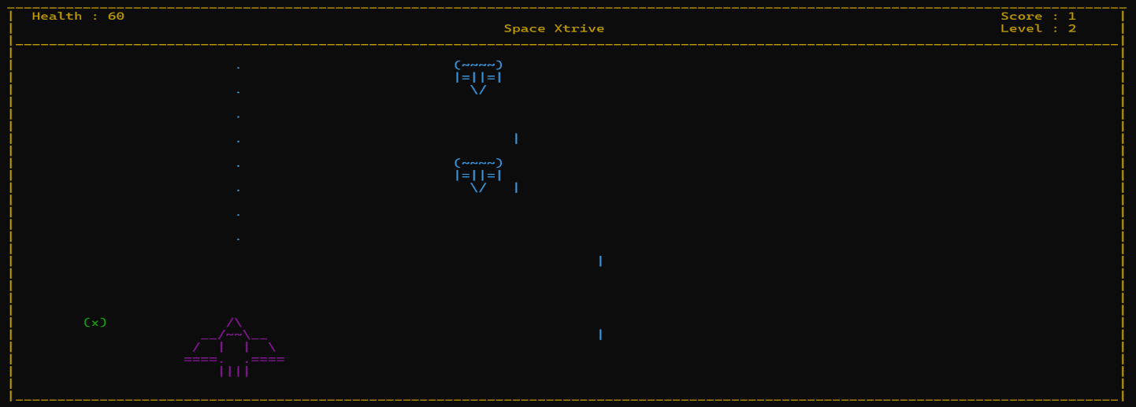

Console Output Line:
"Continue Game selected..."
"Loading saved game from file..."
"Game restored successfully!"

View Instructions

Purpose of The Menu
The “View Instructions” option displays an in-game tutorial explaining the game mechanics, control scheme, objectives, and gameplay tips. This option provides new players with essential information to begin gameplay without external documentation.

Input/Output
Input Format:
User Input: 3 (Integer selection from main menu)
Output Format:
Console Display - Instructions Screen:
[Instructions text displayed in light cyan color (code: 0B)]
[Centered on screen at coordinates (width/2 - 30, height/2 - 1)]
[Four instruction lines displayed]
[Prompt at bottom: "Press any key to continue..."]
Exact Display Content:
=========================================
GAME INSTRUCTIONS
=========================================
1. Instructions: Use arrow keys to move up, down, left and right
2. Spacebar to shoot, and 'esc' to quit.
3. Collect coins to increase your score. Avoid enemy fire and collisions.
4. Defeat all enemies to progress through levels. Good luck!
Press any key to continue...

Validation
Validation Rules: 1. Any keyboard input accepted to dismiss instructions (no validation required) 2. ESC key, SPACE, or any other key returns to main menu 3. No data entry validation needed for this menu 4. Timer-based dismissal optional (can be set to auto-close after 10 seconds if desired)
Behavior: - Instructions display for indefinite duration until user presses any key - No error states possible; display is read-only informational - Pressing any key clears instruction text and returns to main menu - Menu redrawn after instructions cleared

Screenshot
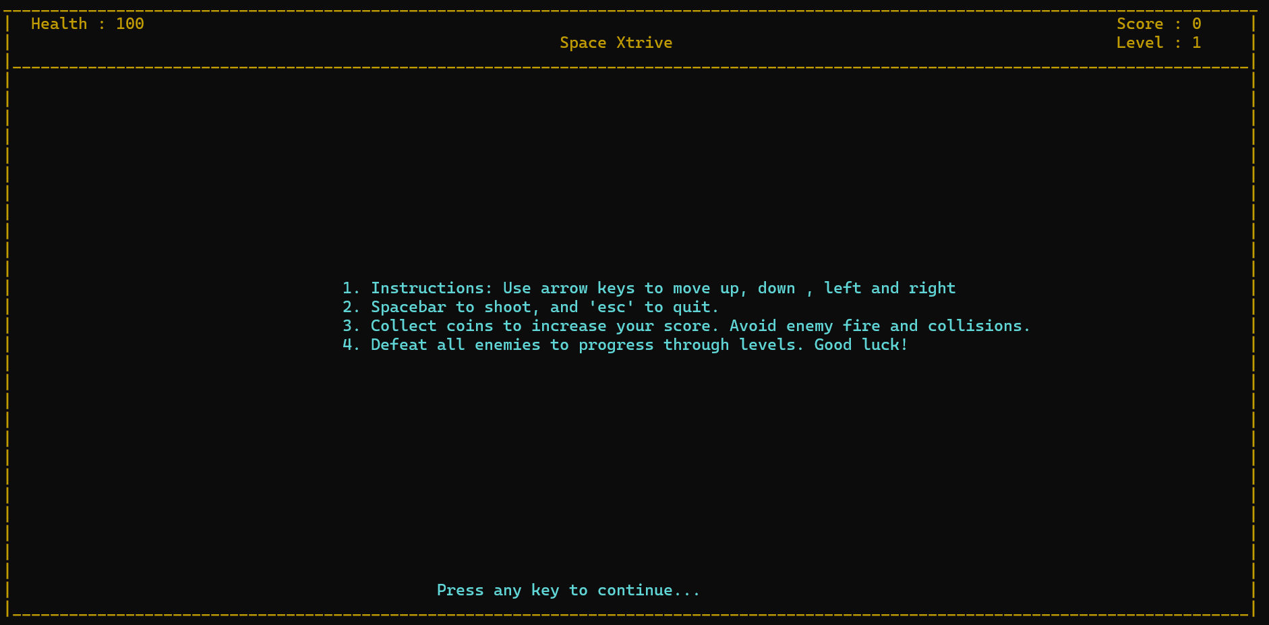
Menu returns to Main Menu screen

Exit Game

Purpose of The Menu
The “Exit Game” option terminates the application cleanly. Selecting this option closes the game window, restores the console to default settings, and returns control to the operating system without saving the current game state.

Input/Output
Input Format:
User Input: 4 (Integer selection from main menu)
Output Format:
Console Action:
[Cursor made visible (if hidden)]
[Console color reset to default (color code "07")]
[System clears screen]
[Program exits with code 0]
[Command prompt/terminal regains focus]
Display Before Exit:
=========================================
Space Xtrive - Exit Confirmed
=========================================
Game closing...
(Console window closes)
(Returns to Windows command prompt or desktop)

Validation
Validation Rules: 1. Input must be integer value “4” 2. No unsaved data warning required (design specification) 3. Immediate exit without confirmation prompt 4. Clean shutdown procedures executed: - Console cursor visibility restored - Text color reset to white (0x07) - All open file handles closed - Memory cleanup performed
Behavior on Selection:
Execution Sequence:
1. setcolor("04") [Red color for exit message]
2. Gameover() [Displays "Game Over." with 1000ms delay]
3. setcolor("07") [Reset to white]
4. showCursor() [Make cursor visible again]
5. exit(0) [Program terminates normally]
Data State on Exit: - Variables not persisted unless “Continue Game” was previously in use - Game state reset to defaults for next launch - File game.txt retains last saved session data

Screenshot
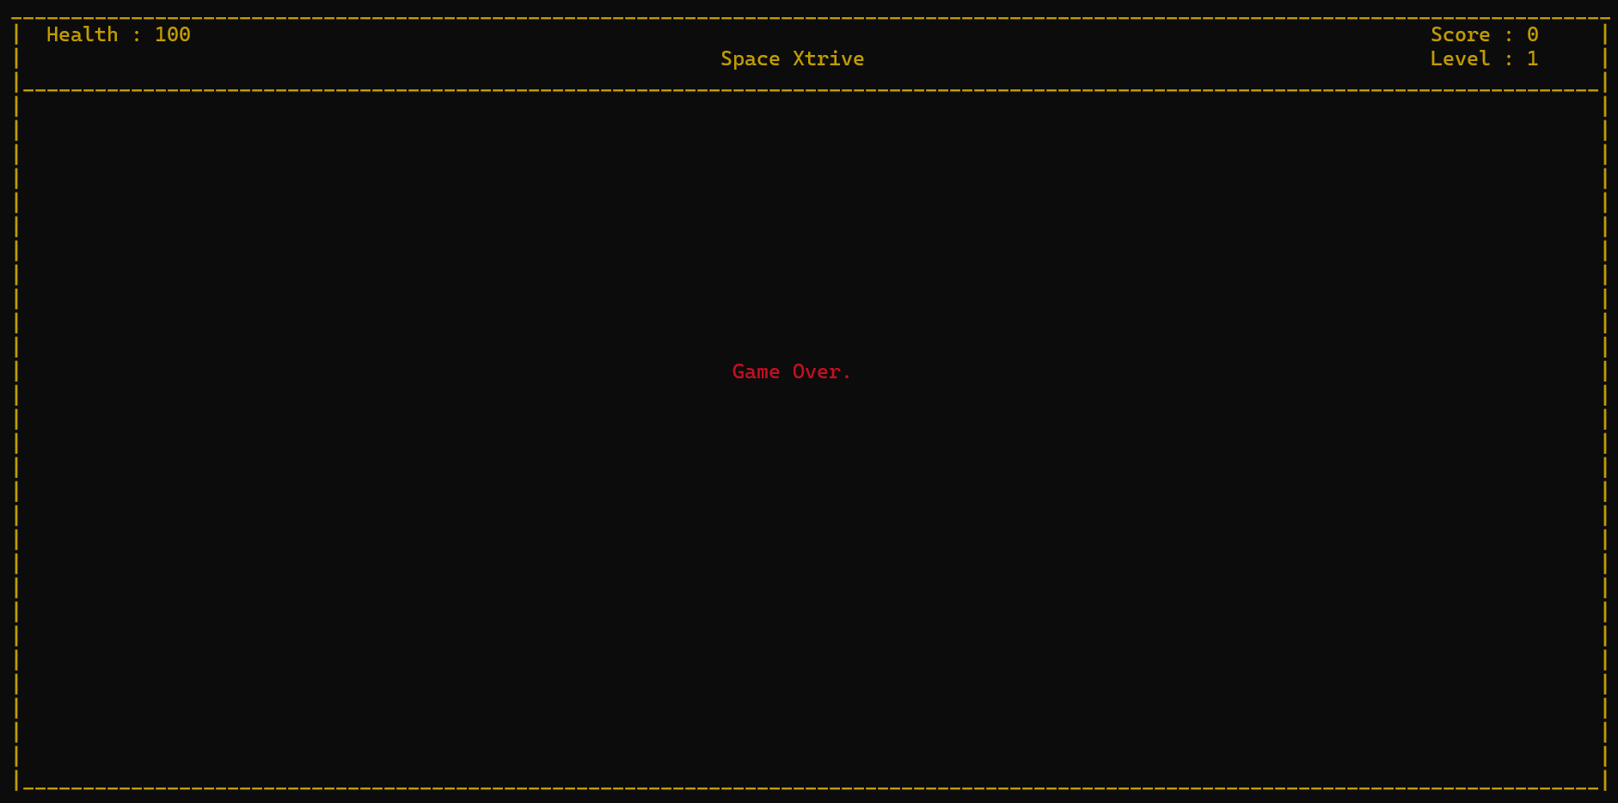
(1 second pause)
(Console window closes)
(Returns to command prompt)
C:\Users\username> _

Game Interface
The Game Interface is the main active gameplay environment where players interact in real-time. It consists of the arena display, player controls, and continuous feedback mechanisms.

Player Movement

Purpose of The Menu
The Player Movement system allows users to control the player character’s spatial position within the game arena using keyboard input. This mechanic forms the fundamental gameplay interaction, enabling collision avoidance, tactical positioning, and targeting.

Input/Output
Input Format:
Keyboard Input (Real-time, continuous):
UP Arrow → Decrease Y-coordinate (move up)
DOWN Arrow → Increase Y-coordinate (move down)
LEFT Arrow → Decrease X-coordinate (move left)
RIGHT Arrow → Increase X-coordinate (move right)
Detection Method: GetAsyncKeyState(VK_KEY) & 0x8000
(Checks key state every 20ms game tick)
Output Format:
Console Display Update:
[Player sprite erased from previous position]
[Player sprite rendered at new position]
[Screen refresh rate: ~50 FPS (20ms per frame)]
[Boundaries enforced simultaneously]
Position Constraints:
- X-axis: 1 < px < (width - 15) [Stays within left/right walls]
- Y-axis: 12 < py < (height + 2) [Stays within playable vertical area]
Movement Display Example:
Before Input (Player at center):
| |
| [Player] |
| [. |
|_____________________________________|
After UP Arrow Input (Player moved up):
| |
| [Player] |
| [. |
|_____________________________________|
After RIGHT Arrow Input (Player moved right):
| |
| [Player] |
| [. |
|_____________________________________|

Validation
Movement Validation Rules: 1. Boundary Checking: - Left boundary: px > 1 (minimum position) - Right boundary: px < width - 15 (account for sprite width) - Top boundary: py > 12 (playable area start) - Bottom boundary: py < height + 2 (below visual arena)
- Simultaneous Input Handling:
  - Multiple keys can be pressed simultaneously
  - Last valid key in polling sequence takes precedence
  - No input queue; state-based polling
- Respawn Movement Restriction:
  - During invincibility (3-second respawn): Slower movement delay (5ms minimum)
  - Normal gameplay: No delay imposed between movements
  - Diagonal movement possible (both horizontal and vertical keys held)
Error Handling & Constraints:
Scenario | Validation | Outcome
Movement beyond left boundary | px > 1 check fails | Movement rejected; position unchanged
Movement beyond right boundary | px < width - 15 check fails | Movement rejected; position unchanged
Movement above playable area | py > 12 check fails | Movement rejected; position unchanged
Movement below arena | py < height + 2 check fails | Movement rejected; position unchanged
Simultaneous opposing keys | Both evaluated | Last polled key takes effect
No key pressed | Idle state | Player remains stationary; sprite redrawn
Sprite Collision with Boundaries:
// Validation pseudocode
if ((GetAsyncKeyState(VK_RIGHT) & 0x8000) && px < width - 15)
{
erasePlayer(px, py);
px++; // Move right by 1 unit
printPlayer(px, py, ...); // Render at new position
}
else if ((GetAsyncKeyState(VK_LEFT) & 0x8000) && px > 1)
{
erasePlayer(px, py);
px--; // Move left by 1 unit
printPlayer(px, py, ...); // Render at new position
}
// Similar logic for UP/DOWN with different constraints

Screenshot
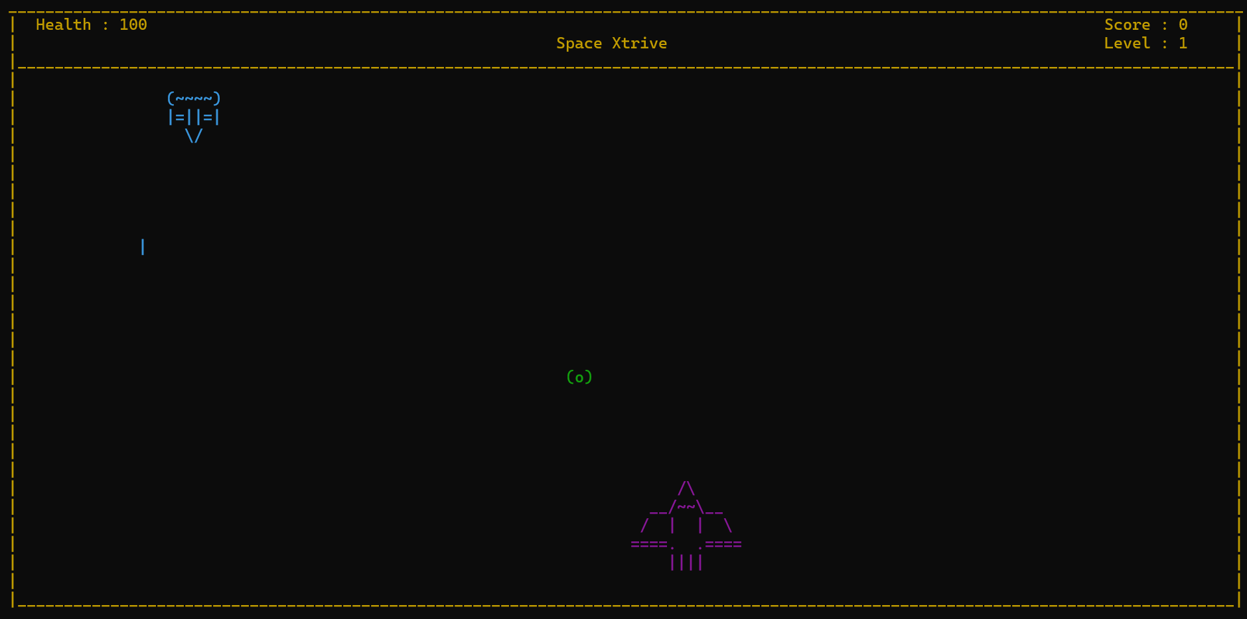
[Player Movement Demonstration]

(Player presses UP arrow)
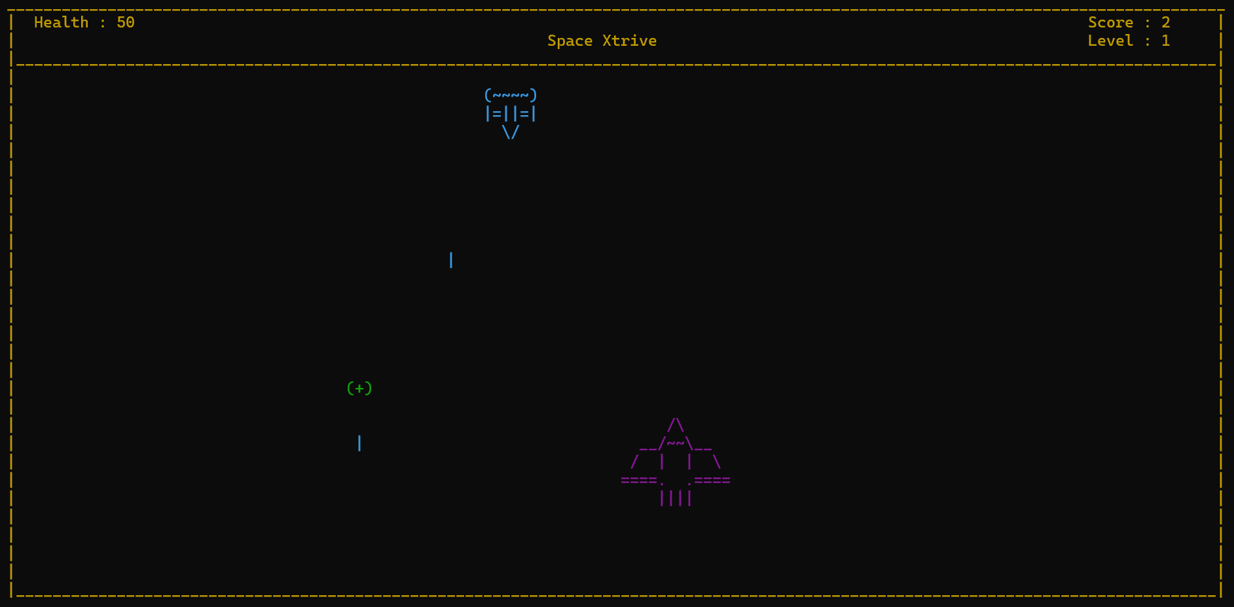
(Player presses RIGHT arrow)
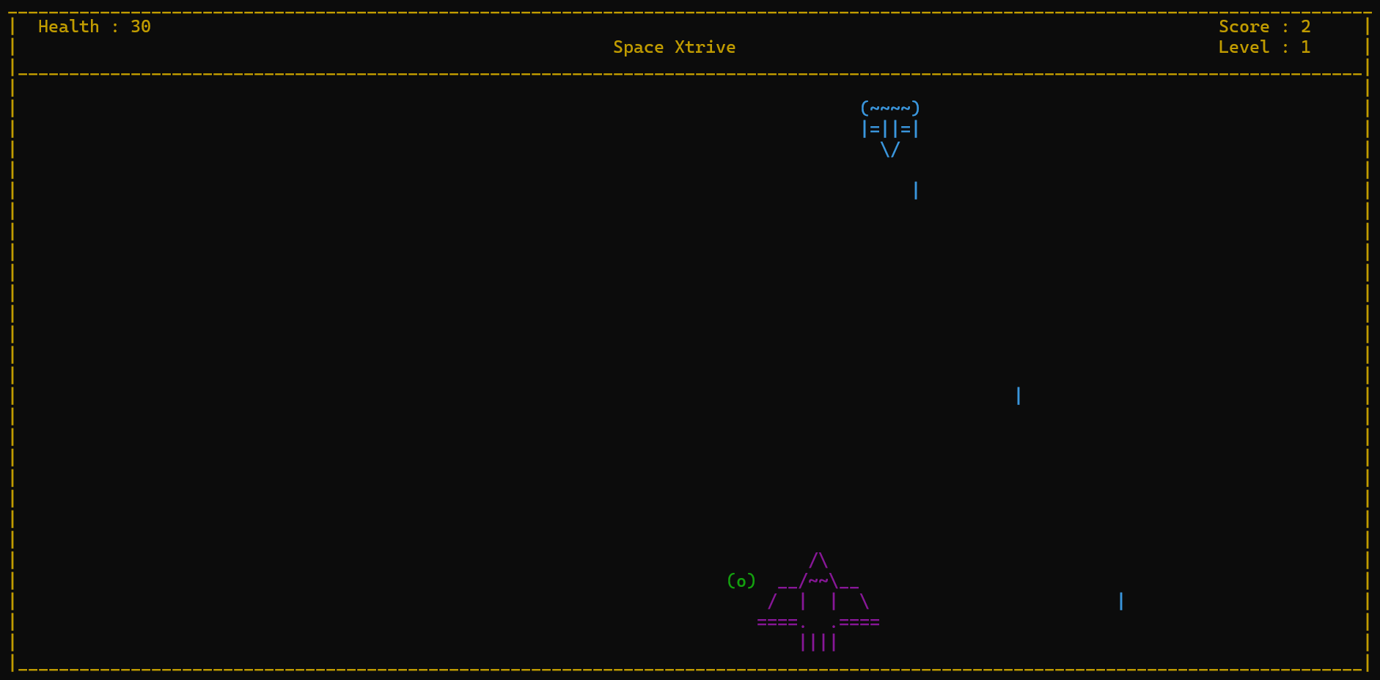
Score: 0 Level: 1 Health: 100
=========================================

Combat System

Purpose of The Menu
The Combat System manages projectile generation, movement, collision detection, and enemy damage calculation. This system enables players to defeat enemies by firing bullets and responding to incoming enemy fire, creating the core gameplay loop.

Input/Output
Input Format - Player Fire:
Keyboard Input: SPACEBAR
Detection: GetAsyncKeyState(VK_SPACE) & 0x8000
Fire Rate Limiting: Minimum 150ms between shots
Input Format - Enemy Fire:
Automatic Generation: Triggered when enemyfirecontrol counter >= 10
Active Enemies: All enemies with health > 0 and level requirement met
Frequency: Approximately every 1.5 seconds (10 game ticks at 150ms delay)
Output Format - Player Bullets:
Visual Representation: '.' (period character)
Spawn Location: (px + 7, py - 9) [Center of player sprite]
Movement Direction: Upward (Y decreases)
Movement Rate: 1 unit per game tick (~150ms)
Active Slots: Up to 100 concurrent bullets (bullets[2][100] array)
Display Pattern:
. ← bullet moving upward
. ← previous position
. ← previous position
[Enemy]
[Player]
Output Format - Enemy Bullets:
Visual Representation: '|' (pipe character)
Spawn Location: (ex + 3, ey + 3) [Center of enemy sprite]
Movement Direction: Downward (Y increases)
Movement Rate: 1 unit per game tick (~150ms)
Active Slots: Up to 100 concurrent bullets (enemybullets[2][100] array)
Display Pattern:
[Player]
|
|
|
[Enemy]
Collision Effects Display:
Player Bullet Hits Enemy:
[Before]
.
.
[Enemy Health: 5]
[After - Collision Detected]
[Enemy Health: 4]
(Bullet removed from play)
Enemy Bullet Hits Player:
[Before]
|
|
[Player Health: 100]
[After - Collision Detected]
[Player Health: 90]
(Bullet removed from play)
(Respawn sequence initiated after 3-second delay)

Validation
Player Projectile Validation:
Validation Rule | Condition | Action
Fire rate limit | Time since last shot < 150ms | Reject fire command; do nothing
Bullet array availability | No INT_MIN slot in bullets[2][100] | Discard shot (array full)
Valid Y boundary | Bullet Y-coordinate <= 4 | Remove bullet from play
Collision with Enemy 1 | AABB collision detected | Decrement enemy1Health; remove bullet
Collision with Enemy 2 | AABB collision detected | Decrement enemy2Health; remove bullet
Collision with Enemy 3 | AABB collision detected | Decrement enemy3Health; remove bullet
Enemy Projectile Validation:
Validation Rule | Condition | Action
Enemy 1 active | enemy1Health > 0 | Can fire
Enemy 2 active | enemy2Health > 0 AND level >= 2 | Can fire
Enemy 3 active | enemy3Health > 0 AND level >= 3 | Can fire
Bullet array availability | No INT_MIN slot in enemybullets[2][100] | Discard shot
Valid Y boundary | Bullet Y-coordinate >= height - 2 | Remove bullet from play
Collision with player | AABB collision detected AND !playerInvincible | Decrement health by 10
Player invincibility active | playerInvincible == true | Bullet passes through (visual only)
Bounding Box Calculations:
Player Bullet vs Enemy Collision:
Enemy Box: X [ex, ex+7], Y [ey+1, ey+4]
Bullet: Point (x, y)
Collision: x < (ex+7) && x > ex && y < (ey+4) && y > (ey+1)
Enemy Bullet vs Player Collision:
Player Box: X [px, px+12], Y [py-8, py-5]
Bullet: Point (x, y)
Collision: x >= px && x <= (px+12) && y >= (py-8) && y <= (py-5)
Damage Application & State Changes:
When player bullet hits enemy:
enemy1Health-- (or enemy2Health--, enemy3Health--)
bullets[1][i] = 4 (Reset bullet off-screen)
If health == 0:
EraseEnemy(ex, ey)
ex = 0, ey = 0 (Deactivate enemy)
When enemy bullet hits player:
health -= 10 (10 HP damage)
enemybullets[1][i] = height - 2 (Reset off-screen)
saveSettingsToFile() (Auto-save health reduction)
Display health update at (12, 1)
If health <= 0:
Gameover()
Reset all variables
exit(0)
Fire Rate Limiting Code:
static DWORD lastFireTime = 0;
if ((GetAsyncKeyState(VK_SPACE) & 0x8000) &&
GetTickCount() - lastFireTime > 150) // 150ms minimum
{
lastFireTime = GetTickCount();
// Fire bullet logic here
}

Screenshot
[Combat System in Action]
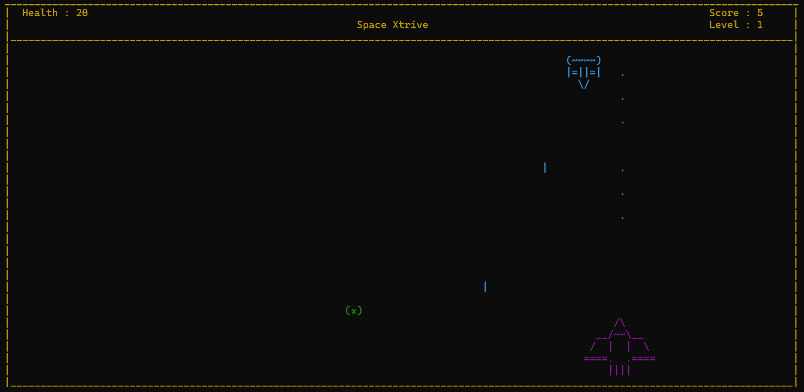
=========================================
Combat System Demo
=========================================
[Combat Sequence 1 - Player Fires]

(SPACEBAR pressed - bullet spawned)

(Bullet moves upward)
| [Enemy Health: 4] |
| |
| [HIT!] |
| |
| [Player] |
|_____________________________________|
[Combat Sequence 2 - Enemy Fires]
| [Enemy] |
| | |
| | |
| |
| [Player] |
|_____________________________________|
| [Enemy] |
| |
| | |
| |
| [Player] |
|_____________________________________|
| [Enemy] |
| |
| |
| | |
| [Player Health: 90] |
|_____________________________________|
Score: 1 Level: 1 Health: 90
=========================================

Pause Menu

Purpose of The Menu
The Pause Menu temporarily suspends gameplay, allowing players to save progress and decide whether to continue playing or exit to the main menu. Activation occurs by pressing ESC during active gameplay.

Input/Output
Input Format:
Keyboard Input: ESC key during gameplay
Detection: GetAsyncKeyState(VK_ESCAPE) & 0x8000
Menu Display: Overlaid dialog centered on screen
Output Format - Pause Dialog Display:
Position: Centered at (width/2 - 10, height/2 - 2)
Size: 22 characters wide × 5 lines tall
Background: Game world preserved behind dialog
Text Color: Light Yellow (code: 0E)
Display Content:
====================
GAME PAUSED
ENTER = Continue
ESC = Exit Game
====================
Console Display Example:
=========================================
Space Xtrive - Paused Game
=========================================
| |
| [Enemy] ==================== |
| | GAME PAUSED | |
| . | ENTER=Continue| |
| | ESC=Exit Game | |
| [Player] ==================== |
| |
|_____________________________________|
Score: 5 Level: 2 Health: 75
=========================================
Functional Behavior:
When ENTER pressed:
1. Pause dialog erased
2. Saved screen region restored
3. Game loop resumes
4. All enemy/player positions preserved
5. No state variables modified
When ESC pressed during pause:
1. Pause dialog cleared
2. Game state saved to file
3. Cursor made visible
4. Console colors reset
5. Game exits to main menu or system

Validation
Input Validation During Pause:
Key Pressed | Validation | Action
ENTER (VK_RETURN) | Key state check | Resume game; erase dialog; continue loop
ESC (VK_ESCAPE) | Key state check | Exit game; save state; display goodbye
Any other key | Ignored | No action; await valid input
No key pressed | N/A | Pause menu remains displayed
Button Hold Debouncing:
while (GetAsyncKeyState(VK_RETURN) & 0x8000) // Wait for key release
{
// Prevents accidental double-activation
}
restoreRegion(...); // Restore background
return false; // Signal continue
Screen Buffer Management:
saveRegion(bx, by, bw, bh, savedBuffer):
- Reads 22×5 character region
- Stores into CHAR_INFO savedBuffer[5][25]
- Preserves colors and characters
restoreRegion(bx, by, bw, bh, savedBuffer):
- Writes savedBuffer back to console
- Original game state displayed
- Game continues seamlessly
Data Persistence on Pause: - Game state automatically saved to game.txt - File contains current positions, health, score, level - No manual save required by player - Game remains fully resumable after save

Screenshot
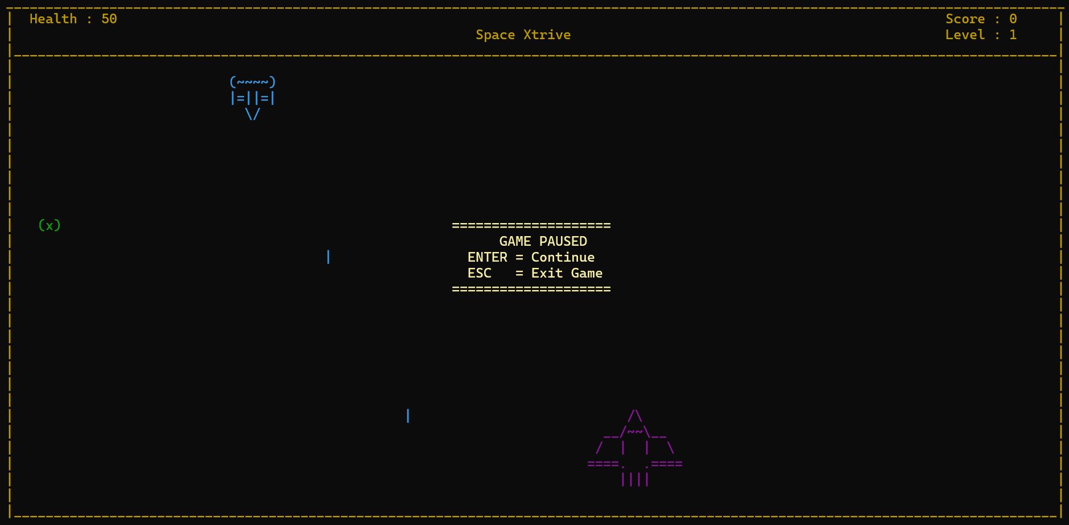

(User presses ENTER)
[Dialog closes, game resumes]
(User presses ESC during pause)
"Game Over."
(1 second delay)
(Program exits)
(Returns to command prompt)

Game Over Screen

Purpose of The Screen
The Game Over Screen displays when the player’s health reaches zero or below. It signifies the end of the current gameplay session, informs the player of defeat, and transitions back to the main menu system.

Input/Output
Input Format:
Automatic Trigger: health <= 0 (during combat or enemy fire processing)
No User Input Required: Screen displays automatically
Output Format - Game Over Display:
Automatic Sequence:
1. Console cleared via system("cls")
2. Color set to Red (code: 04)
3. Text displayed: "Game Over." at (width/2 - 6, height/2 - 1)
4. 1000ms (1 second) pause with Sleep(1000)
5. System reset with system("07")
6. Console cleared again
7. Color reset to White (code: 07)
8. Cursor made visible via showCursor()
Display Content:
Game Over.
[1 second pause]
[Console clears and program resumes/exits]

Validation
Game Over Trigger Validation:
Condition | Trigger Logic | Action
Direct collision | playerCollision(ex, ey, px, py) detected | health -= 20
Enemy bullet hit | bulletCollisionwithplayer() true | health -= 10
Health drops to 0 or below | health <= 0 check | Invoke Gameover()
Respawn countdown finished | respawnPlayerWithDelay() completes | playerInvincible = false
State Reset on Game Over:
// Variables reset when health <= 0
int ex1 = 1, ey1 = 4; // Enemy 1 default position
int ex2 = width - 8, ey2 = 0; // Enemy 2 default position
int ex3 = width / 2 - 5, ey3 = 0; // Enemy 3 default position
int px = width / 2, py = height - 3; // Player default position
int enemy1Health = 5; // Reset enemy health
int enemy2Health = 5;
int enemy3Health = 5;
// Score and level NOT reset - can be reviewed before main menu
saveSettingsToFile(...); // Save final state
exit(0); // Terminate program
Auto-Save Before Exit:
Game state persisted with health = 0
Score retained for review
All positions reset to defaults
File ready for next "Continue Game" load (though health = 0 triggers new game)

Screenshot
[Game Over Sequence]
=========================================
Final Combat Round
=========================================
| [Enemy] |
| | |
| | (Enemy bullet) |
| [Player Health: 10] |
| [Player] |
| |
|_____________________________________|
Score: 8 Level: 2 Health: 10
(Enemy bullet hits player)
| [Enemy] |
| |
| [Player Health: 0] |
| |
| [Player] |
| |
|_____________________________________|
[Screen becomes RED]
Game Over.
[1 second pause]
[Console clears]
[Returns to Windows command prompt]
C:\Users\username\game> _

Victory Screen

Purpose of The Screen
The Victory Screen displays when the player successfully defeats all three enemies across all three levels. It celebrates successful completion, displays final statistics, and concludes the gameplay session.

Input/Output
Input Format:
Automatic Trigger: enemy1Health <= 0 &&
enemy2Health <= 0 &&
enemy3Health <= 0
(during Level 3 gameplay)
No User Input Required: Screen displays automatically
Output Format - Victory Display:
Automatic Sequence:
1. Console cleared via system("cls")
2. Game arena reprinted with current score and level
3. Color set to Green (code: 02)
4. Arena reprinted for visual confirmation
5. Color set to Red (code: 04)
6. "You win." message displayed at (width/2 - 6, height/2 - 1)
7. 1000ms (1 second) pause with Sleep(1000)
8. Console cleared
9. Color reset to White (code: 07)
10. Cursor made visible via showCursor()
11. Program exits with exit(0)
Display Content:
You win.
[1 second pause]
[Final statistics visible before exit]

Validation
Victory Trigger Validation:
Condition | Level | Trigger Logic | Action
All enemies defeated | Level 1 | enemy1Health <= 0 | Advance to Level 2
All enemies defeated | Level 2 | enemy1Health <= 0 && enemy2Health <= 0 | Advance to Level 3
All enemies defeated | Level 3 | enemy1Health <= 0 && enemy2Health <= 0 && enemy3Health <= 0 | Victory!
Progression Logic:
// Level 1 Victory
if (enemy1Health <= 0 && enemy2Health <= 0 && enemy3Health == 5 && level == 1)
{
level = 2; // Advance to Level 2
level2reached = true;
// Enemy 2 introduced, Enemy 1 health refreshed
}
// Level 2 Victory
else if (enemy1Health <= 0 && enemy2Health <= 0 && enemy3Health == 5 && level == 2)
{
level = 3; // Advance to Level 3
level3reached = true;
// Enemy 3 introduced
}
// Level 3 Victory - Game Complete
else if (enemy1Health <= 0 && enemy2Health <= 0 && enemy3Health <= 0)
{
// All enemies defeated across all levels
system("cls");
setcolor("02");
printMaze(width, height, score, level, health);
setcolor("04");
gotoxy(width / 2 - 6, height / 2 - 1);
cout << "You win.";
Sleep(1000);
system("cls");
setcolor("07");
showCursor();
exit(0);
}
Level Transition Display:
When advancing from Level 1 to Level 2:
[Console clears]
[Arena reprinted]
[Yellow text at center: "Level 2 reached."]
[Blinks 6 times over 3 seconds]
[Player repositioned to spawn point]
[All bullets reset]
[Enemy 2 introduced at random position]
[Gameplay continues with Level 2 difficulty]
[Same pattern for Level 2 → Level 3 transition]

Screenshot
[Victory Sequence - Level 3 Completion]
=========================================
Victory Achieved!
=========================================
| |
| [Enemy Health: 0] X |
| |
| |
| [Enemy Health: 0] X |
| |
| |
| [Enemy Health: 0] X |
| |
| [Player] |
|_____________________________________|
Score: 25 Level: 3 Health: 45
[Display turns GREEN briefly]
[1 second pause]
You win.
[Display turns RED]
[1 second pause]
[Console clears]
[Program exits and closes]
Game Statistics Summary:
- Final Score: 25
- Levels Completed: 3/3
- Health Remaining: 45 HP
- Enemies Defeated: 3/3

Appendix

Color Code Reference
Hex Code | Color | Usage
02 | Green | Victory messages, coin color
03 | Cyan | Enemy characters, regular text
04 | Red | Game Over, defeat messages
05 | Magenta | Player character
06 | Yellow | Game title, headings
0A | Light Green | Level advancement messages
0B | Light Cyan | Instructions text
0E | Light Yellow | Pause menu
07 | White | Default, reset color

Keyboard Control Summary
Control | Key | Function
Move Up | ↑ Arrow | Move player upward
Move Down | ↓ Arrow | Move player downward
Move Left | ← Arrow | Move player leftward
Move Right | → Arrow | Move player rightward
Fire | SPACEBAR | Launch player bullet
Pause | ESC | Open pause menu
Menu Select | 1-4 | Select main menu option
Confirm | ENTER | Confirm pause menu choice

File I/O Format
Game.txt Structure: - Lines 1-5: Player ASCII art - Lines 6: Unused - Lines 7-9: Enemy ASCII art - Line 10: Coin animation frames (format: *,+,o,*) - Line 11+: Game save data (format: px,py,ex1,ey1,ex2,ey2,ex3,ey3,level,health,score,e1hp,e2hp,e3hp)

End of Report

