Blinkit Orders Dataset

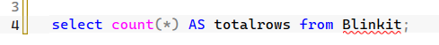
- Check total rows

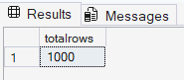

- Preview first 10 rows
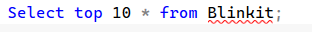
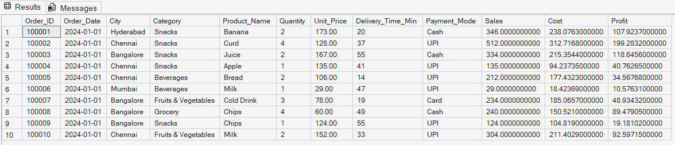
- Remove duplicates based on Order_id
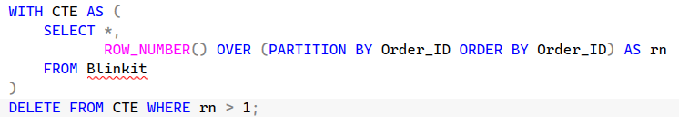

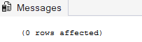

- Ensure numeric columns are properly typed
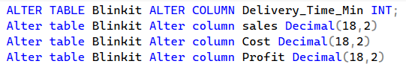
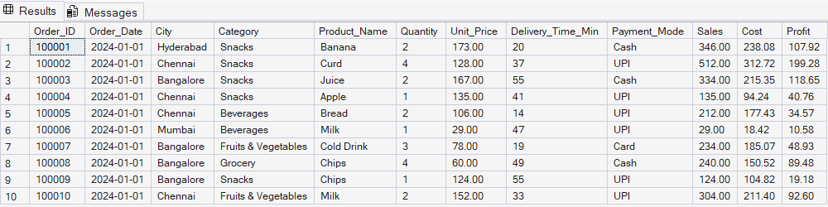

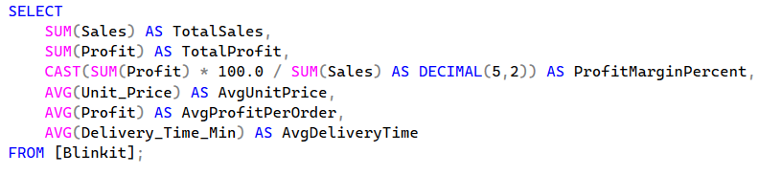
- Add profit margin as a calculated column

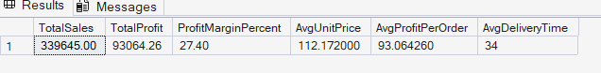

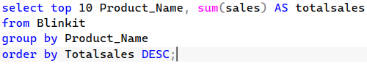
- Top Products by Sales
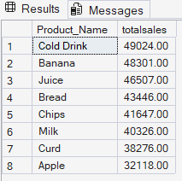

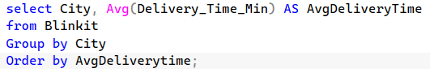
- City‑wise Average Delivery Time

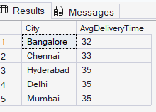

- Payment Mode Distribution
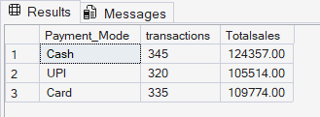
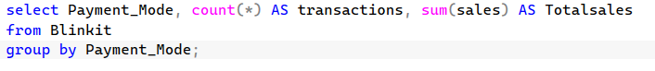

- Profitability by Category
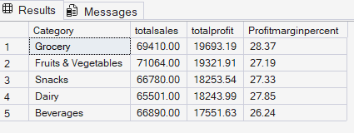
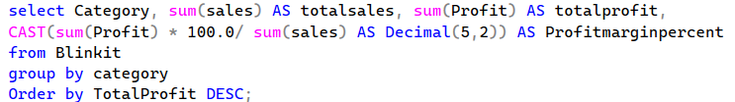

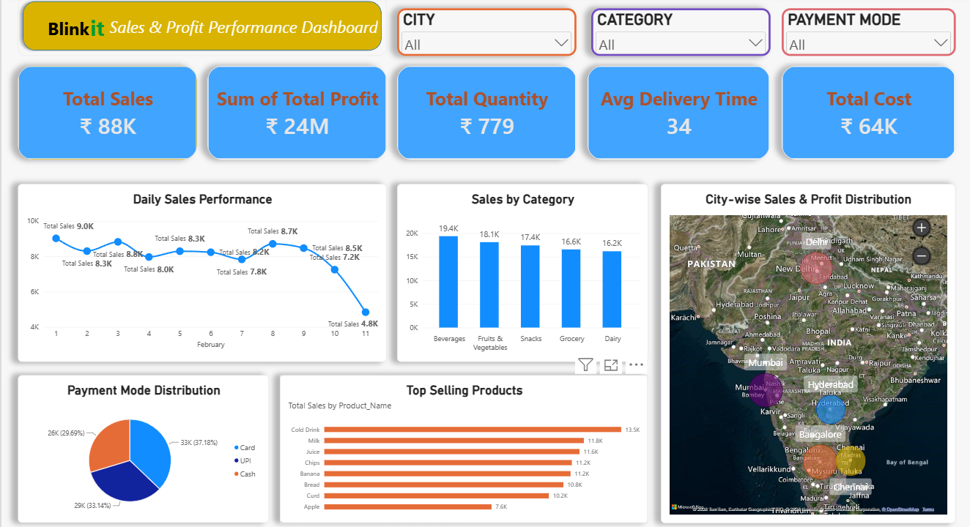
Power bi Dashboard

